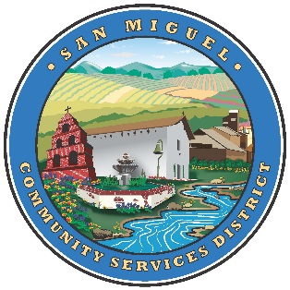Public information Meeting on Rate Increase
MEETINGS TO BE HELD AT 1150 MISSION STREET

FRIDAY APRIL 6TH 2018 @ 7PM
SATURDAY APRIL 28TH 2018 @ 5PM
SATURDAY MAY 5TH 2018 @ 12PM and 5PM

**traducción en español disponible**

