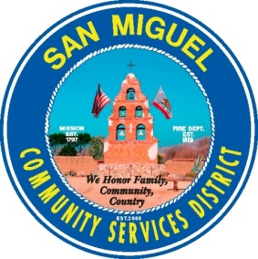

San Miguel Community Services District

NOTICE OF MEETING CANCELLATION OF THE FINANCE & BUDGET COMMITTEE

NOTICE IS HEREBY GIVEN that the regular meeting of the Finance & Budget Committee of the San Miguel Community Services District to be held on Thursday, June 1, 2017, at 4:30 p.m. at the San Miguel Community Services District Boardroom, 1150 Mission St. San Miguel, CA 93451, has been CANCELLED.

Dated: June 1, 2017 Signed: __________________________
Tamara Parent
Account Clerk II/Operations Coordinator

