Agenda

San Miguel Community Services District
BOARD OF DIRECTORS
John Green, President Larry Reuck, Vice President
Anthony Kalvans, Director Gib Buckman, Director Joseph Parent, Director

THURSDAY, DECEMBER 14, 2017
6:00 P.M. closed session 7:00 P.M. opened session
BOARD OF DIRECTORS SPECIAL MEETING AGENDA

SMCSD Boardroom
1150 Mission St.
San Miguel, CA 93451
Cell Phones: As a courtesy to others, please silence your cell phone or pager during the meeting and engage in conversations outside the Boardroom.

Americans with Disabilities Act: If you need special assistance to participate in this meeting, please contact the CSD Clerk at (805) 467-3388. Notification 48 hours in advance will enable the CSD to make reasonable arrangements to ensure accessibility to this meeting. Assisted listening devices are available for the hearing impaired.

Public Comment: Please complete a “Request to Speak” form located at the podium in the boardroom in order to address the Board of Directors on any agenda item. Comments are limited to three minutes, unless you have registered your organization with CSD Clerk prior to the meeting. If you wish to speak on an item not on the agenda, you may do so under “Oral Communications.” Any member of the public may address the Board of Directors on items on the Consent Calendar. Please complete a “Request to Speak” form as noted above and mark which item number you wish to address.

Meeting Schedule: Regular Board of Director meetings are generally held in the SMCSD Boardroom on the fourth Thursday of each month at 7:00 P.M. Agendas are also posted at: www.sanmiguelcsd.org

Agendas: Agenda packets are available for public inspection 72 hours prior to the scheduled meeting at the Counter/ San Miguel CSD office located at 1150 Mission St., San Miguel, during normal business hours. Any agenda-related writings or documents provided to a majority of the Board of Directors after distribution of the agenda packet are available for public inspection at the same time at the counter/ San Miguel CSD office at 1150 Mission St., San Miguel, during normal business hours.

- Call to Order: 6:00 PM
- Pledge of Allegiance:
- Roll Call:
- Approval of Special Meeting Agenda

- ADJOURN TO CLOSED SESSION: Time:___________

A. CLOSED SESSION AGENDA:

      - CONFERENCE WITH DISTRICT GENERAL COUNSEL-ANTICIPATED LITIGATION
Initiation of litigation pursuant to paragraph (4) of subdivision (d) of Section 54956.9 : (1 case)

      - CONFERENCE WITH DISTRICT GENERAL COUNSEL-ANTICIPATED LITIGATION
Significant exposure to litigation pursuant to paragraph (2) subdivision (d) of Section 54956.9: (1 case)

      - CONFERENCE WITH REAL PROPERTY NEGOTIATORS
Pursuant to Government Code Section 54956.8 Properties: 021-051-017 and 021-051-016.
Agency negotiator: (Blaine T. Reely, PhD,PE/Monsoon Consultants, SMCSD Interim General
Manager Rob Roberson, and Director of Utilities Kelly Dodds ) Property Negotiator: San Miguel Ranch, LLC.
Under negotiation: Purchase price & terms of payment.

      - PUBLIC EMPLOYEE PERFORMANCE EVALUATION
Pursuant to Government Code section 54957(b)(1)
Title: General Counsel

      - PUBLIC EMPLOYEE APPOINTMENT
Pursuant to Government Code section 54957(b)(1) Title: General Manager
- Call to Order for Regular Board Meeting/Report out of Closed Session

1. Report out of closed session by District General Counsel

- Public Comment and Communications:

Persons wishing to speak on a matter not on the agenda may be heard at this time; however, no action will be taken until placed on a future agenda. Speakers are limited to three minutes. Please complete a “Request to Speak” form and place in basket provided.

- Special Presentations/Public Hearings/Other:

1. Election of Board Officers and Board Appointments: A. Nominate and Elect Board of Director Officers:
  - President
  - Vice-President

- Staff & Committee Reports – Receive & File: Non-District Reports:
1. San Luis Obispo County Sheriff No Report 2. San Luis Obispo County Board of Supervisors No Report 3. San Luis Obispo County Planning and/or Public Works No Report
      - San Miguel Area Advisory Council No Report
      - Camp Roberts—Army National Guard (LTC Kevin Bender) No Report

District Staff Reports:
      - Interim General Manager (Mr. Roberson) Verbal
      - District General Counsel (Mr. White) Verbal
      - District Engineer (Dr. Reely) Report Attached 9. Director of Utilities (Mr Dodds) Verbal
10. Fire Chief (Chief Roberson) Report Attached

- CONSENT CALENDAR:
The items listed below are scheduled for consideration as a group and one vote. Any Director or a member of the public may request an item be withdrawn from the Consent Agenda to discuss or to change the recommended course of action. Unless an item is pulled for separate consideration by the Board, the following items are recommended for approval without further discussion.

    - Approve Resolution No. 2017-54 establishing Regular Board of Director Meeting Dates for 2018

    - Approve a five-year renewal of the Memorandum of Understanding between the County of San Luis Obispo and the District for the use of radio rack space at the Districts radio shack.

    - Review and Approve Board Meeting Minutes
      - 9-28-2017 Draft Minutes of Special Board Meeting
      - 10-19-2017 Draft Minutes of Special Board Meeting
      - 10-26-2017 Draft Minutes of Regular Board Meeting

- BOARD ACTION ITEMS:

1. Review, Discuss, Receive and File the Financial Report for November 2017
      - Claims Detail Report 11-2017
      - Statement of Revenue Budget vs Actuals 11-2017
      - Statement of Expenditures Budget vs Actual 11-2017
      - Cash Report for Payrolls 11-2017

Public Comments: (Hear public comments prior to Board Action)

M S V

2. Review and Discuss Approving Resolution 2017-55 accepting and approving of the FY 2015-16
Financial Audit Report by Moss Levy Hartzheim (Alex Hom)
RECOMMENDATION: The Board should approve the attached Resolution 2017-55 that accepts and approves the FY 2015-16 Independent Audit Report and authorize the filing of the report to the State and County of San Luis Obispo County Clerk’s office.
Public Comments: (Hear public comments prior to Board Action)

M S V

3. Authorization for Submission of an Application for Financial Assistance for The Planning and Design of Improvements To The Districts Wastewater Treatment Plant by Resolution 2017-57 (Reely)

RECOMMENDATION: Approve Resolution 2017-57 authorizing the Interim General Manager to submit a Financial Assistance Application for a financing agreement from the State Water Resources Control Board for the planning and design of improvements to the Districts WWTP

Public Comments: (Hear public comments prior to Board Action)

M S V

4. Review and approve Resolution 2017-49 authorizing the purchase of a Trailer mounted Sewer
Jetter from Jetter Northwest in amount Not to Exceed $37,659.90 to be funded from the Wastewater Capital Reserve fund. (Dodds)

RECOMMENDATION: Approval of Resolution 2017-49 authorizing the purchase of a Trailer Mounted Sewer Jetter.

Public Comments: (Hear public comments prior to Board Action)

M S V

5. Review and Approve Resolution No. 2017-56 authorizing the Director of Utilities to contract with Aqua Engineering to pull and evaluate the pump equipment at well 3 in an amount not to exceed $7,700 and authorize up to $9,000 to make repairs to the well equipment if necessary. (Dodds)

RECOMMENDATION: Approve Resolution No. 2017-56 authorizing the Director of Utilities to contract with Aqua Engineering to pull and evaluate the pump equipment at well 3 in an amount not to exceed $7,700 and authorize up to $9,000 to make repairs to the well equipment if necessary.

Public Comments: (Hear public comments prior to Board Action)
M S V

6. Review and Approve Resolution 2017-58 Adopting General Manager job description. (Counsel Seikaly)

Public Comments: (Hear public comments prior to Board Action)

M S V

7. Adopt Resolution 2017-59 appointing Robert Roberson as General Manager of the San Miguel Community Services District. (Counsel Seikaly)

Public Comments: (Hear public comments prior to Board Action)
M S V

- BOARD COMMENT:

This section is intended as an opportunity for Board members to make brief announcements, request information from staff, request future agenda item(s) and/or report on their own activities related to District business. No action is to be taken until an item is placed on a future agenda.

- ADJOURNMENT TO NEXT REGULAR MEETING OF 1-25-2018

Time:

ATTEST:

STATE OF CALIFORNIA )
COUNTY OF SAN LUIS OBISPO ) ss.
COMMUNITY OF SAN MIGUEL )

I, Tamara Parent, Board Clerk/Accounts Manager of San Miguel Community Services District, hereby certify that I caused the posting of this agenda at the SMCSD office on December 8, 2017

Date: December 8, 2017

________________________________________
Tamara Parent, Board Clerk/ Accounts Manager
________________________________________
Rob Roberson, Fire Chief/Interim General Manager

San Miguel Community Services District

Regular Board Meeting
Staff Report

DECEMBER 22, 2016 AGENDA ITEMS: VIII - 1

SUBJECT: Election of Board Officers

STAFF RECOMMENDATION:

Elect new Board Officers for President and Vice-President for 2018

BACKGROUND:
District Board Rules & By laws provides for the annual election of Board officers, specifically President and Vice-President. Chapter 2 section C-1 states “The President shall be selected by the Board annually in December”. No specific procedures for nomination and election of officers are delineated.

Current Officers:

President: John Green Nominations: __________________

Vice-President: Larry Reuck Nominations:

ACTION DISCUSSION:
Nominate and elect Board President and Vice-President to serve as Board officers for 2018.

PREPARED BY:
Tamara Parent
Board Clerk/Accounts Manager

Page 1 of 1
12-14-2017 Board Meeting

AGENDA ITEM IX - 8

P.O. Box 151 San Luis Obispo, CA 93406
(805) 476-6168 www.monsoonconsultants.com

SAN MIGUEL COMMUNITY SERVICES DISTRICT | BOARD OF DIRECTORS
Rob Roberson, Interim General Manager | John Green, President
Post Office Box 180 | Larry Reuck, Vice President
San Miguel, CA 93451 | Anthony Kalvans
(805) 467-3300 | Gib Buckman
 | Joseph Parent

Re: DISTRICT ENGINEER REPORT – DECEMBER 2017

Gentlemen:
The following is a summary of the activities performed and the status of relevant issues which pertain to the duties and responsibilities of this position:

OVERVIEW

The District produced approximately 7.6 MGAL (10,160 CCF) of water during the month of October 2017. This represents a decrease of approximately 25.2% from the prior month. No major failures or unexpected major expenditures were encountered within the water, wastewater, or street lighting systems during the month. The District completed its required tri-annual lead sampling event and no lead was detected in the samples.

MEETING PARTICIPATION
A brief summary of relevant issues that were discussed during meetings attended by the DE during the previous month are summarized below. (Note that routine meetings with SMCSD staff are not included):
1. December 6, 2017: The DE, Director Parent and the Utilities Director attended a meeting of the Paso Robles Groundwater Basin GSA Cooperative Committee in Paso Robles.

CIVIL ENGINEERING / HYDROLOGY

WATER PRODUCTION HISTORY
The following graph depicts the water production and sales for the proceeding 34months.
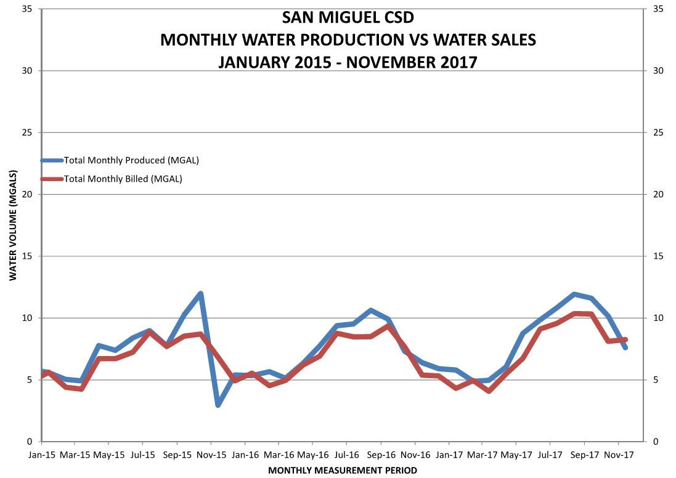

CAPITAL IMPROVEMENT PROGRAM
The following is a summary of the principal activities that were related to the Capital Improvements Program during the previous month:
- San Lawrence Terrace Arsenic Blending Pipeline & Tank Improvements: The contractor (Whitaker Construction Group, Inc.) was issued a Notice to Proceed in late September but due to delays in obtaining the HDPE pipe, they have not yet mobilized. Work on this project is expected to begin before the end of the year.
- Waterline Replacement on 11th Street & UPRR and 10th Street & Mission: The DE is in the process of preparing plans, specifications, bidding documents and UPRR/Caltrans ROW encroachment permit applications for this project.
- Wastewater Treatment Plant Renovation / Upgrade: We have been notified that the District will be the recipient of $177,750 Prop 1 IRWM DAC Involvement Grant Funds which will be used to fund a Wastewater Treatment Plant Update and Recharge Basin Study. We’re still a few months or more from being able to invoice for reimbursement funds; however, we can request reimbursement for work performed within the scope back to January 22, 2016. Because of the DAC status, no matching funds are required.
2

- Wastewater Treatment Plant Renovation / Upgrade: We have submitted a grant application to the DWR for funding in the amount of $250,000 for Planning & Design for the Wastewater Treatment Plant renovation. We have been assigned a project manager at the DWR and are in the process of collecting supplemental information for their agencies review.

DEVELOPMENT
The following is a summary of private development projects that are either in-progress or planned that staff is currently reviewing or inspecting during construction:

- People's Self Help (Tract 2527, formerly Mission Garden Estates): The contractor continues the installation of the underground utilities. The majority of the sanitary sewer collection system and the water distribution system have been installed.
- People’s Self Help (Tract 2710). This is a 24 Lot residential subdivision. Construction of water and sewer lines have been completed, tested and passed inspection. Homes are now under construction and they will be building in groups of 8 at once. The District is providing lateral inspections as needed. To date, more than 75% of the planned homes have been framed.
- Tract 2779 (Nino - 34 lots) –Site work on for this development was initiated in October 2017.

GROUNDWATER SUSTAINABILITY AGENCY
A meeting of the Paso Robles Groundwater Basin GSA Cooperative Committee was held in Paso Robles on December 6, 2017. Director Parent, our Utility Director and the DE attended.
Proposals for professional engineering & hydrogeological services as required to prepare a Groundwater Sustainability Plan (GSP) for the Paso Robles Groundwater Basin were received on December 4, 2017. The proposals will be reviewed and a recommendation for subsequent selection of a “short list” of firms to be interviewed will be brought before the Cooperative Committee.
An application to the DWR for grant funding for the preparation of the Paso Robles Groundwater Basin GSP was completed and submitted in November. We are currently waiting on the DWR to make an announcement regarding award of grant funds.

I would like to take this opportunity to thank each of you and District staff that will review the information contained in this report. If there are any questions or you wish to discuss, please do not hesitate to contact me.
Respectfully Submitted,

MONSOON CONSULTANTS
Blaine T. Reely
December 5, 2017
Blaine T. Reely, Ph.D., P.E. Date
President, Monsoon Consultants
3

San Miguel Community Services District
Board of Directors Meeting

Staff Report

Dec 14th, 2017 AGENDA ITEM: IX 10

SUBJECT: Fire Chief Report for November 2017
______________________________________________________________________________
STAFF RECOMMENDATION: Receive and File Monthly Reports for the Fire Department
______
INCIDENT RESPONSE:
- Total Incidents for November 2017 26
- Average Calls for per Month in 2017 29.1
- Total calls for the year to date 321

Emergency Response Man Hours in Nov = 72 2017 total 901
Stand-By Man Hours for Nov = 19 397
Total hr. 1,298

Emergency Response Man Hours = 2.7 hr. Per call for Nov 2.8 hr. Per call for the year
Stand–By Average per Call = 1.3 hr. Per call for, Nov 1.2 hr. Per call for the year

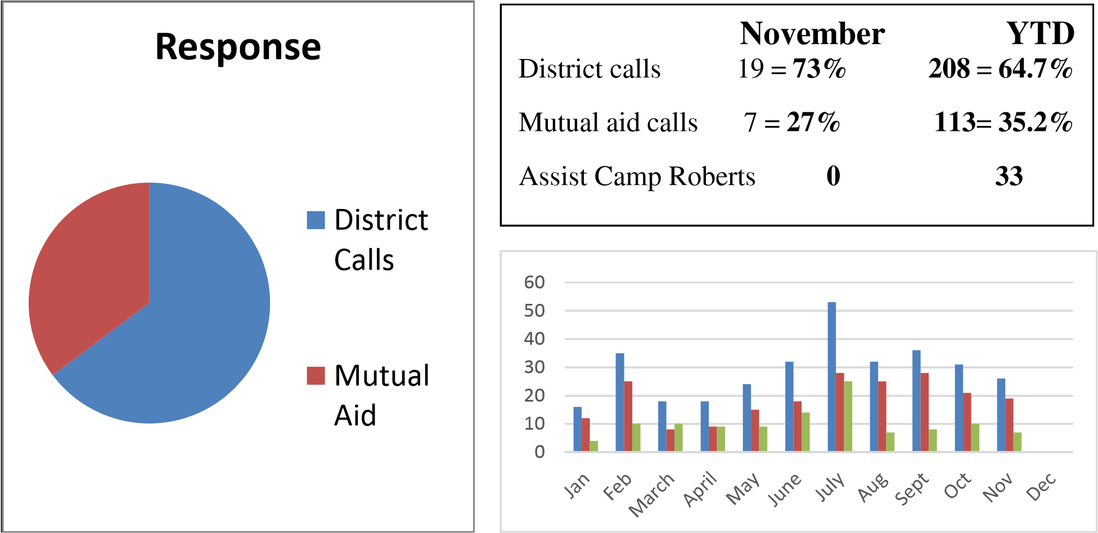

1.5  7.7  3.4  3.4  1.2  9.6  3.7  1.8  0  1.2  8.1  59.7  Response Breakdown by %  Structure fires  Wildland Fires  Vehicle Fires  Misc. fire  Illegal Burn  Vehicle Accidents  False Alarms  Haz Condition  Haz Mat  Stand by  PSA  Medical Aids | For 321 calls for 11 Months in 2017  District Calls 64.7% Mutual Aid 35.2 %  xxxxxxxxxxxxxxxxxxxxxxxxxxxx  Structure fires 1.5%  Wildland Fires 7.7%  Vehicle Fires 3.4%  Misc. fire 3.4%  Illegal Burn 1.2%  Vehicle Accidents 9.6%  False Alarms 3.7%  Haz Condition 1.8%  Haz Mat 0%  Stand by 1.2%  PSA 8.7%  Medical Aids 58.9%
Personnel:

We currently have 20 active members.
2 Fire Captains
2 Engineers
11 Firefighters
5 Trainees

Fire Captain Kyle Root resigned as a Fire Captain with the department after 8 years of dedicated service. Kyle is moving out of the area but will still be responding to our district as a Camp Roberts Firefighter.

Equipment:

- New pickup for Fire Dept. has been purchased and is being equipped with Radios, Identification stickers, and emergency light package and will be placed in service Mid December

- SCBAs have been purchased and should be delivered in a few weeks. No update at this time

Activities:

November

Date Subject matter
7 EMT Skill Assessments
14 Medical Scenarios Company Op’s CPR/ MCI
- Tour Court Side Cellars
- Association Meeting 28 No Drill

December

Date Subject matter
5 Auto Extrication/ Patient Removal/ Assessment
12 Christmas Dinner
19 No Drill
28 Association Meeting
Information:

Prepared By:
Rob Roberson

Rob Roberson, Fire Chief

IX-10
San Miguel  Fire Dept. | JAN |  | FEB |  | MAR |  | APR |  | MAY |  | JUN |  | JUL |  | AUG |  | SEP |  | OCT |  | NOV |  | DEC |  | TOTAL
 | District | Mutual Aid | District | Mutual Aid | District | Mutual Aid | District | Mutual Aid | District | Mutual Aid | District | Mutual Aid | District | Mutual Aid | District | Mutual Aid | District | Mutual Aid | District | Mutual Aid | District | Mutual Aid | District | Mutual Aid | District | Mutual Aid
Structure Fires | 0 | 0 | 0 | 0 | 0 | 0 | 0 | 0 | 0 | 0 | 0 | 1 | 1 | 0 | 1 | 0 | 0 | 0 | 0 | 2 | 0 | 0 | 0 | 0 | 2 | 3
Veg. Fires | 0 | 0 | 0 | 0 | 0 | 0 | 1 | 1 | 1 | 5 | 1 | 6 | 0 | 5 | 0 | 2 | 0 | 1 | 0 | 2 | 0 | 0 | 0 | 0 | 3 | 22
Vehicle Fires | 0 | 0 | 1 | 0 | 0 | 1 | 0 | 0 | 1 | 1 | 0 | 2 | 0 | 0 | 0 | 1 | 0 | 0 | 0 | 0 | 2 | 1 | 0 | 0 | 4 | 7
Misc. Fires | 2 | 0 | 0 | 0 | 1 | 0 | 1 | 0 | 0 | 0 | 0 | 0 | 1 | 0 | 3 | 0 | 0 | 0 | 1 | 0 | 1 | 1 | 0 | 0 | 10 | 1
Illegal Burning | 0 | 0 | 0 | 0 | 0 | 0 | 0 | 0 | 0 | 0 | 0 | 0 | 1 | 0 | 0 | 0 | 2 | 0 | 1 | 0 | 0 | 0 | 0 | 0 | 4 | 0
Vehicle Accidents | 1 | 2 | 2 | 2 | 0 | 3 | 2 | 1 | 0 | 2 | 1 | 3 | 0 | 3 | 0 | 0 | 1 | 2 | 0 | 1 | 1 | 2 | 0 | 0 | 8 | 23
False Alarms | 0 | 0 | 2 | 0 | 0 | 0 | 0 | 0 | 1 | 0 | 0 | 0 | 0 | 0 | 2 | 0 | 3 | 0 | 0 | 2 | 0 | 0 | 0 | 0 | 8 | 4
Hazardous Condition | 0 | 0 | 1 | 0 | 1 | 0 | 1 | 0 | 0 | 0 | 0 | 0 | 0 | 0 | 0 | 0 | 0 | 0 | 1 | 0 | 0 | 1 | 0 | 0 | 4 | 2
Hazardous Materials | 0 | 0 | 0 | 0 | 0 | 0 | 0 | 0 | 0 | 0 | 0 | 0 | 0 | 0 | 0 | 0 | 0 | 0 | 0 | 0 | 0 | 0 | 0 | 0 | 0 | 0
Standby | 0 | 0 | 0 | 0 | 0 | 0 | 0 | 0 | 0 | 0 | 0 | 0 | 4 | 0 | 0 | 0 | 0 | 0 | 0 | 0 | 0 | 0 | 0 | 0 | 4 | 0
Pub.Svc.Asst. | 0 | 0 | 3 | 0 | 0 | 1 | 0 | 1 | 5 | 0 | 2 | 0 | 2 | 0 | 3 | 0 | 4 | 0 | 3 | 0 | 4 | 0 | 0 | 0 | 26 | 2
Medical Aids | 9 | 2 | 16 | 8 | 6 | 5 | 4 | 6 | 7 | 1 | 14 | 2 | 19 | 17 | 16 | 4 | 18 | 5 | 15 | 3 | 11 | 2 | 0 | 0 | 135 | 55
Call TOTALS | 12 | 4 | 25 | 10 | 8 | 10 | 9 | 9 | 15 | 9 | 18 | 14 | 28 | 25 | 25 | 7 | 28 | 8 | 21 | 10 | 19 | 7 | 0 | 0 | 208 | 113
 | 16 |  | 35 |  | 18 |  | 18 |  | 24 |  | 32 |  | 53 |  | 32 |  | 36 |  | 31 |  | 26 |  | 0 |  | 321
CPR | 0 | 0 | 0 | 0 | 0 | 0 | 0 | 0 | 0 | 0 | 0 | 0 | 0 | 0 | 0 | 0 | 0 | 0 | 0 | 0 | 0 | 0 | 0 | 0 | 0 | 0
Mutual Aid SLO/Mon. | 4 | 0 | 8 | 2 | 10 | 0 | 9 | 0 | 8 | 1 | 14 | 0 | 24 | 1 | 6 | 0 | 0 | 0 | 0 | 0 | 0 | 0 | 0 | 0 | 87
Camp Bob Asst. | 1 |  | 1 |  | 3 |  | 2 |  | 3 |  | 5 |  | 16 |  | 2 |  | 0 |  | 0 |  | 0 |  | 0 |  | 33
Average Calls Per | Month |  | 22.2 | Day |  | 0.9 | SLO Co. MA |  |  |  | 83 |  | Montrey Co. MA |  |  |  | 4 |  | CPR TOTAL |  |  |  |  |  | 0

FIRE EQUIPMENT
IX-10-3
2017 MILEAGE / FUEL REPORT
Mileage/ Fuel | January |  | February |  | March |  | April |  | May |  |  | June |  |  | Total |  |  |  | Avg. MPG
Diesel | mi. | gal. | mi. | gal. | mi. | gal. | mi. | gal. | mi. |  | gal. | mi. | gal. |  | mi. |  | gal.
E-8696 | 9 | 0 | 64 | 21.4 | 46 | 0 | 94 | 21 | 23 |  | 0 | 63 | 17.5 |  | 299 |  | 59.9 |  | 5.0
E-8687 | 0 | 0 | 15 | 0 | 15 | 20 | 82 | 16.1 | 142 |  | 19 | 338 | 64.1 |  | 592 |  | 119.2 |  | 5.0
E-8668 | 68 | 0 | 44 | 14.6 | 11 | 0 | 15 | 0 | 74 |  | 0 | 12 | 0 |  | 224 |  | 14.6 |  | 15.3
 |  |  |  |  |  |  |  |  |  |  | 6 Month Total |  |  |  | 1115 |  | 193.7 |  | 5.8
Gas | mi. | gal. | mi. | gal. | mi. | gal. | mi. | gal. | mi. |  | gal. | mi. | gal. |  | mi. |  | gal.
U-8630 | 647 | 37 | 300 | 10 | 388 | 45 | 191 | 22 | 156 |  | 11 | 176 | 28.54 |  | 1858 |  | 153.5 |  | 12.1
C-8600 | 694 | 26.4 | 466 | 29.6 | 135 | 19 | 616 | 20.7 | 600 |  | 46 | 673 | 59.5 |  | 3184 |  | 201.2 |  | 15.8
 |  |  |  |  |  |  |  |  |  |  | 6 Month Total |  |  |  | 5042 |  | 354.7 |  | 14.2
Mileage / Fuel | July |  | August |  | September |  | October |  | November |  |  | December |  |  | Total |  |  |  | Avg. MPG
Diesel | mi. | gal. | mi. | gal. | mi. | gal. | mi. | gal. | mi. |  | gal. | mi. | gal. |  | mi. |  | gal.
E-8696 | 9 | 15 | 75 | 0 | 20 | 11 | 1240 | 248 | 37 |  | 0 |  |  |  | 1680 |  | 333.9 |  | 5.0
E-8687 | 328 | 30.5 | 70 | 17 | 173 | 20 | 87 | 17 | 33 |  | 0 |  |  |  | 1283 |  | 203.7 |  | 5.6
E-8668 | 3 | 11 | 13 | 9 | 103 | 0 | 22 | 10 | 124 |  | 29 |  |  |  | 489 |  | 73.6 |  | 11.0
 |  |  |  |  |  |  |  |  |  |  | 6 Month Total |  |  |  | 3452 |  | 611.2 |  | 5.6
Gas | mi. | gal. | mi. | gal. | mi. | gal. | mi. | gal. | mi. |  | gal. | mi. | gal. |  | mi. |  | gal.
U-8630 | 587 | 72 | 572 | 53 | 602 | 60 | 1087 | 88.4 | 941 |  | 55.5 |  |  |  | 5647 |  | 482.4 |  | 11.9
C-8600 | 209 | 51 | 510 | 22 | 537 | 53 | 511 | 31 | 885 |  | 23.4 |  |  |  | 5836 |  | 381.6 |  | 15.6
 |  |  |  |  |  |  |  |  |  |  | 6 Month Total |  |  |  | 11483 |  | 864 |  | 13.3
 |  |  |  |  |  |  |  |  |  | YTD 2016 Total |  |  |  | mi. |  | gal. |  | Avg. MPG
 |  |  |  |  |  |  |  |  |  | Diesel |  |  |  | 4567 |  | 804.9 |  | 5.7
 |  |  |  |  |  |  |  |  |  | Gas |  |  |  | 16525 |  | 1219 |  | 13.6

San Miguel Community Services District

Regular Board Meeting
Staff Report

DECEMBER 14, 2017 AGENDA ITEMS: X-1

SUBJECT: Discuss and Approve Resolution No 2017-54 establishing calendar year 2018
Regular Board of Director Meeting Dates

STAFF RECOMMENDATION:
Approve Resolution 2017-54 establishing Regular Board Meeting Dates for calendar year 2018

BACKGROUND:
The requirements of the District’s Board of Director bylaws and also State laws specify setting local agency meetings by elected boards, city councils, special districts and other agencies to with regular scheduled public meetings.

The proposed schedule and resolution is based on the District requirements to hold its monthly meetings on the fourth Thursday of each month, except in November and December 2018, when holidays affect those regular meeting dates.

The attached resolution will set the schedule for Calendar Year 2018 Regular Board meetings by date.

PREPARED BY:

Attachment: Resolution No. 2017-54
Exhibit “A” Meeting Dates

RESOLUTION 2017-54
EXHIBIT “A”
CALENDAR YEAR 2018

REGULAR BOARD OF DIRECTOR MEETING DATES AND TIMES
Meeting Times shall begin at 7pm, every Thursday of each month, unless otherwise noticed
THURSDAY-- JANUARY 25, 2018
THURSDAY--FEBRUARY 22, 2018
THURSDAY--MARCH 22, 2018
THURSDAY-- APRIL 26, 2018
THURSDAY--MAY 24, 2018
THURSDAY--JUNE 28, 2018
THURSDAY—JULY 26, 2018
THURSDAY--AUGUST 23, 2018
THURSDAY—SEPTEMBER 27, 2018
THURSDAY—OCTOBER 25, 2018
THURSDAY—NOVEMBER 15, 2018 **
THURSDAY—DECEMBER 13, 2018 **
** = This meeting date is not the regular 4th Thursday of the month due to conflict with Thanksgiving holidays on November 23 and 24th, 2018 and Christmas holidays on December 24th and 25th.
Special Board meeting dates and times may be established or set by the Board of Directors pursuant to adopted Board policy and applicable procedures.
Adopted by Board Action on: December 14, 2017

RESOLUTION NO. 2017-54
A RESOLUTION OF THE BOARD OF DIRECTORS OF THE
SAN MIGUEL COMMUNITY SERVICES DISTRICT ESTABLISHING
BOARD OF DIRECTOR REGULAR MEETING DATES AND TIMES FOR
2018 CALENDAR YEAR

WHEREAS, San Miguel Community Services District (“SMCSD”) authority for fire protection, water, wastewater, solid waste collection/disposal and street lighting infrastructure and services within the district,

WHEREAS, (“SMCSD”) Board of Directors (“Board”) is required by District ordinance to hold and conduct regular monthly public business meetings, hereby determines its intent to establishing calendar year dates and times for regular Board of Director meetings for 2018, and

NOW THEREFORE, BE IT RESOLVED, the Board does, hereby, adopts the 2018 Calendar for Regular Board of Director Meeting Agenda dates and times as set forth on Exhibit “A” attached hereto.

BE IT FURTHER RESOLVED, this Resolution shall remain in full force and effect until rescinded by the Board by resolution.

On the motion of Director __________seconded by Director ________and on the following roll call vote, to wit:

AYES:

NOES:

ABSENT:

ABSTAINING:

The foregoing Resolution is hereby passed and adopted this 14th day of December 2017.

___________________________
John Green, President
Board of Directors

Page 1 of 2
ATTEST: APPROVED AS TO FORM:

____________________________________ ____________________________________ Tamara Parent Doug White, District General Counsel
Board Clerk/Accounts Manager

Attachments:

Exhibit A: 2018 Calendar Year – Board Meeting Dates

I, Tamara Parent, Board Clerk/Accounts Manager of the San Miguel Community Services District, hereby certify the foregoing to be a full, true and correct copy of the record of the action of the action as the same appears in the Official Minutes of Board of Directors at its meeting of December 14, 2017.

Page 2 of 2

MEMORANDUM OF UNDERSTANDING

BETWEEN COUNTY OF SAN LUIS OBISPO

AND

SAN MIGUEL COMMUNITY SERVICES DISTRICT

THIS MEMORANDUM OF UNDERSTANDING (“MOU”) is entered into by and between the
County of San Luis Obispo, a political subdivision of the State of California hereinafter referred to as "COUNTY," and San Miguel Community Services District, hereinafter referred to as "DISTRICT," and will replace and supersede any and all prior written or verbal agreements made and entered into by and between County and District relative to the real property hereinafter described.

WHEREAS, County has a need for additional radio communications for County of San Luis Obispo Fire Department / Cal Fire to better serve the community of San Miguel; and

WHEREAS, the District manages that certain District owned real property located off Tenth
Street in the community of San Miguel, which currently has equipment rack space suitable for a County owned radio repeater; and

WHEREAS, the District has space available on its antenna to accommodate County radio communications; and,

WHEREAS, the District and County desire to enter into this MOU to occupy a portion of said District owned rack located off of Tenth Street for the purpose of accommodating the County’s radio equipment to enhance radio communications for the public safety.

NOW, THEREFORE, in consideration of the mutual promises, covenants, agreements and conditions herein set forth, County and the District mutually agree as follows:

- PREMISES: District hereby rents to County, and County hires and takes from District for the term, and upon the conditions hereinafter set forth, those certain premises hereinafter referred to as the "Premises", and more particularly described as rack space located within a building located off of Tenth Street in the Community of San Miguel and antenna space at the same location.

- TERM: The term of this MOU shall be for a period commencing February 1, 2018 until January 31, 2023, unless terminated by either party giving thirty (30) days prior written notice to the other party of its intention to do so.

- RENT: There is no rental charge as the placement of the subject County radio equipment is a benefit to the community of San Miguel.

- TENANT IMPROVEMENTS: County shall make no alterations to the Premises without
District’s prior written consent. All materials and/or outside contractor costs for materials or services for the County owned facilities or equipment on the Premises, including, but not limited to the radio repeater shall be paid directly by County.

- USE OF PREMISES: The Premises shall be used for business of the County to provide communications for public safety and for no other purpose.

- UTILITIES: The District agrees to pay electric utility service charges used by County during its occupation of the Premises. Any and all fire suppression systems and any existing fire detection systems shall be maintained by the District according to the requirements of CalFire/County of San Luis Obispo Fire Department.

- REPAIRS AND MAINTENANCE: County is solely responsible for maintenance and repair of its County installed radio equipment and the District is responsible for maintaining and repairing the equipment rack space and antenna. Upon termination of this MOU, County shall restore the Premises to original condition, to the satisfaction of the District.

- DESTRUCTION OF PREMISES: In the event of a partial destruction of the Premises during the term hereof, from any cause, County shall have the option to terminate this MOU. A total destruction of the building in which the Premises are situated shall terminate this MOU.

- ACCESS: District shall use its best efforts to provide County with access to the Premises on a twenty-four hour a day, seven days a week basis.

- INSURANCE:

A. Fire Insurance.
  - District: District’s policy as to the building and Premises shall be primary. District at its cost shall maintain during the term of this MOU on the building and Premises a policy or policies of standard fire and extended coverage insurance to the extent of at least ninety (90%) percent of full replacement value thereof.
  - County: County is presently self-insured. County at its cost shall procure
and maintain during the term of this MOU, a policy of fire insurance on County’s personal property including improvements paid for by the County, within the Premises. B. Liability Insurance.
  - District: District agrees to maintain in force throughout the term hereof, at District’s cost, commercial general liability insurance. This insurance shall include, but shall not be limited to, commercial general liability insurance providing protection against third party claims arising from bodily and personal injury, including death resulting therefrom, and damage to property resulting from any act or occurrence arising out of District’s operations during the time of this MOU. The commercial general liability policies shall name “County of San Luis Obispo, its officers and employees” as additional insureds. The policy shall provide that the District’s insurance will operate as primary insurance and that no other insurance maintained by the County will be called upon to contribute to a loss hereunder.
  - County: County is presently self-insured. C. Exemption of County from Liability.
Except for County’s willful sole neglect conduct, District hereby agrees that County shall not be liable for any reason in connection with the building, including, without limitation, events that occur in the common areas, or for damage or injury caused by fire, utility outage or interruption, pipe or sprinkler leakage, or similar causes, injury to District’s business or loss of income therefrom or for damage to the goods, wares, merchandise, or other property of District, District’s employees, or District’s invitees, in or about the Premises; nor shall County be liable for injury to the person of District, District’s employees, or District’s invitees, whether such damage results from conditions arising upon the Premises or upon other portions of the building in which the Premises are a part, or from any other sources or places. County shall not be liable to District for any damages arising from any act or neglect of any other tenant, if any, of the building in which the Premises are located.

- INDEMNIFICATION: To the fullest extent permitted by law, District shall indemnify, defend, and hold harmless the County and its officers, agents, employees, and volunteers from and against all claims, demands, damages, liabilities, loss, costs, and expense (including attorney’s fees and costs of litigation) of every nature arising out of or in connection with District’s performance or attempted performance of any obligation or duty provided for or relating to this MOU and/or the Premises, except such loss or damage which was caused by sole negligence or willful misconduct of the County.

- NOTICES: Any notices, demands, or communication, under or in connection with this MOU, may be served upon County by personal service, or by mailing the same by certified mail in the United States Post Office, postage prepaid, and directed to County at:

County of San Luis Obispo
Central Services Department
Real Property Services Division
1087 Santa Rosa Street
San Luis Obispo, CA 93408
Attention: Phil D’Acri, County Real Property Manager
Direct: (805) 781-5206
Email: pdacri@co.slo.ca.us

and may likewise be served on the District by mailing the same addressed to:
San Miguel Community Services District
Post Office Box 180, San Miguel, CA 93451
Attention: Kelly Dodds, Assistant Fire Chief
Direct: (805) 467-3388 x 206
Email: kdodds@sanmiguelcsd.ord

Either County or District may change such address by notifying the other party in writing as to such new address as Landlord or County may desire used and which address shall continue as the address until further written notice.

- ASSIGNMENT: This MOU is of a personal nature and County shall not assign, sublet, pledge or otherwise transfer this MOU, either voluntarily or by operation of law, in whole or in part.

- ENVIRONMENTAL MATTERS/COVENANTS REGARDING HAZARDOUS MATERIALS:
District shall at all times and in all respects comply with all federal, state and local laws, ordinances and regulations ("Hazardous Materials Laws") relating to industrial hygiene, environmental protection or the use, analysis, generation, manufacture, storage, disposal or transportation of any oil, flammable explosives, asbestos, urea formaldehyde, radioactive materials or waste, or other hazardous, toxic, contaminated or polluting materials, substances or wastes, including, without limitation, any "hazardous substances," "hazardous wastes," "hazardous materials" or "toxic substances" under such laws, ordinance or regulations (collectively, "Hazardous Materials").
District shall further indemnify, defend, protect, and hold County free and harmless from and against any and all claims, liabilities, penalties, forfeitures, losses or expenses (including attorneys' fees) or death of or injury to any person or damage to any property whatsoever, arising from or caused in whole or in part, directly or indirectly, by:
  - the presence in, on, under or about the Premises or discharge in or from the Premises of any Hazardous Materials or District's use, analysis, storage, transportation, disposal, release, threatened release, discharge or generation of Hazardous Materials to, in, on, under, about or from the Premises, or
  - District's failure to comply with any Hazardous Materials Law. District’s and obligations hereunder shall include, without limitation, and whether foreseeable or unforeseeable, all costs of any required or necessary repair, cleanup or detoxification or decontamination of the Premises, and the preparation and implementation of any closure, remedial action or other required plans in connection therewith, and shall survive the expiration or earlier termination of the term of this lease. For purposes of the release and indemnity provisions hereof, any acts or omissions of District, or by employees, agents, assignees, contractors or subcontractors of District or others acting for or on behalf of District (whether or not they are negligent, intentional, willful or unlawful) shall be strictly attributable to District.

- INSPECTION: The District shall have the right to inspect the Premises and to perform maintenance and repairs to the premises or the building of which the Premises is a part.

- STATUS: County shall during the entire term of this MOU, be construed to be an independent contractor, and shall in no event be construed to be an employee of District.

- CLOSURE: At any time should an occurrence necessitate the closing of the Premises, County shall have no recourse by law to District for losses incurred.

- EMPLOYEES OF COUNTY: All employees, agents and assignees of County shall be licensed when required by law. All such employees, agents, and assignees shall be employees, agents, or assignees of County only and shall not in any instance be, or construed to be, employees, agents or assignees of District.

- VENUE: This MOU has been executed and delivered in the State of California and the validity, enforceability and interpretation of any of the clauses of this MOU, shall be determined and governed by the laws of the State of California. The duties and obligations of the parties created hereunder are performable in San Luis Obispo County and such County shall be the venue for any action or proceeding that may be brought or arise out of, in connection with or by reason of this MOU.

- SEVERABILITY: The invalidity of any provision of this MOU shall not affect the validity, enforceability or any other provision of this MOU.

- ENTIRE AGREEMENT AND MODIFICATIONS: This MOU supersedes all previous
agreements and constitutes the entire understanding of the parties hereto. County shall be entitled to no other benefits than those specified herein. District makes no other promises or covenants beyond the scope of this MOU. No changes, amendments, or modifications shall be effective unless in writing and signed, in advance of the effective date of the change, amendment or modification, by both parties. County specifically acknowledges that in entering into this MOU, County relies solely upon the provisions contained in the MOU and no other MOU or oral discussions prior to entering this MOU.

/////////////////NOTHING FURTHER PAST THIS POINT EXCEPT SIGNATURES////////////////////

IN WITNESS WHEREOF, the parties hereto have executed this Memorandum of Understanding this ______ day of ________________, 2017.

COUNTY OF SAN LUIS OBISPO  By: _________________________________  Will Clemens, Central Services Director  APPROVED AS TO FORM AND LEGAL EFFCT:  RITA L. NEAL  County Counsel | By: _________________________  Deputy County Counsel  Date: _______________________  SAN MIGUEL COMMUNITY SERVICES  DISTRICT  By: ______________________________  KELLY DODDS, Director of  Utilities/Assistant Fire Chief

Page 5 of 5
SAN MIGUEL COMMUNITY SERVICES DISTRICT BOARD OF DIRECTORS
September 28, 2017 SPECIAL MEETING MINUTES
MEETING HELD AT DISTRICT OFFICES
1150 MISSION STREET
SAN MIGUEL, CA 93451

- Meeting Called to Order by President Green – 6:00 p.m.

- Pledge of Allegiance lead by President Green.

- Roll Call: Directors Present: Buckman, Green, Reuck, and Parent.
Director Absent: Kalvans
District Staff in attendance: Rob Roberson, Tamara Parent, Kelly Dodds,
District General Counsel White, and Schweikert,

- Adoption of Special Meeting Agenda:
Motion by Director Parent to adopt Special Meeting Agenda as presented.
Seconded by Director Reuck Motion was approved by vote of 4 AYES and 0 NOES and 1
ABSENT

- Public Comment and Communications (for items not on the agenda): No public comment.

- ADJOURN TO CLOSED SESSION: 6:03 P.M.

  - CLOSED SESSION AGENDA:
    - CONFERENCE WITH LABOR AGREEMENT NEGOTIATORS
Pursuant to Government Code Section 54957.6
District Representatives: District General Counsel, Director Kalvans, and President Green.
Unrepresented Bargaining Units:
    - Non-Management Non-Confidential unit; and
    - Non-Management Confidential unit.

    - CONFERENCE WITH DISTRICT GENERAL COUNSEL-ANTICIPATED LITIGATION
Significant exposure to litigation pursuant to paragraph (2) subdivision (d) of Section 54956.9: (1 case)

  - RECONVENE TO OPEN SESSION President Green reconvened to Open Session at 6:46 p.m.

  - REPORT OUT OF CLOSED SESSION
Report out of Closed Session by District General Counsel. Nothing to report

- Call to Order for Regular Board Meeting @6:47 P.M.

- Public Comment and Communications:
President Green asked that Public Comment be moved to after Staff & Committee Reports. Majority Agreed

- STAFF & COMMITTEE REPORTS:

1. San Luis Obispo County Sheriff No Report 2. San Luis Obispo County Board of Supervisors No Report 3. San Luis Obispo County Planning and/or Public Works No Report
  - San Miguel Area Advisory Council No Report
  - Camp Roberts—Army National Guard (Col. Nicole Balliet): No Report
  - Interim General Manager: Verbal Report updated the Board of Directors that the District Audit is being completed and will be at the November Board Meeting. The District office will be closed October 13th, because of the electrical conversion due to generator. District Personnel will be painting front office on that day.
Board Comments: None
Public Comments: None
  - District General Counsel: Presented by Counsel White, ChurchwellWhite has nothing else to report.
Board Comments: None
Public Comments: None
  - District Engineer: Written report submitted as is. Blaine Reely
Board Comments: Director Parent is excited to see the Water and Wastewater Master Plans being scheduled for the October Board Meeting.
Director Reuck thanked Dr. Reely for his report update on the SLT well.
Director Buckman asked about the Water vs. Billing spike in January 2014.
Tamara Parent Accounts Manager, explained that the spike in billing was when she started with the District as an Account Clerk and the reporting after January 2014 are more accurate.
Dr. Reely explained that reporting was not accurate at that time, due to metering issues. Director of Utilities Kelly Dodds, pointed out that the spike is a billing issue and has been addressed.
Public Comments: No Public Comments
9. Director of Utilities: Presented by Director of Utilities, Kelly Dodds. He explained that he has been in touch with PG&E, and the poles in the District with power already are little to no cost to put a streetlight on. Mr. Dodds explains that when we have to start bringing power to the poles, that is when charges start adding up and it gets expensive if we have to put up a whole new pole. Discussion ensued about places and different problems with locations. Director of Utilities Kelly Dodds updates the Board on Tract 2779, 12th Street by the District well #3 and how the project has already been started. Peoples Self-Help Housing Tract #2710 off 11th Street, the first eight houses have been finished and the new residence have moved in, and there are 16 more under construction. The other Self-Help Development Tract 2527 of 60 new homes have started with water and sewer mains being put in now.
Board Comments: No Board Comment
Public Comments: No Public Comment

President Green opens Public Comment up on items not on the Agenda @ 7:07 p.m.

Public Comments: Richard Smithen, San Miguel resident voiced his concern on the Board starting the Board Meeting this evening before 7:00 p.m. It was pointed out that the Agenda says approximately 7:00 p.m.
Donelle Arrowsmith, San Miguel Resident spoke of the issues he has been having with the homeless in the riverbed off Rio Vista. He has talked to the SLO County Sherriff Department and the garbage accumulation has become more like a landfill. He has not received any help and asked if the Board can do anything. Director Green, asked if this issue is in the riverbed? Mr. Arrowsmith explained that “yes” it was. At this time, Interim General Manager/Fire chief Rob Roberson asked to introduce his new Safety Offices Jason Taylor, informing the Board the he had information pertaining to Mr. Arrowsmith’s concerns.
San Miguel Safety Officer Jason Taylor, updated the Board and community members. Mr. Taylor explained, that on his first day of call he responded to a call about a fire in the riverbed. When he arrived, there was a fire and it exploded a cadmium lamp they had for lighting. Mr. Taylor explains from his experience, he was able to find a Fire Code to charge them and arrest them under a felony. Mr. Taylor has been in touch with the Fish and Game and the Homeless Sherriff task force.
Ashley Sangster San Miguel Resident, spoke to the Board of Directors about the nuisance of these homeless individuals and stated that he has seen that the fence to the riverbed has been cut. Mr. Sangster, has been in touch with the County to patch up the fence and feels that if we make it harder on them to get down to the riverbed, then they might leave.
Interim General Manager/Fire chief Rob Roberson, explained that everybody needs to contact the SLO County District Attorney’s office to ask them to enforce the citations and pick up the cases for these homeless. The community needs to get involved. Discussion ensued about why they keep arresting them and they get right back out.
Nanette Roe San Miguel resident, informed the Board that she heard that the mom, of the group will not go into get help from Social Services. Mrs. Roe stated that if the community gets the mother to go and then the boys will go with her.
Richard Smithen, asked who owns the river property, that is being discussed. Director Buckman explains that where the old pool on River Road was is County Property. Discussion Ensued about who owns the fence and if property owners could get involved.

President Green ended Public Comment, not on the agenda

- Fire Chief: Written report submitted with formal introduction of Safety Officer Jason Taylor; former Cal fire, Paso City Fire, SLO county Sheriff, and SLO school safety officer.
Mr. Taylor will be doing Fire Safety, and coverage for the District and he will be paid hourly. Fire Chief Rob Roberson feels that this will be a great asset to San Miguel.
Board Comments: None
Public Comment: None
- Bookkeeper: Paola Freeman was introduced by Rob Roberson Interim General Manager and explained that the reports are attached.
Board Comments: None
Public Comments: None

VIII. CONSENT ITEMS:

- Review, Receive and File the Enumeration of Claims Report for August 2017, Interim General Manager/Fire chief Rob Roberson informed the Board of Directors that if they see anything that needs to be changed, this would be the time to do that. The Financials will be filed once they vote.
- Review and Approve Board Meeting Minutes

Motion by Director Buckman to Review, Receive and File the Enumeration of Claims Report for July 2017 and all Draft Board Meeting minutes.

Seconded by Director Reuck. Motion was approved by Voice Vote of 4 AYES and 0 NOES and 1 ABSENT.

XI. PUBLIC HEARINGS:

1. Proposition 218—Public Hearing on Proposed Increase to Trash Collection and Disposal Service Charges by San Miguel Garbage Company and approve Resolution No. 2017-47

Item presented by Interim General Manager Rob Roberson, explained that all Pro218 directives have been done.
Aron Kardashian voiced that they are only asking for a raise to the commercial solid waste price.
Board Comments: None
Public Comments: Richard Smithen San Miguel Resident, voiced that the San Miguel Garbage Company has the cleanest truck in the county and are always very helpful to the community. Mr. Smithen agrees with the raise in price.
Motion by Director Buckman to adopt Resolution No. 2017-47 to Increase to Trash
Collection and Disposal Service Charges by San Miguel Garbage Company

Seconded by Director Parent. Motion was approved by vote of 4 AYES and 0 NOES and 1 ABSENT.

XII. BOARD ACTION ITEMS:

2. Review proposed Amendments to the FY 2017-18 Operational and Capital Budgets and approve Resolution No 2017-44 adopting amendments to the budget.

Item presented by Joan Aguilar consultant, PowerPoint. Ms. Aguilar commended and thanked Director of Utilities Kelly Dodds for all the work he had put into these amendments.
Consultant Joan Aguilar, informed the Board that as they directed for (fund10) Admin. department there has been reductions in the amount by $345,347.00 in the transfer of revenue. In expenditures side, salary and benefits have been removed resulting in a reduction of $268,874.00. There were also decreases for actual webpage maintenance and removal of engineering cost in the amount of $17,500.00. There is an increase in legal services in the admin fund. Fire (fund20), the inclusion of VFFA Grant in the revenue and appropriation side. The appropriation side will show the full amount $36k and the revenue side will show the fifty percent or 18k, the matching funds required. There is also the transfer from Capital Reserve for approved purchases in the amount of $163,021.00 and some minor adjustment related to Firework permit fees reduced, and increase in ambulance reimbursements. On the expenditures side, there is a reduction on Strike Team pay, increase in new report writing station, and the removal of all vehicle replacement funds throughout the budget transfers. Lighting (Fund30), Revenue has a reduction in the amount of $95,867.00. Salary/Wages has had an increase of $8,400.00, and we are accounting for an additional $6,000 for legal fees, and CPA services, and a percentage allocated for the District generator. Wastewater (Fund40) sales are projected to be higher by $14,355.00 and increase in revenue by Prop1 grant funds of $45,000.00. As before Salary/Wages redistribution from Admin Fund Wastewater will go up by $59,920.00. It was also noticed that fuel and energy cost are trending higher and those categories have been increased. Additionally, with generator and 50% of new utility vehicle and 10k reduction in vehicle replacement fund. Water (Fund50), revenue amount that is withdrawn from the Capital reserves account has been decreasing by $25,299.00 and again we see on the Salary/Wages side the distribution from Admin has increased by $59,920.00. There is an increase in the chemicals and water line repairs for 11th and 10th Street and SLT Blending line (CBDG). There is also a percentage for the Utility Vehicle and District generator. Solid Waste (Fund60), there is a decrease in Salary/Wages of $4,800. There has also been an increase in the transfer to administration that had previously not been accounted for and we are eliminating the transfer for legal cost. Overall Revenues will be decreasing by $226,221.00 and Expenditures decreasing $364,273.00, and total amended Revenues $2,222,454.00 and Expenditures 2,589,413. The necessary Budget Amendments have been entered into the financial system, Black Mountain and the reports show that those changes have been made
Board Comment: Director Buckman asked about Fire Capital Reserve and Kelly Dodds explained what was in the appropriated money and what it was to be used for.
Director Reuck asked about Fire impact fees and getting SCBA, and aware that it needs to be replaced.
Public Comments: No Comment

Motion by Director Buckman to adopt proposed Amendments to the FY 2017-18 Operational and Capital Budgets and approve Resolution No 2017-44.

Seconded by Director Reuck. Motion was approved by vote of 4 AYES and 0 NOES and 1 ABSENT.

3. Review & Appoint Director Parent as the SMCSD GSA Member and Mr. Kelly Dodds, Director of Utilities, as the Alternate Member to the GSP Cooperative Committee in accordance with Section 4 of the Memorandum of Agreement (MOA) for the Groundwater Sustainability Plan (GSP) preparation among all groundwater sustainability agencies in the Paso Robles Basin

Item presented by Dr. Blaine Reely explained that this is an item that has already been approved and only needs to appoint of members. These members will be making policy with the GSP Cooperative Committee.

Board Comment: President Green, asked if Director Parent and Director of Utilities Kelly Dodds where “okay” with this appointment. Director Parent voiced that “yes” he had been approached and would be okay with appointment.

Public Comments: No public comment.

Motion by Director Parent to Appoint Director Parent as the SMCSD GSA Member and Mr. Kelly Dodds, Director of Utilities, as the Alternate Member to the GSP Cooperative Committee in accordance with Section 4 of the Memorandum of Agreement (MOA) for the Groundwater Sustainability Plan (GSP) preparation among all groundwater sustainability agencies in the Paso Robles Basin

Seconded by Director Buckman. Motion was approved by vote of 4 AYES and 0 NOES and 1 ABSENT.

4. Review and approve RESOLUTION 2017-50 authorizing the Director of Utilities to purchase a utility truck for Utilities not to exceed $70,000 to be paid from water and wastewater Capital Reserves.

Item presented by Director of Utilities explained that this item has been brought back per the Board’s request and it is defiantly a needed in the Utilities Department. Mr. Dodds showed pictures of what the vehicle would look like but does explained that it will be a single cab.

Board Comment: Director Buckman feels it is just like the Fire vehicle 8668.
Director Green asked what brand of vehicle they have been looking at. Director of Utilities explains, that he has sent out information for a cost and Ford has not returned a cost estimate and so far, the best prices have been GMC or RAM trucks.
Director Green asked if the truck would be diesel?
The Majority agreed that a Diesel Truck is preferred.
Director Parent asked about where the vehicle would be stored, with Mr. Dodds explaining that it would be stored at the Wastewater facility under cover, and when the Wastewater facility is upgraded they will make a spot for the vehicles. Funding would be $60k for truck and 5-8k for equipment.
Director Buckman, voiced that he would like to sell the Fire vehicle 8668 to the water department. Discussion ensued about the use of the Fire vehicle and the problems it has had and what has been done to fix those problems.
Director Green voiced that he is having a tough time approving 70k and was worried about firefighters in harm’s way. Director Green asked that the new Pump on of Engine 8668 be tested.
Interim General Manager/ Fire Chief Rob Roberson, explained that most of the new VFF need to start out driving the smaller fire vehicle 8668.
Director Green asked if new or used, it was explained with utilities vehicle are always worked hard and would be in the best interest of the District to buy new and have vehicle for the life of the vehicle.
Director Green and Parent voiced that they would prefer a diesel vehicle.

Public Comments: No public comment.

Motion by Director Parent to approve RESOLUTION 2017-50 authorizing the Director of Utilities to purchase a Diesel utility truck for Utilities not to exceed $70,000 to be paid from water and wastewater Capital Reserves.

Seconded by Director Reuck. Motion was approved by vote of 3 AYES and 1 NOES and 1 ABSENT.

5. Review and Approve Resolution 2017-51 authorizing the Fire Chief to purchase replacement Self Contained Breathing Apparatus (SCBA) at a cost not to exceed $151,021.00 from Bauer Compressors.

Item presented by Interim General Manager/ Fire Chief Rob Roberson, explained that the San Miguel Fire Departments SCBA hydro date is expired and can’t be extended any longer. Example of the Bauer SCBA were shown to the Board of Directors. Replacement of the SCBAs is a life safety equipment purchase. Firefighters use these SCBA’s for protection during emergency incidents, so they must function properly and reliable 100% of the time. Normally any purchase of this amount would need to be sent out to bid and the lowest responsive bid accepted. However, since this purchase is a life safety item, and to ensure compatibility with the neighboring agencies we do not have to follow those same bidding procedures.
Board Comment: President Green asked if they will still be use some SCBA’s for training?
Staff Comment: Assistant Fire Chief Kelly Dodds explained that they would have SCBA designated for training and will be compatible with other departments in the area. The new SCBA’s from Bauer will have a life span of approximately, 15 years.
Board Comment: Director Parent asked about filling the bottles, it was explained that we have the capabilities to fill in house.
Discussion ensued about SCBA, mask use and training.
Public Comments: No Comment

Motion by Director Reuck to Adopt Resolution 2017-51 authorizing the Fire Chief to purchase replacement Self Contained Breathing Apparatus (SCBA) at a cost not to exceed $151,021.00 from Bauer Compressors.

Seconded by Director Buckman. Motion was approved by vote of 4 AYES and 0 NOES and 1 ABSENT.

Staff Comment: Tamara Parent Board Clerk/Accounts Manager informs the Board that the Staff would like to have a Special Finance meeting. Interim General Manager Rob Roberson explained that the Special Financial Meeting will be about policy for the fund accounts, and where money can be attributed too. He feels the meeting would be about 2 to 3 hours. Discussion ensued about dates.
Majority of the board decided on October 19, 2017 at 6pm

- BOARD COMMENT
Director Parent informed the Board that he will not be available for October 26th.

Director Green re-opened public comment
Public Comment: Richard Smithen, San Miguel Resident, asked about the water and wastewater fund accounts and how they are in the red. He would like to see the Board look at getting a rate increase. President Green explained that we have hired Bartle Wells to perform a rate study in January 2017.
Director Green closed public comment

Interim General Manager/ Fire Chief Rob Roberson would like it known that Director Kalvans had sent him a text at 17:08 (5:08 p.m.) explaining that he would not be able to make closed session due to work schedule conflict.

- ADJOURNMENT
President Green adjourned the open session meeting at 8:17 p.m.

SAN MIGUEL COMMUNITY SERVICES DISTRICT BOARD OF DIRECTORS
OCTOBER 19, 2017 SPECIAL MEETING MINUTES
MEETING HELD AT DISTRICT OFFICES
1150 MISSION STREET
SAN MIGUEL, CA 93451

- Meeting Called to Order by Vice President Reuck – 6:00. p.m.

- Pledge of Allegiance lead by Vice President Reuck.

- Roll Call: Directors Present: Buckman, Reuck and Parent.
Director Absent: Kalvans, Green
District Staff in attendance: Rob Roberson, Kelly Dodds, Tamara Parent,
Paola Freeman
District General Counsel Schweikert

- Adoption of Special Meeting Agenda:
Motion by Director Buckman to adopt Special Meeting Agenda as presented.
Seconded by Director Parent Motion was approved by vote of 3 AYES and 0 NOES 2 ABSENT.

- Public Comment and Communications (for items not on the agenda): No Public Comment

- BOARD WORKSHOP:
1. Discussion on district financials;
PowerPoint presentation on Restricted and Unrestricted District funds (PP on file)

Interim General Manager/Fire Chief Rob Roberson, informed the Board that this meeting was called because The Board of Directors has not seen any financials for a long time and this was due to previous management. This meeting is to establish a common ground between the Board and District staff, and update the Board on how the financials are being handled. This Meeting will have information regarding what is Restricted, Unrestricted funds and how the funds are identified correctly. Bookkeeper, Paola Freeman and Director of Utilities, Kelly Dodds presented a PowerPoint presentation and Discuss on Restricted and Unrestricted District funds.

Staff Comment: Director of Utilities Kelly Dodds explained the Fire Impact Fees/Public
Facility Fees can only be used for Capital Projects, Public Facilities and Equipment. The District must report the use of these funds on a quarterly basis to the County of SLO. If the District doesn’t show that the money is being spent correctly then the County can withhold the funds.

Board Comment: Director Parent asked about how Impact Fees are set and if it requires a Prop 218 to raise the Impact Fees.
District Counsel Schweikert, explained that it is not a Prop 218 requirement because it is not a utilities fee. The Board of Directors sets the fees by resolution or ordinance.

Public Comment: Laverne Buckman San Miguel Resident, asked about who specifically at the San Luis Obispo County collects these funds. Director of Utilities, Kelly Dodds explained that the Planning Department Collects the fees when the developer gets permits from them and the San Luis Obispo County Auditor/Controller office holds the funds and sends the check distribution to the district.
Mrs. Buckman also asked about Connection Fees and had a comment that these funds are restricted funds but in the past, they have been put into the general fund and would like to know if these funds should be put into a restricted fund account to keep track of them better. She would like to see a better check and balances system.
District Counsel Schweikert explained that Connection Fees are a Prop 218 process, and have requirement that need to be meet before rates can be increased.

Discussion Ensued about how the fee is established.

Interim General Manager/Fire chief Rob Roberson, explained that he would like the help of the board by asking about these funds before approving any expenditures. Mr. Roberson updated the Board on how money is processed in the office, and how the District Staff have set up a process of having two different office staff check the deposit before and after the deposit goes to the bank.

Public Comment: Nannette Roe, San Miguel Resident asked about the Black Mountain Software fund numbers and percentages used in the District financials.

Discussion Ensued about Black Mountain Software fund numbers, property tax and revenue and capital reserve appropriations.

Public Comment: Laverne Buckman, voiced that she would like to see a difference in Operating Revenue and Budget Revenue. She would like to be able to see what the difference is in operating expenses each year, and not an incorporation with projects. Mrs. Buckman feels that the Operating and Restricted funds are an important piece to the finances of the District.
Director of Utilities Kelly Dodds, explained that this would not explain anything until the next year, but said it would be easy to fix in the reports and this has been done in the past. Interim General Manager/Fire chief Rob Roberson, explained that previous management went away form that and is one of the ways we have gotten into a problem trying to explain were these funds have been spent. He would like to make it easily identifiable in the future, but explains that we are working through it and waiting for Audit.

Bookkeeper Paola Freeman, explained that we have not transferred any moneys out of
Pacific Premier Bank into any other District bank accounts. She updated the Board on what
District Bank Account the District currently has. She would also like clarification on why and what these accounts where set up for. Director of Utilities, Kelly Dodds explains that the money has not been transferred within the two District accounts at Pacific Primer Bank. Mrs. Freeman explained that when she transfers money from the Capital Reserves account, she gets an invoice it gets coded and she receives the Board Resolution for documentation and makes the transfer and has someone else in the office initial that the correct amount was transferred out of that account.

Board Comment: Director Parent asked if this was how thing have been done in the past, and it was explained to him that “no”, one person in the office, typically the General Manager looked at these fund transfers and made the decision on how much to transfer and for where, then makes the transfer. Interim General Manager/Fire chief Rob Roberson that this process is not transparent and is not going to proceed.

Interim General Manager/Fire chief Rob Roberson, informs the Board that there will not be borrowing money from other funds like it has been done in the past and if it does happen that there will be a Resolution detailing how the money will be paid back to that funds.

Public Comment: Laverne Buckman San Miguel Resident, voiced that she feels that it is very important that the Board approves the financials monthly on each agenda but would like the Directors to ask more questions and take it more seriously.
Interim General Manager/Fire chief Rob Roberson, explains that it is the exactly the reason he has moved the approval of the District Monthly Financials, to the Action Item on the agenda. The staff wants and needs the Directors and Public to be involved and have a discussion to make this all work correctly.

Board Comment: Director Buckman reminded the Staff about the USDA Loan account and informed the staff that as soon as we see that the USDA Loan payment has been made we are to put the next payment into the account.
Director of Utilities, Kelly Dodds explains that the account they are referring to is an account for “just in case”, and the money just sits there, never moves and if we keep the payment that comes due into an account that the lender can take for payment twice a year we have no problems. The “just in case” account is just a backup account and part of the stipulations of the loan. There are two accounts, all in Pacific Premier Bank

Discussion ensued about the other District Bank accounts, and this issue will be coming back to the Board of Directors asking for direction on these accounts.

Director Buckman explained that he would like the Admin account to go away, and in the past this account has only caused problems. District Staff agreed.

Discussion ensued with Nannette Roe and Lavern Buckman about how to read the reports that are given to the Board of Directors each month.

- BOARD COMMENT:

Director Parent, Thanks staff for the information, and that the information was very helpful. He also, spoke about the Groundwater GSP meeting he attended, and feels it will be a productive group.
Director Buckman, asked about the accounts list for Black Mountain seeing that the Farrar Fire engine was still on report. It was explained to him that all the Account Codes will stay in Black Mountain Software even if it was only used once, due to reports that might be needed in the future or for reports.

Director Reuck explained that he will be moving and closing escrow very soon.

- ADJOURNMENT: Director Reuck adjourned meeting Time: 8:10 P.M.

SAN MIGUEL COMMUNITY SERVICES DISTRICT
BOARD OF DIRECTORS
October 26, 2017 SPECIAL MEETING MINUTES
MEETING HELD AT DISTRICT OFFICES
1150 MISSION STREET
SAN MIGUEL, CA 93451

- Meeting Called to Order by President Green – 6:30 p.m.

- Pledge of Allegiance lead by Vic President Reuck.

- Roll Call: Directors Present: Buckman, Green, Reuck.

Director Parent Absent do to work schedule Director Kalvans arrived at 7:14 P.M.

District Staff in attendance: Rob Roberson, Tamara Parent, Kelly Dodds, Paola Freeman and District General Counsel Schweikert,

- Adoption of Special Meeting Agenda:
Motion by Director Buckman to adopt Special Meeting Agenda as presented.
Seconded by Director Reuck Motion was approved by vote of 3 AYES and 0 NOES and
2 ABSENT

- Public Comment and Communications (for items not on the agenda): No public comment.

- ADJOURN TO CLOSED SESSION:
Closed Session convened at 6:33 p.m.

  - CLOSED SESSION AGENDA:
  - CONFERENCE WITH DISTRICT GENERAL COUNSEL – Existing Litigation
Pursuant to Government Code Section 54956.9 (d)(1) Case: Steinbeck v. City of Paso Robles, Santa Clara County Superior Court Case No. 1-14-CV-265039 and Case:
Eidemiller v. City of Paso Robles, Santa Clara County Superior Court Case No. 1-14CV-269212

  - CONFERENCE WITH DISTRICT GENERAL COUNSEL-ANTICIPATED LITIGATION
Significant exposure to litigation pursuant to paragraph (2) subdivision (d) of Section 54956.9: (1 case)
  - RECONVENE TO OPEN SESSION: President Green reconvened to Open Session at 7:00 P.M.

  - REPORT OUT OF CLOSED SESSION
Report out of Closed Session by District General Counsel. Nothing to report.

Call to Order for Regular Board Meeting @7:02 P.M.

Public Comment and Communications:
No public comment.

- CONSENT ITEMS

- STAFF & COMMITTEE REPORTS:

  - San Luis Obispo County Sheriff No Report
  - San Luis Obispo County Board of Supervisors No Report
  - San Luis Obispo County Planning and/or Public Works No Report
  - San Miguel Area Advisory Council No Report
  - Camp Roberts—Army National Guard (LTC Kevin Bender) No Report
  - Interim General Manager: Verbal Report updating the Board of Directors that the District Staff has been working with Cramer,CPA, to reconcile accounts with EDD, and IRS.
District Audit for FY 2015-16 should be presented to the Board of Directors at the November Meeting.
Monthly District financials will be moved to the Action Items portion of the Agenda for transparence and clarity.
Tamara Parent has just returned from the Board Sectary conference put on through CSDA.
Board Comments: None
  - District General Counsel: Presented by Counsel Karl Schweikert. ChurchwellWhite, LLC. has nothing new to report.
Board Comments: None
  - District Engineer: Written report submitted as is. Blaine Reely
Board Comments: None
Public Comments: None
  - Director of Utilities: Kelly Dodds, Director of Utilities updated the Board that our new Utilities Operator, Mike started work a week or so ago, and it seems to be working out. The Utilities Vehicle should be purchased in the next week or so. Mr. Dodds explained that Engineer Blaine Reely and him had just got back from the GSP Basin meeting, where they okayed an RFP to hire a consultant for the GSA, feels that some information will be brought to the Directors by January 2018.
Board Comments: None
Public Comments: Laverne Buckman resident of San Miguel, asked about information she had heard about the GSA, and the study that had been done. She has an understanding that they were all working together for the GSA report. District Engineer, Blaine Reely explained that the Templeton-Santa Margarita-Atascadero GSA, were able to redefine their ground water sub-basin, and is being dealt with separately then the Paso Groundwater basin.
  - Fire Chief: The district sent four (4) members of the Fire Department up north to the wildland fires. The District Firefighters, were up there for ten days with no injuries. The Interim General Manager/Fire Chief Rob Roberson, explained that the Fire Engine, put in 170 hours that the district will get compensated for in the amount of an estimated 16k., and 4k for admin reporting costs. Fire Chief would like to also thank Director Green for introducing the Fire Department to Rich Souer, who came to the District on 10/25/2017 for a demo with a fire suppression system.
District calls are up and this year is over 300 calls to date
Board Comments: Director Green asked for clarification on the 16k, making sure he heard the amount correctly, and wanted to know if that amount was combined or separate from the firefighter pay. It was explained that the District Engine receives the 16k and the firefighters pay is separate from that amount. Public Comment: None

President Green, announced that Director Kalvans arrived at 7:15

- CONSENT ITEMS:

  - Review and Approve Board Meeting Minutes
    - July 6, 2017 Special Meeting Minutes
    - July 27, 2017 Special Meeting Minutes

Motion by Director Kalvan to Review, Receive and File the Enumeration of Consent item number 1.a & 1.b

Seconded by Director Reuck. Motion was approved by Voice Vote of 4 AYES and 0 NOES and 1 ABSENT.

XI.
1. Review, Discuss, Receive and File the Enumeration of Financial Report for
September 2017
Item presented by Interim General Manager Rob Roberson, explaining that this item has been changed from the Consent Item to the Action Items in the Agenda to give the Board of Directors an opportunity to discuss the financials in more detail if needed. Paola Freeman, Bookkeeper will be here to answer any questions needed.
Board Comments: Director Kalvans, asked the District Staff at what percentage do they feel their confidence in the numbers being presented.
Interim General Manager Rob Roberson, explained that we discussed this at the October 19th financial meeting, and explained that the District Staff is working very hard to give the Directors the correct information. Mr. Roberson feels that the information they have given the Board for September 2017 is Correct, but would like the Board to ask any questions before the vote to File and receive the Financial Reports for September 2017. Director Green asked specifically asked about Item three on page one, for $39k and would like to know what that purchase was. Paola Freeman explained that was for the purchase of the Fire Utility Vehicle. Public Comments: None
Motion by Director Kalvans to Receive and File the Enumeration of Financial Report for September 2017
Seconded by Director Reuck. Motion was approved by vote of 4 AYES and 0 NOES and 1 ABSENT.

2. Review and Discuss the 2017 Water & Wastewater Draft Masterplan as prepared by Monsoon Consulting
Item presented by District Engineer Blaine Reely with a PowerPoint as prepared by
Monsson Consulting for 2017 Water & Wastewater DRAFT Masterplan (PowerPoint on
File)
Discussion ensued about Draft Master plans, new wells & SLT well, and how to move forward. Mr. Reely explained that he has prioritized what he feels needs to be the Districts priorities in the future, and would like the Board of Directors to review and bring back any changes to District Staff before the next meeting where he hopes that these Master plans are approved.
Board Comment: Director Kalvans asked the District Engineer and Counsel, about the Wastewater expansion, and specifically if the Mindy Laws/SB168. (10 road blocks) would be something the District should be aware of. The timeline for the Wastewater expansion is scheduled for five years out and feels that it should be sooner if the Mindy Law applies.
District Engineer Dr. Reely explains that under our current permits, we could get to full build out and would be at 75% at the Wastewater facility.
District Counsel feels that we would not be putting up any road blocks, for any interested developers.
Director Green asked about acquiring land for the expansion of the Machado Wastewater Facility
Discussion ensued about purchasing land for expansion.
Public Comments: Laverne Buckman asked about were the board will be going from here. District engineer explained that this is a Draft Master Plan, and would like Board, and Public to review the document. The Final Master Plan with changes will be brought to the Directors at the next board meeting in November. Mr. Reely explained how the Rate Study that is being done by Bartle Wells, Inc. will be considering these priorities and it is an ongoing document.
Nanette Roe, asked about grant funds and/or District loans.
Discussion about loan requirements for the future ensued.
Board Comment: Director Kalvans, asked due to the cost of some of these projects and different zones within the community. Director Kalvans feels that the Director should also be discussing what areas in the community may have more of a need then others, and if that was a question for the Rate Study or Master Plan. Director of Utilities, Kelly
Dodds agreed that it was a rate study question, but feels the question can be discussed.
Director Buckman asked about prioritizing the 10th & 11th Street projects

Discussion Item only

3. Discuss and Review ideas for a new San Miguel C.S.D. Logo

Item presented by Interim General Manager/Fire Chief Rob Roberson, updating the Board of Directors on the idea of updating the District Logo. The current District Logo is outdated and to pixelated for new graphics.
Discussion ensued about different ideas for a new District Logo.
Board Comment: Director Green discussed with General Manager the cost associated with changing the Logo.

Majority agreed that when the Logo gets changed the District items should be changed by attrition.

Director Kalvans asked about using the image of the Mission and is worried about offending atheist groups. Interim General Manager/Fire Chief Rob Roberson explained that a lot of cities and fire department have embraced California Missions in their logos. District Counsel explained that it is a “fair use” and explained that because we took photo we could use it. San Miguel is named after Saint Michael, and is part of the town’s identity.
Director Kalvans would like to see a collage.
Director Reuck would like to see a fire engine and mission
Interim General Manager/Fire Chief Rob Roberson, explained that he would bring back mock-ups. Board Agreed
Discussion ensued
Public Comments: No Comment

District general Counsel would like to respond to Director Kalvans question for item # 2 President Green, agreed.

Counsel Schweikert, explained to Director Kalvans that he understood that he is concerned about the waste treatment facilities and the possibilities of fines if the District did not approve a development. The laws Director Kalvans cited are all linked solely to Cities and not Special Districts. SB-35 required streamlined permitting for affordable housing. Zoning is not in the District's power, so it does not affect the District.
SB 167 creates fines for cities that block affordable housing by claiming lack of available services. Also prevents Cities from refusing to upgrade services. Again, linked solely to Cities and not Special Districts. District Counsel feels that it is unlikely that SMCSD would deny affordable housing options if a developer was looking to create them and pay the requisite hookup fees. Even if they did, these laws would have no effect upon the district.

- BOARD COMMENT
No Board Comment

- Adjournment at 9:10 P.M.

Claim/ Check Vendor #/Name/ Document $/ Disc $ Cash
Line # Invoice #/Inv Date/Description Line $ PO # Fund Org Acct Object Proj Account
————————————————————————————————————————————————————————————————————————————————————————————————————————————————————————————————————
3463 16882S 434 76 FLEET CARD 684.08
Account Number : 0201-00-108861-6
- 51838491 10/31/17 Fuel - Truck #8600 139.30 20 62000 485 10200
- 51838491 10/31/17 Fuel - Truck #8601 71.89 20 62000 485 10200
- 51838491 10/31/17 Fuel - Truck #8632 148.04 50 65000 485 10200
- 51838491 10/31/17 Fuel - Truck #8632 148.04 40 64000 485 10200
- 51838491 10/31/17 Fuel - Truck #8601 71.89 40 64000 485 10200
- 51838491 10/31/17 Fuel - Truck #8601 71.89 50 65000 485 10200 7 51838491 10/31/17 Fuel - Truck #E8696 33.03 20 62000 485 10200 Total for Vendor: 684.08
3445 16859S 524 APPLIED TELECOM TECHNOLOGY 240.27
Move and Repair phone lines after office changes
- 1015224 10/27/17 repair multi-line phone syste 39.64 20 62000 305 10200
- 1015224 10/27/17 repair multi-line phone syste 7.21 30 63000 305 10200
- 1015224 10/27/17 repair multi-line phone syste 96.11 40 64000 305 10200
- 1015224 10/27/17 repair multi-line phone syste 96.11 50 65000 305 10200
- 1015224 10/27/17 repair multi-line phone syste 1.20* 60 66000 305 10200 Total for Vendor: 240.27
3495 16883S 569 BANK OF THE WEST 933.34
School Fire Prevention
Microsoft
- 8458 10/28/17 Embassy Suite/Tam Conference 118.77 20 62000 386 10200
- 10/28/17 Embassy Suite/Tam Conference 21.59* 30 63000 386 10200
- 10/28/17 Embassy Suite/Tam Conference 287.93 40 64000 386 10200
- 10/28/17 Embassy Suite/Tam Conference 287.93 50 65000 386 10200
- 10/28/17 Embassy Suite/Tam Conference 3.60 60 66000 386 10200
- 10/28/17 Mullahey Service Truck #8601 85.46 20 62000 354 10200
- 10/28/17 Shell/Chevron Fuel 142.06 20 62000 485 10200
- 10/28/17 Dispute Parking Embassy Suite -2.31 20 62000 386 10200
- 10/28/17 Dispute Parking Embassy Suite -0.42* 30 63000 386 10200
- 10/28/17 Dispute Parking Embassy Suite -5.60 40 64000 386 10200
- 10/28/17 Dispute Parking Embassy Suite -5.60 50 65000 386 10200 12 10/28/17 Dispute Parking Embassy Suite -0.07 60 66000 386 10200 Total for Vendor: 933.34 ———————————————————————————————————————————————————————————————————————————————————————————————————————————————————————————————————— Claim/ Check Vendor #/Name/ Document $/ Disc $ Cash
Line # Invoice #/Inv Date/Description Line $ PO # Fund Org Acct Object Proj Account
————————————————————————————————————————————————————————————————————————————————————————————————————————————————————————————————————
3446 16860S 548 BARTLE WELLS ASSOCIATES 8,995.00
Rate Study
1 1003A 10/24/17 Rate Study 4,497.50 50 65000 432 10200 2 1003A 10/24/17 Rate Study 4,497.50 40 64000 432 10200 Total for Vendor: 8,995.00
3464 16884S 34 BLAKE'S INC 120.24
- 1172620 10/29/17 Trash Bags,Trash Can 51.69 20 62000 305 10200
- 1175455 10/29/17 Plumbing & Heating 1.61 50 65000 305 10200
- 1175455 10/29/17 Foldup Hex Key 8.33 40 64000 305 10200
- 1175455 10/29/17 Foldup Hex Key 8.34 50 65000 305 10200
- 1175455 10/29/17 Carb Cleaner 5.17 20 62000 352 10200
- 175455 10/29/17 Reset Combo Bpad 20.47 40 64000 305 10200
- 175455 10/29/17 Reset Combo Bpad 20.46 50 65000 305 10200
- 175455 10/29/17 Picture Hangers 2.09 40 64000 305 10200 9 175455 10/29/17 Picture Hangers 2.08 50 65000 305 10200 Total for Vendor: 120.24
3493 16885S 535 BRENDLER JANITORIAL SERVICE 275.00
- 1645C 11/01/17 October 2017 Janitorial Serv 45.37 20 62000 305 10200
- 1645C 11/01/17 October 2017 Janitorial Serv 8.25 30 63000 305 10200
- 1645C 11/01/17 October 2017 Janitorial Serv 110.00 40 64000 305 10200
- 1645C 11/01/17 October 2017 Janitorial Serv 110.00 50 65000 305 10200 5 1645C 11/01/17 October 2017 Janitorial Serv 1.38* 60 66000 305 10200 Total for Vendor: 275.00
3443 16861S 39 BUCKMAN, GIB 100.00
Board Member Stipend October 26, 2017 meeting
1 Oct 2017 10/26/17 October 2017 Board Mtg Stip 100.00 10 61000 111 10200
3465 16886S 39 BUCKMAN, GIB 64.58
Coffee (6 containers)
1 10-29-2017 11/01/17 Office Supplies 64.58 10 61000 305 10200 Total for Vendor: 164.58
Claim/ Check Vendor #/Name/ Document $/ Disc $ Cash
Line # Invoice #/Inv Date/Description Line $ PO # Fund Org Acct Object Proj Account
————————————————————————————————————————————————————————————————————————————————————————————————————————————————————————————————————
3496 16902S 573 BURT INDUSTRIAL SUPPLY 839.91
Equipment for new service truck 2017 RAM 4500
1 46584 11/02/17 Pipe Wrench,Hammer,Shovel 419.96 40 64000 500 10200 2 46584 11/02/17 Bolt Cutter,Cord,Manhole hook 419.95 50 65000 500 10200
3497 16902S 573 BURT INDUSTRIAL SUPPLY 346.43
1 46583 11/02/17 Paint,Hose,Ball Valve,Sealant 346.43 50 65000 353 10200 Total for Vendor: 1,186.34
3520 16920S 416 CALPERS 714.61
Annual Unfunded Accrued Liability Actuarial Valuation
1 15104658 11/01/17 Annual Unfunded Accrued Liab 357.31 40 64000 225 10200 2 15104658 11/01/17 Annual Unfunded Accrued Liab 357.30 50 65000 225 10200
3521 16920S 416 CALPERS 3.89
Annual Unfunded Accrued Liability Actuarial Valuation
- 15104665 11/01/17 Annual Unfunded Accrued Liab 1.95 40 64000 225 10200
- 15104665 11/01/17 Annual Unfunded Accrued Liab 1.94 50 65000 225 10200 Total for Vendor: 718.50
3498 16903S 521 CHAPARRAL BUSINESS MACHINES, 65.82
Maintenance Contract #6913-02
Samsung/X4250LX
Acct No. 013014
Contract #6913-02
- 419567 10/02/17 Maint Contract 11/4 to 12/3/17 32.91 40 64000 320 10200
- 419567 10/02/17 Overage 10/4-11/3/17 32.91 50 65000 320 10200 Total for Vendor: 65.82
3515 16904S 67 CHARTER COMMUNICATIONS 336.66
Account #8245 10 105 0027311 Spectrum Buiness - Monthly
Internet/Voice
1 11/11-12/1 11/01/17 Internet/Voice 336.66 10 61000 375 10200 Total for Vendor: 336.66

Claim/ Check Vendor #/Name/ Document $/ Disc $ Cash
Line # Invoice #/Inv Date/Description Line $ PO # Fund Org Acct Object Proj Account
————————————————————————————————————————————————————————————————————————————————————————————————————————————————————————————————————
3469 16887S 473 CHURCHWELL WHITE LLP 21,752.30
Professional Services Rendered through September 30, 2017
- 26011 10/17/17 General Counsel 5,041.10 10 61000 327 10200
- 26012 10/17/17 Steinbeck v SLO 9,610.00 50 65000 332 10200
- 26014 10/17/17 Solid Waste 1,522.00* 60 66000 327 10200
- 26017 10/17/17 HR 3,664.00 10 61000 327 10200
- 26020 10/17/17 Farrar Termination 957.60* 40 64000 327 10200
- 26020 10/17/17 Farrar Termination 957.60* 50 65000 327 10200 Total for Vendor: 21,752.30
3449 16862S 72 COAST ELECTRONICS 5,212.31
2018 GMC #8600
1 7103253 10/25/17 50-Watt VHF Deck/Mount Kit/An 2,606.16* 20 62000 470 10200 2 7103253 10/25/17 50-Watt VHF Deck/Mount Kit/An 2,606.15 20 62000 500 10200
3450 16862S 72 COAST ELECTRONICS 248.00
Factory Repair GPH5102XCMD 0645196
2010 F150 #8600
1 7103252 10/23/17 Factory Repair 2010 Ford 248.00* 20 62000 470 10200 Total for Vendor: 5,460.31
3519 16905S 583 COBLENTZ BIEHLE & CRAMER 633.50
File payroll tax return IRS and EDD 2nd and 3rd Qt
- 3807 10/31/17 Payroll tax return 104.53* 20 62000 325 10200
- 3807 10/31/17 Payroll tax return 19.01 30 63000 325 10200
- 3807 10/31/17 Payroll tax return 253.40* 40 64000 325 10200
- 3807 10/31/17 Payroll tax return 253.40* 50 65000 325 10200 5 3807 10/31/17 Payroll tax return 3.16* 60 66000 325 10200 Total for Vendor: 633.50
3454 16863S 429 COUNTY OF SAN LUIS OBISPO - EH 343.90
ACCT# AR0011381
- IN0108768 02/28/17 Cross Connection 100.60 50 65000 362 10200
- IN0109775 07/06/17 Cross Connection Dollar Sto 112.00 50 65000 362 10200 3 IN0109775 08/31/17 Cross COnnection Admin Cost 131.30 50 65000 362 10200 Total for Vendor: 343.90
Claim/ Check Vendor #/Name/ Document $/ Disc $ Cash
Line # Invoice #/Inv Date/Description Line $ PO # Fund Org Acct Object Proj Account
————————————————————————————————————————————————————————————————————————————————————————————————————————————————————————————————————
3522 16906S 999999 DAVID ARDEBILI 100.00
Water Refund 830 River Road
1 830 River 11/14/17 D.Ardebili 830 River Road 100.00 50 20550 10200 Total for Vendor: 100.00
3491 16888S 581 DAVID TRACEY CONTRACT SVS 500.00
SVS Date 10/14/17 - 10/15/17
1 2017-4 11/01/17 Contract SVS 250.00 40 64000 330 10200 2 2017-4 11/01/17 Contract SVS 250.00 50 65000 330 10200 Total for Vendor: 500.00
3470 16889S 93 DODDS, KELLY 13.05
Mileage Reimbursement Adjustment -
08/02/17 -09/6/17
2 11/01/17 Mileage reimbursement adj 6.52 50 65000 345 10200 3 11/01/17 Mileage reimbursement adj 6.53 40 64000 345 10200 Total for Vendor: 13.05
3500 16907S 999999 ENTENMANN-ROVIN CO. 120.71
Dome Badge for Fire Prevention Chief Jason Taylor
1 0131093 11/07/17 Dome Badge 120.71 20 62000 495 10200 Total for Vendor: 120.71
3505 16908S 109 FERGUSON ENTERPRISES 75.35
Acct #725334
1 5338467 10/31/17 2PC THRD FP, Galv Nip 75.35 50 65000 353 10200 Total for Vendor: 75.35
3457 16864S 112 FGL - ENVIRONMENTAL ANALYTICAL 106.00
Acct #8000653
1 783755A 10/16/17 Metals 106.00 50 65000 358 10200
3458 16864S 112 FGL - ENVIRONMENTAL ANALYTICAL 105.00
Acct #8000653
1 783794A 10/18/17 Coliform 105.00 50 65000 358 10200 Claim/ Check Vendor #/Name/ Document $/ Disc $ Cash
Line # Invoice #/Inv Date/Description Line $ PO # Fund Org Acct Object Proj Account
————————————————————————————————————————————————————————————————————————————————————————————————————————————————————————————————————
3501 16909S 112 FGL - ENVIRONMENTAL ANALYTICAL 67.00
Acct #8000653
1 783658A 10/28/17 Metal 67.00 50 65000 358 10200
3502 16909S 112 FGL - ENVIRONMENTAL ANALYTICAL 105.00
Account #8000653
1 783910A 10/26/17 Coliform-Colilert 105.00 50 65000 359 10200
3503 16909S 112 FGL - ENVIRONMENTAL ANALYTICAL 105.00
Account #8000653
1 783888A 10/26/17 Coliform-Colilert 105.00 50 65000 359 10200
3504 16909S 112 FGL - ENVIRONMENTAL ANALYTICAL 67.00
Account #8000653
1 783896A 10/30/17 Metals 67.00 50 65000 358 10200 Total for Vendor: 555.00
3447 16865S 308 FRONTIER COMMUNICATIONS 53.79
Acct #805-467-2818-010412-5
Phone 805-467-2818
1 10/22/17 SCADA 26.90 40 64000 310 10200 2 10/22/17 SCADA 26.89 50 65000 310 10200
3506 16910S 308 FRONTIER COMMUNICATIONS 70.21
Acct #805-467-2015-051216-5
Phone 805-467-2015
1 Nov 2017 10/01/17 Backup for alarm 35.11 40 64000 310 10200 2 10/01/17 Backup for alarm 35.10 50 65000 310 10200 Total for Vendor: 124.00
3437 16866S 125 GREAT WESTERN ALARM 72.00
Acct #A0702
Service Period: 11/01/17 to 11/30/17
- 02242101 11/01/17 Answering Service 36.00 40 64000 380 10200
- 02242101 11/01/17 Answering Service 36.00 50 65000 380 10200 Claim/ Check Vendor #/Name/ Document $/ Disc $ Cash
Line # Invoice #/Inv Date/Description Line $ PO # Fund Org Acct Object Proj Account
————————————————————————————————————————————————————————————————————————————————————————————————————————————————————————————————————
3438 16866S 125 GREAT WESTERN ALARM 30.00
Acct GW-661
Service Period: 11/01/17 to 11/30/17
1 000545101 11/01/17 Alarm Monitoring 15.00 40 64000 380 10200 2 000545101 11/01/17 Alarm Monitoring 15.00 50 65000 380 10200 Total for Vendor: 102.00
3441 16867S 126 GREEN, JOHN 100.00
Board Member Stipend - October 26, 2017 meeting
1 Oct 2017 10/26/17 October 26 2017 Board Mtg St 100.00 10 61000 111 10200 Total for Vendor: 100.00
3472 16890S 129 HACH 219.43
Acct #292463
1 10689682 10/25/17 Dispenser & Powder 109.71 40 64000 355 10200 2 10689682 10/25/17 Probe service 109.72 50 65000 359 10200 Total for Vendor: 219.43
3499 16911S 580 JOAN MICHAELS AGUILAR 605.00
Review budget material prepared by Dodds
- 09-17 11/10/17 Board report, meeting 99.83* 20 62000 325 10200
- 09-17 11/10/17 Board report, meeting 18.15 30 63000 325 10200
- 09-17 11/10/17 Board report, meeting 242.00* 40 64000 325 10200
- 09-17 11/10/17 Board report, meeting 242.00* 50 65000 325 10200 5 09-17 11/10/17 Board report, meeting 3.02* 60 66000 325 10200 Total for Vendor: 605.00
3444 16868S 406 KALVANS, ANTHONY 100.00
Board Member Stipen October 2017
1 Oct 2017 10/26/17 October Board Mtg Stipen 10- 100.00 10 61000 111 10200 Total for Vendor: 100.00
3460 16869S 999999 KRISTI & EARL MILLS 39.74
Water Deposit Refund
Mills 610 Tielo Street #01705-03
1 610 Tielo 10/30/17 Water deposit refund 39.74 50 20550 10200 Total for Vendor: 39.74
Claim/ Check Vendor #/Name/ Document $/ Disc $ Cash
Line # Invoice #/Inv Date/Description Line $ PO # Fund Org Acct Object Proj Account
————————————————————————————————————————————————————————————————————————————————————————————————————————————————————————————————————
3466 16891S 474 L.N. CURTIS & SONS 2,034.48
Lg size forest fire shelter, hydration pack, shelter case, omega reservoir, bite valve
1 INV134959 10/17/17 Shelter,hydration pk,omega 2,034.48 20 62000 455 10200
3467 16891S 474 L.N. CURTIS & SONS 441.73 Porta count MSA G1 adapter kit
1 INV134712 10/18/17 MSA GI Adapter Kit 441.73 20 62000 455 10200 Total for Vendor: 2,476.21
3452 16870S 586 LEHR 2,668.95
Truck #8600 2018 GMC
1 01 140126 10/09/17 Siren Speaker,Bracket,Justi 2,668.95 20 62000 500 10200
3453 16870S 586 LEHR 85.54
Truck #8600 2018 GMC
1 01 140127 10/09/17 Wide Body Consol 85.54 20 62000 500 10200
3482 16892S 586 LEHR 551.35
Truck #8600 2018 GMC
1 01 1405382 10/23/17 Remote Head/Consol/Face Pl 551.35 20 62000 500 10200
3483 16892S 586 LEHR 268.77
Truck #8600 2018 GMC
1 01 140852 10/31/17 M2 KED R/A 268.77 20 62000 500 10200
3485 16892S 586 LEHR 762.01
Truck #8600 2018 GMC
1 01 140569 10/23/17 TAM83,Cable,LED 762.01 20 62000 500 10200 Total for Vendor: 4,336.62
3451 16871S 165 MAILFINANCE INC. 1,008.38
Lease No. N15013110
Nov 23 - Feb 22- 2017
- N6815147 11/23/17 Qtrly Lease of mailing equip 166.38 20 62000 385 10200
- N6815147 11/23/17 Qtrly Lease of mailing equip 30.25* 30 63000 385 10200

———————————————————————————————————————————————————————————————————————————————————————————————————————————————————————————————————— Claim/ Check Vendor #/Name/ Document $/ Disc $ Cash
Line # Invoice #/Inv Date/Description Line $ PO # Fund Org Acct Object Proj Account
————————————————————————————————————————————————————————————————————————————————————————————————————————————————————————————————————
- N6815147 11/23/17 Qtrly Lease of mailing equip 403.35 40 64000 385 10200
- N6815147 11/23/17 Qtrly Lease of mailing equip 403.35 50 65000 385 10200 5 N6815147 11/23/17 Qtrly Lease of mailing equip 5.05* 60 66000 385 10200 Total for Vendor: 1,008.38
3435 16872S 517 MARK'S TIRE SERVICE 219.37
Mastertrak Trailer Tires
1 22438 10/19/17 Chipper Tires 219.37 20 62000 351 10200 Total for Vendor: 219.37
3473 16893S 999999 MICHAEL SOBOTKA 259.63
Reimbursement for Boots & Pants 11/1/17
1 11/01/17 11/01/17 Pants & Pants 129.81 40 64000 495 10200 2 11/01/17 11/01/17 Pants & Pants 129.82 50 65000 495 10200 Total for Vendor: 259.63
3455 16873S 175 MIKE ROACH ELECTRIC 5,000.00
Final Bill 48KW Generator
- 4338 10/11/17 Final Bill Generator 1,600.00 20 62000 500 10200
- 4338 10/11/17 Final Bill Generator 200.00 30 63000 500 10200
- 4338 10/11/17 Final Bill Generator 1,600.00 40 64000 500 10200 4 4338 10/11/17 Final Bill Generator 1,600.00 50 65000 500 10200
3456 16873S 175 MIKE ROACH ELECTRIC 3,143.02
Terrace Well Scada Level/Move well sensor
1 4345 10/18/17 Material & Labor 3,143.02 50 65000 353 10200 Total for Vendor: 8,143.02
3508 16912S 559 MONSOON VENTURES, INC. 660.00
SMCSD District Engineer
1 2198 11/08/17 GSA Meeting/Summary 660.00* 50 65000 324 10200
3509 16912S 559 MONSOON VENTURES, INC. 330.00
SMCSD District Engineer
1 2196 11/08/17 SLT pre-meeting w/staff 330.00 50 65000 431 10200 Claim/ Check Vendor #/Name/ Document $/ Disc $ Cash
Line # Invoice #/Inv Date/Description Line $ PO # Fund Org Acct Object Proj Account
————————————————————————————————————————————————————————————————————————————————————————————————————————————————————————————————————
3510 16912S 559 MONSOON VENTURES, INC. 770.00
SMCSD District Engineer
1 2197 11/08/17 Oct 2017 Report/Inspections 385.00 40 64000 326 10200 2 2197 11/08/17 Presented Master Plan 385.00* 50 65000 326 10200
3511 16912S 559 MONSOON VENTURES, INC. 25,120.00
SMCSD District Engineer
1 2195 11/08/17 Water/Waste Waste Master Plan 12,560.00 40 64000 326 10200 2 2195 11/08/17 Water/Waste Waste Master Plan 12,560.00* 50 65000 326 10200 Total for Vendor: 26,880.00
3459 16874S 999999 MULLHEY DODGE PASO ROBLES 62,500.00
2017 Ram 4500 Tradesman with Contractor Body
1 Res2017-50 10/27/17 2017 Ram 4500 31,250.00 40 64000 500 10200 2 Res2017-50 10/27/17 2017 Ram 4500 31,250.00 50 65000 500 10200 Total for Vendor: 62,500.00
3512 16913S 17 N REX AWALT CORPORATION 7.76
1 17912 11/07/17 3/4 CAP Schedule 40 PVC 7.76 20 62000 305 10200 Total for Vendor: 7.76
3487 16894S 328 PARENT, TAMARA 45.21
CSDA Board Secty Conference
- 10/25/17 Meal Reimbursement 7.45 20 62000 335 10200
- 10/25/17 Meal Reimbursement 1.35* 30 63000 335 10200
- 10/25/17 Meal Reimbursement 18.08 40 64000 335 10200
- 10/25/17 Meal Reimbursement 18.08 50 65000 335 10200
- 10/25/17 Meal Reimbursement 0.25* 60 66000 335 10200
3488 16894S 328 PARENT, TAMARA 299.81
CSDA Board Secty Conference 10/23/2017
- 10/25/17 Mileage Reimbursement 49.48 20 62000 345 10200
- 10/25/17 Mileage Reimbursement 8.99 30 63000 345 10200
- 10/25/17 Mileage Reimbursement 119.92 40 64000 345 10200
- 10/25/17 Mileage Reimbursement 119.92 50 65000 345 10200
- 10/25/17 Mileage Reimbursement 1.50* 60 66000 345 10200 Claim/ Check Vendor #/Name/ Document $/ Disc $ Cash
Line # Invoice #/Inv Date/Description Line $ PO # Fund Org Acct Object Proj Account
————————————————————————————————————————————————————————————————————————————————————————————————————————————————————————————————————
3489 16894S 328 PARENT, TAMARA 14.92
Mileage Reimbursement correction
7-12-17 to 7-26-17
- 11/07/17 Mileage Reimbursement 2.46 20 62000 345 10200
- 11/07/17 Mileage Reimbursement 0.44 30 63000 345 10200
- 11/07/17 Mileage Reimbursement 5.96 40 64000 345 10200
- 11/07/17 Mileage Reimbursement 5.96 50 65000 345 10200 5 11/07/17 Mileage Reimbursement 0.10* 60 66000 345 10200 Total for Vendor: 359.94
3439 16875S 208 PG&E 1,154.01
Acct #8565976480-8
- 10/17/17 12th & K Street - 8565976725 11.09 30 63000 381 10200
St
- 10/17/17 Tract 2605 - 8565976109 45.17 30 63000 381 10200
- 10/17/17 Mission Heights - 8565976482 210.80 30 63000 381 10200
- 10/17/17 9898 River Rd. - 8565976002 411.53 30 63000 381 10200
- 10/17/17 9898 River Rd. - 8565976004 55.45 30 63000 381 10200
- 10/17/17 9898 River Rd. - 8565976008 255.69 30 63000 381 10200
- 10/17/17 9898 River Rd. - 8565976014 85.23 30 63000 381 10200
- 10/17/17 9898 River Rd. - 8565976481 54.69 30 63000 381 10200 9 10/17/17 9898 River Rd. - 8565976483 24.36 30 63000 381 10200 Total for Vendor: 1,154.01
3448 16876S 209 PG&E 13,025.66
Acct #3675186851-8
- 10/18/17 Old Fire Station / 1297 L St 39.79* 20 62000 381 10200
- 10/18/17 Water Works #1 / Well 3 1,458.62 50 65000 381 10200
- 10/18/17 Bonita Pl & 16th / Well 4 2,084.73 50 65000 381 10200
- 10/18/17 N St / WWTP 5,916.36 40 64000 381 10200
- 10/18/17 14th St. & K St. 40.62 50 65000 381 10200
- 10/18/17 Landscape/Streetlights 235.99 30 63000 381 10200
- 10/18/17 SLT Well Drink Water 80.51 50 65000 381 10200
- 10/18/17 Mission Heights Booster 9.53 50 65000 381 10200
- 10/18/17 2HP Booster Station 9.53 50 65000 381 10200 10 10/18/17 New Fire Station 1150 Mission 3,149.98* 20 62000 381 10200 Total for Vendor: 13,025.66
Claim/ Check Vendor #/Name/ Document $/ Disc $ Cash
Line # Invoice #/Inv Date/Description Line $ PO # Fund Org Acct Object Proj Account
————————————————————————————————————————————————————————————————————————————————————————————————————————————————————————————————————
3507 16914S 999999 PHILLIP GOLDBLOOM 1,500.00
Outfit and Install new command vehicle with emergency lighting and radio 2018
GMC Sierra
1 101 11/15/17 Install lighting & Radios GMC 1,500.00 20 62000 500 10200
3462 16877S 999999 RAYMOND BARKER 25.00
Refund Over Payment 577 11th Street-Torres/Barker
#27287-01
1 Torres 577 10/30/17 Refund over payment 25.00 50 20550 10200 Total for Vendor: 1,525.00
3442 16878S 441 REUCK, LARRY 100.00
Board Member Stipend for October 26, 2017
1 Oct 2017 10/26/17 October 2017 Board Mtg Stipe 100.00 10 61000 111 10200 Total for Vendor: 100.00
3440 16879S 233 SAFEGUARD BUSINESS SYSTEMS 467.96
Customer #QMG2PP
1 032450385 10/11/17 Imprinted Checks 467.96 10 61000 320 10200
3513 16915S 233 SAFEGUARD BUSINESS SYSTEMS 629.15
Customer #QMG2PP
1 032480719 10/26/17 Pullover,shirts 314.58 40 64000 495 10200 2 032480719 10/26/17 Pullover,shirts 314.57 50 65000 495 10200 Total for Vendor: 1,097.11
3514 16916S 238 SAN MIGUEL GARBAGE 103.98
Monthly Service November 2017
Acct #318691
1 11/01/17 WWTP Monthly Trash Disposal 51.99 40 64000 383 10200 2 11/01/17 WWTP Monthly Trash Disposal 51.99 50 65000 383 10200 Total for Vendor: 103.98

———————————————————————————————————————————————————————————————————————————————————————————————————————————————————————————————————— Claim/ Check Vendor #/Name/ Document $/ Disc $ Cash
Line # Invoice #/Inv Date/Description Line $ PO # Fund Org Acct Object Proj Account
————————————————————————————————————————————————————————————————————————————————————————————————————————————————————————————————————
3461 16880S 999999 SOSA CONSTRUCTION 750.00
Hydrant -Water L & 13TH
#27486-03
1 L & 13th 10/30/17 Water Hydrant refund 750.00 50 20550 10200 Total for Vendor: 750.00
3436 16881S 269 STAPLES & ASSOCIATES 195.69
Installation at 1577 Bonita
1 EW-5499 10/17/17 Well #4 195.69 50 65000 305 10200 Total for Vendor: 195.69
3474 16895S 280 TEMPLETON UNIFORMS 126.16
Pants/Name Tag - Nathan Taylor
1 105413 10/26/17 Pants,Name tag 126.16 20 62000 495 10200
3475 16895S 280 TEMPLETON UNIFORMS 140.86 Pants/Belt - Danny Sackett
1 105407 10/26/17 Pants, Belt 140.86 20 62000 495 10200 Total for Vendor: 267.02
3523 16917S 999999 THRESSA BAKER 4.03
Water Refund T Baker 1470 K Street
1 1470 K Str 11/14/17 T Baker 1470 K Street 4.03 50 20550 10200 Total for Vendor: 4.03
3477 16896S 491 ULINE 1,594.40 Customer #11813523
- 91507068 10/19/17 Locker 215.33 40 64000 305 10200
- 91507068 10/19/17 Locker 215.33 50 65000 305 10200
- 91507068 10/19/17 Pallet Rack, rack add-on 1,009.84 40 64000 582 10200
- 91507068 10/19/17 Tyvek Coverall 76.95 40 64000 305 10200 5 91507068 10/19/17 Tyvek Coverall 76.95 50 65000 305 10200 Total for Vendor: 1,594.40
Claim/ Check Vendor #/Name/ Document $/ Disc $ Cash
Line # Invoice #/Inv Date/Description Line $ PO # Fund Org Acct Object Proj Account
————————————————————————————————————————————————————————————————————————————————————————————————————————————————————————————————————
3526 16921S 999999 UNITED STATES TREASURY 10,293.60
2nd Quarter 2017 941-V Taxes EIN#77-0538466
1 2Qt/17/940 11/20/17 2nd Quarter 2017 941-V Tax 10,293.60* 10 61000 130 10200
3527 16922S 999999 UNITED STATES TREASURY 8,962.45
3nd Quarter 2017 941-V Taxes EIN#77-0538466
1 3Qt/17/940 11/20/17 3nd Quarter 2017 941-V Tax 8,962.45* 10 61000 130 10200 Total for Vendor: 19,256.05
3478 16897S 298 UNIVAR USA INC 920.95
Customer #701341
1 F0878652 10/24/17 SOD HYPO 12.5 % Liquichlor 920.95 50 65000 482 10200
3479 16897S 298 UNIVAR USA INC 729.95
Customer #701341
1 FO878651 10/23/17 SOD HYPO 729.95 50 65000 481 10200 Total for Vendor: 1,650.90
3481 16898S 301 US BANK 1,984.12
Acct #4246 0445 5565 2647
- 10/12/17 Jose Country Kit/Fire Prevent 111.96 20 62000 335 10200
- 09/26/17 Galls-Report Holder 77.57 20 62000 305 10200
- 10/02/17 Lowes Building Material 152.17 20 62000 510 10200
- 09/28/17 Lowes Building Material 233.45 20 62000 510 10200
- 09/28/17 Lowes Building Material 113.12 20 62000 305 10200
- 09/28/17 Lowes Building Material 64.25 50 65000 305 10200
- 09/28/17 Lowes Building Material 38.05 40 64000 490 10200
- 09/28/17 Lowes Building Material 9.14 40 64000 305 10200
- 10/03/17 Amazon 2018 GMC Circuit Breake 54.09 20 62000 500 10200
- 10/04/17 Lowes Batteries-Stripping 57.19 20 62000 510 10200
- 10/13/17 Takens Boots/Dodds 84.48 40 64000 495 10200
- 10/13/17 Takens Boots/Dodds 84.49 50 65000 495 10200
- 10/17/17 ENO Scientific Well Watch 709.97 50 65000 351 10200
- 10/17/17 CAL-Ag Quickrete 16.81 40 64000 305 10200
- 10/17/17 CAL-Ag Quickrete 16.81 50 65000 305 10200
- 10/19/17 Lowes paintcare recovery 77.00 20 62000 305 10200 ———————————————————————————————————————————————————————————————————————————————————————————————————————————————————————————————————— Claim/ Check Vendor #/Name/ Document $/ Disc $ Cash
Line # Invoice #/Inv Date/Description Line $ PO # Fund Org Acct Object Proj Account
————————————————————————————————————————————————————————————————————————————————————————————————————————————————————————————————————
- 10/22/17 Lowes Batteries 43.04 20 62000 305 10200
- 10/22/17 Lowes Hevty Bags 21.51 40 64000 355 10200
- 10/22/17 Lowes Batteries 9.51 40 64000 305 10200 20 10/22/17 Lowes Batteries 9.51 50 65000 305 10200 Total for Vendor: 1,984.12
3480 16899S 303 USA BLUEBOOK 180.83
Customer No. 931858
1 395394 10/17/17 Skimming Net,Bag 180.83 40 64000 582 10200
3516 16918S 303 USA BLUEBOOK 399.92
Customer No. 931858
2017 4500 RAM
1 931858 11/03/17 Meter Box,Shutoff tool 399.92 50 65000 500 10200
3517 16918S 303 USA BLUEBOOK 787.46
Customer No. 931858
2017 4500 RAM
1 931858 11/02/17 Hot Tapping System 787.46 50 65000 500 10200 Total for Vendor: 1,368.21
3476 16900S 327 VALLI INFORMATION SYSTEMS 91.16
Web Posting
1 44184 08/31/17 Web Posting, Online Maint. 45.58 40 64000 305 10200 2 44184 08/31/17 Web Posting, Online Maint. 45.58 50 65000 305 10200 Total for Vendor: 91.16
3471 16901S 317 WESTERN JANITOR SUPPLY INC 101.24
Account #S1235
1 146943 11/02/17 Cottenelle TP, Paper Towel 101.24 10 61000 305 10200 Total for Vendor: 101.24
3518 16919S 318 WILDHORSE PROPANE 327.30
ACCT #SANMI1
- U0017434 10/30/17 Propane 109.10 20 62000 382 10200
- U0017434 10/30/17 Propane 109.10 40 64000 382 10200
- U0017434 10/30/17 Propane 109.10 50 65000 382 10200
Total for Vendor: 327.30
# of Claims 85 Total: 195,350.93

Page: 17 of 17
14:54:25 Fund Summary for Claims Report ID: AP110
For the Accounting Period: 11/17
———————————————————————————————————————————————————————————————————————————————————————————————————————————————————————————————————— Fund/Account Amount
———————————————————————————————————————————————————————————————————————————————————————————————————————————————————————————————————— 10 ADMINISTRATION DEPARTMENT
10200 HOB Bank- General $29,331.59 20 FIRE PROTECTION DEPARTMENT
10200 HOB Bank- General $21,366.66 30 STREET LIGHTING DEPARTMENT
10200 HOB Bank- General $1,704.82 40 WASTEWATER DEPARTMENT
10200 HOB Bank- General $62,553.32 50 WATER DEPARTMENT
10200 HOB Bank- General $78,853.35 60 SOLID WASTE DEPARTMENT
10200 HOB Bank- General $1,541.19 Total: $195,350.93
Fund Account Current Month Received YTD Estimated Revenue To Be Received Received
————————————————————————————————————————————————————————————————————————————————————————————————————————————————————————————————————
10 ADMINISTRATION DEPARTMENT
46000 Revenues & Interest
46020 Transfer In -Fire (16.5%) 0.00 0.00 37,499.00 37,499.00 0 %
46030 Transfer In -Lighting (3%) 0.00 0.00 6,818.00 6,818.00 0 %
46040 Transfer In -Sewer (40%) 0.00 0.00 90,907.00 90,907.00 0 %
46050 Transfer In -Water (40%) 0.00 0.00 90,907.00 90,907.00 0 %
46060 Transfer In- Solid Waste (0.5%) 0.00 0.00 1,136.00 1,136.00 0 %
- Miscellaneous Income 0.00 15.00 0.00 -15.00 ** %
- Refund/Adjustments 0.00 486.20 0.00 -486.20 ** %
Account Group Total: 0.00 501.20 227,267.00 226,765.80 0 % Fund Total: 0.00 501.20 227,267.00 226,765.80 0 %
20 FIRE PROTECTION DEPARTMENT
40000
40220 Weed Abatement Fees 0.00 0.00 1,100.00 1,100.00 0 %
40300 Fireworks Permit Fees 0.00 0.00 800.00 800.00 0 %
40320 Fire Impact Fees 0.00 9,296.92 0.00 -9,296.92 ** %
40420 Ambulance Reimbursement 0.00 1,124.95 4,400.00 3,275.05 26 %
40500 VFA Assistance Grant 0.00 0.00 18,000.00 18,000.00 0 % Account Group Total: 0.00 10,421.87 24,300.00 13,878.13 43 %
43000 Property Taxes Collected
43000 Property Taxes Collected 39,823.06 46,911.29 337,351.00 290,439.71 14 % Account Group Total: 39,823.06 46,911.29 337,351.00 290,439.71 14 %
44000 Forestry & Fire Protection Reimbursement
44000 Forestry & Fire Protection Reimbursement 4,396.92 4,396.92 10,000.00 5,603.08 44 %
Account Group Total: 4,396.92 4,396.92 10,000.00 5,603.08 44 %
46000 Revenues & Interest
46000 Revenues & Interest 0.00 0.00 300.00 300.00 0 %
46010 Transfer In 0.00 0.00 233,021.00 233,021.00 0 %
- Miscellaneous Income 510.00 530.00 0.00 -530.00 ** %
- Refund/Adjustments 90.00 105.07 1,000.00 894.93 11 %
46155 Will Serve Processing Fees 0.00 0.00 100.00 100.00 0 %
46175 Sale of Surplus Property 0.00 229.37 0.00 -229.37 ** %
Account Group Total: 600.00 864.44 234,421.00 233,556.56 0 %
Fund Total: 44,819.98 62,594.52 606,072.00 543,477.48 10 % Fund Account Current Month Received YTD Estimated Revenue To Be Received Received
————————————————————————————————————————————————————————————————————————————————————————————————————————————————————————————————————
30 STREET LIGHTING DEPARTMENT
43000 Property Taxes Collected
43000 Property Taxes Collected 11,325.46 13,224.01 93,488.00 80,263.99 14 % Account Group Total: 11,325.46 13,224.01 93,488.00 80,263.99 14 %
46000 Revenues & Interest
46000 Revenues & Interest 0.00 0.00 50.00 50.00 0 %
46010 Transfer In 0.00 0.00 8,525.00 8,525.00 0 %
- Miscellaneous Income 100.00 200.00 0.00 -200.00 ** %
- Refund/Adjustments 0.00 3.20 200.00 196.80 2 %
Account Group Total: 100.00 203.20 8,775.00 8,571.80 2 % Fund Total: 11,425.46 13,427.21 102,263.00 88,835.79 13 %
40 WASTEWATER DEPARTMENT
40000
40850 Wastewater Hook-up Fees 0.00 66,656.00 0.00 -66,656.00 ** %
40900 Wastewater Sales 29,917.23 148,766.09 356,000.00 207,233.91 42 %
40910 Wastewater Late Charges 498.96 2,788.14 5,500.00 2,711.86 51 % Account Group Total: 30,416.19 218,210.23 361,500.00 143,289.77 60 %
43000 Property Taxes Collected
43000 Property Taxes Collected 6,055.83 7,187.51 51,302.00 44,114.49 14 % Account Group Total: 6,055.83 7,187.51 51,302.00 44,114.49 14 %
46000 Revenues & Interest
46000 Revenues & Interest 0.00 0.00 700.00 700.00 0 %
46010 Transfer In 0.00 0.00 101,116.00 101,116.00 0 %
- Miscellaneous Income 0.00 0.00 45,000.00 45,000.00 0 %
- Refund/Adjustments 484.50 521.03 1,000.00 478.97 52 %
46180 Public Records Requests 0.00 0.00 10.00 10.00 0 %
Account Group Total: 484.50 521.03 147,826.00 147,304.97 0 % Fund Total: 36,956.52 225,918.77 560,628.00 334,709.23 40 %
50 WATER DEPARTMENT
40000
40440 CDBG Grant 0.00 0.00 150,000.00 150,000.00 0 % Account Group Total: 0.00 0.00 150,000.00 150,000.00 0 %
41000 Water Sales
- Water Sales 34,507.02 194,077.45 352,000.00 157,922.55 55 %
- Water Connection Fees 28,470.00 47,450.00 0.00 -47,450.00 ** %
41005 Water Late Charges 5,161.35 23,450.04 18,000.00 -5,450.04 130 %
41010 Water Meter Fees 1,350.00 1,965.55 12,250.00 10,284.45 16 %
Account Group Total: 69,488.37 266,943.04 382,250.00 115,306.96 70 % Fund Account Current Month Received YTD Estimated Revenue To Be Received Received
————————————————————————————————————————————————————————————————————————————————————————————————————————————————————————————————————
50 WATER DEPARTMENT
46000 Revenues & Interest
46000 Revenues & Interest 0.00 0.00 700.00 700.00 0 %
46010 Transfer In 0.00 0.00 159,701.00 159,701.00 0 %
- Miscellaneous Income 102.13 102.13 0.00 -102.13 ** %
- Refund/Adjustments 484.50 521.03 1,000.00 478.97 52 %
46155 Will Serve Processing Fees 0.00 0.00 250.00 250.00 0 %
Account Group Total: 586.63 623.16 161,651.00 161,027.84 0 %
Fund Total: 70,075.00 267,566.20 693,901.00 426,334.80 39 %
60 SOLID WASTE DEPARTMENT
46000 Revenues & Interest
46005 Franchise Fees 2,945.54 14,702.57 32,323.00 17,620.43 45 %
Account Group Total: 2,945.54 14,702.57 32,323.00 17,620.43 45 %
Fund Total: 2,945.54 14,702.57 32,323.00 17,620.43 45 %
Grand Total: 166,222.50 584,710.47 2,222,454.00 1,637,743.53 26 %

10 ADMINISTRATION DEPARTMENT
61000 Administration
61000 Administration
111 BOD Stipend 400.00 2,000.00 6,000.00 6,000.00 4,000.00 33 %
120 Workers' Compensation 0.00 1,123.28 0.00 0.00 -1,123.28 *** %
130 Payroll Tax - Fed W/H 19,256.05 19,256.05 0.00 0.00 -19,256.05 *** %
305 Operations and maintenance 165.82 1,736.28 3,300.00 3,300.00 1,563.72 53 %
310 Phone and fax expense 0.00 0.00 3,000.00 3,000.00 3,000.00 0 %
315 Postage, shipping and freight 0.00 0.00 50.00 50.00 50.00 0 %
320 Printing and reproduction 467.96 467.96 500.00 500.00 32.04 94 %
325 Professional svcs - Accounting 0.00 8,522.50 21,000.00 21,000.00 12,477.50 41 %
- Professional svcs - Legal (General) 8,705.10 87,741.23 150,000.00 150,000.00 62,258.77 58 %
- Insurance - prop and liability 0.00 18,644.93 3,000.00 3,000.00 -15,644.93 621 %
330 Contract labor 0.00 0.00 15,000.00 15,000.00 15,000.00 0 %
332 Professional Services - Legal 0.00 -51,501.62 0.00 0.00 51,501.62 *** %
335 Meals - Reimbursement 0.00 139.38 500.00 500.00 360.62 28 %
340 Meetings and conferences 0.00 0.00 500.00 500.00 500.00 0 %
345 Mileage expense reimbursement 0.00 0.00 500.00 500.00 500.00 0 %
- Repairs and maint - computers 0.00 1,960.00 500.00 500.00 -1,460.00 392 %
- Repairs and maint - equip 0.00 0.00 500.00 500.00 500.00 0 %
- Repairs and maint - structures 0.00 0.00 1,000.00 1,000.00 1,000.00 0 %
- Internet expenses 336.66 1,680.00 3,917.00 3,917.00 2,237.00 43 %
- Webpage- Upgrade/Maint 0.00 600.00 2,400.00 2,400.00 1,800.00 25 %
- Dues and subscriptions 0.00 0.00 500.00 500.00 500.00 0 %
- Education and training 0.00 0.00 4,000.00 4,000.00 4,000.00 0 %
- Advertising and public notices 0.00 197.80 500.00 500.00 302.20 40 %
- LAFCO Allocations 0.00 6,100.97 6,100.00 6,100.00 -0.97 100 %
410 Office Supplies 0.00 513.04 4,000.00 4,000.00 3,486.96 13 %
415 Office Equipment 0.00 145.67 0.00 0.00 -145.67 *** %
465 Cell phones, radios and pagers 0.00 105.00 500.00 500.00 395.00 21 %
Account Total: 29,331.59 99,432.47 227,267.00 227,267.00 127,834.53 44 %
Account Group Total: 29,331.59 99,432.47 227,267.00 227,267.00 127,834.53 44 % Fund Total: 29,331.59 99,432.47 227,267.00 227,267.00 127,834.53 44 %
20 FIRE PROTECTION DEPARTMENT
62000 Fire
62000 Fire
105 Salaries and Wages 4,231.11 25,213.85 66,000.00 66,000.00 40,786.15 38 %
- Workers' Compensation 0.00 5,958.02 7,700.00 7,700.00 1,741.98 77 %
- Physicals 0.00 0.00 2,600.00 2,600.00 2,600.00 0 %
- Volunteer firefighter stipends 0.00 12,393.19 34,000.00 34,000.00 21,606.81 36 %
- Strike Team Pay - VFF 0.00 35,464.13 5,000.00 5,000.00 -30,464.13 709 %
130 Payroll Tax - Fed W/H 0.00 0.00 4,000.00 4,000.00 4,000.00 0 %
135 Payroll Tax - FICA 0.00 2,967.16 3,910.00 3,910.00 942.84 76 %
140 Payroll Tax - Medicare 62.79 1,063.14 1,845.00 1,845.00 781.86 58 %
155 Payroll Tax - SUI 8.24 1,486.67 3,500.00 3,500.00 2,013.33 42 %
160 Payroll Tax - ETT 4.35 72.73 200.00 200.00 127.27 36 %
165 Payroll Tax - FUTA 13.75 2,539.06 5,000.00 5,000.00 2,460.94 51 % 20 FIRE PROTECTION DEPARTMENT
205 Insurance - Health 41.93 151.70 0.00 0.00 -151.70 *** %
210 Insurance - Dental 11.61 205.55 0.00 0.00 -205.55 *** %
215 Insurance - Vision 1.82 31.99 0.00 0.00 -31.99 *** %
225 Retirement - PERS expense 56.33 485.80 0.00 0.00 -485.80 *** %
305 Operations and maintenance 455.19 2,119.77 4,000.00 4,000.00 1,880.23 53 %
315 Postage, shipping and freight 0.00 0.00 500.00 500.00 500.00 0 %
320 Printing and reproduction 0.00 0.00 350.00 350.00 350.00 0 %
325 Professional svcs - Accounting 204.36 1,771.86 0.00 0.00 -1,771.86 *** %
- Professional svcs - Legal (General) 0.00 770.00 0.00 0.00 -770.00 *** %
- Insurance - prop and liability 0.00 5,193.10 8,000.00 8,000.00 2,806.90 65 %
331 Professional Services - Legal 0.00 421.50 0.00 0.00 -421.50 *** %
335 Meals - Reimbursement 119.41 119.41 525.00 525.00 405.59 23 %
340 Meetings and conferences 0.00 0.00 750.00 750.00 750.00 0 %
345 Mileage expense reimbursement 51.94 51.94 670.00 670.00 618.06 8 %
- Repairs and maint - equip 219.37 1,662.56 7,000.00 7,000.00 5,337.44 24 %
- Repairs and maint - structures 5.17 368.64 1,000.00 1,000.00 631.36 37 %
354 Repairs and maint - vehicles 85.46 4,592.43 9,500.00 9,500.00 4,907.57 48 %
370 Dispatch services (Fire) 0.00 7,543.80 7,543.00 7,543.00 -0.80 100 %
- Utilities - alarm service 0.00 0.00 180.00 180.00 180.00 0 %
- Utilities - electric 3,189.77 3,283.26 950.00 950.00 -2,333.26 346 %
- Utilities - propane 109.10 218.73 300.00 300.00 81.27 73 %
- Dues and subscriptions 166.38 1,446.78 2,500.00 2,500.00 1,053.22 58 %
- Education and training 116.46 588.33 6,500.00 6,500.00 5,911.67 9 %
- Education and training: Training 0.00 0.00 4,000.00 4,000.00 4,000.00 0 %
393 Advertising and public notices 0.00 0.00 200.00 200.00 200.00 0 %
395 Community Outreach 0.00 836.15 3,000.00 3,000.00 2,163.85 28 %
405 Software 0.00 971.52 1,000.00 1,000.00 28.48 97 %
410 Office Supplies 0.00 38.06 0.00 0.00 -38.06 *** %
420 Equipt. & Supplies 0.00 0.00 1,500.00 1,500.00 1,500.00 0 %
450 EMS supplies 0.00 635.80 3,000.00 3,000.00 2,364.20 21 %
- Fire Safety Gear & Equipment 2,476.21 2,476.21 10,000.00 10,000.00 7,523.79 25 %
- VFF Assistance Grant 0.00 0.00 36,000.00 36,000.00 36,000.00 0 %
465 Cell phones, radios and pagers 0.00 0.00 500.00 500.00 500.00 0 %
470 Communication equipment 2,854.16 5,651.41 4,500.00 4,500.00 -1,151.41 126 %
475 Computer supplies and upgrades 0.00 0.00 4,000.00 4,000.00 4,000.00 0 %
485 Fuel expense 386.28 1,585.32 6,765.00 6,765.00 5,179.68 23 %
490 Small tools and equipment 0.00 1,384.43 2,000.00 2,000.00 615.57 69 %
495 Uniform expense 387.73 1,076.03 3,450.00 3,450.00 2,373.97 31 %
500 Capital Outlay 10,096.86 56,566.43 224,988.00 224,988.00 168,421.57 25 %
503 Weed Abatement Costs 0.00 197.80 3,200.00 3,200.00 3,002.20 6 %
505 Fire Training Gounds 0.00 0.00 3,000.00 3,000.00 3,000.00 0 %
510 Fire station addition 442.81 9,341.61 19,766.00 19,766.00 10,424.39 47 %
710 County hazmat dues 0.00 2,000.00 2,000.00 2,000.00 0.00 100 %
715 Licenses, permits and fees 0.00 258.25 700.00 700.00 441.75 37 %
905 0.00 0.00 37,499.00 37,499.00 37,499.00 0 %
960 Property tax expense 0.00 199.86 250.00 250.00 50.14 80 %
Account Total: 25,798.59 201,403.98 555,341.00 555,341.00 353,937.02 36 %
Account Group Total: 25,798.59 201,403.98 555,341.00 555,341.00 353,937.02 36 % Fund Total: 25,798.59 201,403.98 555,341.00 555,341.00 353,937.02 36 %
30 STREET LIGHTING DEPARTMENT
63000 Lighting
63000 Lighting
105 Salaries and Wages 232.60 2,434.39 15,000.00 15,000.00 12,565.61 16 %
120 Workers' Compensation 0.00 0.00 465.00 465.00 465.00 0 %
130 Payroll Tax - Fed W/H 0.00 0.00 1,000.00 1,000.00 1,000.00 0 %
135 Payroll Tax - FICA 0.00 0.00 500.00 500.00 500.00 0 %
140 Payroll Tax - Medicare 3.18 34.58 100.00 100.00 65.42 35 %
155 Payroll Tax - SUI 1.48 21.56 100.00 100.00 78.44 22 %
160 Payroll Tax - ETT 0.23 2.44 100.00 100.00 97.56 2 %
165 Payroll Tax - FUTA 2.47 35.95 150.00 150.00 114.05 24 %
205 Insurance - Health 7.54 78.18 720.00 720.00 641.82 11 %
210 Insurance - Dental 2.15 17.64 36.00 36.00 18.36 49 %
215 Insurance - Vision 0.33 2.62 15.00 15.00 12.38 17 %
225 Retirement - PERS expense 11.95 142.68 793.00 793.00 650.32 18 %
305 Operations and maintenance 15.46 15.46 3,900.00 3,900.00 3,884.54 0 %
320 Printing and reproduction 0.00 0.00 100.00 100.00 100.00 0 %
325 Professional svcs - Accounting 37.16 359.66 750.00 750.00 390.34 48 %
- Professional svcs - Legal (General) 0.00 0.00 6,000.00 6,000.00 6,000.00 0 %
- Insurance - prop and liability 0.00 0.00 500.00 500.00 500.00 0 %
331 Professional Services - Legal 0.00 89.42 1,000.00 1,000.00 910.58 9 %
335 Meals - Reimbursement 1.35 1.35 0.00 0.00 -1.35 *** %
340 Meetings and conferences 0.00 0.00 350.00 350.00 350.00 0 %
345 Mileage expense reimbursement 9.43 9.43 150.00 150.00 140.57 6 %
- Repairs and maint - equip 0.00 0.00 1,000.00 1,000.00 1,000.00 0 %
- Repairs and maint - structures 0.00 95.97 0.00 0.00 -95.97 *** %
- Repairs & Maint- Infrastructure 0.00 0.00 24,000.00 24,000.00 24,000.00 0 %
- Utilities - electric 1,390.00 5,489.46 20,000.00 20,000.00 14,510.54 27 %
- Utilities - propane 0.00 13.71 0.00 0.00 -13.71 *** %
- Dues and subscriptions 30.25 95.05 0.00 0.00 -95.05 *** %
- Education and training 21.17 31.11 0.00 0.00 -31.11 *** %
405 Software 0.00 206.08 500.00 500.00 293.92 41 %
485 Fuel expense 0.00 0.00 50.00 50.00 50.00 0 %
490 Small tools and equipment 0.00 0.00 500.00 500.00 500.00 0 %
500 Capital Outlay 200.00 1,025.16 8,525.00 8,525.00 7,499.84 12 %
715 Licenses, permits and fees 0.00 1.75 0.00 0.00 -1.75 *** %
905 0.00 0.00 6,818.00 6,818.00 6,818.00 0 %
Account Total: 1,966.75 10,203.65 93,122.00 93,122.00 82,918.35 11 %
Account Group Total: 1,966.75 10,203.65 93,122.00 93,122.00 82,918.35 11 %
Fund Total: 1,966.75 10,203.65 93,122.00 93,122.00 82,918.35 11 % 40 WASTEWATER DEPARTMENT
64000 Sanitary
64000 Sanitary
105 Salaries and Wages 5,732.46 50,451.78 163,320.00 163,320.00 112,868.22 31 %
109 Stand-by Hours 604.00 2,986.50 7,500.00 7,500.00 4,513.50 40 %
120 Workers' Compensation 0.00 3,104.86 12,000.00 12,000.00 8,895.14 26 %
130 Payroll Tax - Fed W/H 0.00 0.00 11,000.00 11,000.00 11,000.00 0 %
135 Payroll Tax - FICA 0.00 0.00 3,800.00 3,800.00 3,800.00 0 %
140 Payroll Tax - Medicare 89.87 766.57 2,000.00 2,000.00 1,233.43 38 %
155 Payroll Tax - SUI 56.40 296.78 1,000.00 1,000.00 703.22 30 %
160 Payroll Tax - ETT 6.35 53.42 200.00 200.00 146.58 27 %
165 Payroll Tax - FUTA 93.98 494.57 2,000.00 2,000.00 1,505.43 25 %
205 Insurance - Health 564.73 11,675.79 11,280.00 11,280.00 -395.79 104 %
210 Insurance - Dental 44.32 371.62 564.00 564.00 192.38 66 %
215 Insurance - Vision 6.71 56.26 235.00 235.00 178.74 24 %
225 Retirement - PERS expense 797.00 3,565.94 12,422.00 12,422.00 8,856.06 29 %
305 Operations and maintenance 610.32 1,640.23 6,000.00 6,000.00 4,359.77 27 %
310 Phone and fax expense 62.01 369.12 1,450.00 1,450.00 1,080.88 25 %
315 Postage, shipping and freight 0.00 1,211.24 3,000.00 3,000.00 1,788.76 40 %
320 Printing and reproduction 32.91 209.76 600.00 600.00 390.24 35 %
- Professional svcs - Accounting 495.40 4,295.40 0.00 0.00 -4,295.40 *** %
- Professional svcs - Engineering 12,945.00 21,483.75 24,000.00 24,000.00 2,516.25 90 %
- Professional svcs - Legal (General) 957.60 1,494.75 0.00 0.00 -1,494.75 *** %
- Insurance - prop and liability 0.00 1,182.91 6,000.00 6,000.00 4,817.09 20 %
- New Hire Screening 0.00 40.00 450.00 450.00 410.00 9 %
- Contract labor 250.00 1,575.00 5,000.00 5,000.00 3,425.00 32 %
- Professional Services - Legal 0.00 12,082.99 9,400.00 9,400.00 -2,682.99 129 %
335 Meals - Reimbursement 18.08 18.08 200.00 200.00 181.92 9 %
340 Meetings and conferences 0.00 0.00 750.00 750.00 750.00 0 %
345 Mileage expense reimbursement 132.41 181.63 500.00 500.00 318.37 36 %
- Repairs and maint - equip 0.00 57.44 21,000.00 21,000.00 20,942.56 0 %
- Repairs and maint - structures 0.00 95.97 3,000.00 3,000.00 2,904.03 3 %
- Repairs & Maint- Infrastructure 0.00 135.00 8,000.00 8,000.00 7,865.00 2 %
- Repairs and maint - vehicles 0.00 0.00 2,000.00 2,000.00 2,000.00 0 %
- Testing & Supplies (WWTP) 131.22 1,295.72 10,500.00 10,500.00 9,204.28 12 %
358 Testing & Supplies- SLT Well (Water) 0.00 191.00 0.00 0.00 -191.00 *** %
- Utilities - alarm service 51.00 204.00 1,000.00 1,000.00 796.00 20 %
- Utilities - electric 5,916.36 25,144.91 75,000.00 75,000.00 49,855.09 34 %
- Utilities - propane 109.10 218.73 450.00 450.00 231.27 49 %
- Utilities - trash 51.99 247.18 600.00 600.00 352.82 41 %
- Dues and subscriptions 403.35 1,267.35 2,500.00 2,500.00 1,232.65 51 %
- Education and training 282.33 396.07 500.00 500.00 103.93 79 %
393 Advertising and public notices 0.00 0.00 200.00 200.00 200.00 0 %
395 Community Outreach 0.00 0.00 1,200.00 1,200.00 1,200.00 0 %
405 Software 0.00 2,355.20 4,000.00 4,000.00 1,644.80 59 %
410 Office Supplies 0.00 95.03 150.00 150.00 54.97 63 %
415 Office Equipment 0.00 0.00 3,000.00 3,000.00 3,000.00 0 %
420 Equipt. & Supplies 0.00 0.00 4,900.00 4,900.00 4,900.00 0 %
432 Utility Rate Design Study 4,497.50 5,414.50 31,915.00 31,915.00 26,500.50 17 %
459 Scada - Maintenance Fees 0.00 72.64 1,000.00 1,000.00 927.36 7 %
465 Cell phones, radios and pagers 0.00 0.00 1,000.00 1,000.00 1,000.00 0 % 40 WASTEWATER DEPARTMENT
485 Fuel expense 219.93 2,623.46 5,000.00 5,000.00 2,376.54 52 %
490 Small tools and equipment 38.05 1,088.62 3,000.00 3,000.00 1,911.38 36 %
495 Uniform expense 528.87 623.47 1,575.00 1,575.00 951.53 40 %
500 Capital Outlay 33,269.96 39,871.24 45,201.00 45,201.00 5,329.76 88 %
545 Sewer System Mngmt Plan (SSMP) 0.00 0.00 30,000.00 30,000.00 30,000.00 0 %
570 Repairs, Maint. and Video Sewer Lines 0.00 0.00 12,000.00 12,000.00 12,000.00 0 %
- WWTP Expansion 0.00 0.00 45,000.00 45,000.00 45,000.00 0 %
- WWTP Plant Maintenance 1,190.67 1,652.94 12,000.00 12,000.00 10,347.06 14 %
585 Sludge Removal Project 0.00 2,969.62 3,000.00 3,000.00 30.38 99 %
705 Waste Discharge Fees/Permits 0.00 0.00 25,000.00 25,000.00 25,000.00 0 %
715 Licenses, permits and fees 0.00 295.00 5,500.00 5,500.00 5,205.00 5 %
905 0.00 0.00 90,907.00 90,907.00 90,907.00 0 %
960 Property tax expense 0.00 14.67 0.00 0.00 -14.67 *** %
Account Total: 70,189.88 205,938.71 734,769.00 734,769.00 528,830.29 28 %
Account Group Total: 70,189.88 205,938.71 734,769.00 734,769.00 528,830.29 28 % Fund Total: 70,189.88 205,938.71 734,769.00 734,769.00 528,830.29 28 %
50 WATER DEPARTMENT
65000 Water
65000 Water
105 Salaries and Wages 6,022.99 52,643.15 163,320.00 163,320.00 110,676.85 32 %
109 Stand-by Hours 604.00 2,986.50 7,500.00 7,500.00 4,513.50 40 %
120 Workers' Compensation 0.00 2,445.88 12,000.00 12,000.00 9,554.12 20 %
130 Payroll Tax - Fed W/H 0.00 0.00 11,000.00 11,000.00 11,000.00 0 %
135 Payroll Tax - FICA 0.00 0.00 4,500.00 4,500.00 4,500.00 0 %
140 Payroll Tax - Medicare 92.24 793.32 2,500.00 2,500.00 1,706.68 32 %
155 Payroll Tax - SUI 48.17 286.66 1,500.00 1,500.00 1,213.34 19 %
160 Payroll Tax - ETT 6.51 55.33 150.00 150.00 94.67 37 %
165 Payroll Tax - FUTA 80.28 477.72 1,800.00 1,800.00 1,322.28 27 %
205 Insurance - Health 514.85 9,630.47 12,000.00 12,000.00 2,369.53 80 %
210 Insurance - Dental 49.34 392.60 600.00 600.00 207.40 65 %
215 Insurance - Vision 7.45 59.40 250.00 250.00 190.60 24 %
225 Retirement - PERS expense 831.84 3,747.86 12,400.00 12,400.00 8,652.14 30 %
305 Operations and maintenance 862.72 4,556.68 8,500.00 8,500.00 3,943.32 54 %
310 Phone and fax expense 61.99 369.09 1,450.00 1,450.00 1,080.91 25 %
315 Postage, shipping and freight 0.00 1,330.53 3,000.00 3,000.00 1,669.47 44 %
320 Printing and reproduction 32.91 166.21 600.00 600.00 433.79 28 %
- Professional Svcs- GSA-GSP 660.00 660.00 0.00 0.00 -660.00 *** %
- Professional svcs - Accounting 495.40 4,295.40 0.00 0.00 -4,295.40 *** %
- Professional svcs - Engineering 12,945.00 31,481.66 25,000.00 25,000.00 -6,481.66 126 %
- Professional svcs - Legal (General) 957.60 14,048.65 0.00 0.00 -14,048.65 *** %
- Insurance - prop and liability 0.00 0.00 8,000.00 8,000.00 8,000.00 0 %
- New Hire Screening 0.00 40.00 450.00 450.00 410.00 9 %
- Contract labor 250.00 1,575.00 5,000.00 5,000.00 3,425.00 32 %
- Professional Services - Legal 0.00 12,082.99 9,400.00 9,400.00 -2,682.99 129 %
- Professional Services - Legal 9,610.00 88,646.68 100,000.00 100,000.00 11,353.32 89 %
335 Meals - Reimbursement 18.08 18.08 200.00 200.00 181.92 9 % 50 WATER DEPARTMENT
340 Meetings and conferences 0.00 0.00 750.00 750.00 750.00 0 %
345 Mileage expense reimbursement 132.40 181.62 500.00 500.00 318.38 36 %
- Repairs and maint - equip 709.97 767.41 4,000.00 4,000.00 3,232.59 19 %
- Repairs and maint - structures 0.00 95.98 1,500.00 1,500.00 1,404.02 6 %
- Repairs & Maint- Infrastructure 3,564.80 11,418.46 15,000.00 15,000.00 3,581.54 76 %
- Repairs and maint - vehicles 0.00 0.00 3,500.00 3,500.00 3,500.00 0 %
- Testing & Supplies - Well #3 (Water) 0.00 1,240.93 2,500.00 2,500.00 1,259.07 50 %
- Testing & Supplies - Well #4 (Water) 0.00 1,459.10 2,500.00 2,500.00 1,040.90 58 %
- Testing & Supplies- SLT Well (Water) 345.00 2,365.18 5,000.00 5,000.00 2,634.82 47 %
- Testing & Supplies-Other 319.72 1,872.72 5,000.00 5,000.00 3,127.28 37 %
362 Cross-Connection Control Srvcs. 343.90 611.10 1,000.00 1,000.00 388.90 61 %
- Utilities - alarm service 51.00 204.00 1,000.00 1,000.00 796.00 20 %
- Utilities - electric 3,683.54 17,666.57 37,000.00 37,000.00 19,333.43 48 %
- Utilities - propane 109.10 218.73 450.00 450.00 231.27 49 %
- Utilities - trash 51.99 247.19 600.00 600.00 352.81 41 %
- Dues and subscriptions 403.35 1,267.35 4,000.00 4,000.00 2,732.65 32 %
- Education and training 282.33 396.07 1,000.00 1,000.00 603.93 40 %
393 Advertising and public notices 0.00 0.00 250.00 250.00 250.00 0 %
395 Community Outreach 0.00 0.00 1,200.00 1,200.00 1,200.00 0 %
405 Software 0.00 2,355.20 4,000.00 4,000.00 1,644.80 59 %
410 Office Supplies 0.00 95.03 150.00 150.00 54.97 63 %
415 Office Equipment 0.00 0.00 3,000.00 3,000.00 3,000.00 0 %
420 Equipt. & Supplies 0.00 528.12 4,900.00 4,900.00 4,371.88 11 %
- SLT Blending Line - CDBG Project 330.00 6,298.76 157,000.00 157,000.00 150,701.24 4 %
- Utility Rate Design Study 4,497.50 5,414.50 31,915.00 31,915.00 26,500.50 17 %
- K Street Waterline Replacement 0.00 7,328.60 7,500.00 7,500.00 171.40 98 %
459 Scada - Maintenance Fees 0.00 72.65 1,000.00 1,000.00 927.35 7 %
465 Cell phones, radios and pagers 0.00 0.00 1,000.00 1,000.00 1,000.00 0 %
475 Computer supplies and upgrades 0.00 0.00 1,500.00 1,500.00 1,500.00 0 %
- Chemicals- Well #3 729.95 1,214.32 2,500.00 2,500.00 1,285.68 49 %
- Chemicals-Well #4 920.95 2,087.47 3,000.00 3,000.00 912.53 70 %
- Chemicals-SLT Well 0.00 347.95 1,500.00 1,500.00 1,152.05 23 %
485 Fuel expense 219.93 1,270.93 4,000.00 4,000.00 2,729.07 32 %
490 Small tools and equipment 0.00 1,531.40 3,000.00 3,000.00 1,468.60 51 %
495 Uniform expense 528.88 623.49 1,575.00 1,575.00 951.51 40 %
500 Capital Outlay 34,457.33 41,058.61 45,201.00 45,201.00 4,142.39 91 %
520 Water Main Valves Replacement 0.00 0.00 6,000.00 6,000.00 6,000.00 0 %
525 Water meter replacement 0.00 5,904.16 14,500.00 14,500.00 8,595.84 41 %
535 Water Lines Repairs 0.00 0.00 27,000.00 27,000.00 27,000.00 0 %
605 USDA Loan Payment 0.00 0.00 67,000.00 67,000.00 67,000.00 0 %
715 Licenses, permits and fees 0.00 270.00 6,700.00 6,700.00 6,430.00 4 %
905 0.00 0.00 90,907.00 90,907.00 90,907.00 0 %
Account Total: 85,833.01 349,203.46 962,718.00 962,718.00 613,514.54 36 %
Account Group Total: 85,833.01 349,203.46 962,718.00 962,718.00 613,514.54 36 %
Fund Total: 85,833.01 349,203.46 962,718.00 962,718.00 613,514.54 36 %

————————————————————————————————————————————————————————————————————————————————————————————————————————————————————————————————————
60 SOLID WASTE DEPARTMENT
66000 SOLID WASTE
66000 SOLID WASTE
105 Salaries and Wages 0.50 73.76 1,800.00 1,800.00 1,726.24 4 %
120 Workers' Compensation 0.00 0.00 465.00 465.00 465.00 0 %
140 Payroll Tax - Medicare 0.00 1.04 0.00 0.00 -1.04 *** %
160 Payroll Tax - ETT 0.00 0.07 0.00 0.00 -0.07 *** %
205 Insurance - Health 0.00 9.42 720.00 720.00 710.58 1 %
210 Insurance - Dental 0.00 0.37 0.00 0.00 -0.37 *** %
215 Insurance - Vision 0.00 0.05 0.00 0.00 -0.05 *** %
225 Retirement - PERS expense 0.00 8.63 1,275.00 1,275.00 1,266.37 1 %
305 Operations and maintenance 2.58 2.58 0.00 0.00 -2.58 *** %
325 Professional svcs - Accounting 6.18 16.18 0.00 0.00 -16.18 *** %
327 Professional svcs - Legal (General) 1,522.00 4,554.60 200.00 200.00 -4,354.60 *** %
335 Meals - Reimbursement 0.25 0.25 0.00 0.00 -0.25 *** %
340 Meetings and conferences 0.00 0.00 200.00 200.00 200.00 0 %
345 Mileage expense reimbursement 1.60 1.60 0.00 0.00 -1.60 *** %
- Dues and subscriptions 5.05 15.85 0.00 0.00 -15.85 *** %
- Education and training 3.53 3.53 150.00 150.00 146.47 2 %
393 Advertising and public notices 0.00 495.00 250.00 250.00 -245.00 198 %
905 0.00 0.00 1,136.00 1,136.00 1,136.00 0 %
Account Total: 1,541.69 5,182.93 6,196.00 6,196.00 1,013.07 84 %
Account Group Total: 1,541.69 5,182.93 6,196.00 6,196.00 1,013.07 84 %
Fund Total: 1,541.69 5,182.93 6,196.00 6,196.00 1,013.07 84 %
Grand Total: 214,661.51 871,365.20 2,579,413.00 2,579,413.00 1,708,047.80 34 % 12/05/17 SAN Page: 1 of 1
08:53:53 Cash Report For Payrolls from 11/01/17 to 11/30/17 Report ID: P220
————————————————————————————————————————————————————————————————————————————————————————————————————————————————————————————————————
Fund Amount
————————————————————————————————————————————————————————————————————————————————————————————————————————————————————————————————————
20 FIRE PROTECTION DEPARTMENT 5,618.56
30 STREET LIGHTING DEPARTMENT 597.92
40 WASTEWATER DEPARTMENT 14,588.70
50 WATER DEPARTMENT 15,591.49
60 SOLID WASTE DEPARTMENT 5.10
Total for all Funds 36,401.77
***NOTE: Before sending the Payroll Summary Journal voucher to the Finance Application, please verify that the total of each of these three reports match: Cash Report, Payroll Summary (Gross pay + employer contributions), Payroll Expenditure Detail.
There are a few exceptions to this: 1. Advances that Cross Periods; 2. WC Discount; 3. Prior Period Checks Cancelled in this Period; 4. Local Deductions with Receipt Accounting set up.

San Miguel Community Services District Board of Directors

Staff Report

December 14th, 2017 AGENDA ITEM: XI.2

SUBJECT: Review and Discuss Resolution No. 2017-55 accepting and approving the Independent Auditor’s report and Financial Statements for FY 2015-16

STAFF RECOMMENDATION:
Approve Resolution No. 2017-55 accepting and approving the Independent Auditor’s report and Financial Statements for FY 2015-16.

BACKGROUND:
Moss Levy was hired, to complete the FY 2015-16 and FY 2016-17 audits, as the District’s Independent Auditor to prepare annual audit report and financial statements for FY 2015-16. There have been significant delays for Moss Levy to complete the audit for FY 2015-16 due to District staffing changes and other issues gathering information.
Once the FY 2015-16 audit is reviewed and approved but the Board Moss Levy will begin the task of completing the FY 2016-17 audit. The FY 2016-17 audit should go much smoother as the current District Staff has already been working on preparations for this upcoming audit.

FISCAL IMPACT:
As Moss Levy is currently under agreement to perform audit services for the FY 2015-16 and FY 2016-17 audits, there is no additional cost associated with approving this audit.

STAFF RECOMMENDATION:
The Board should approve the attached Resolution that accepts and approves the FY 2015-16 Independent Audit Report and authorize the filing of the report to the State and County of San Luis Obispo County Clerk’s office.

PREPARED BY: Rob Roberson
Interim General Manager
Attachment: FY 2015-16 Independent Auditor’s Report of District Financial Statements
Resolution 2017-55
12-14-17 Regular Board Meeting

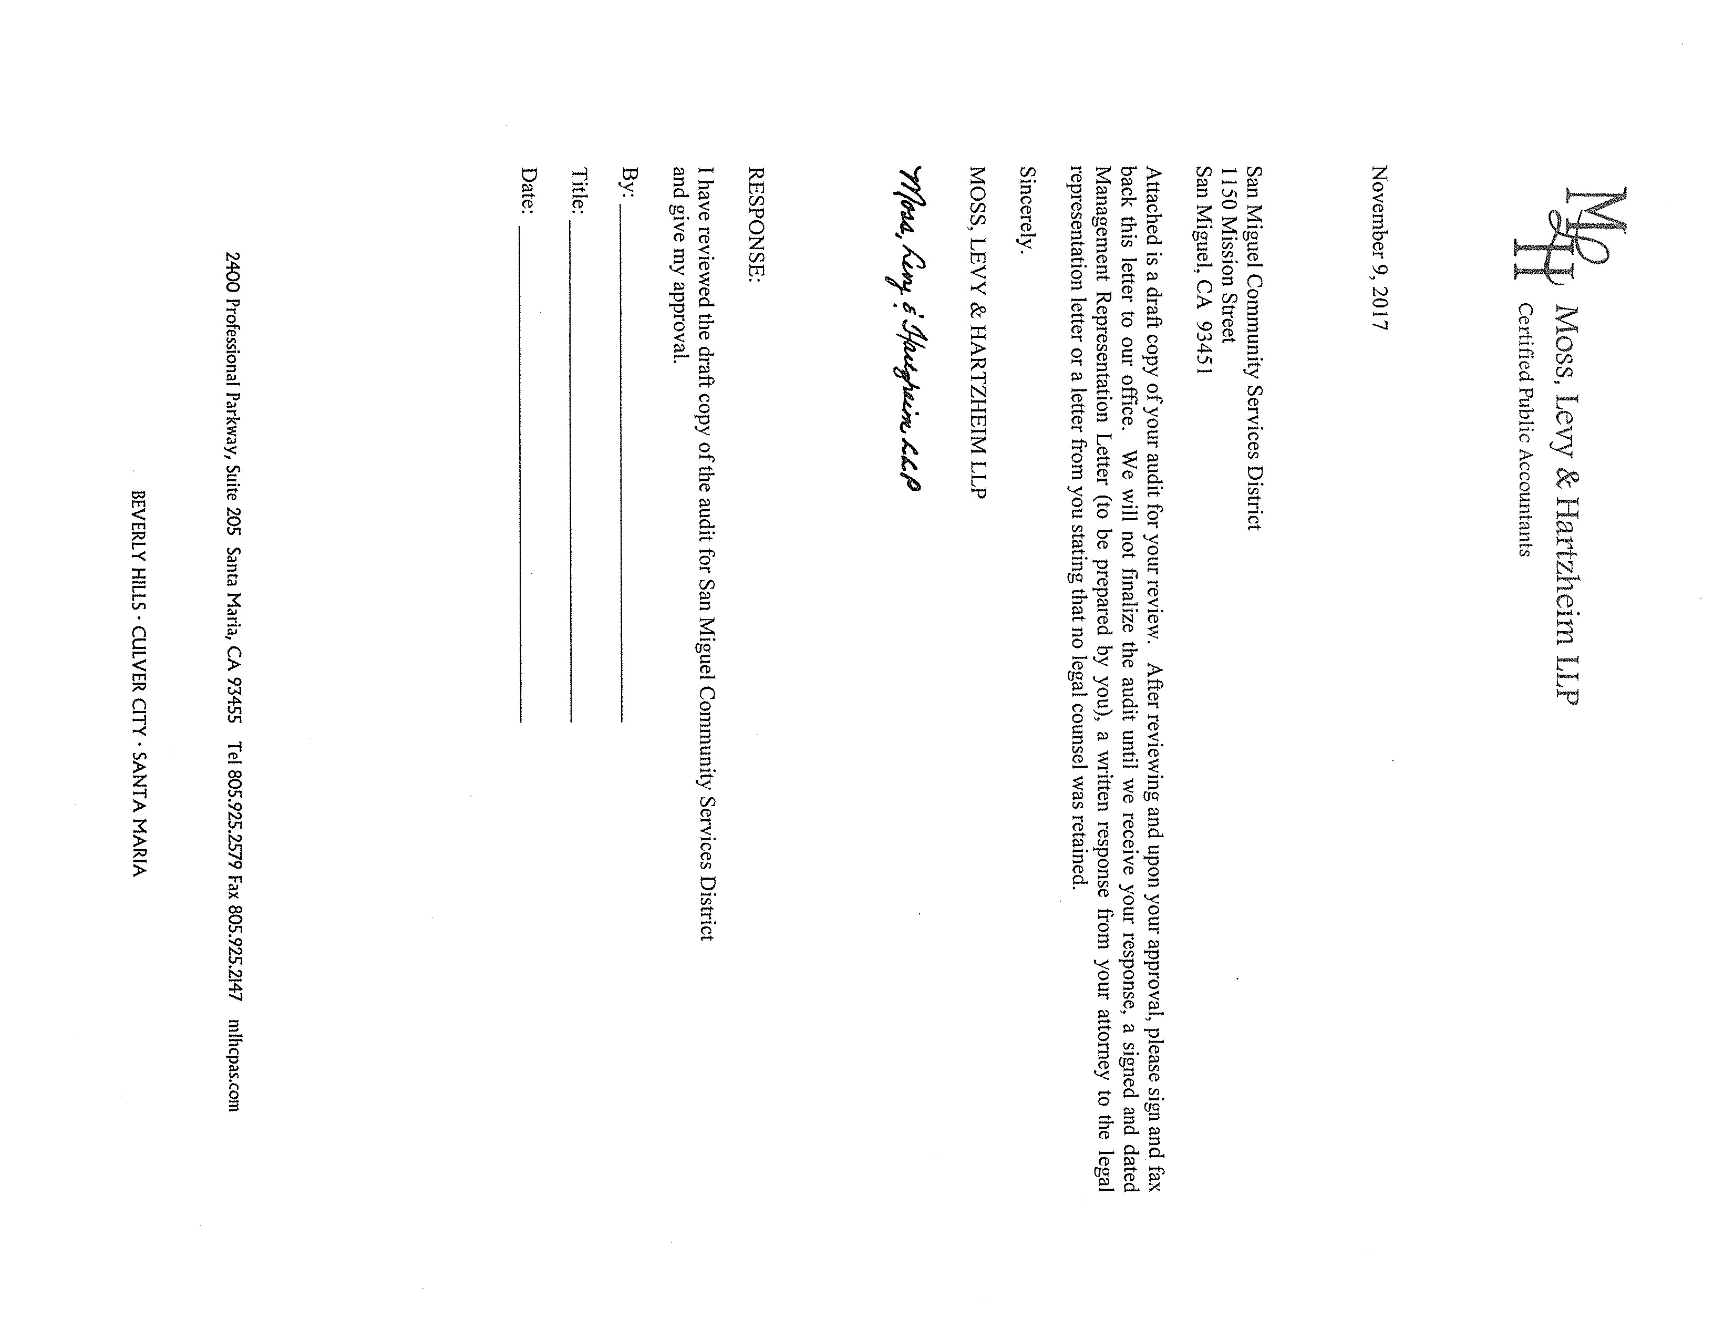
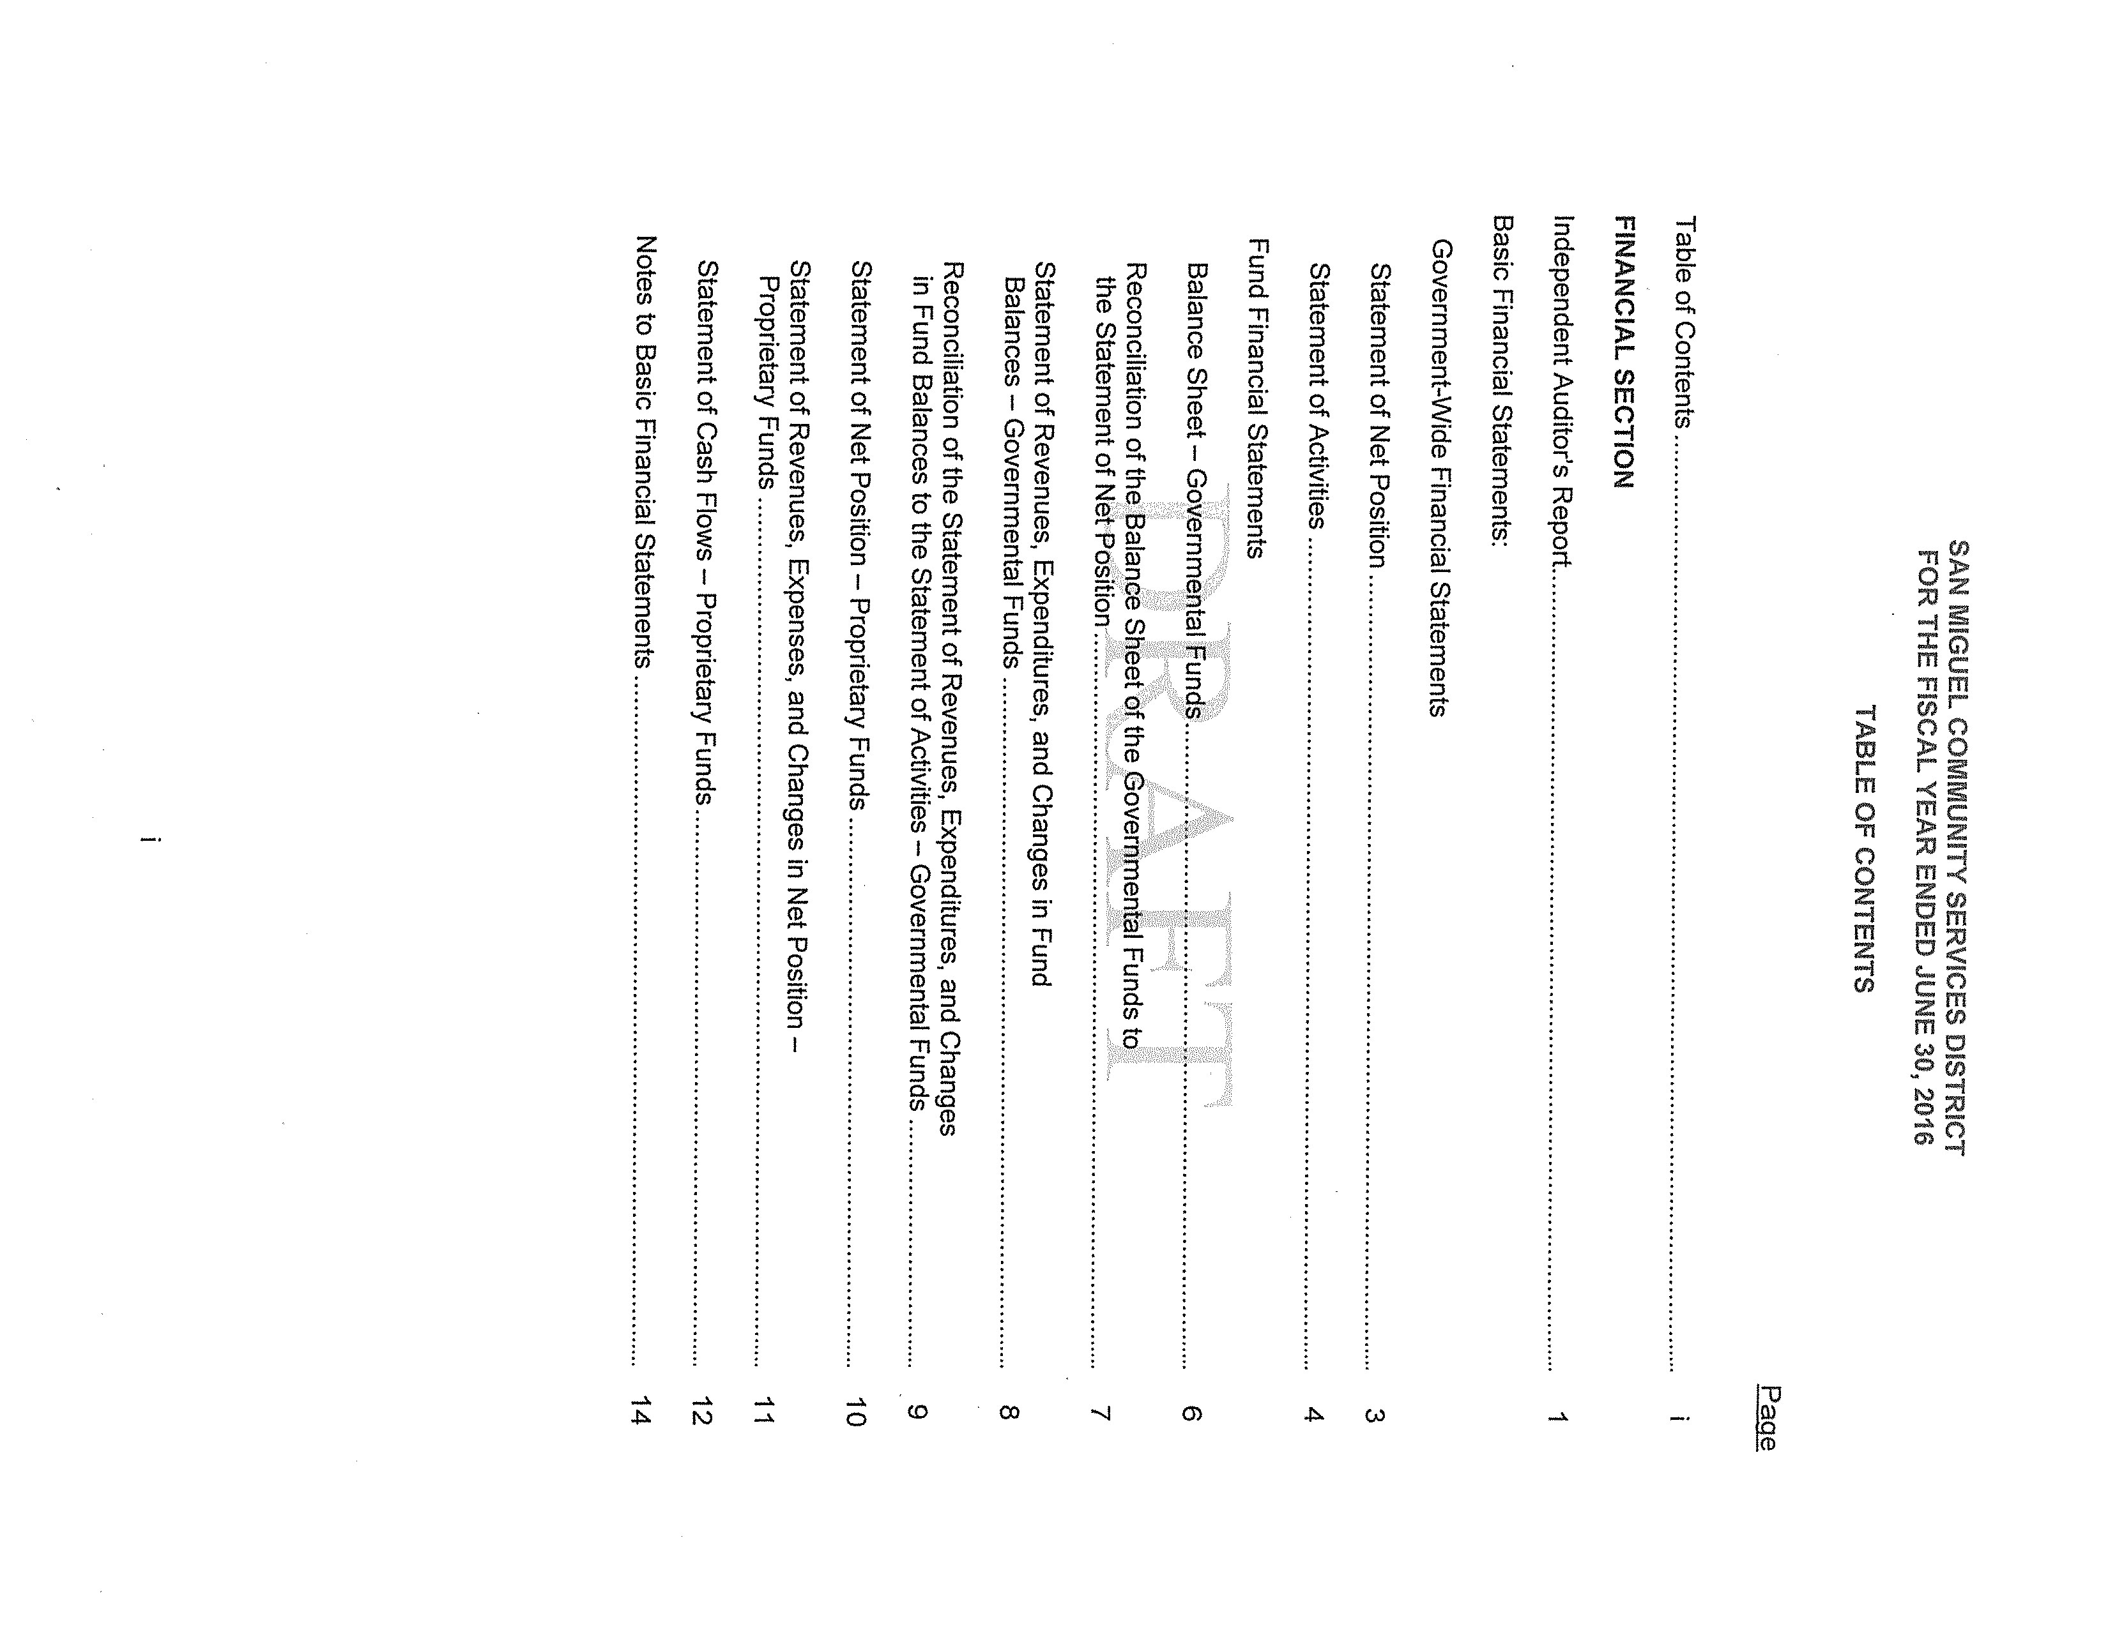
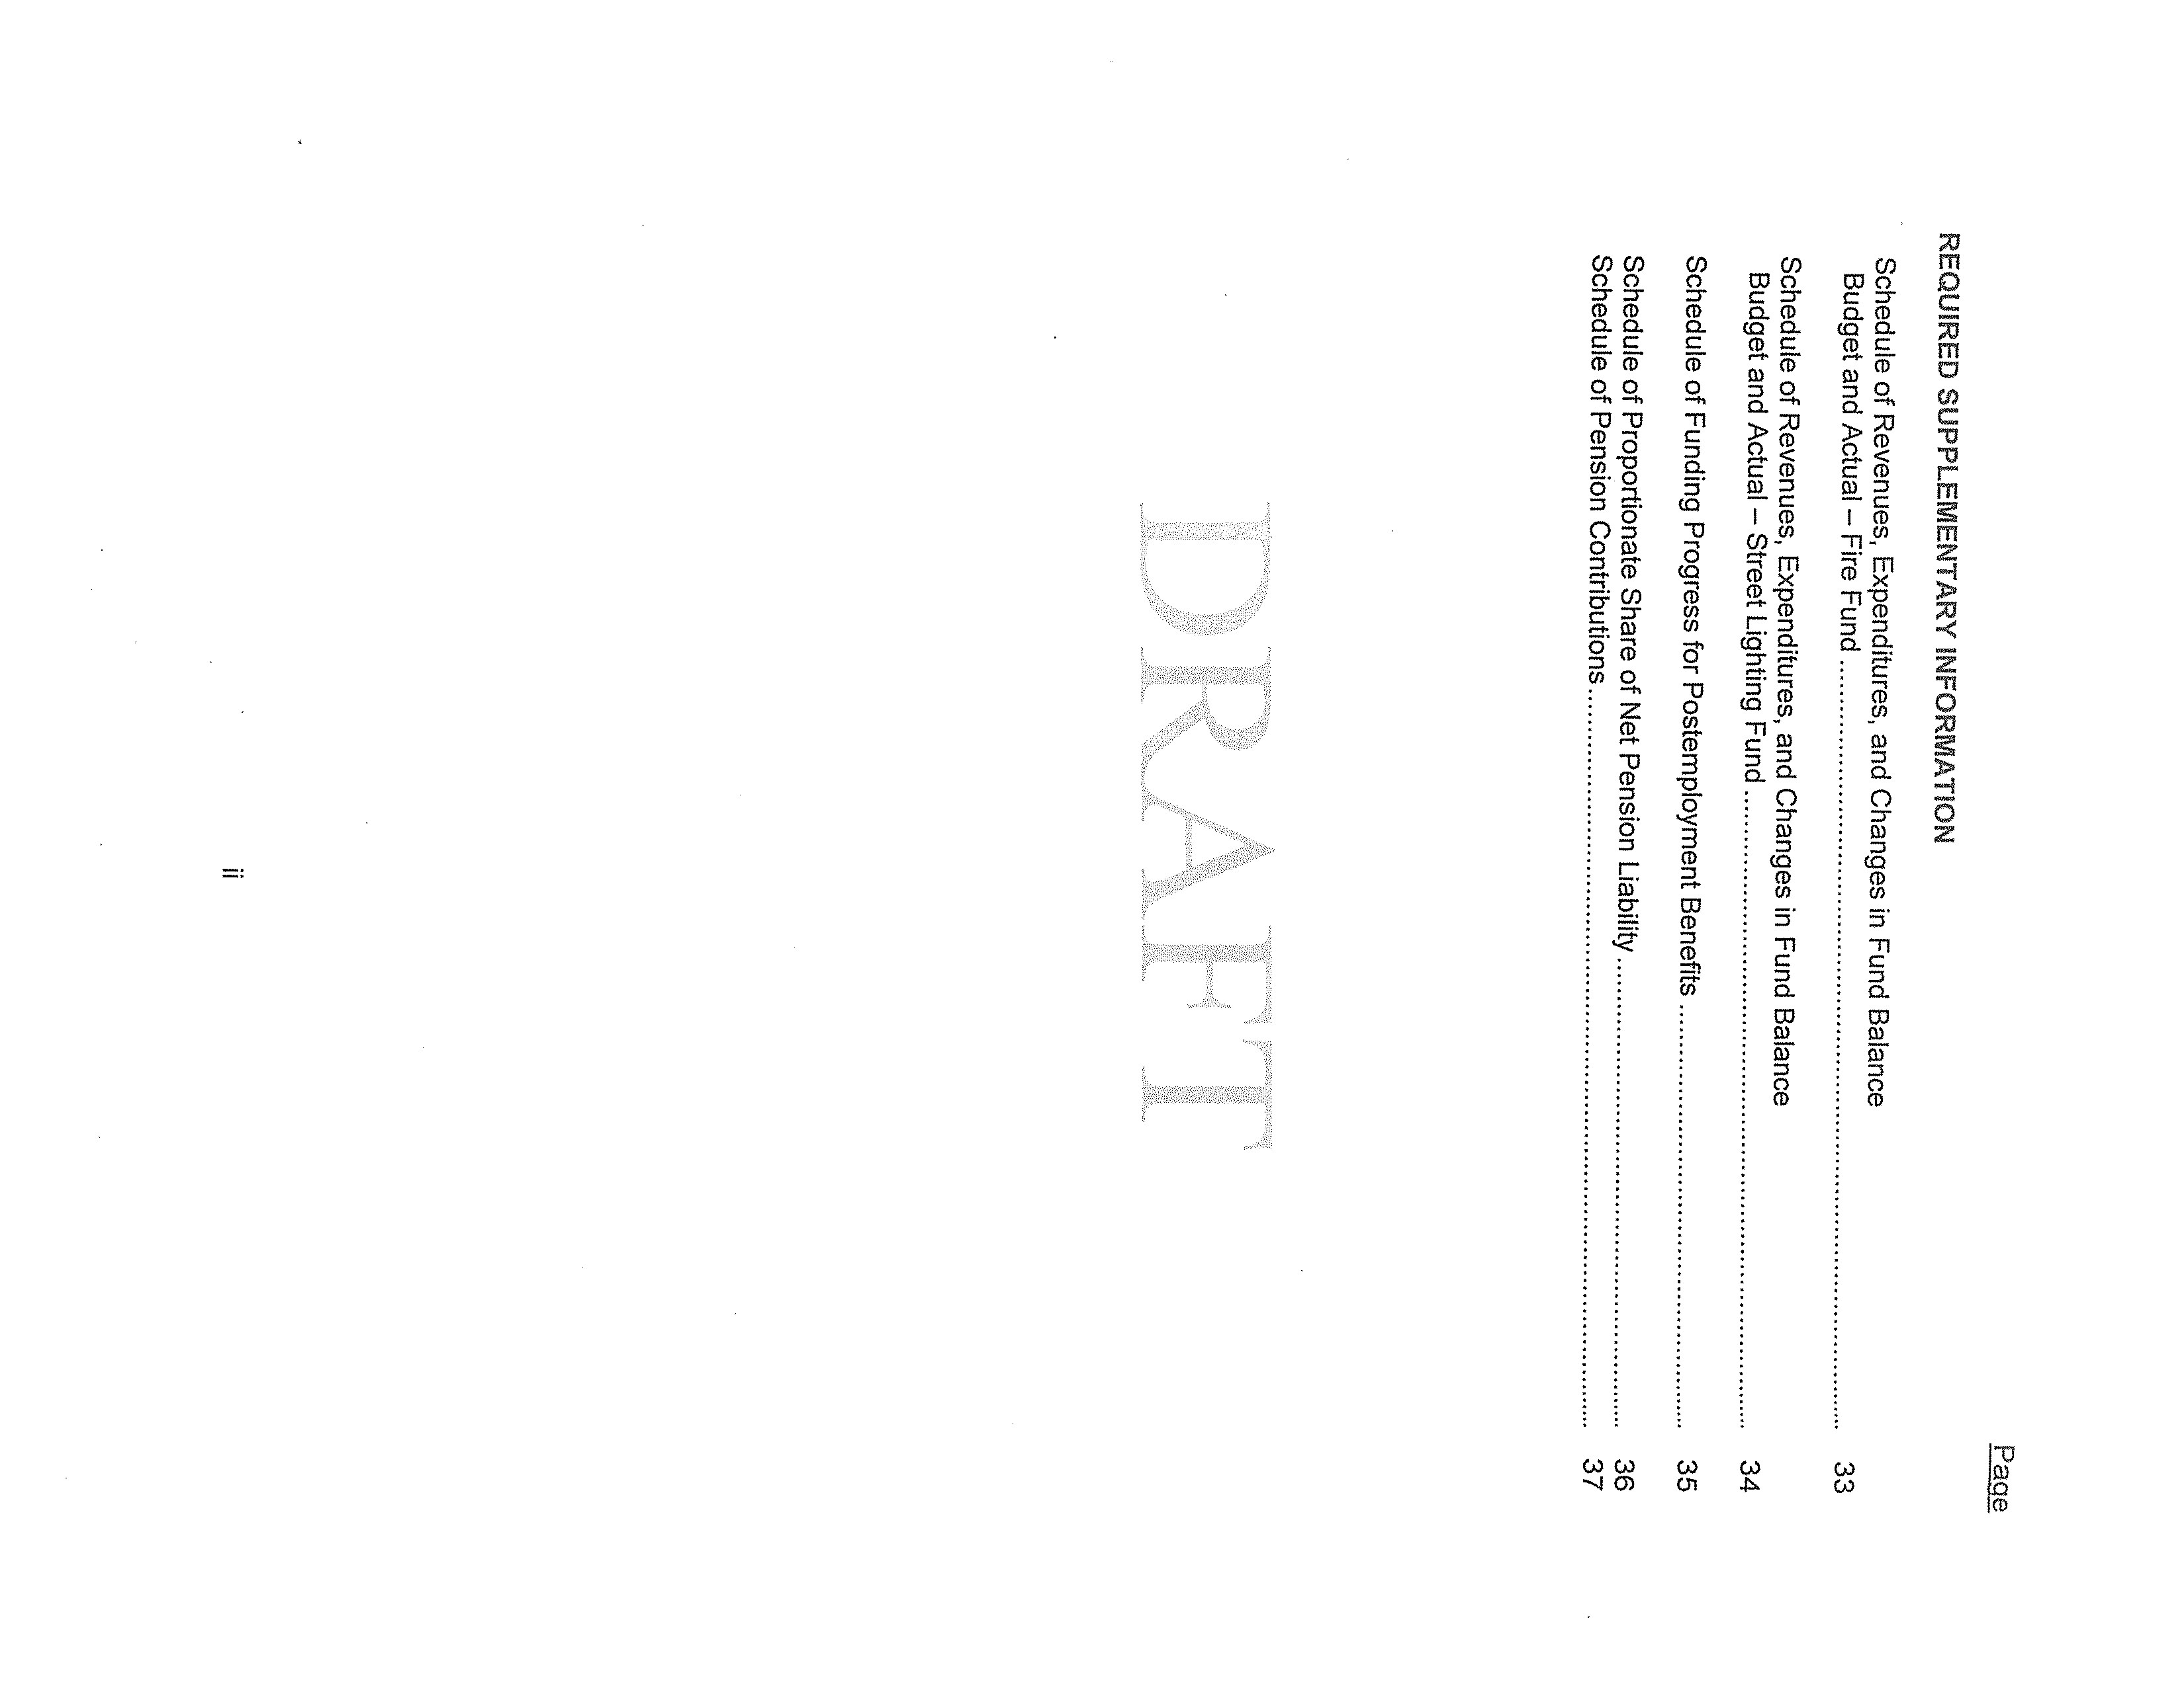
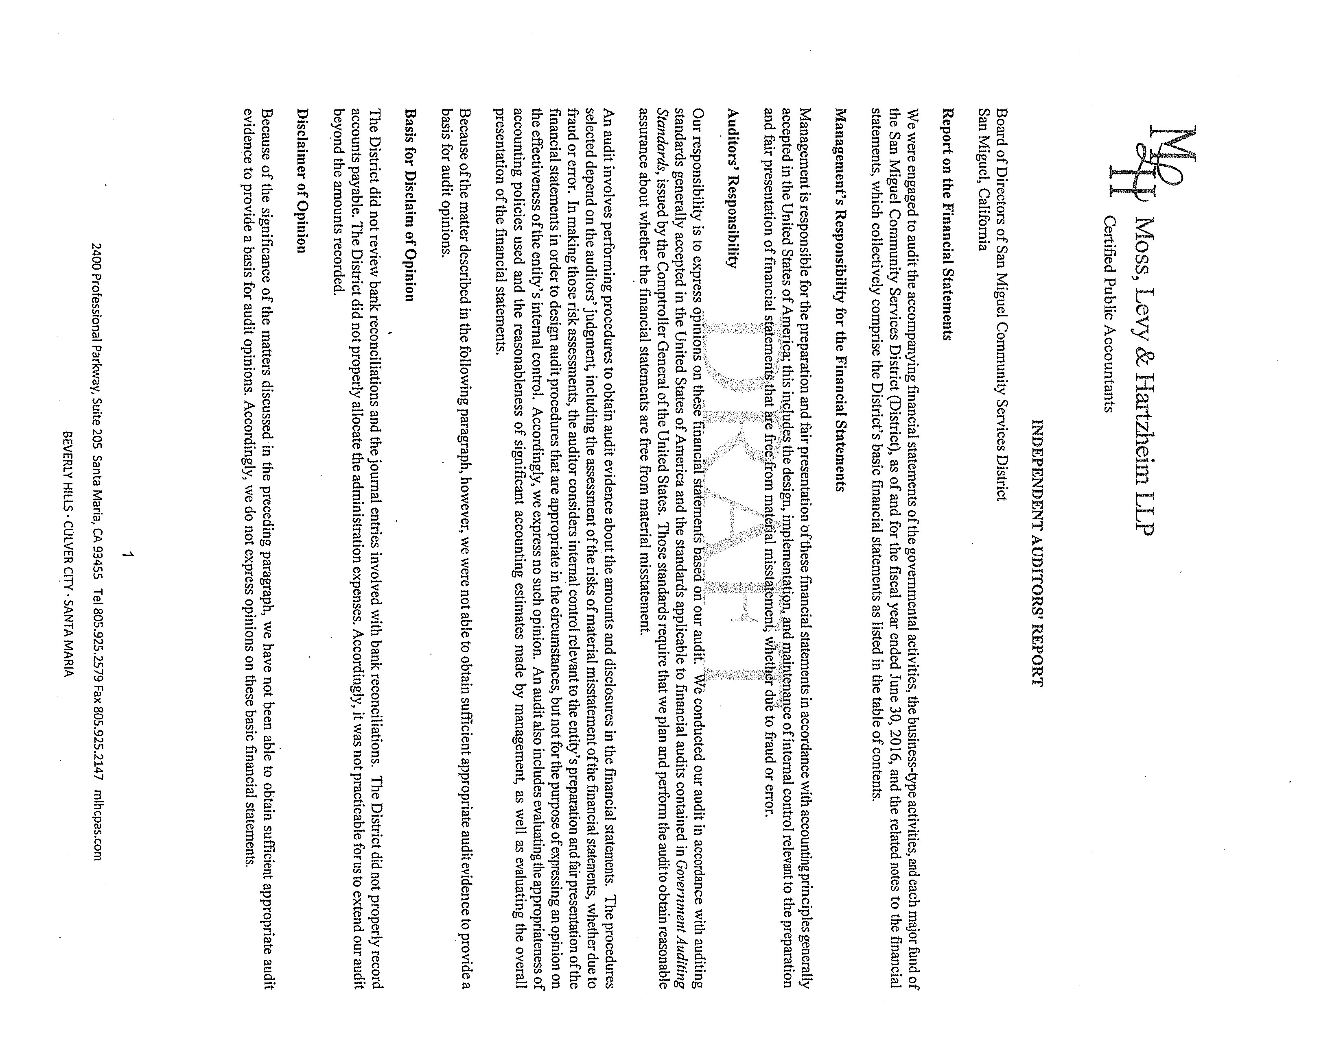
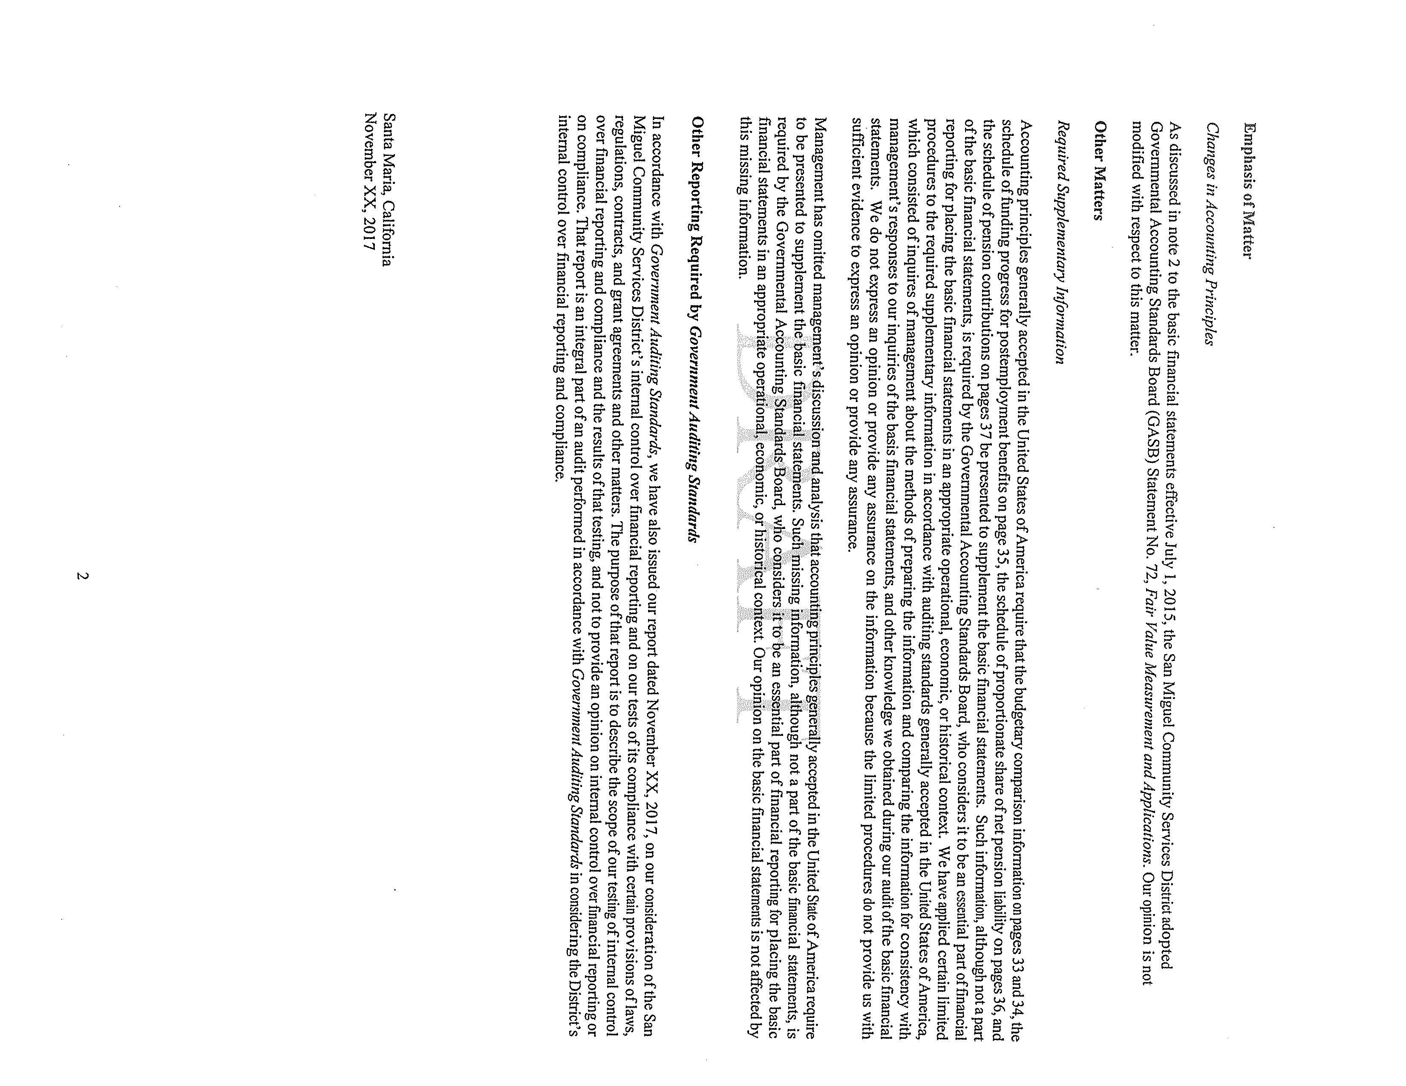
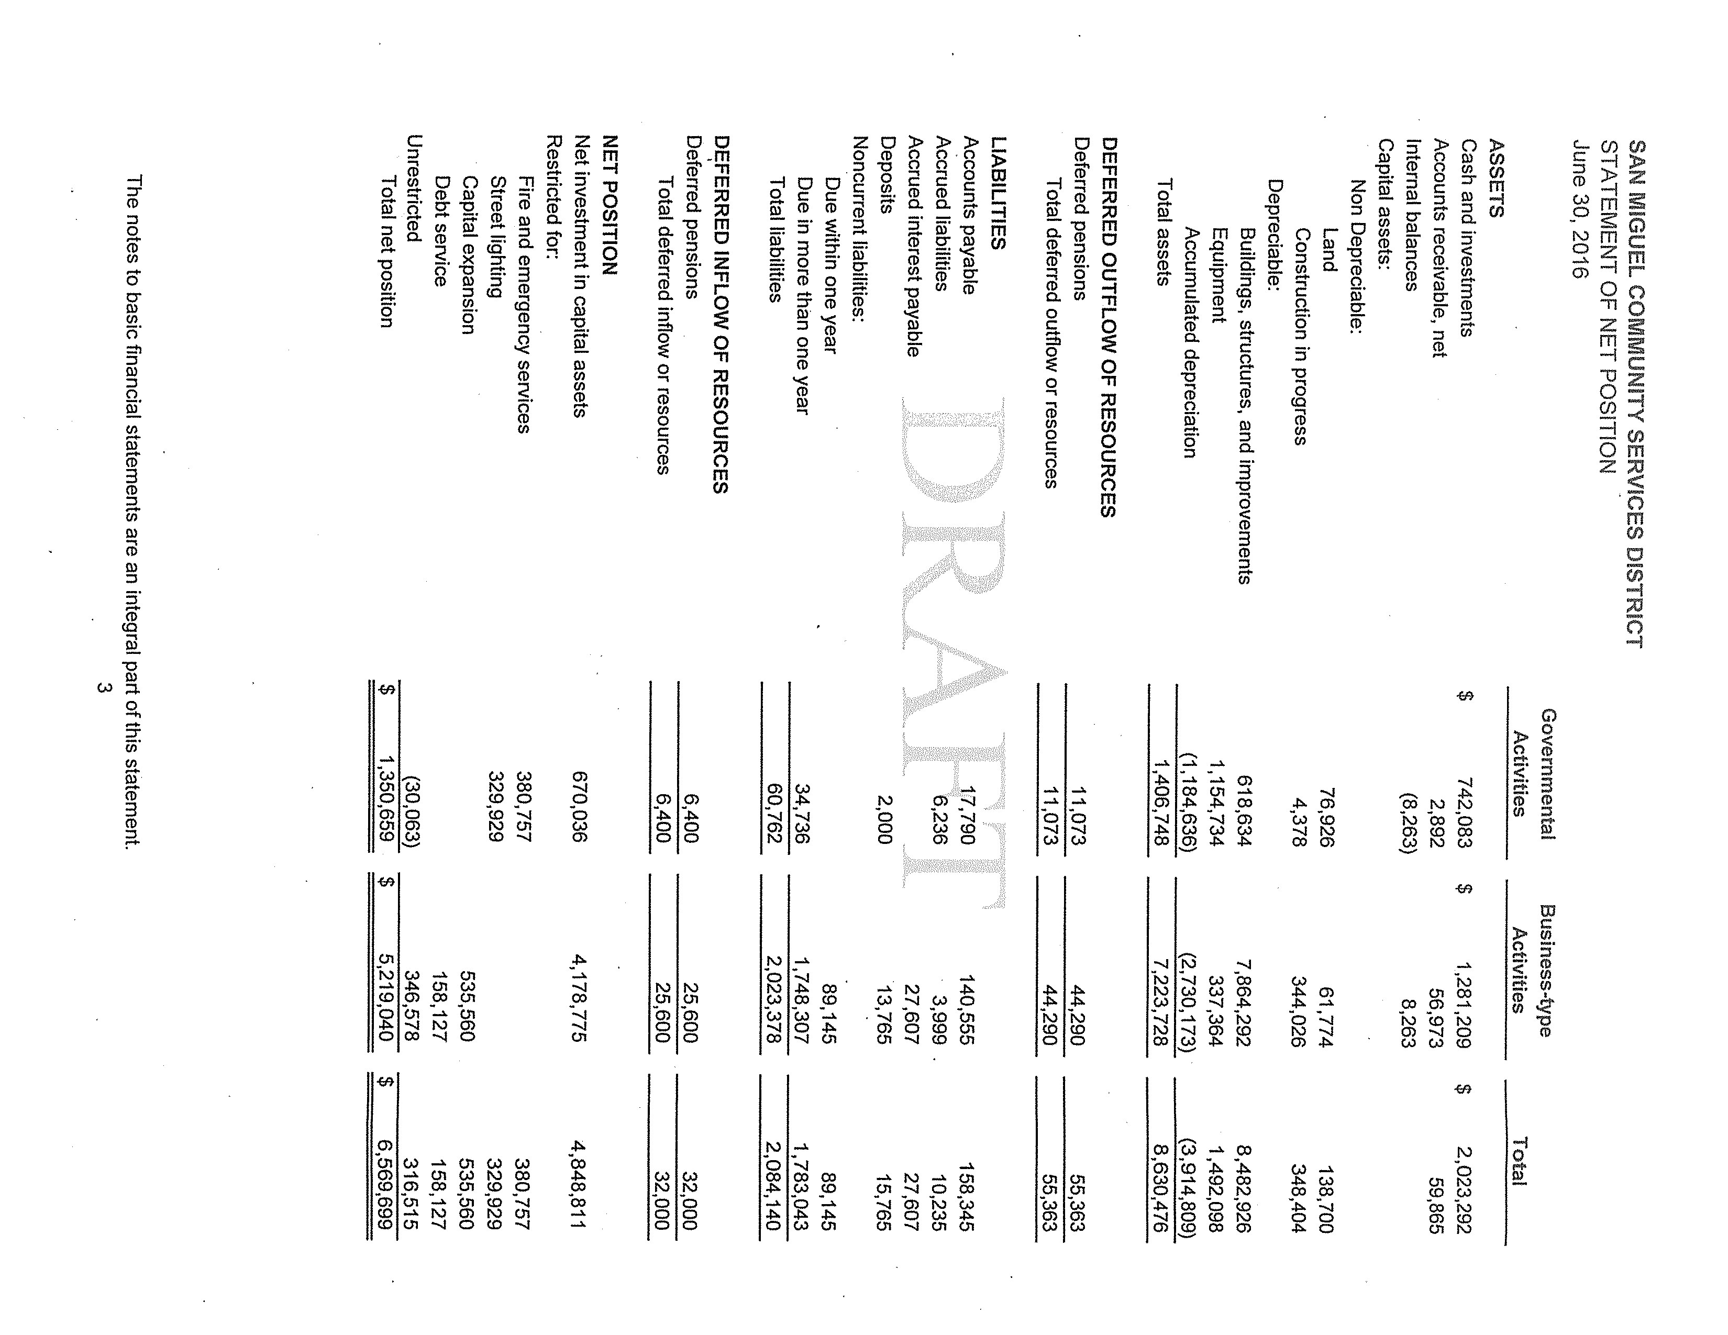
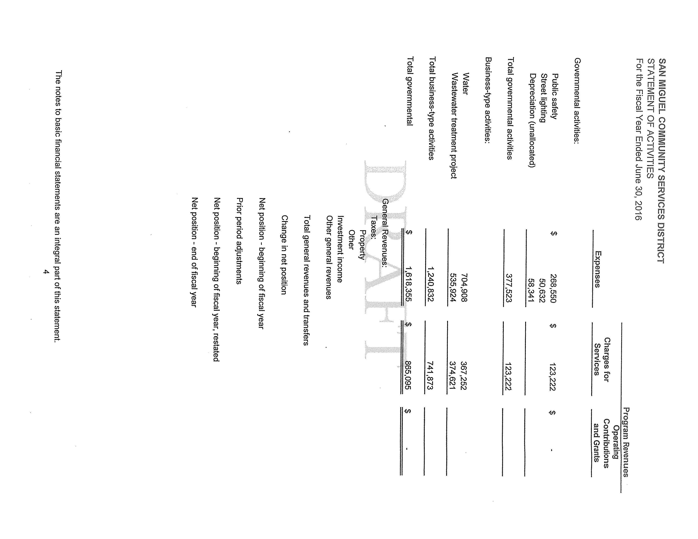
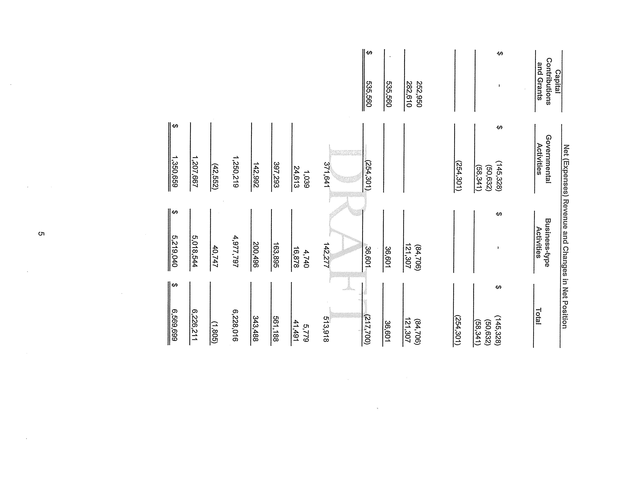
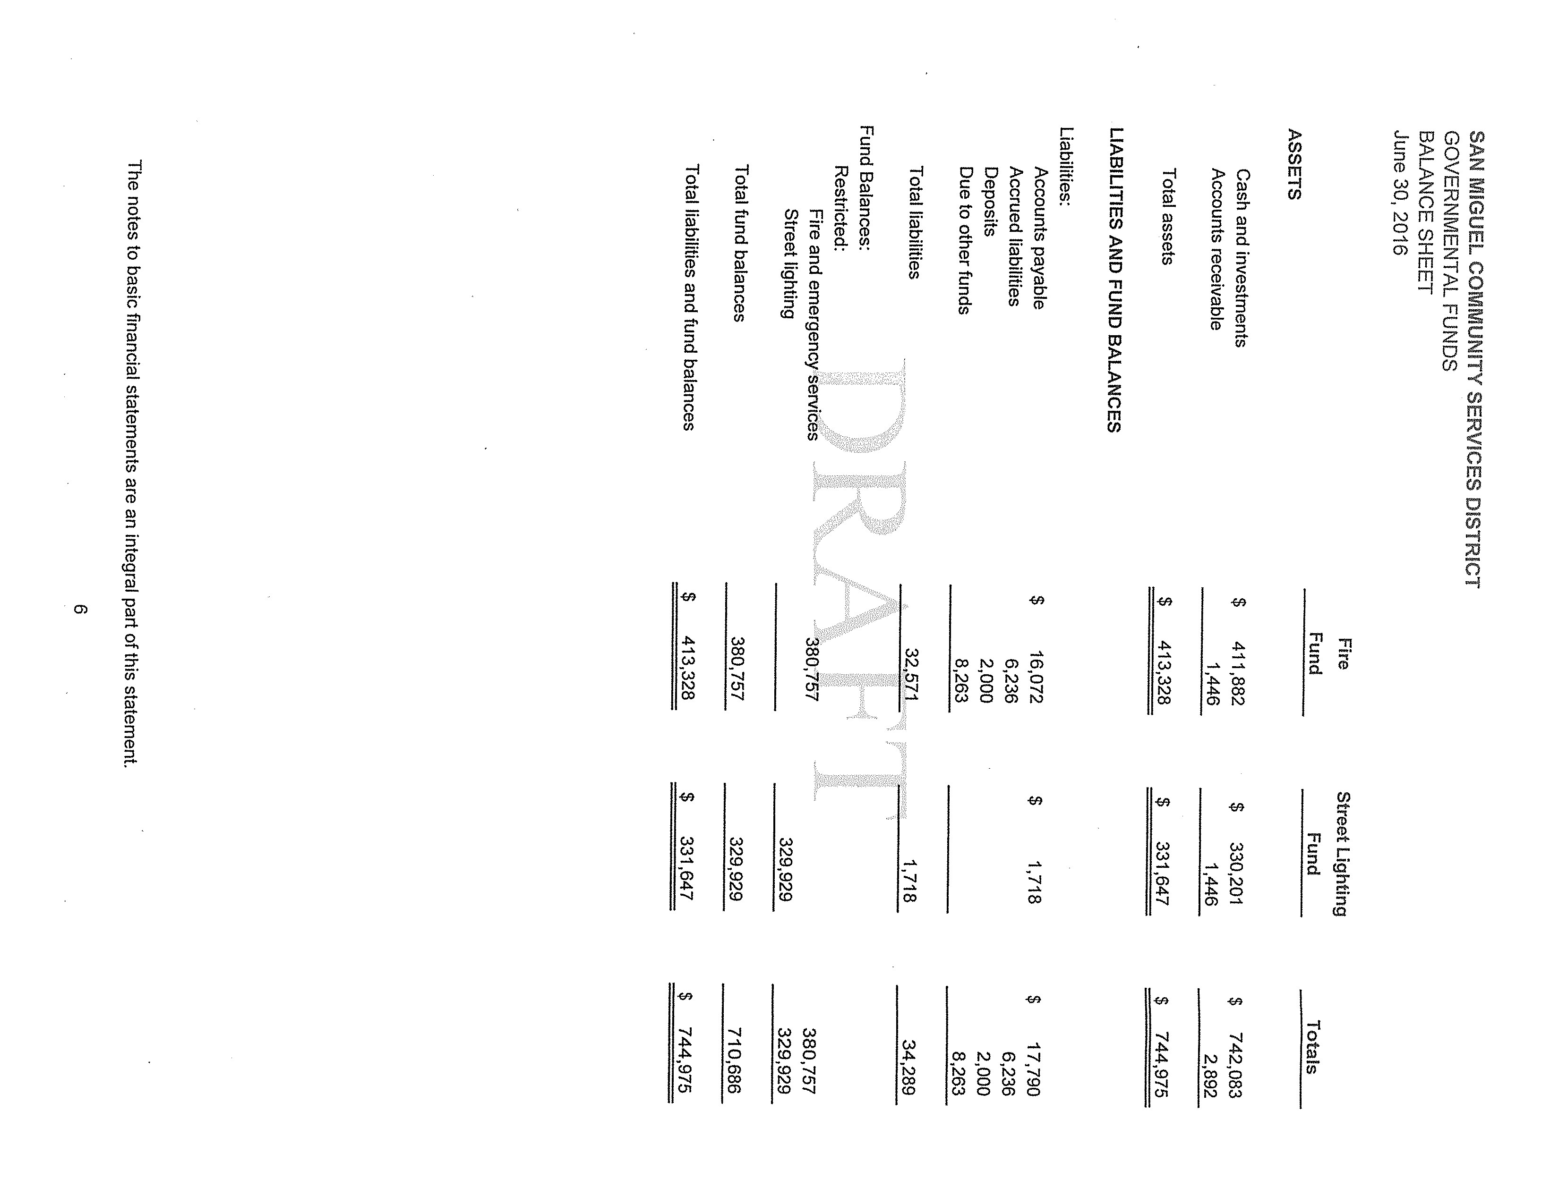
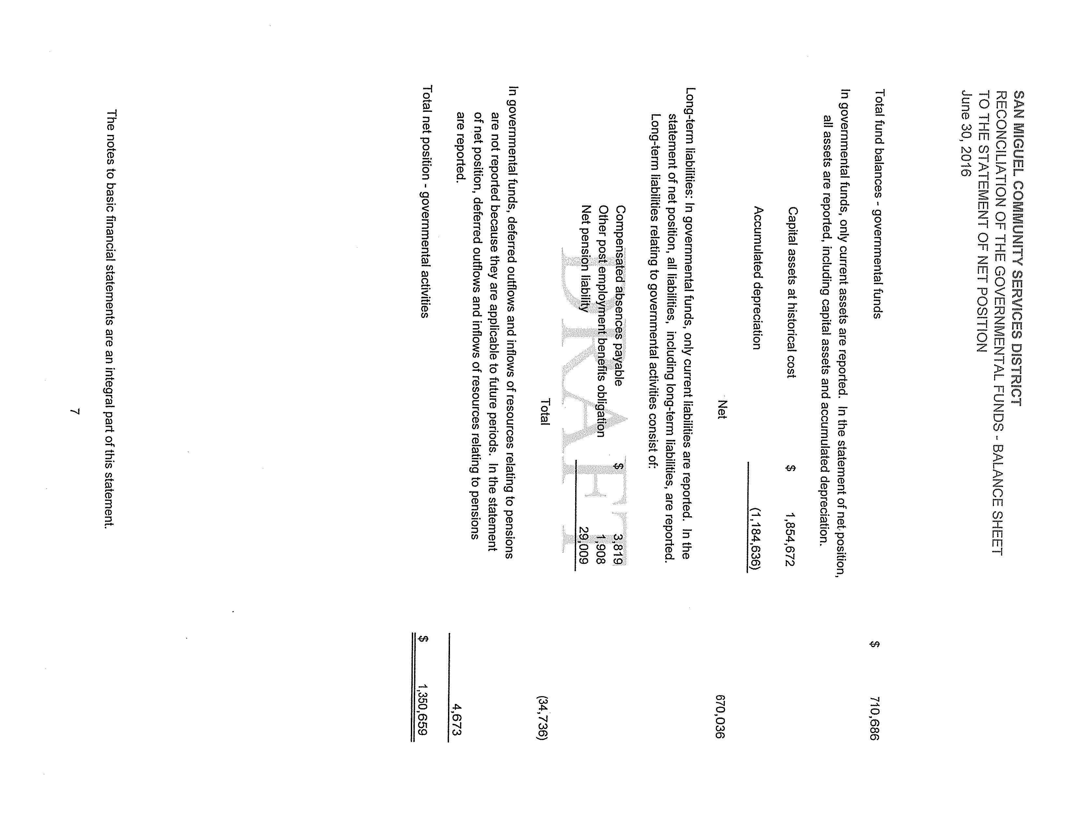
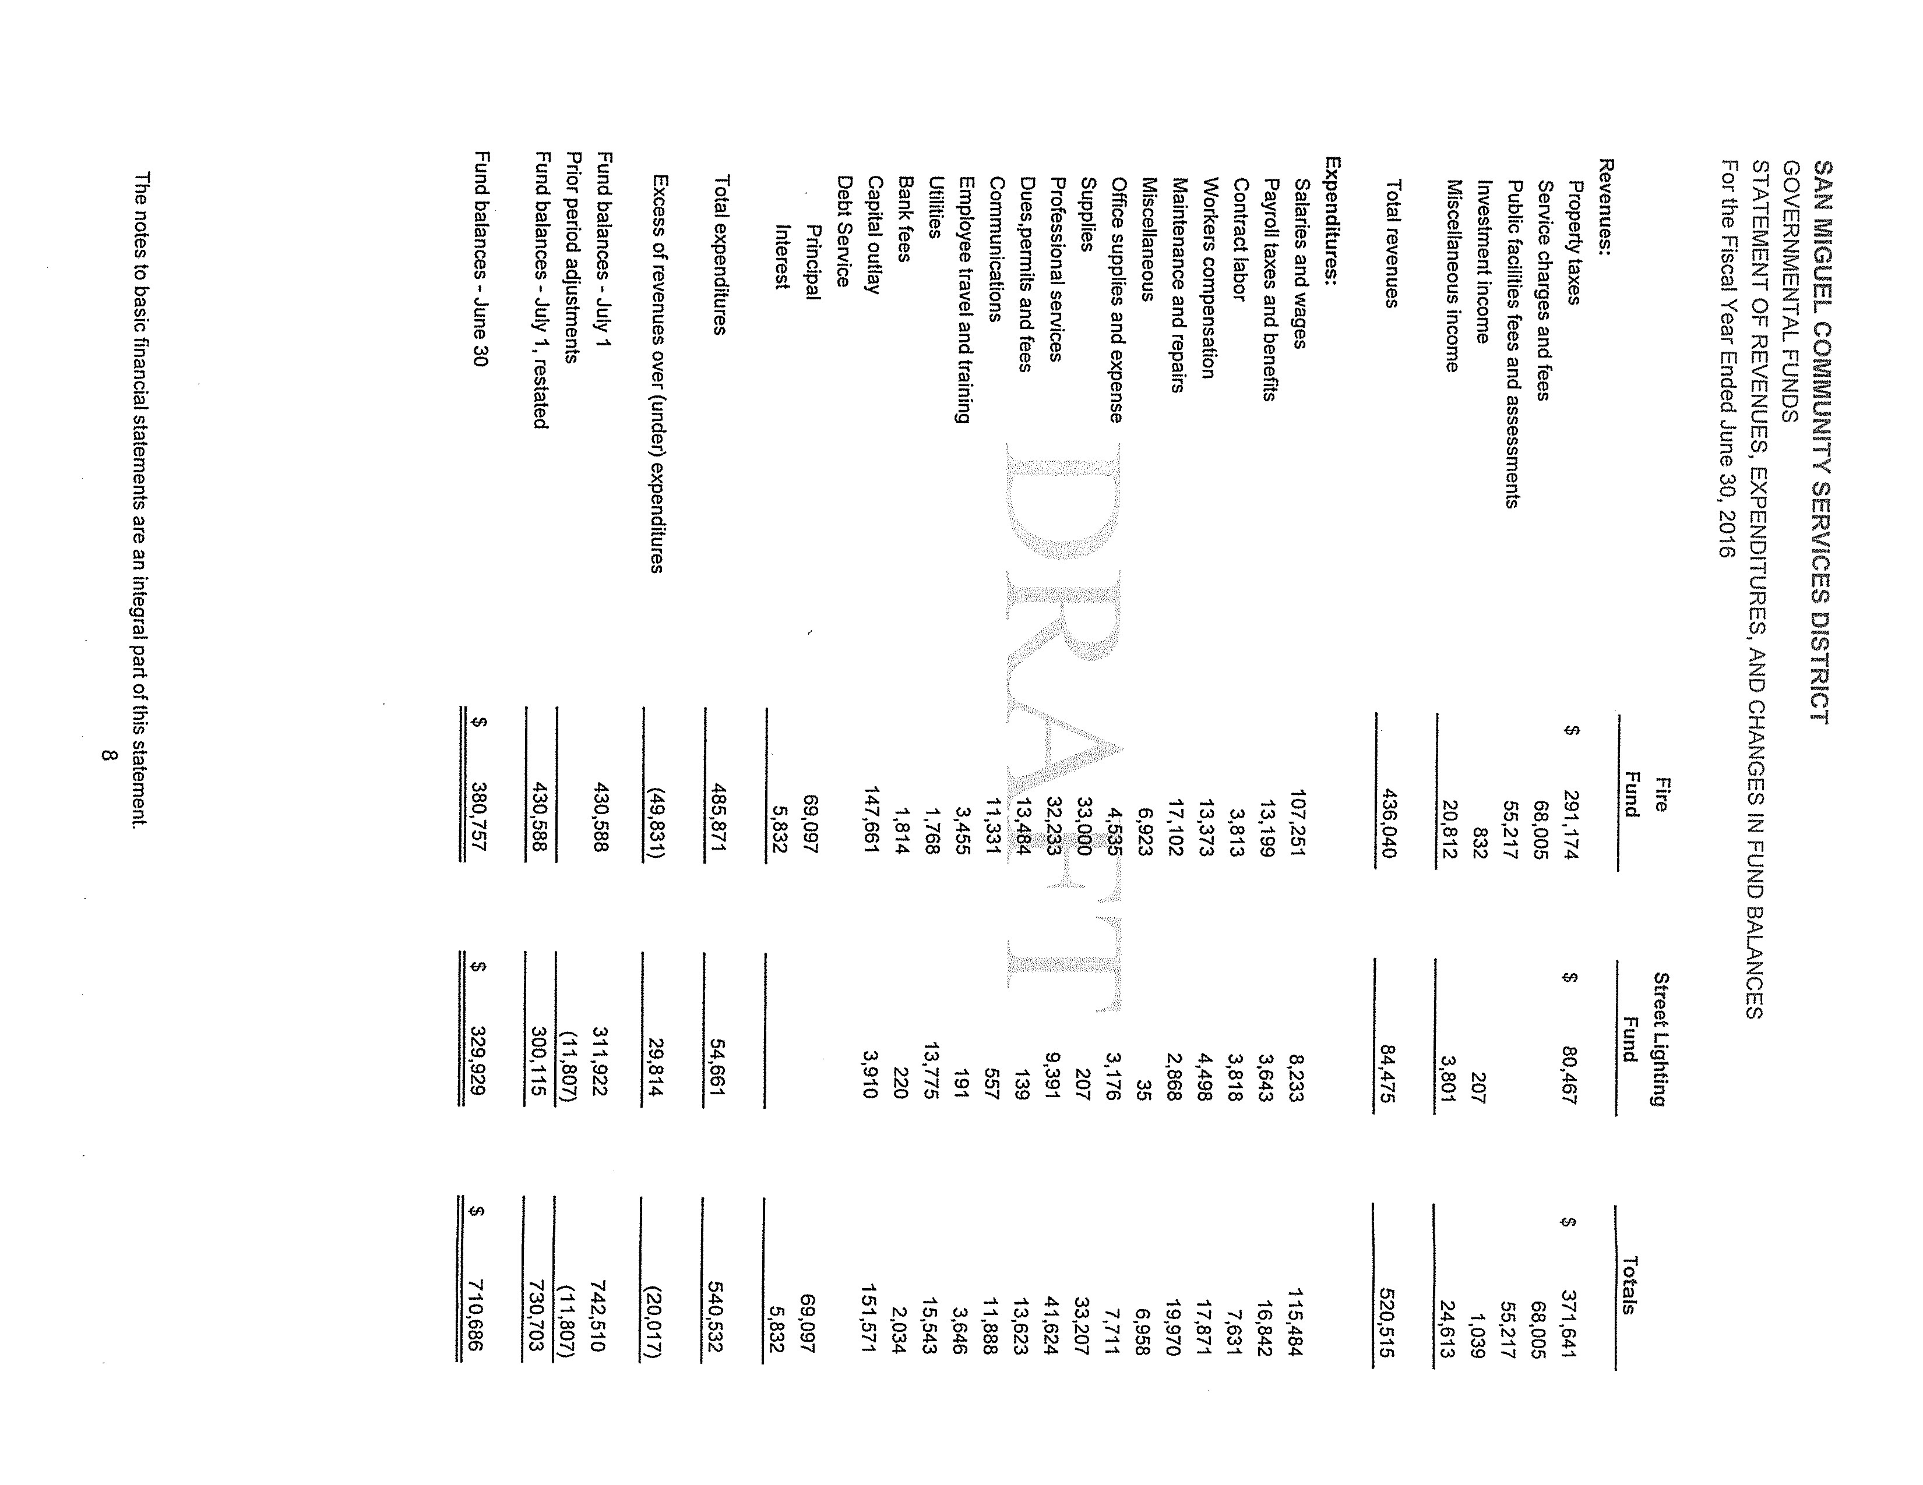
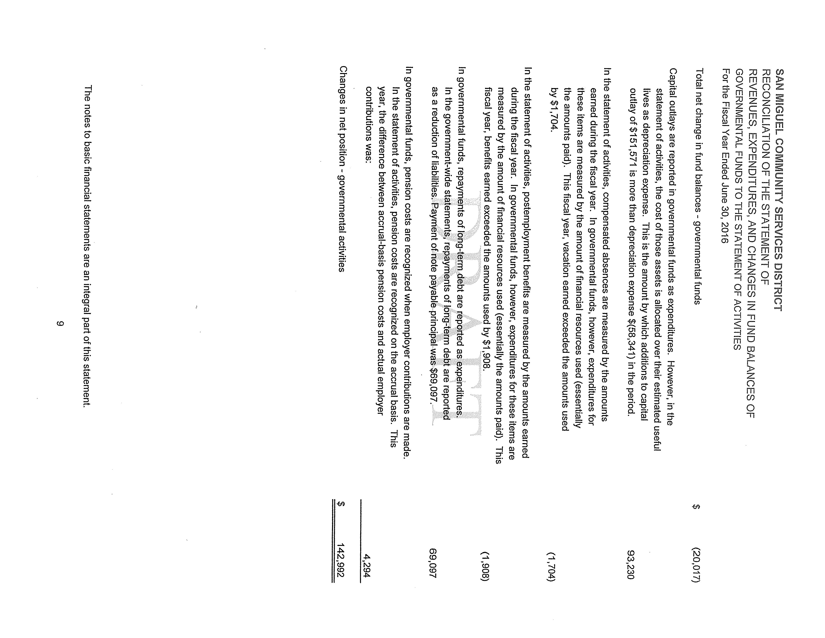
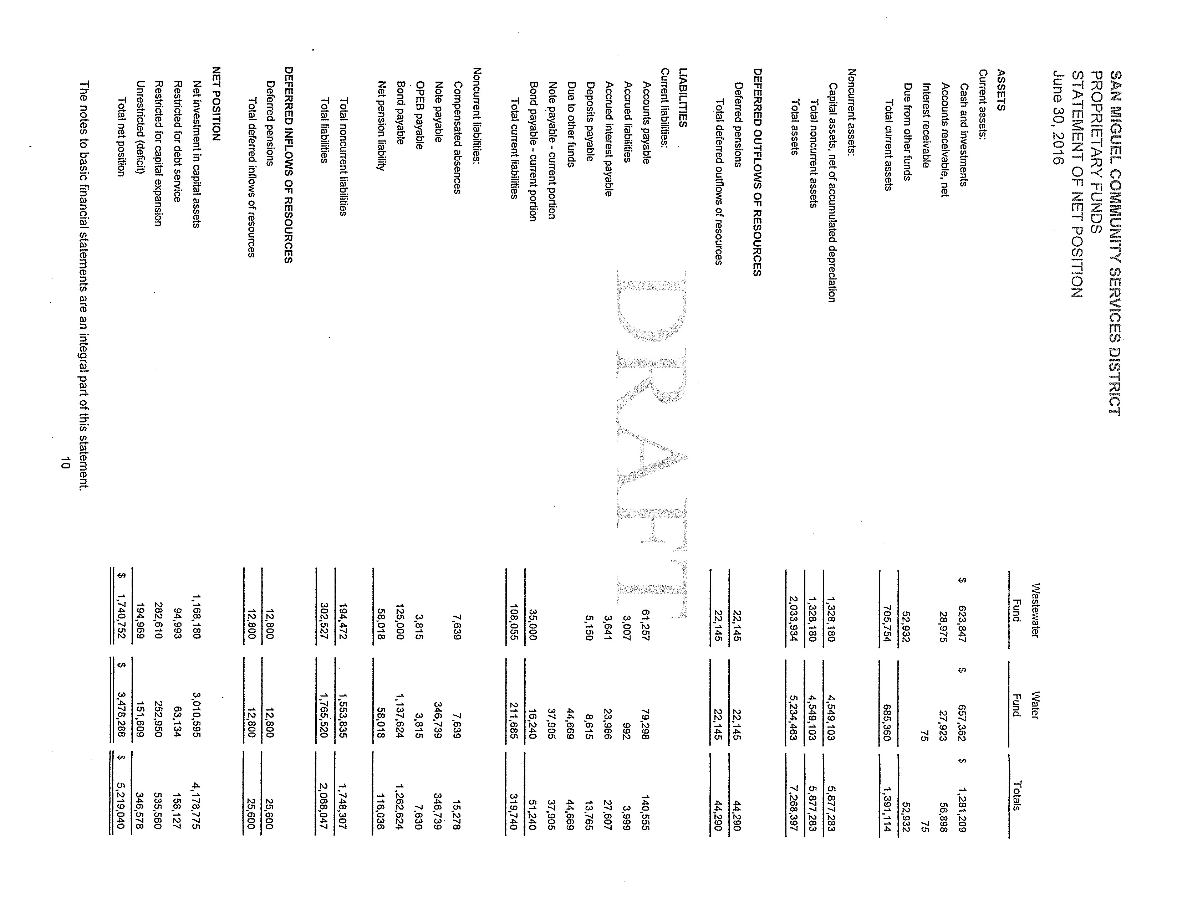
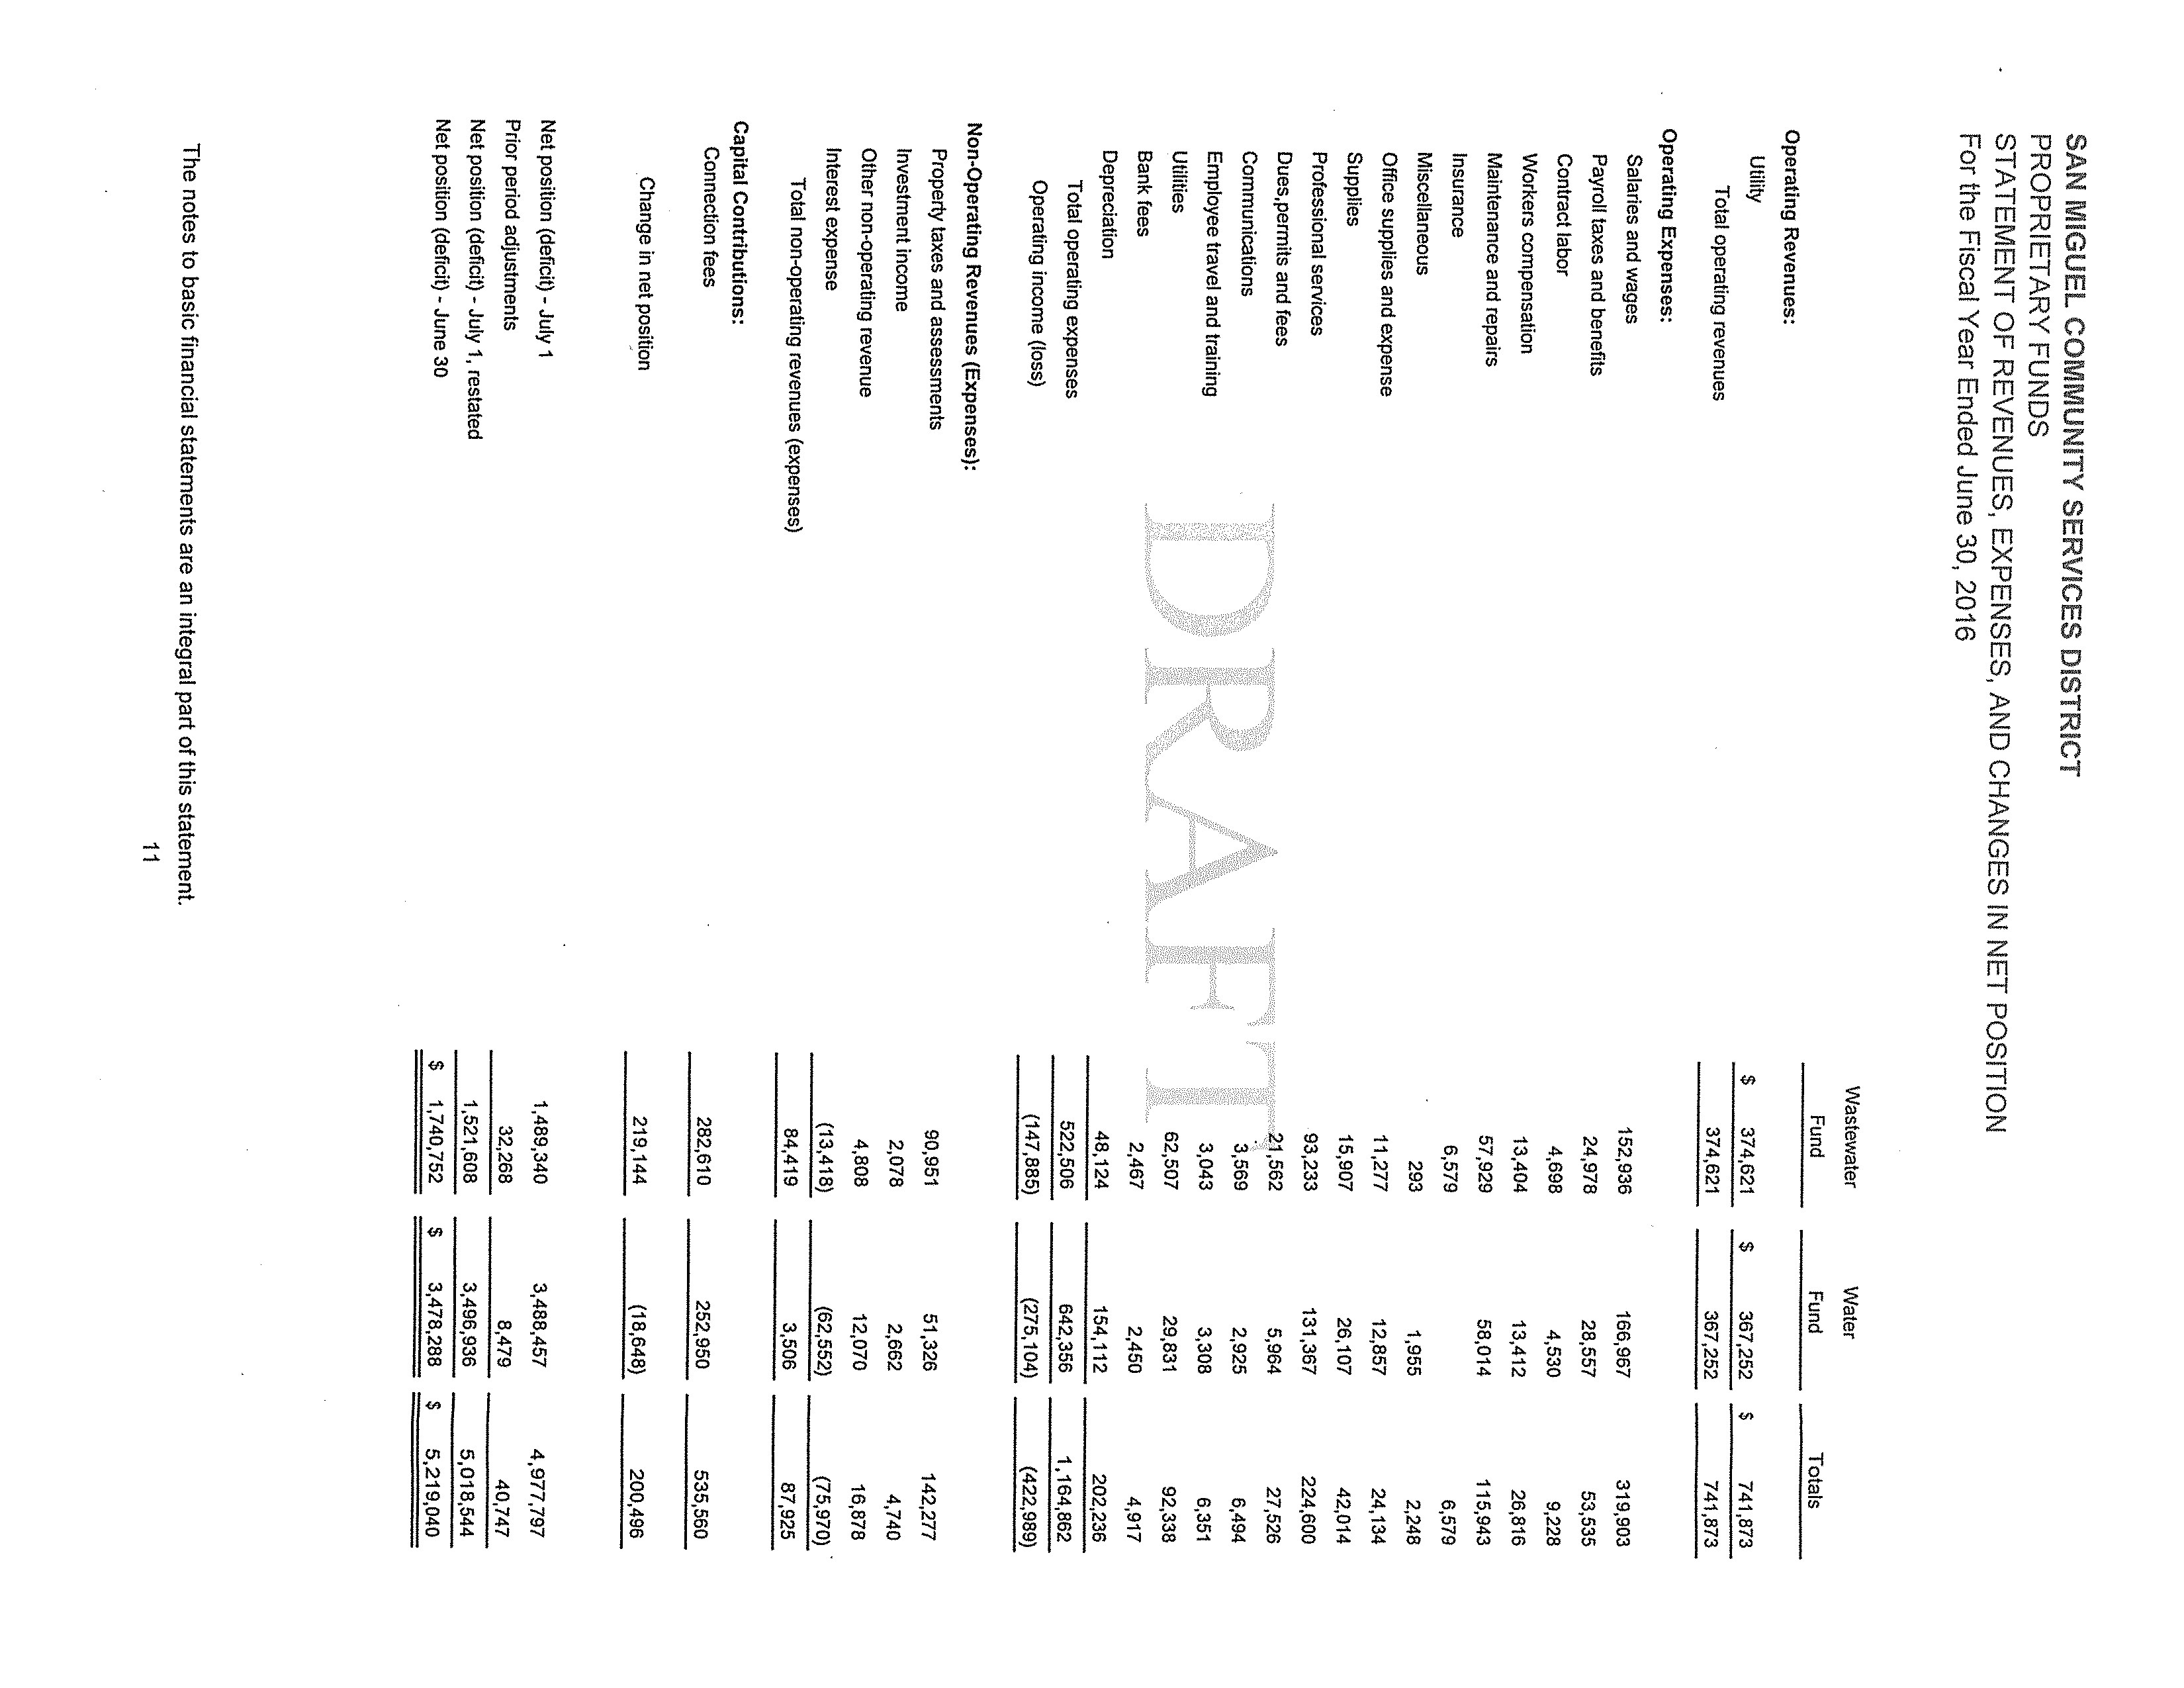
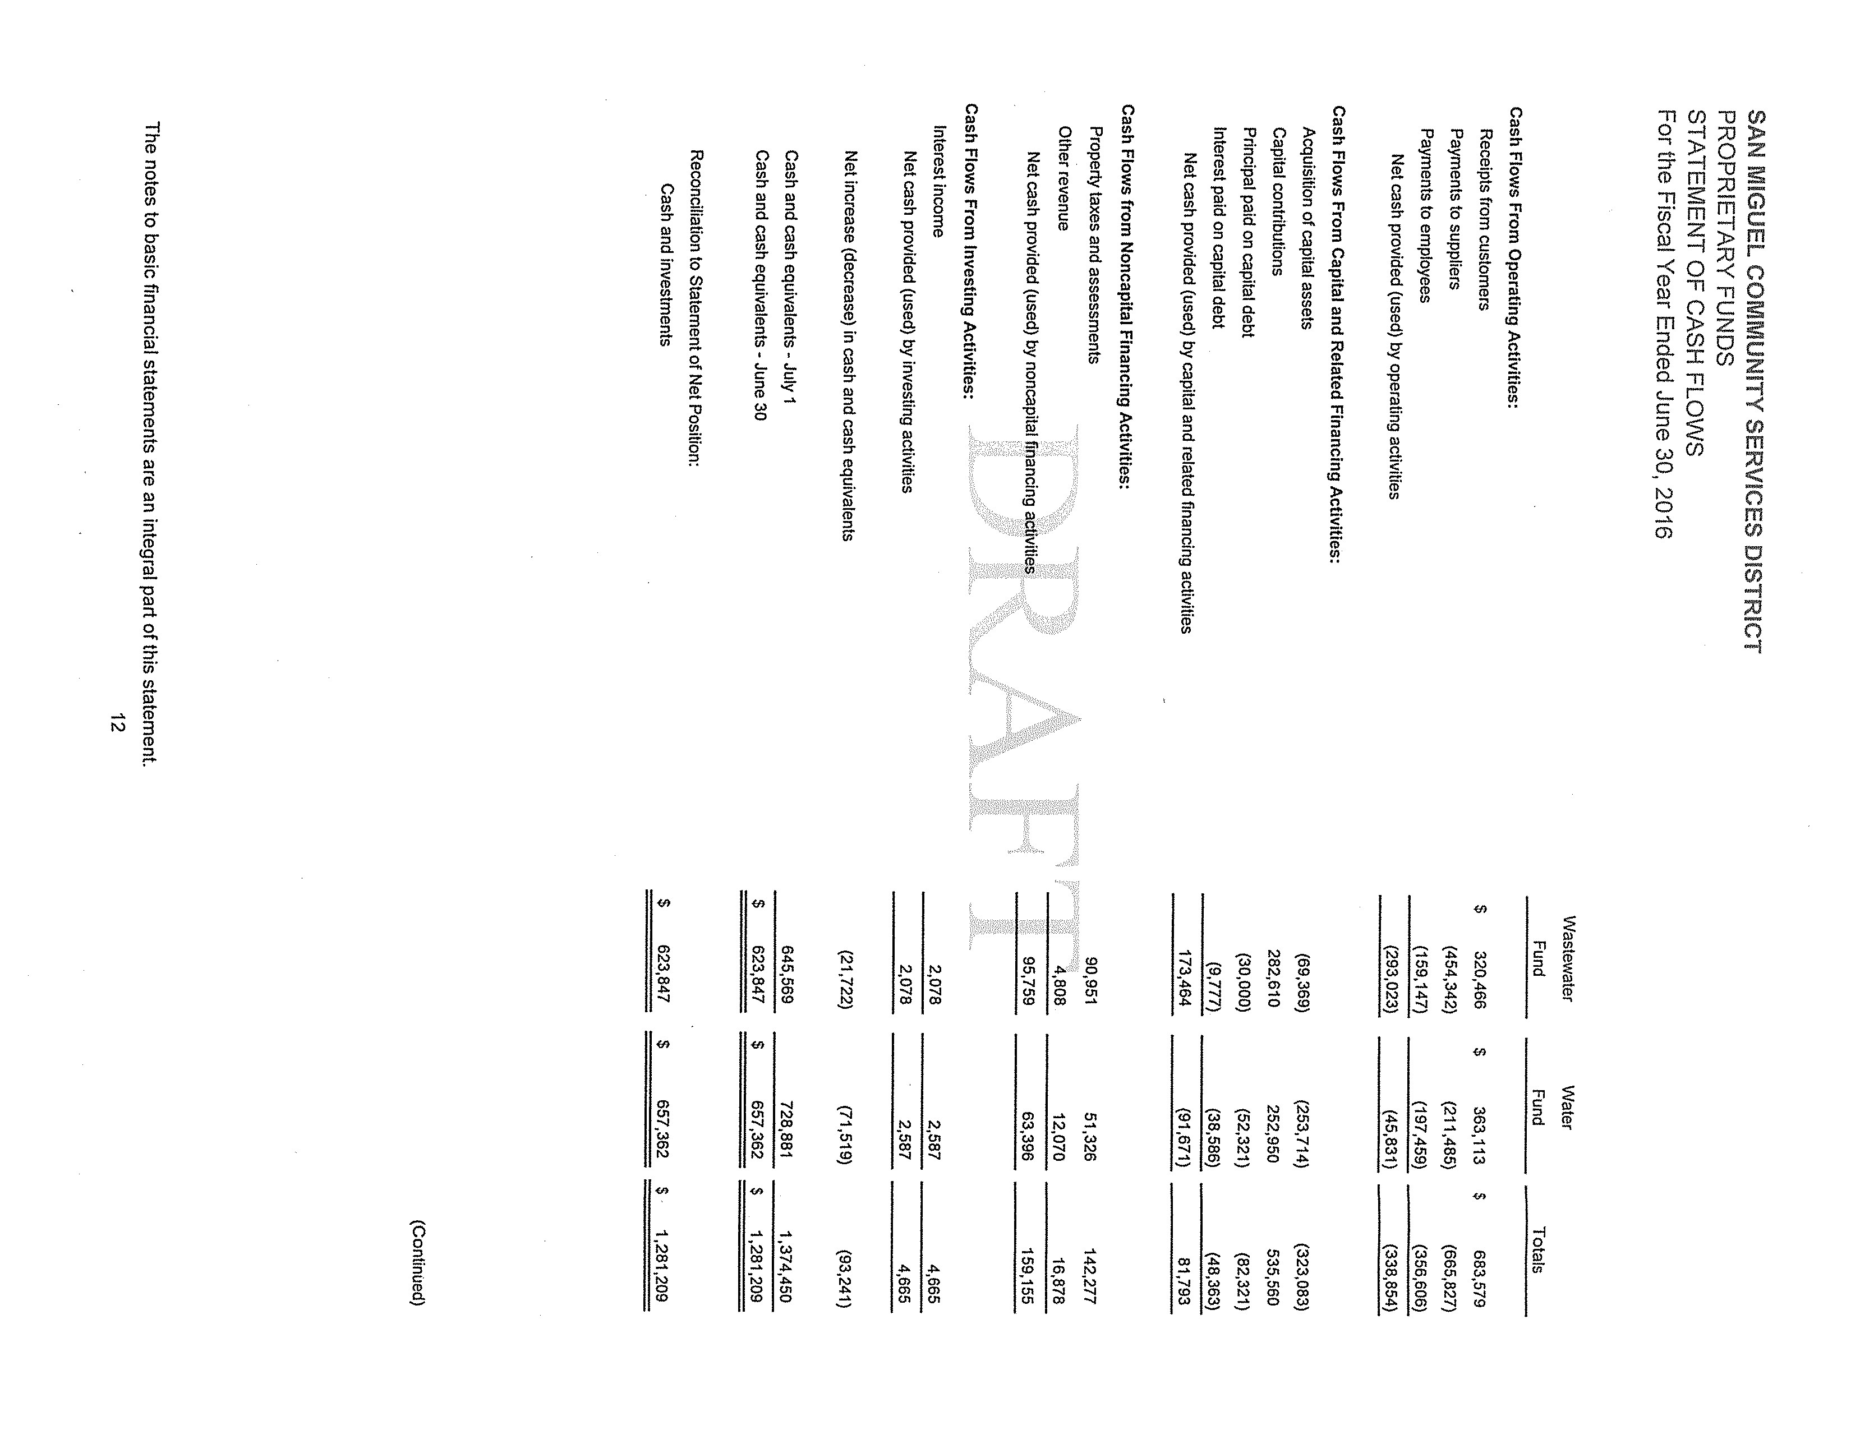
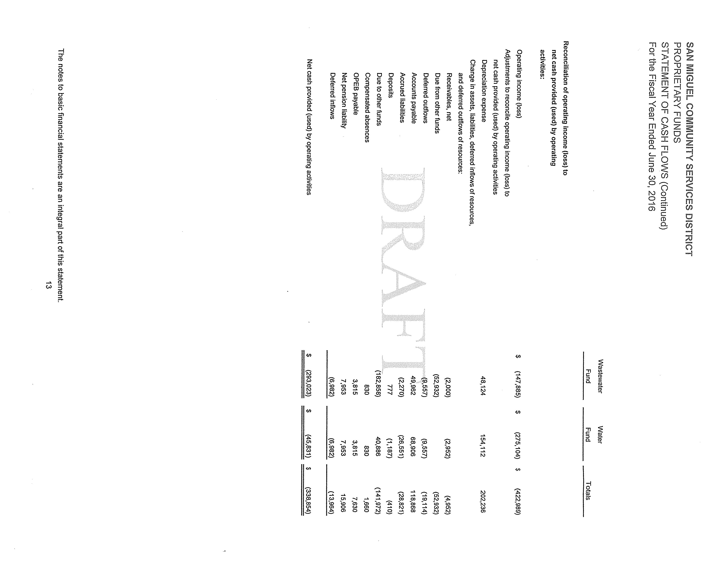
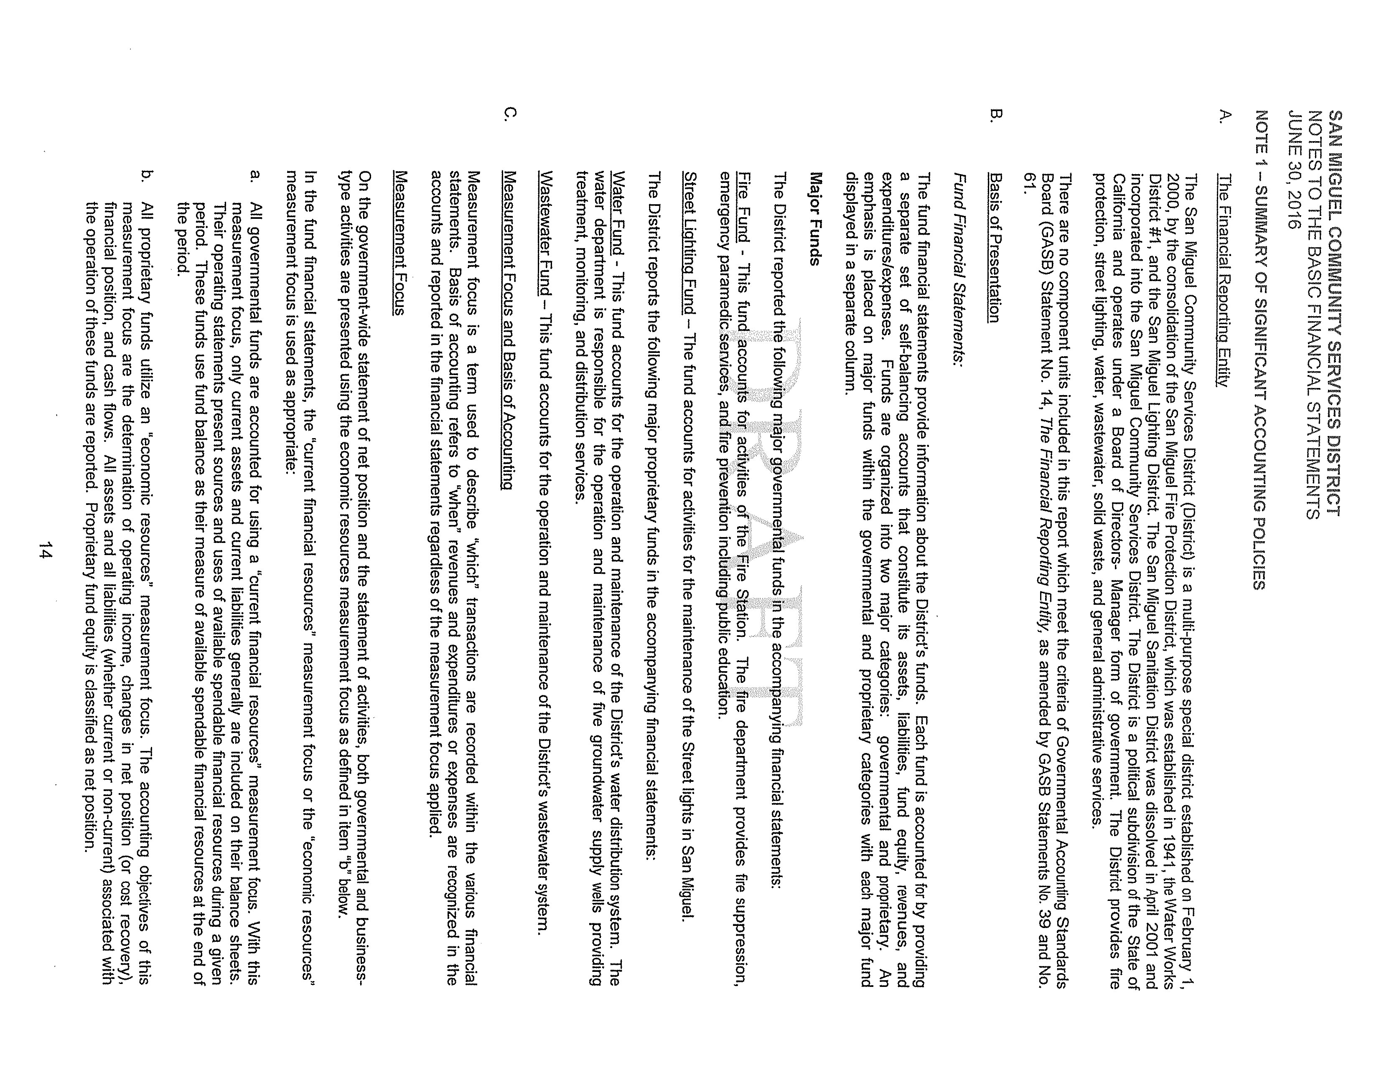
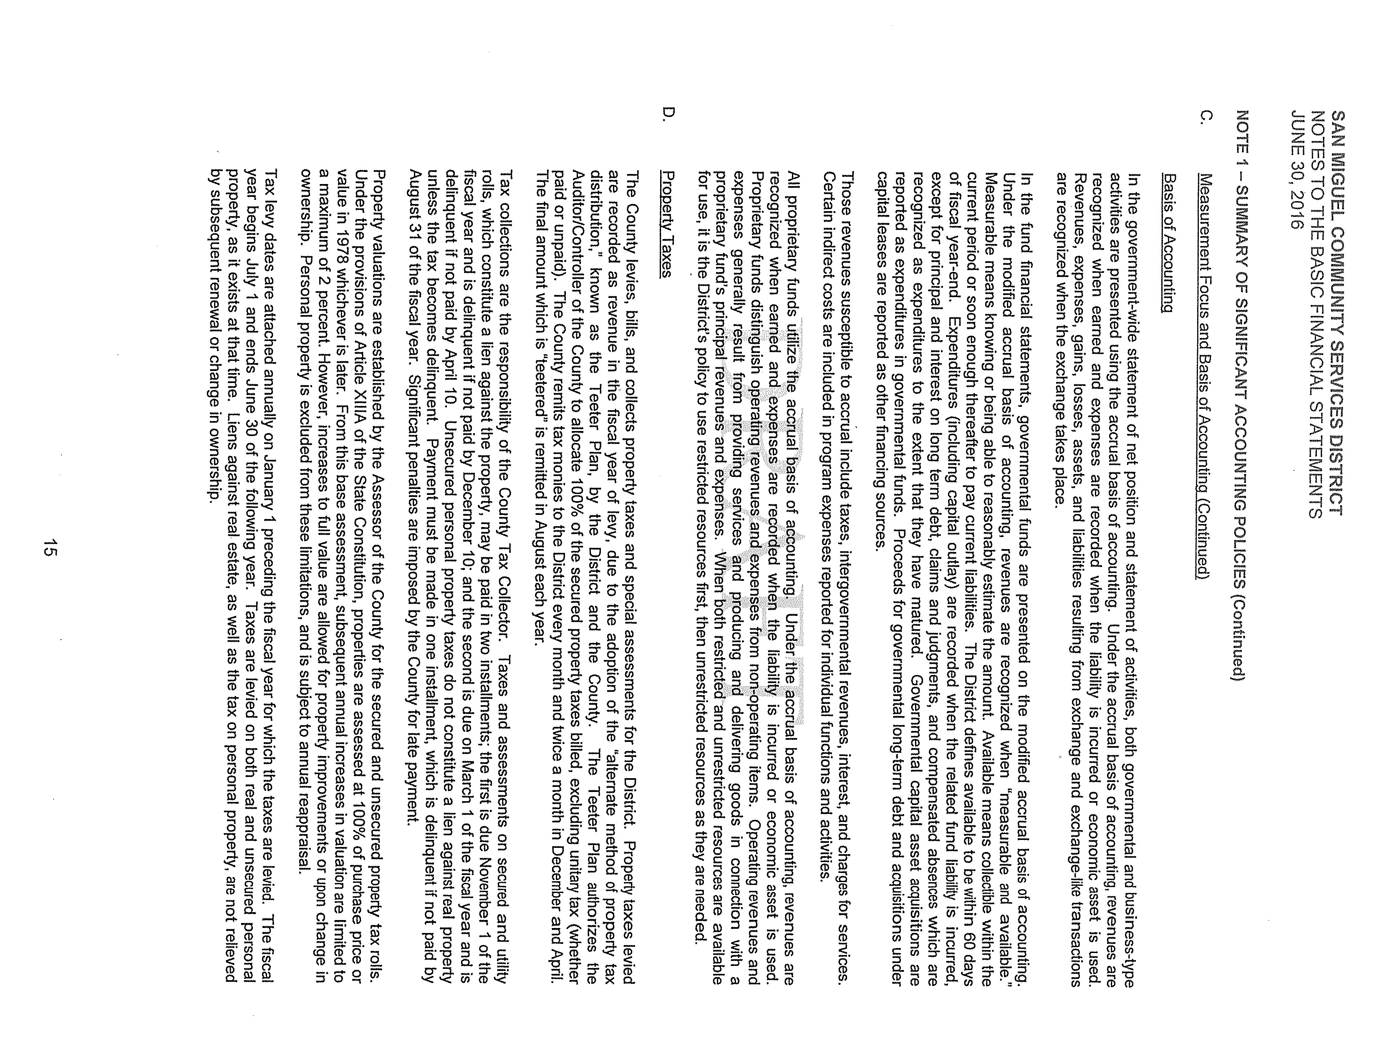
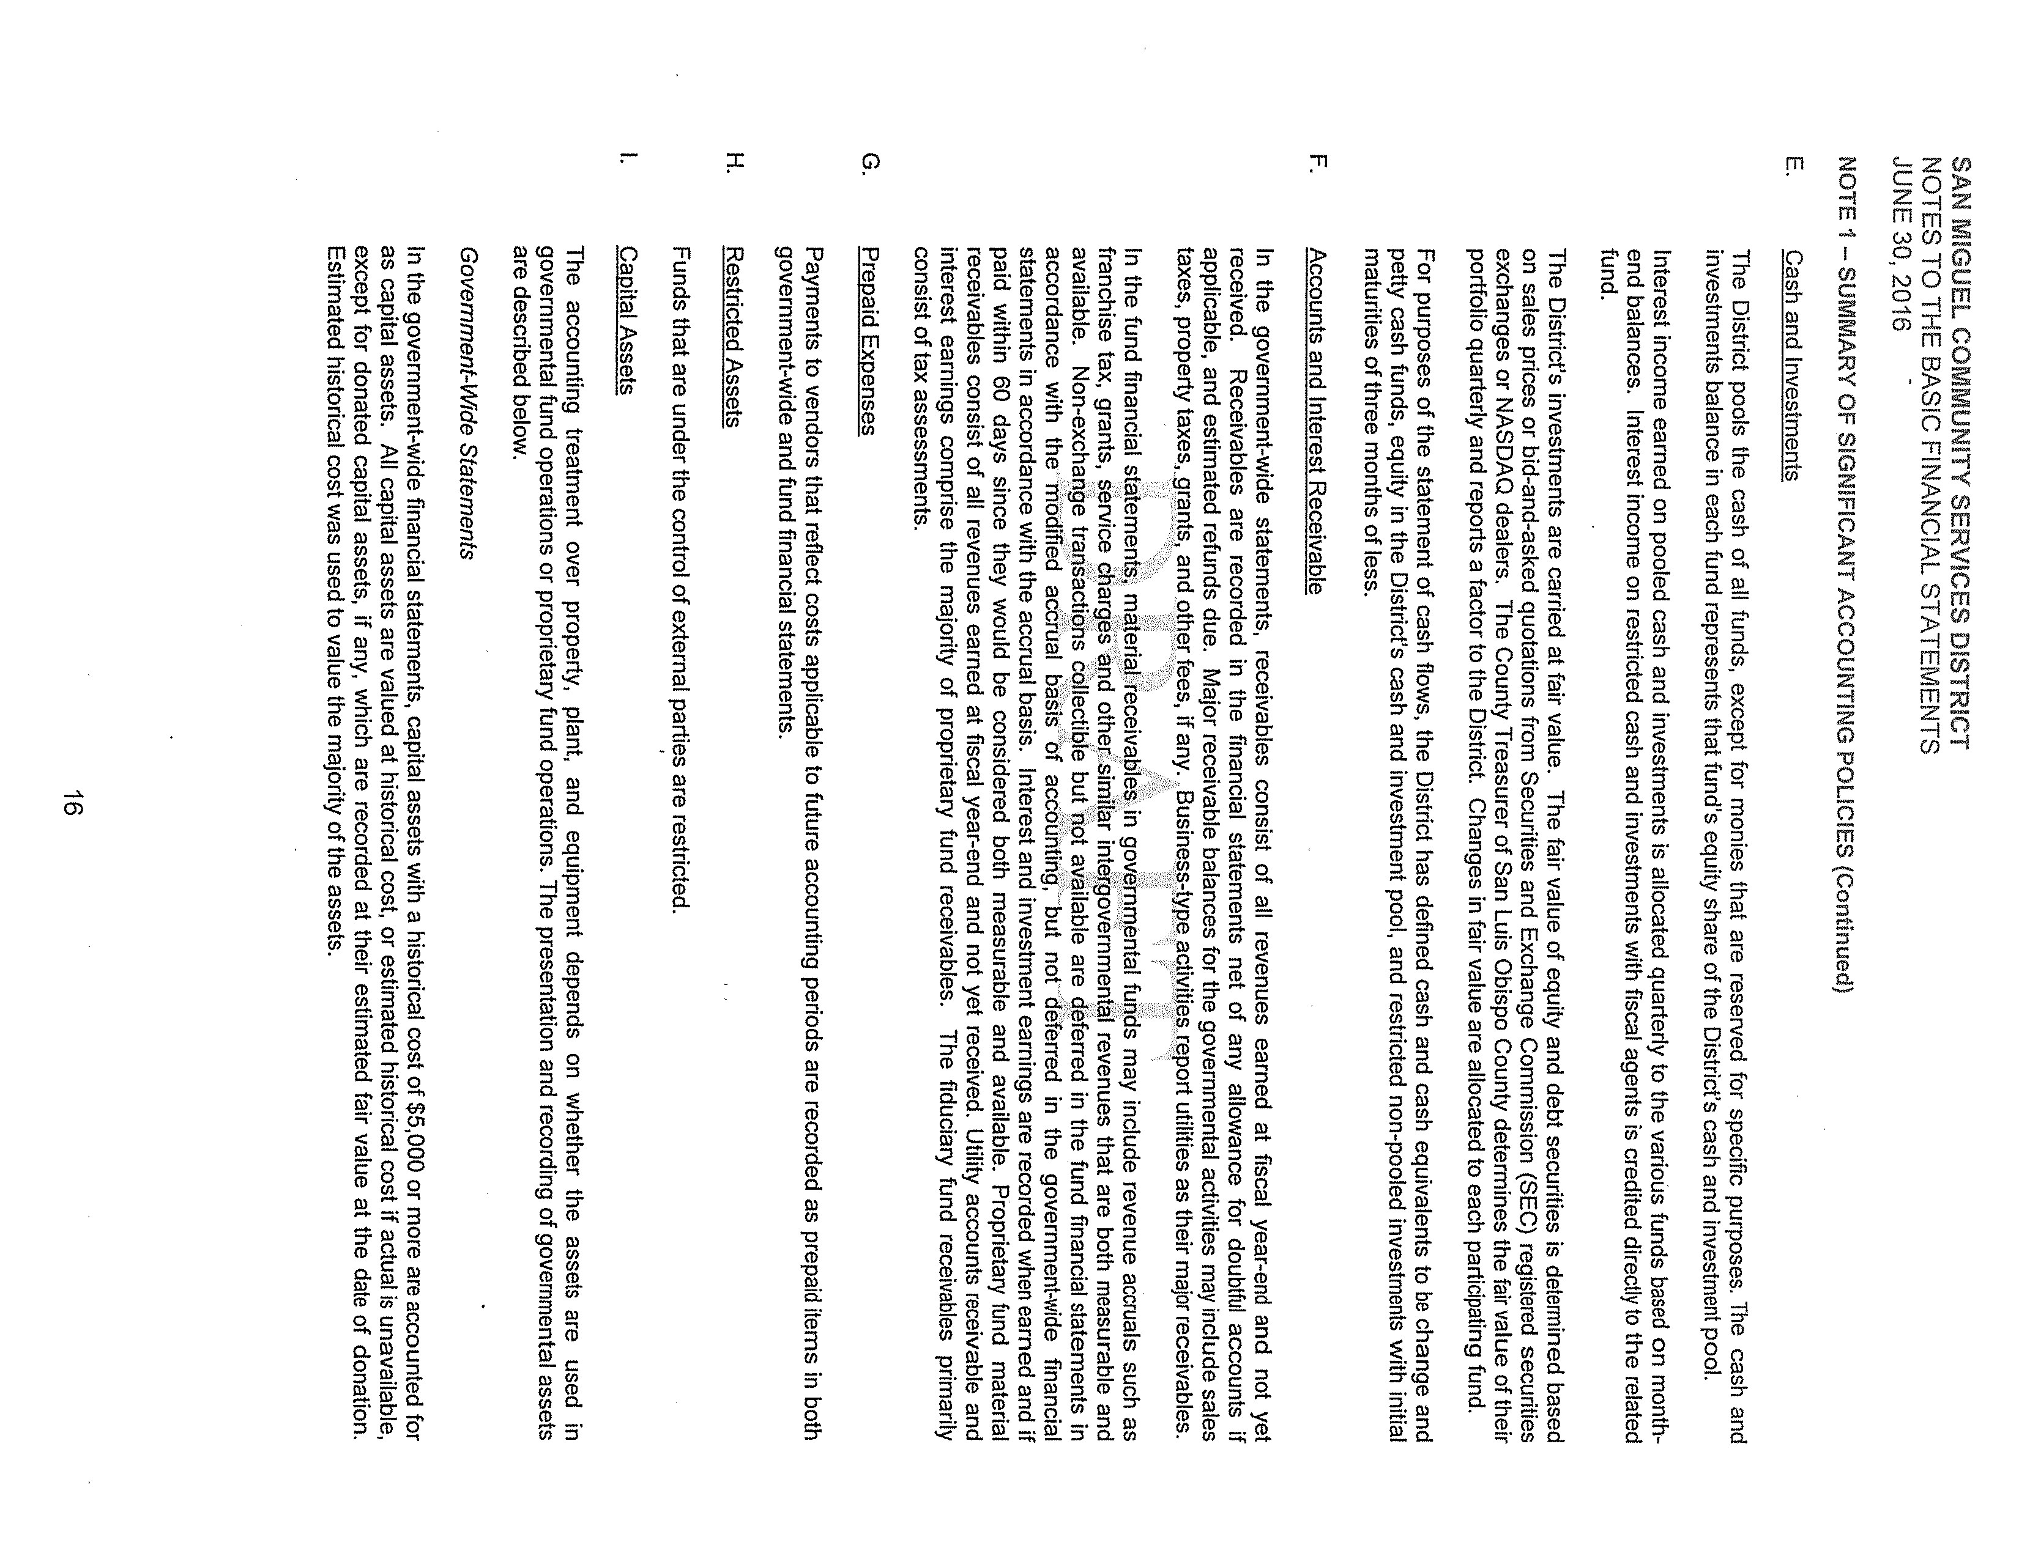
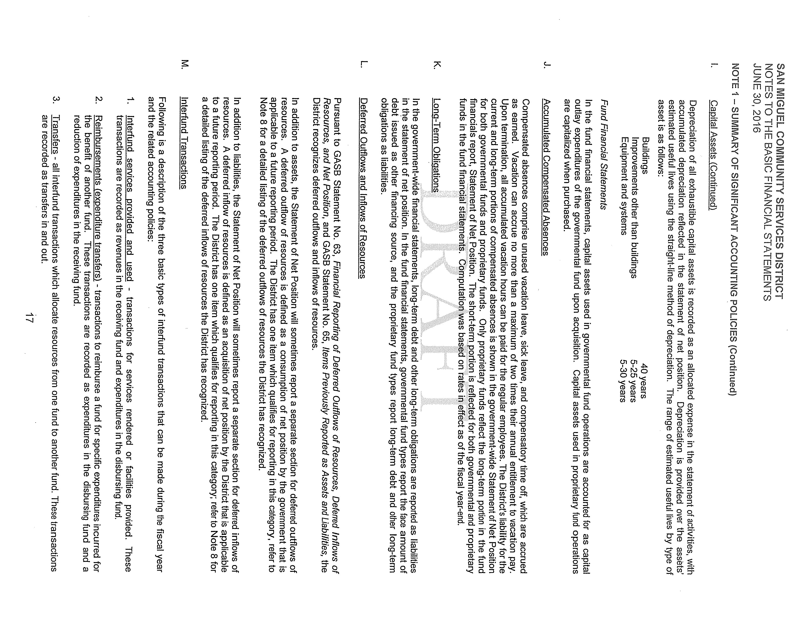
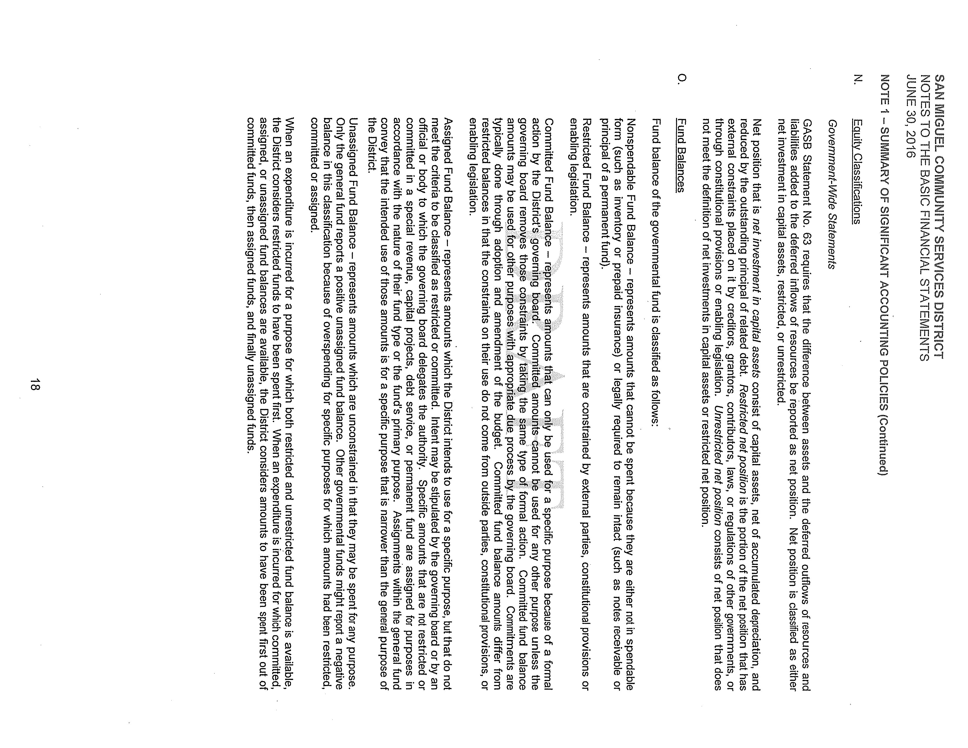
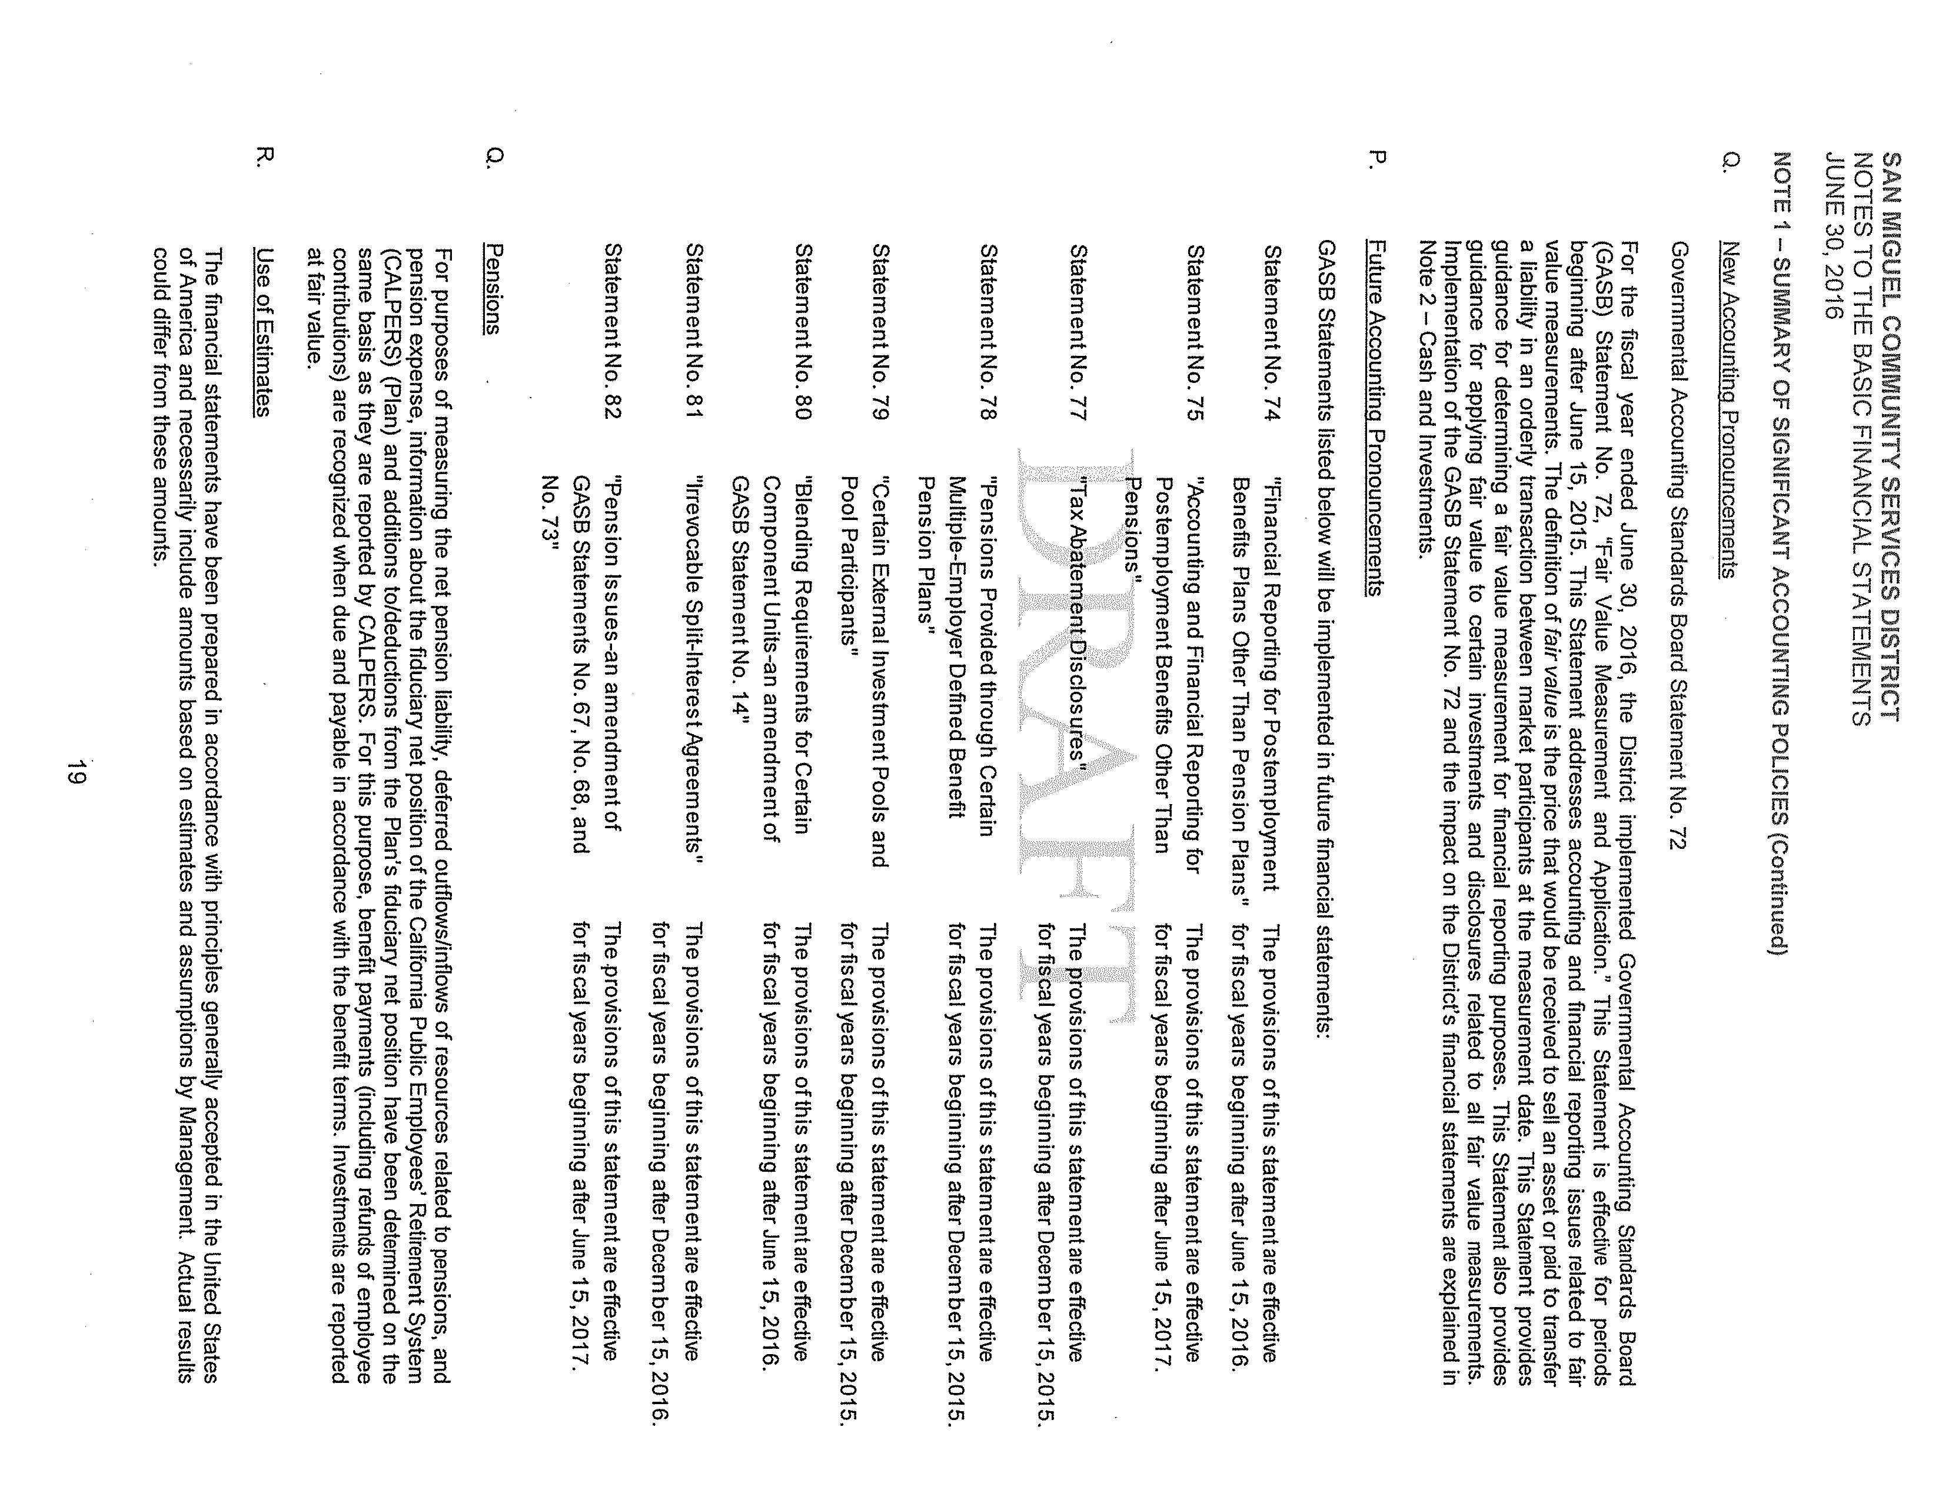
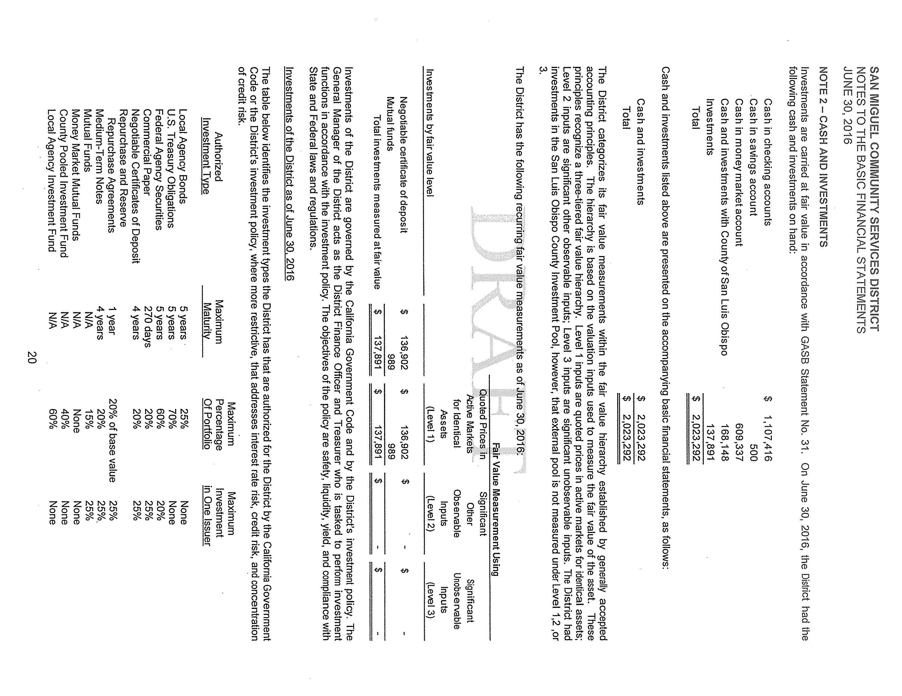
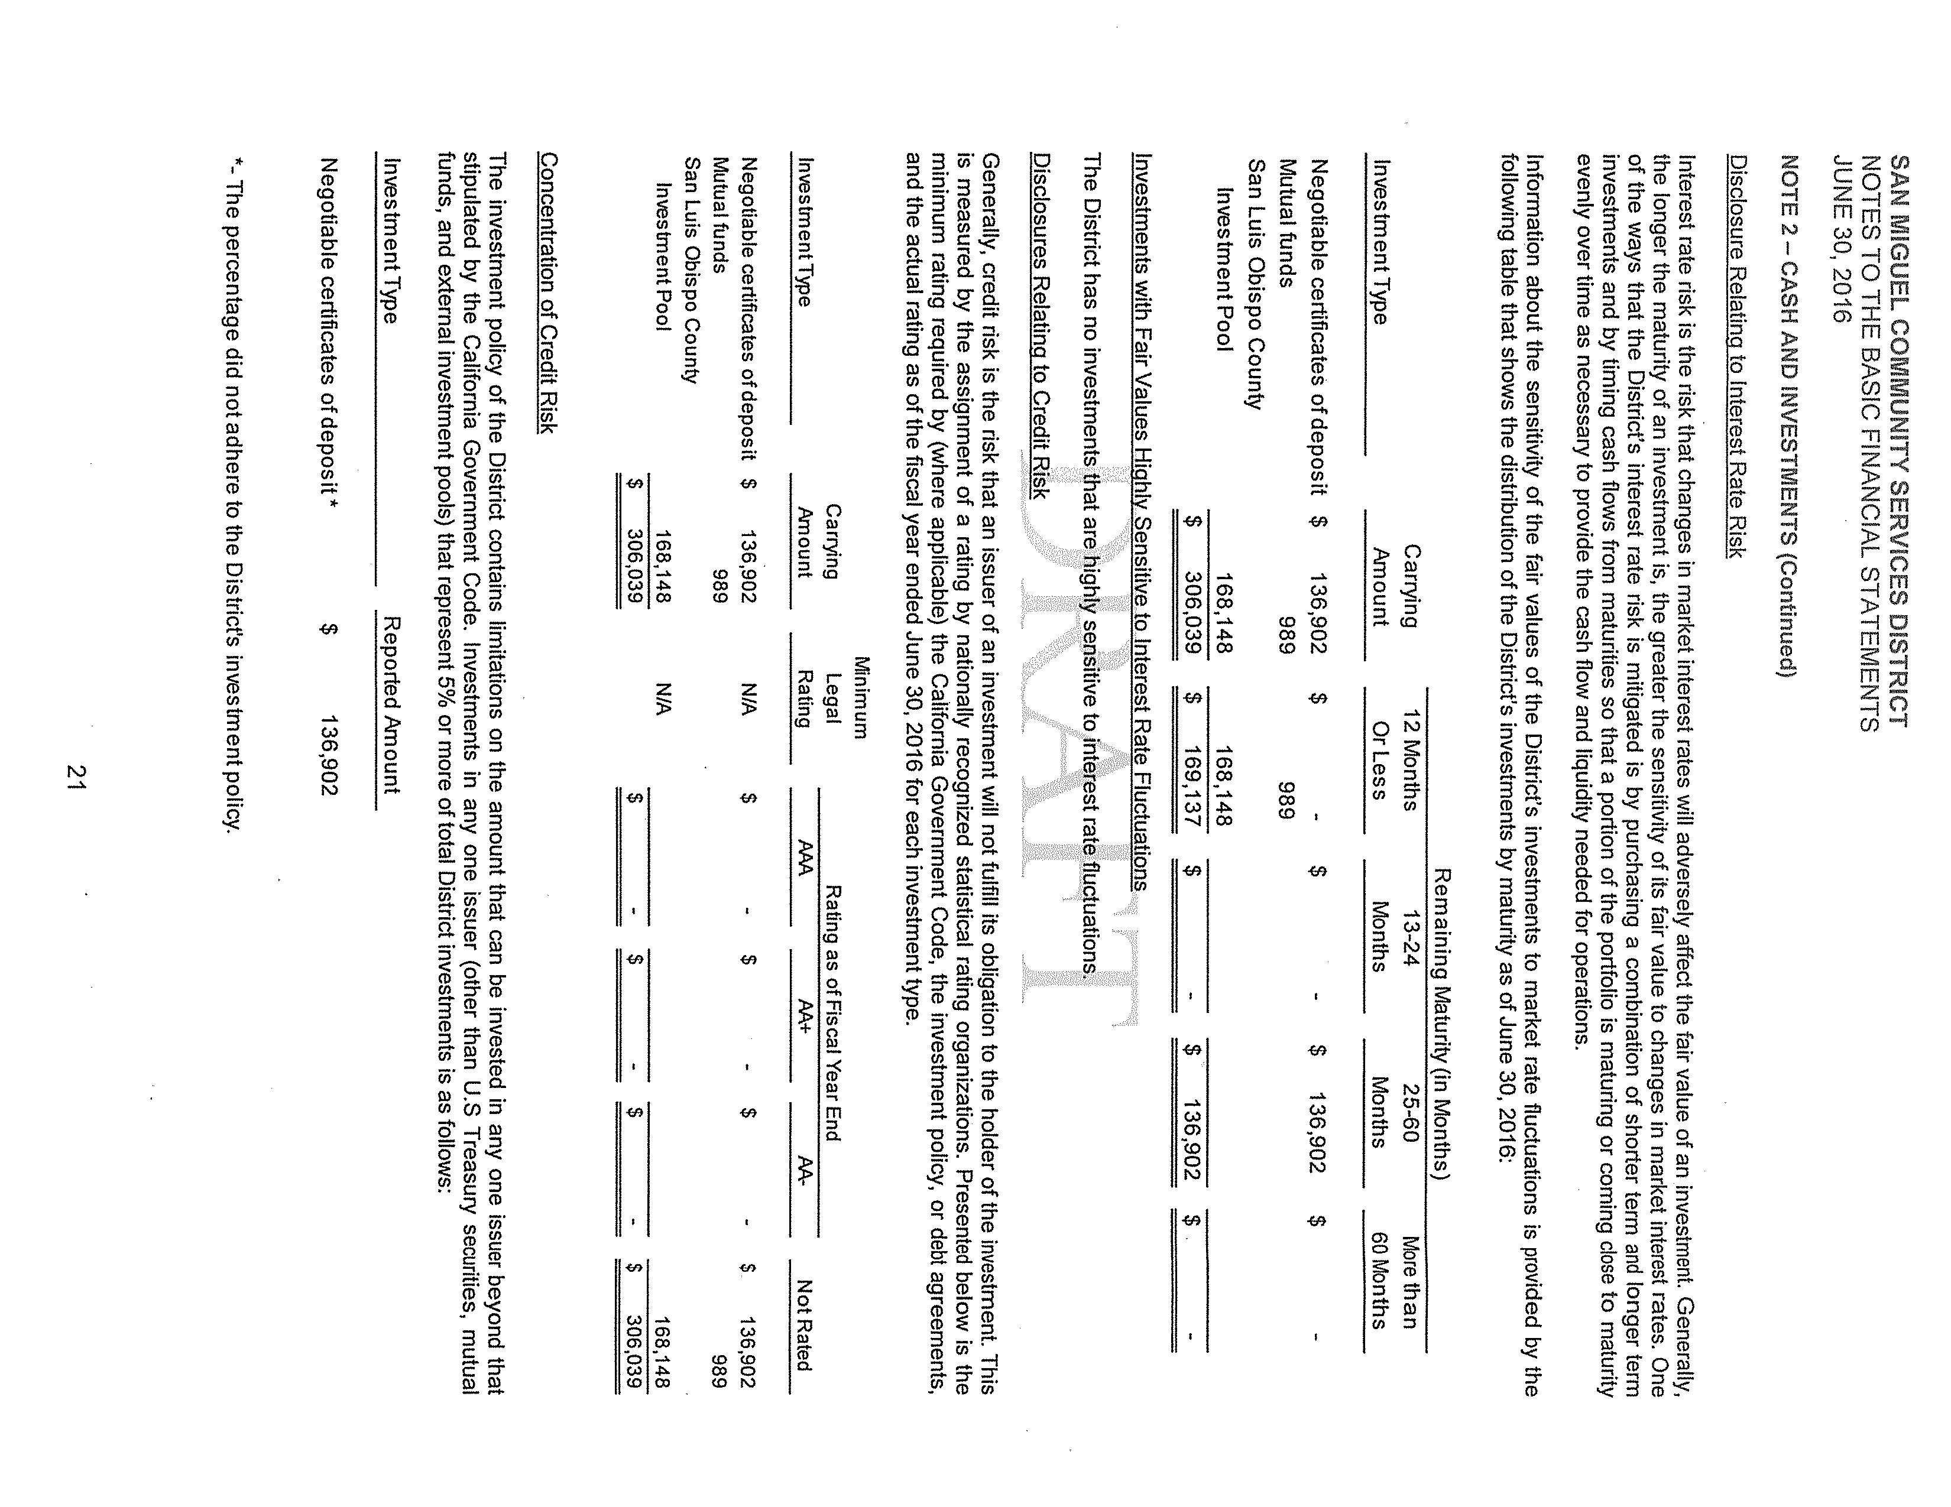
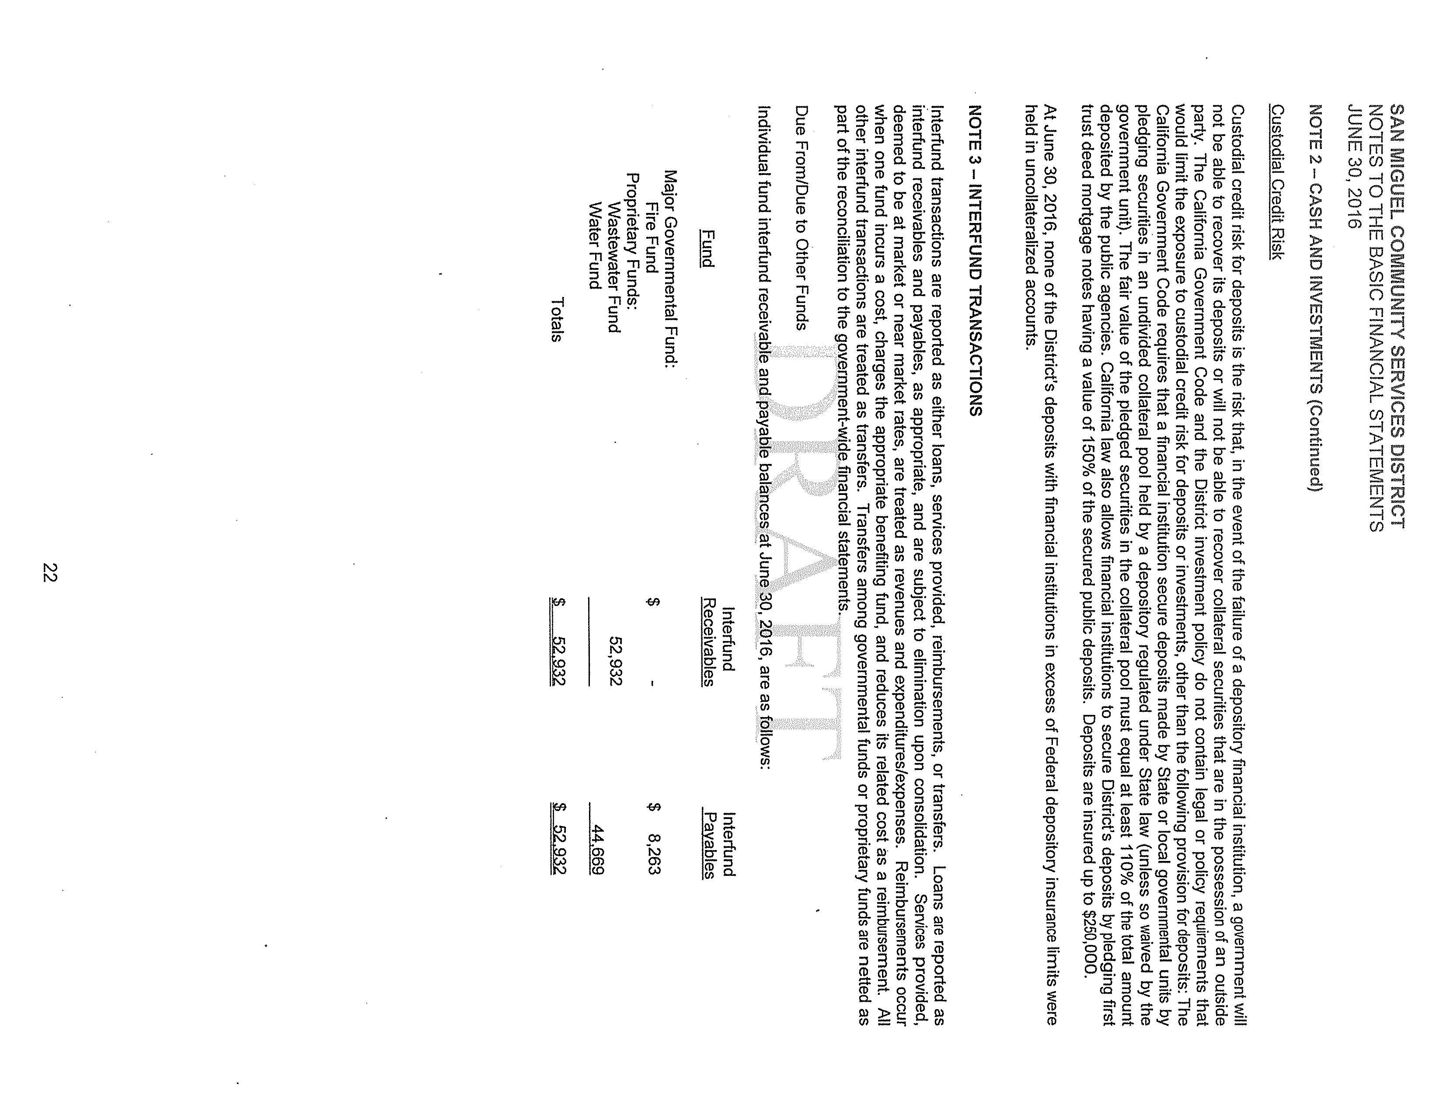
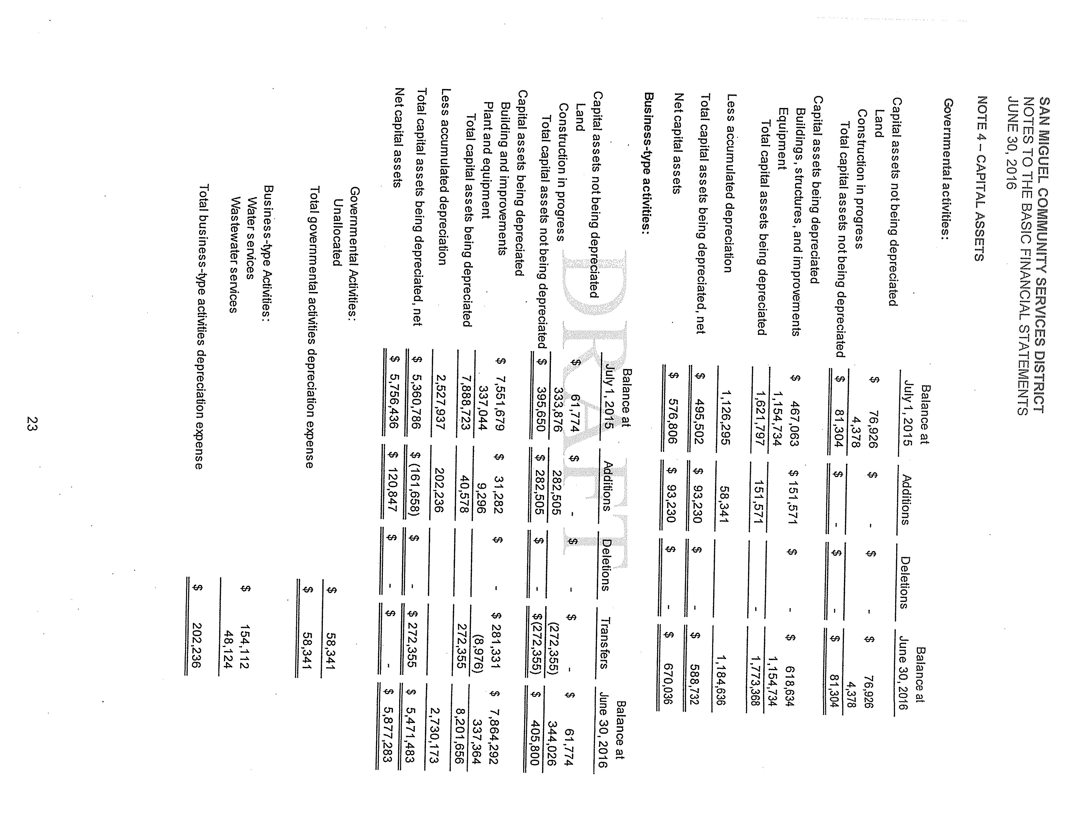
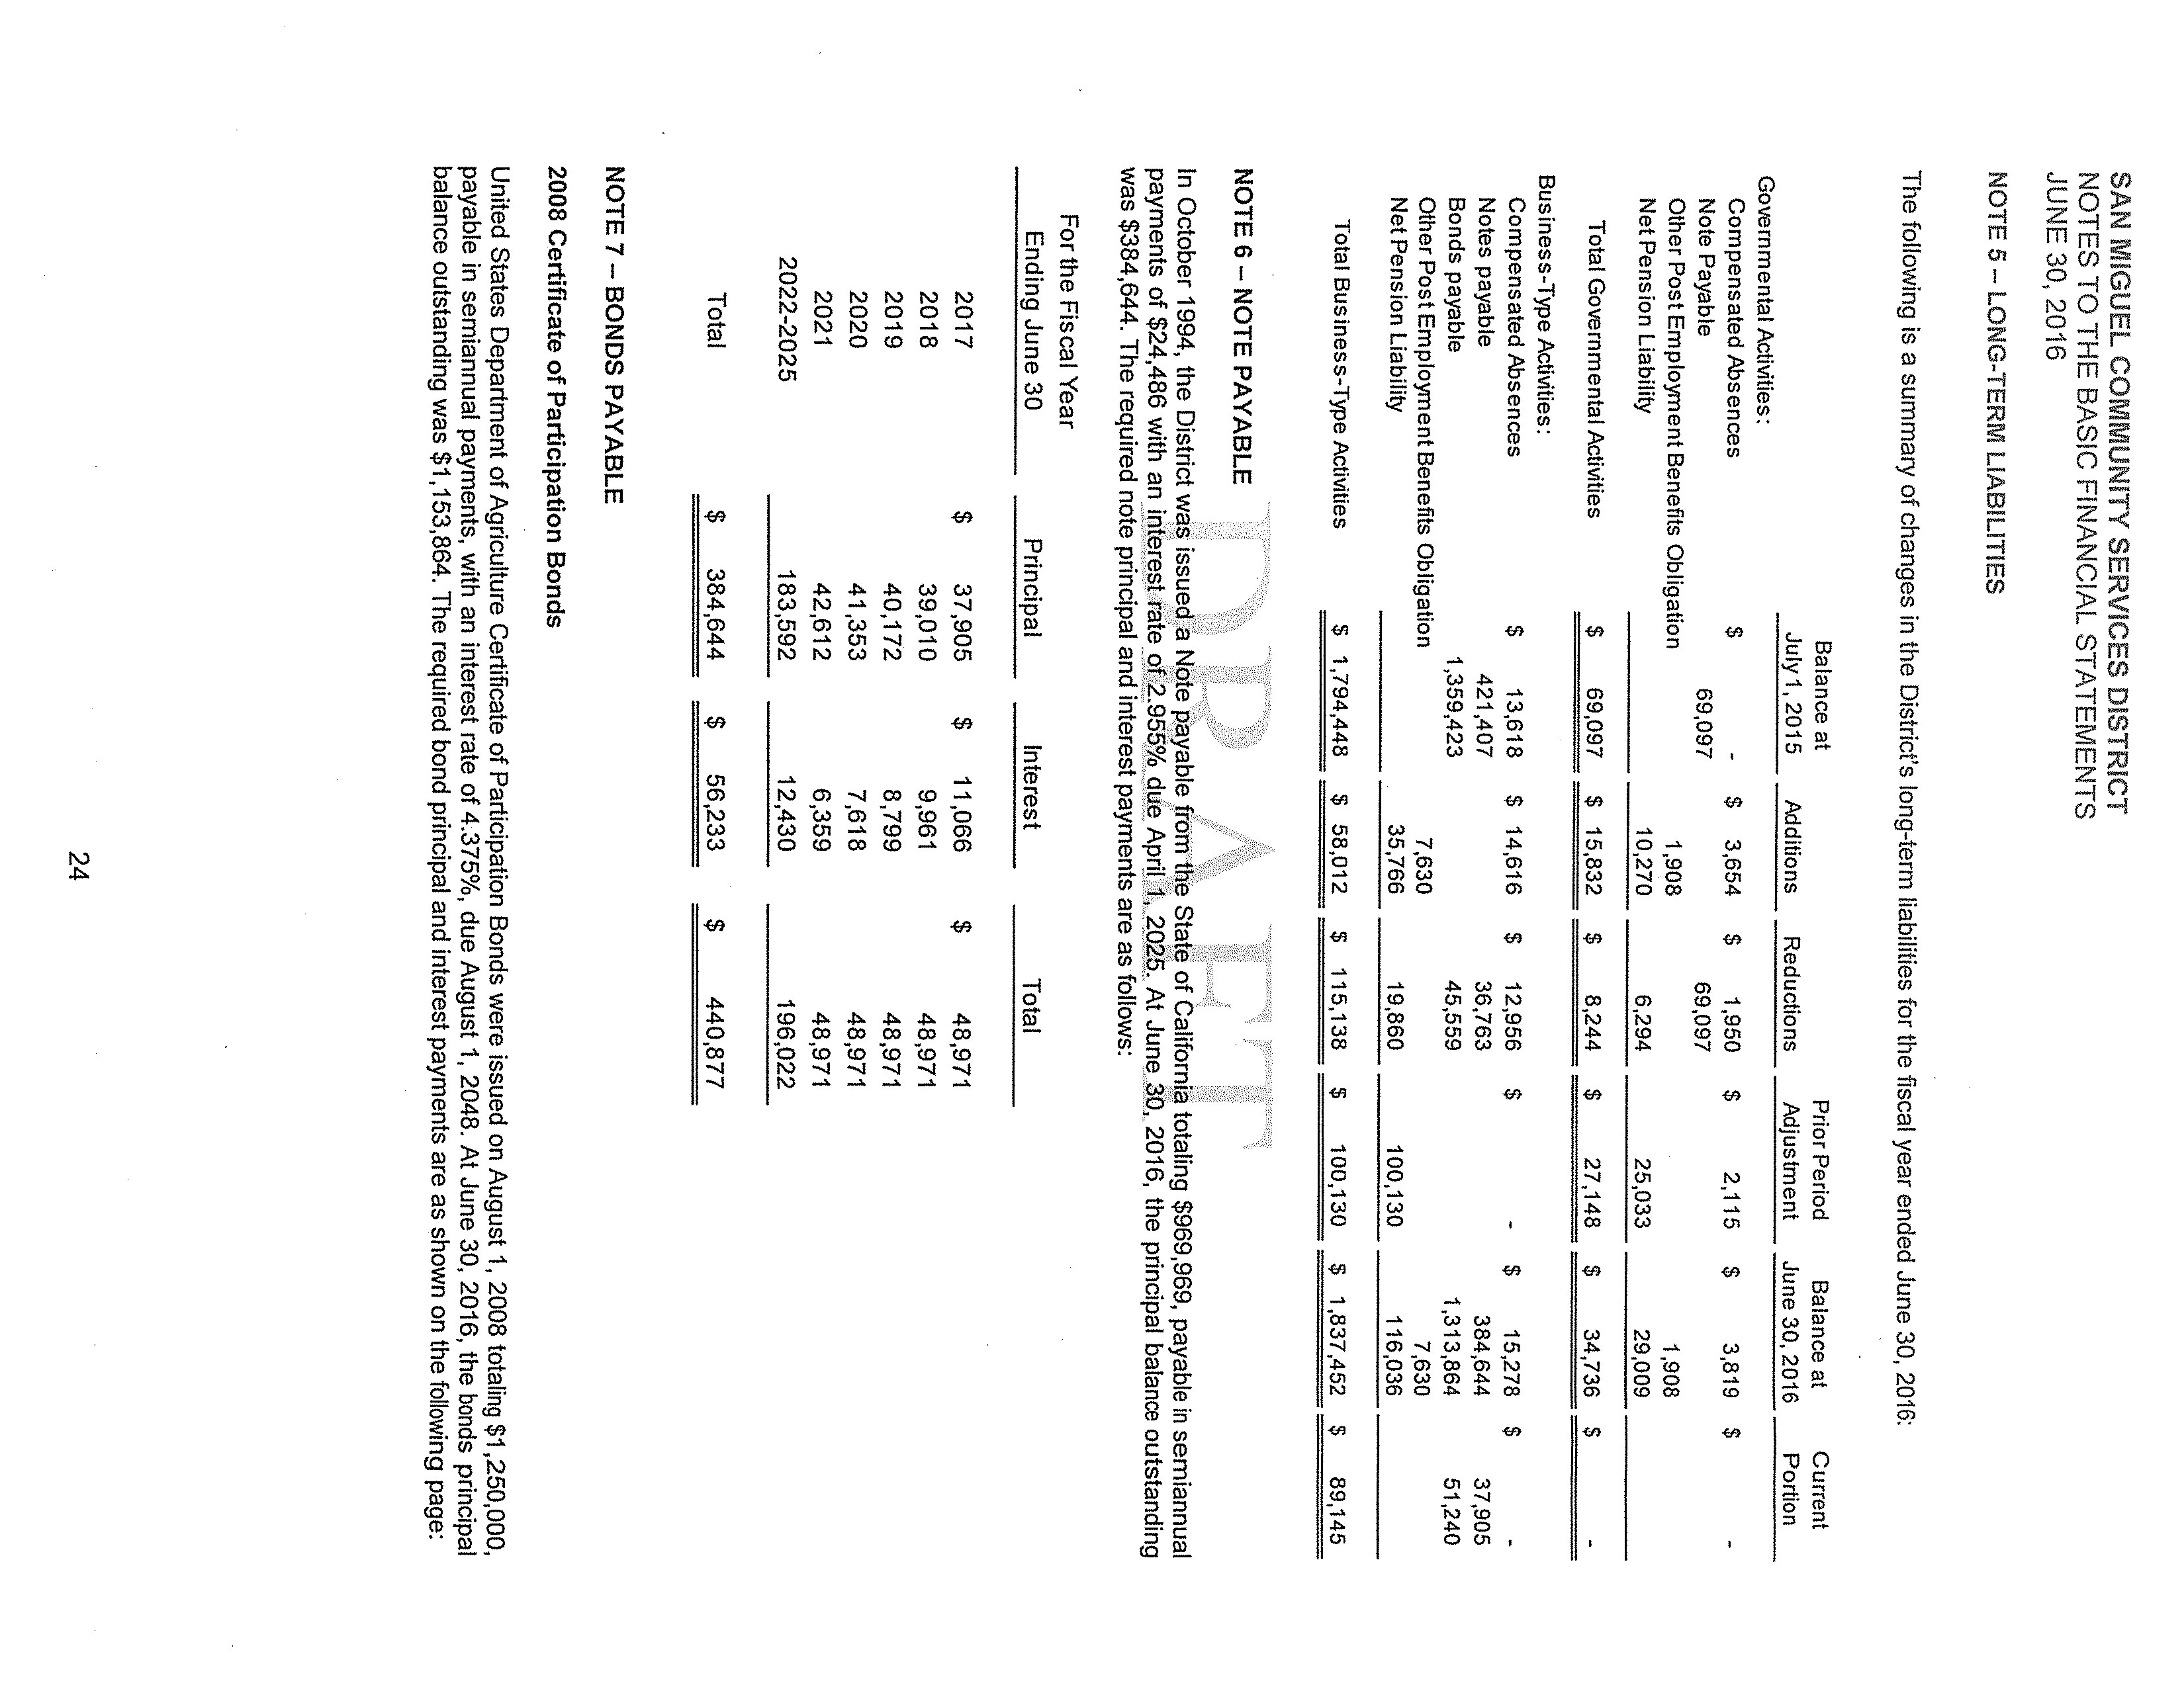
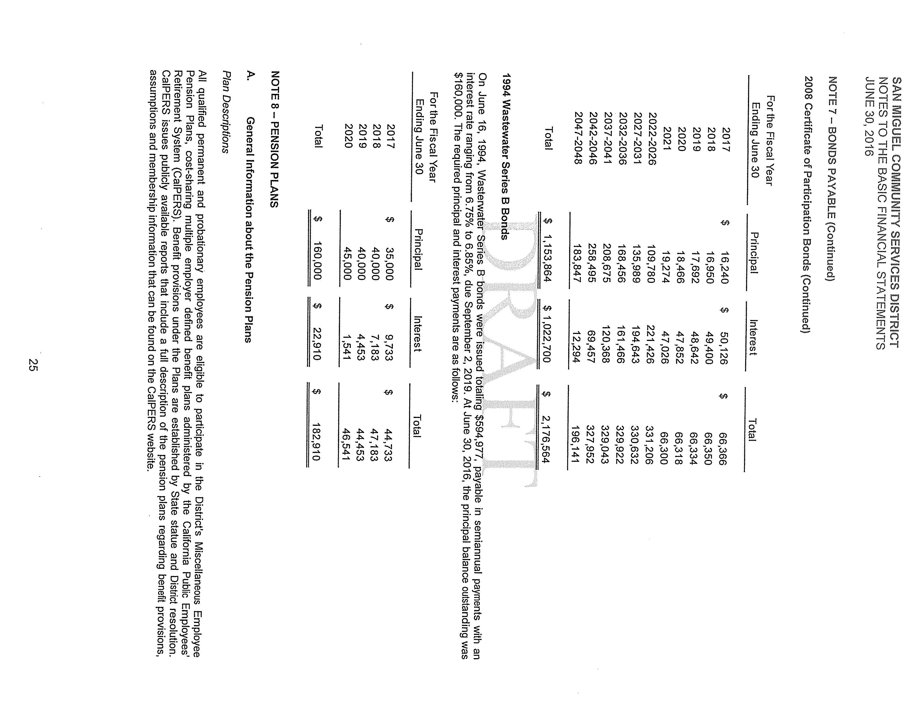
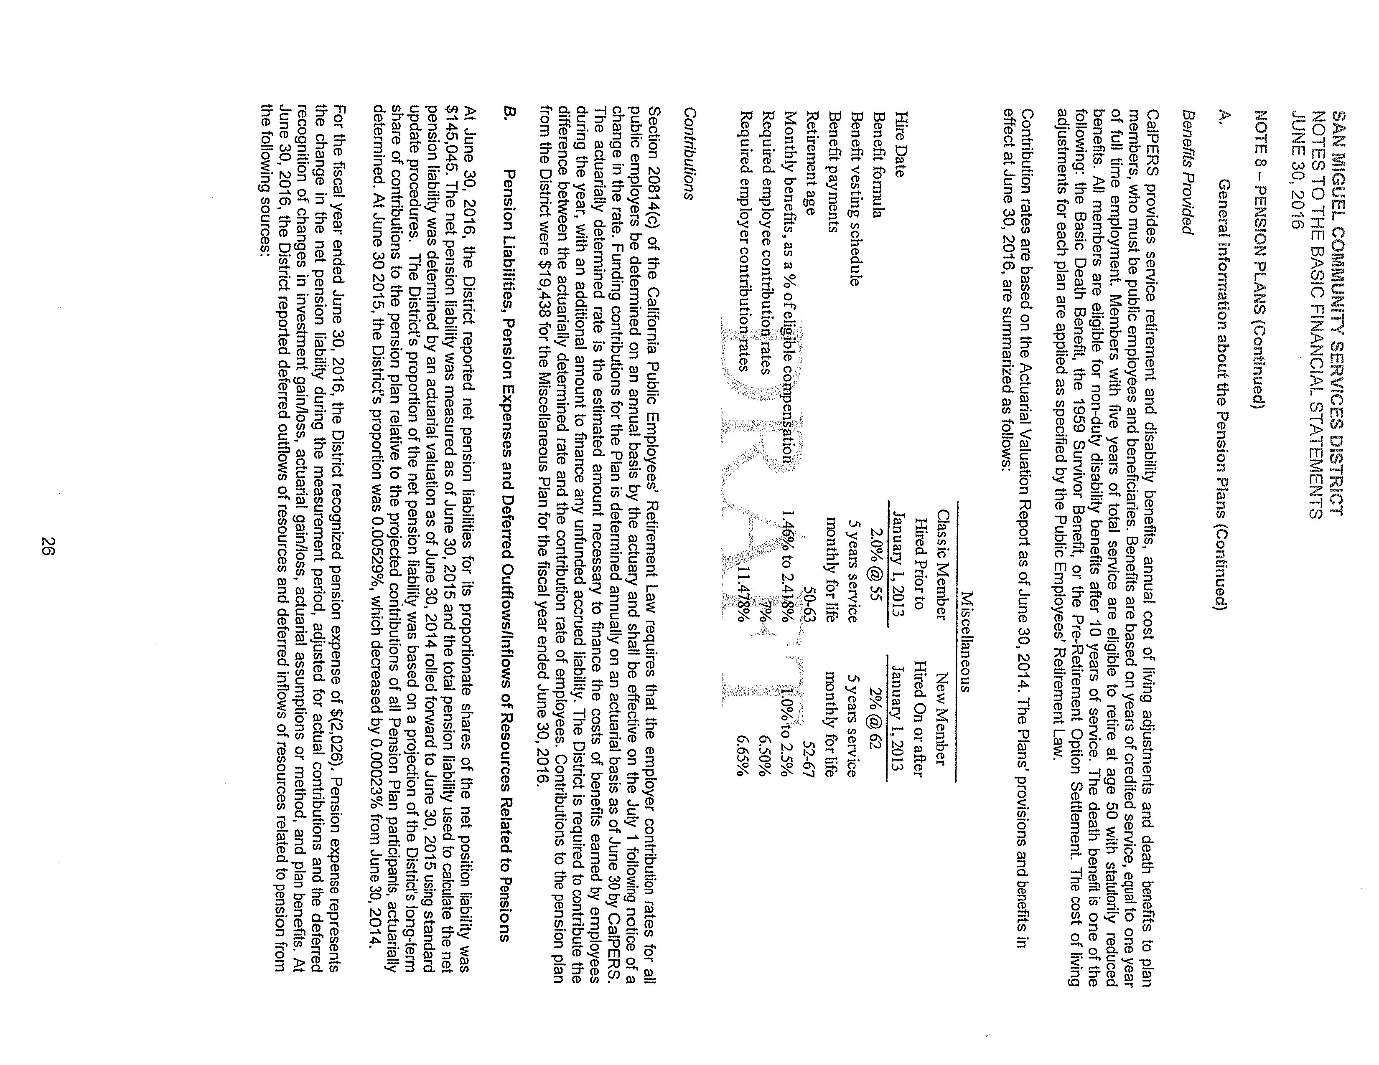
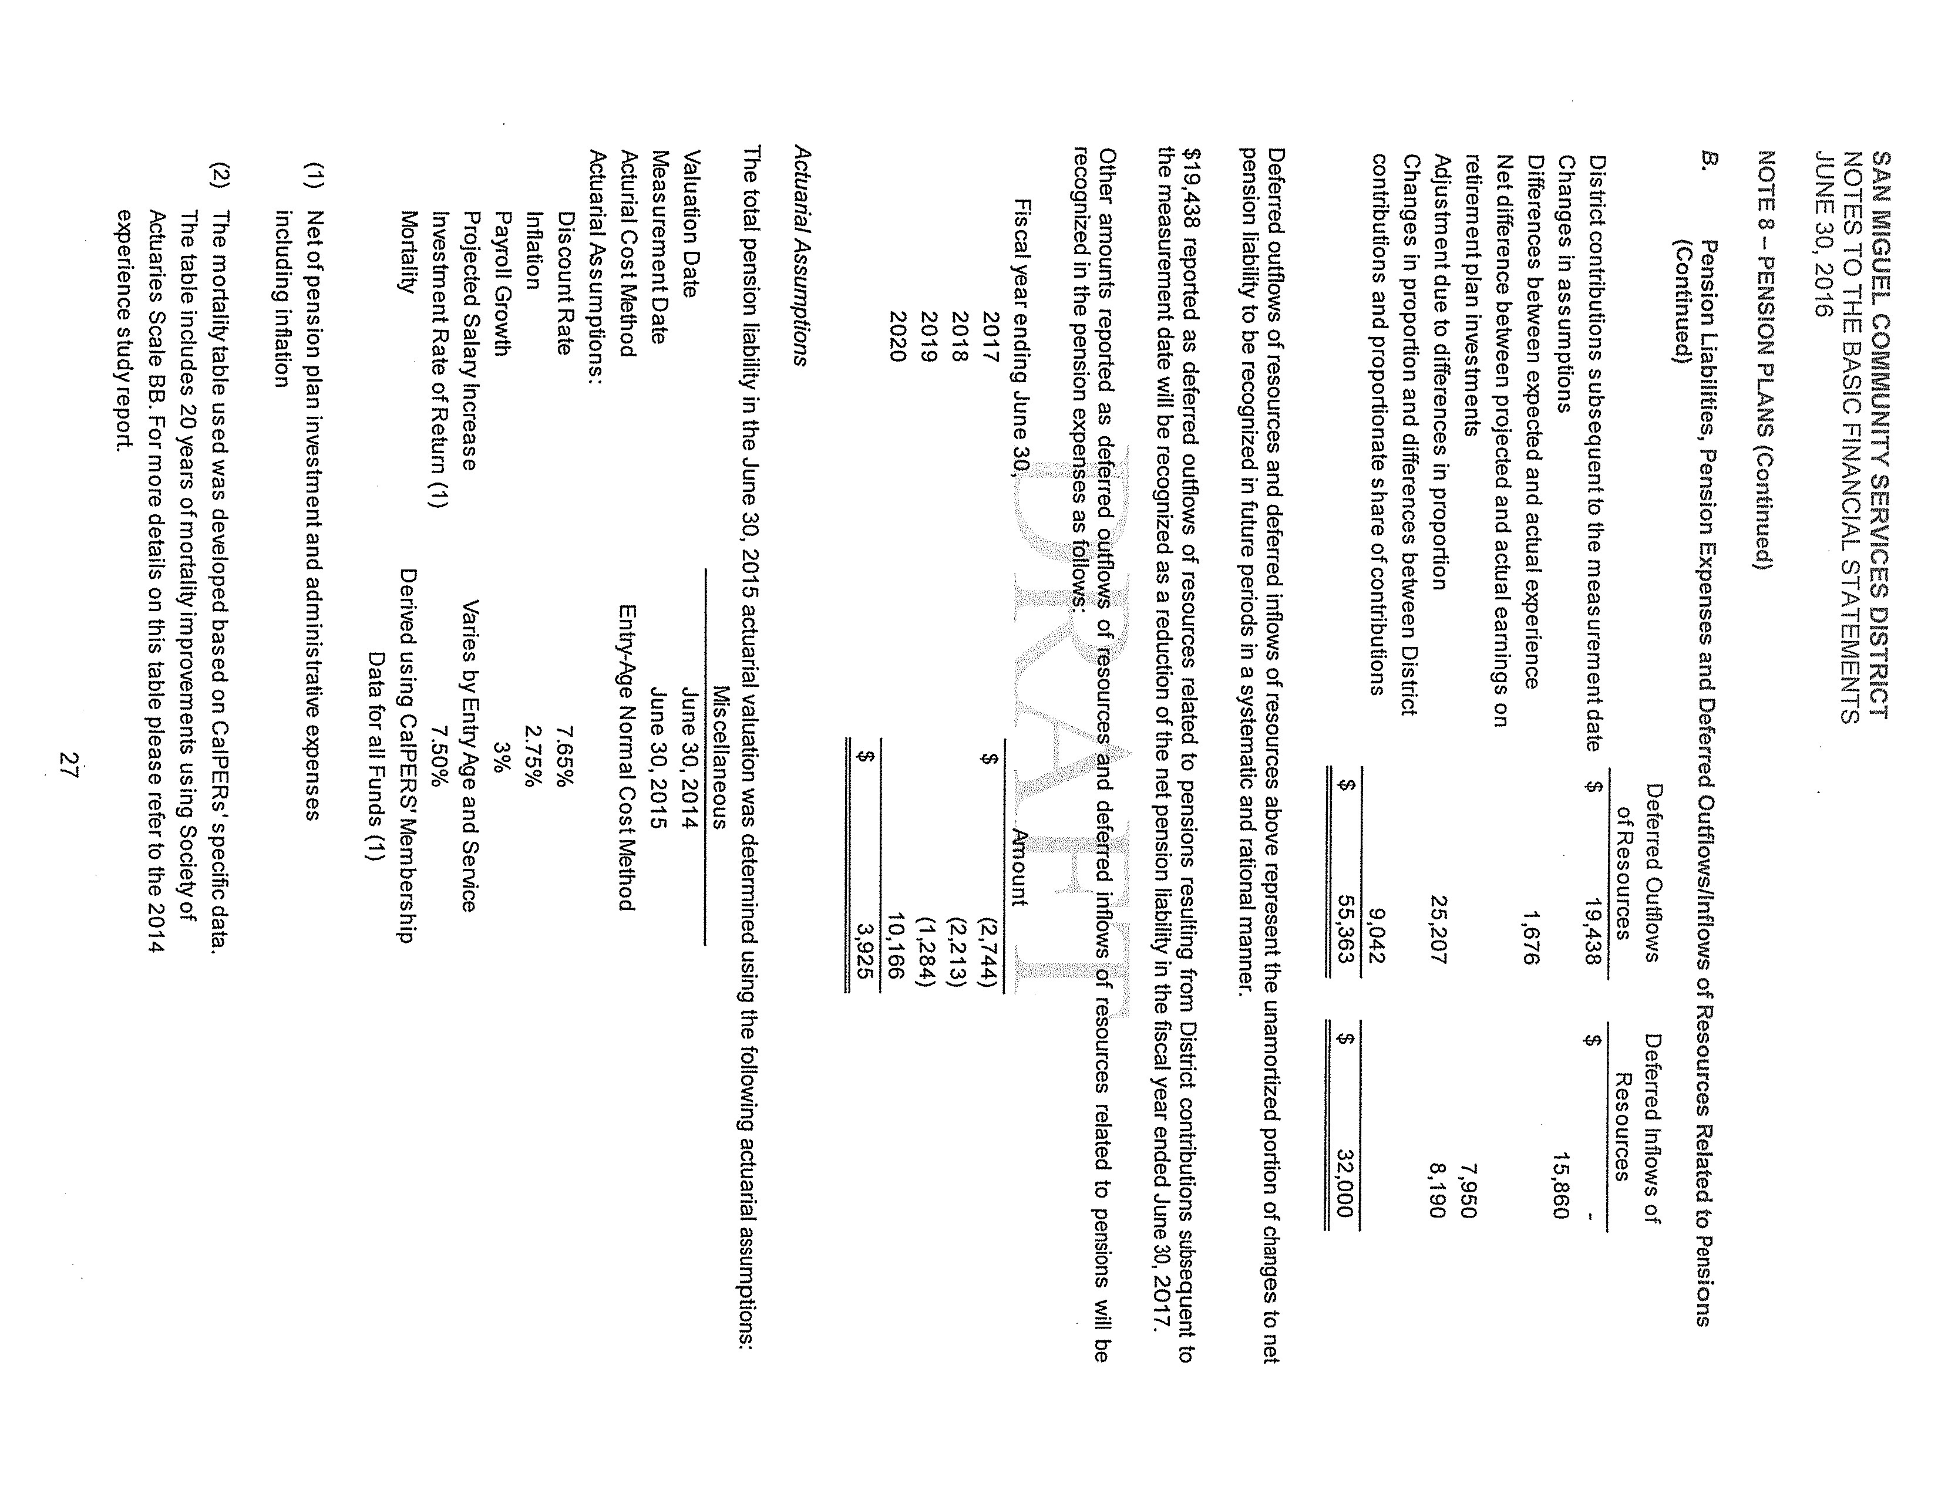
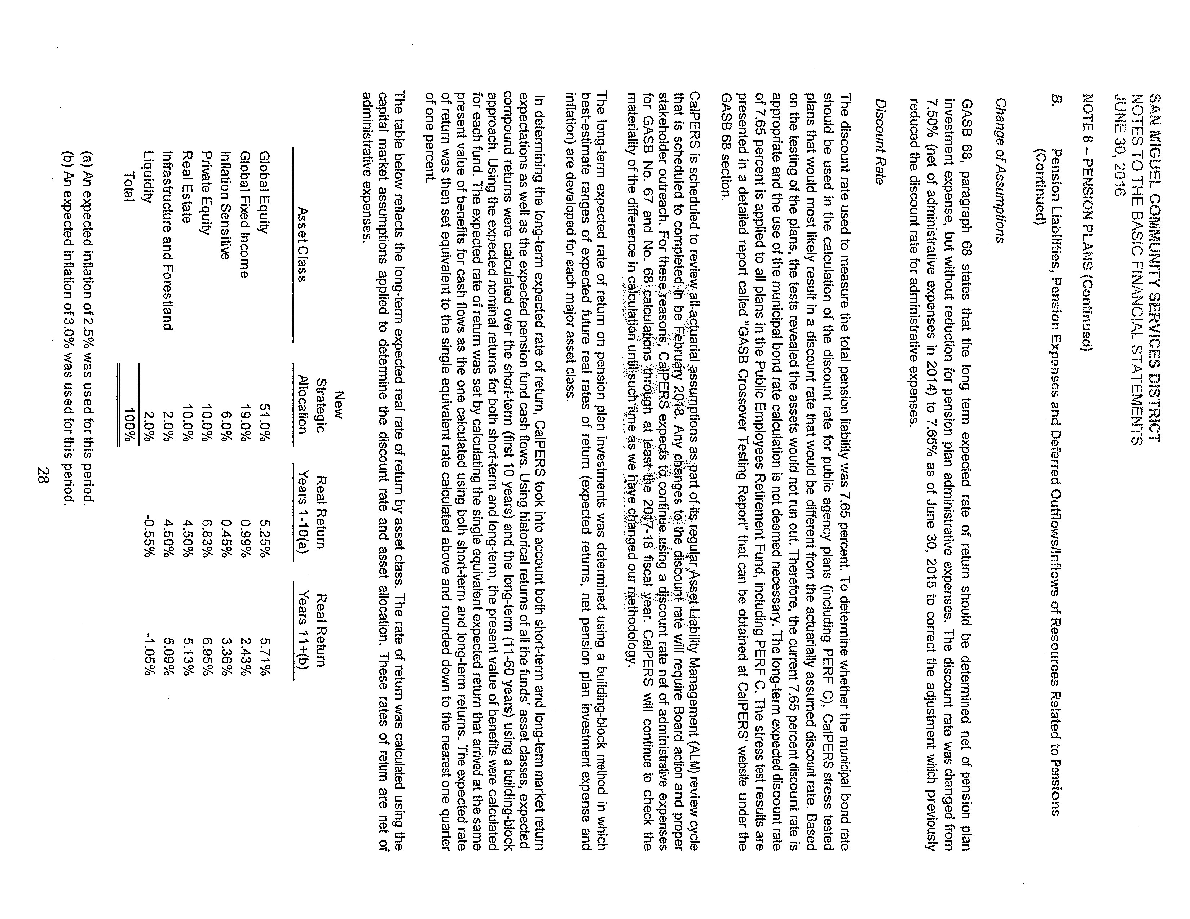
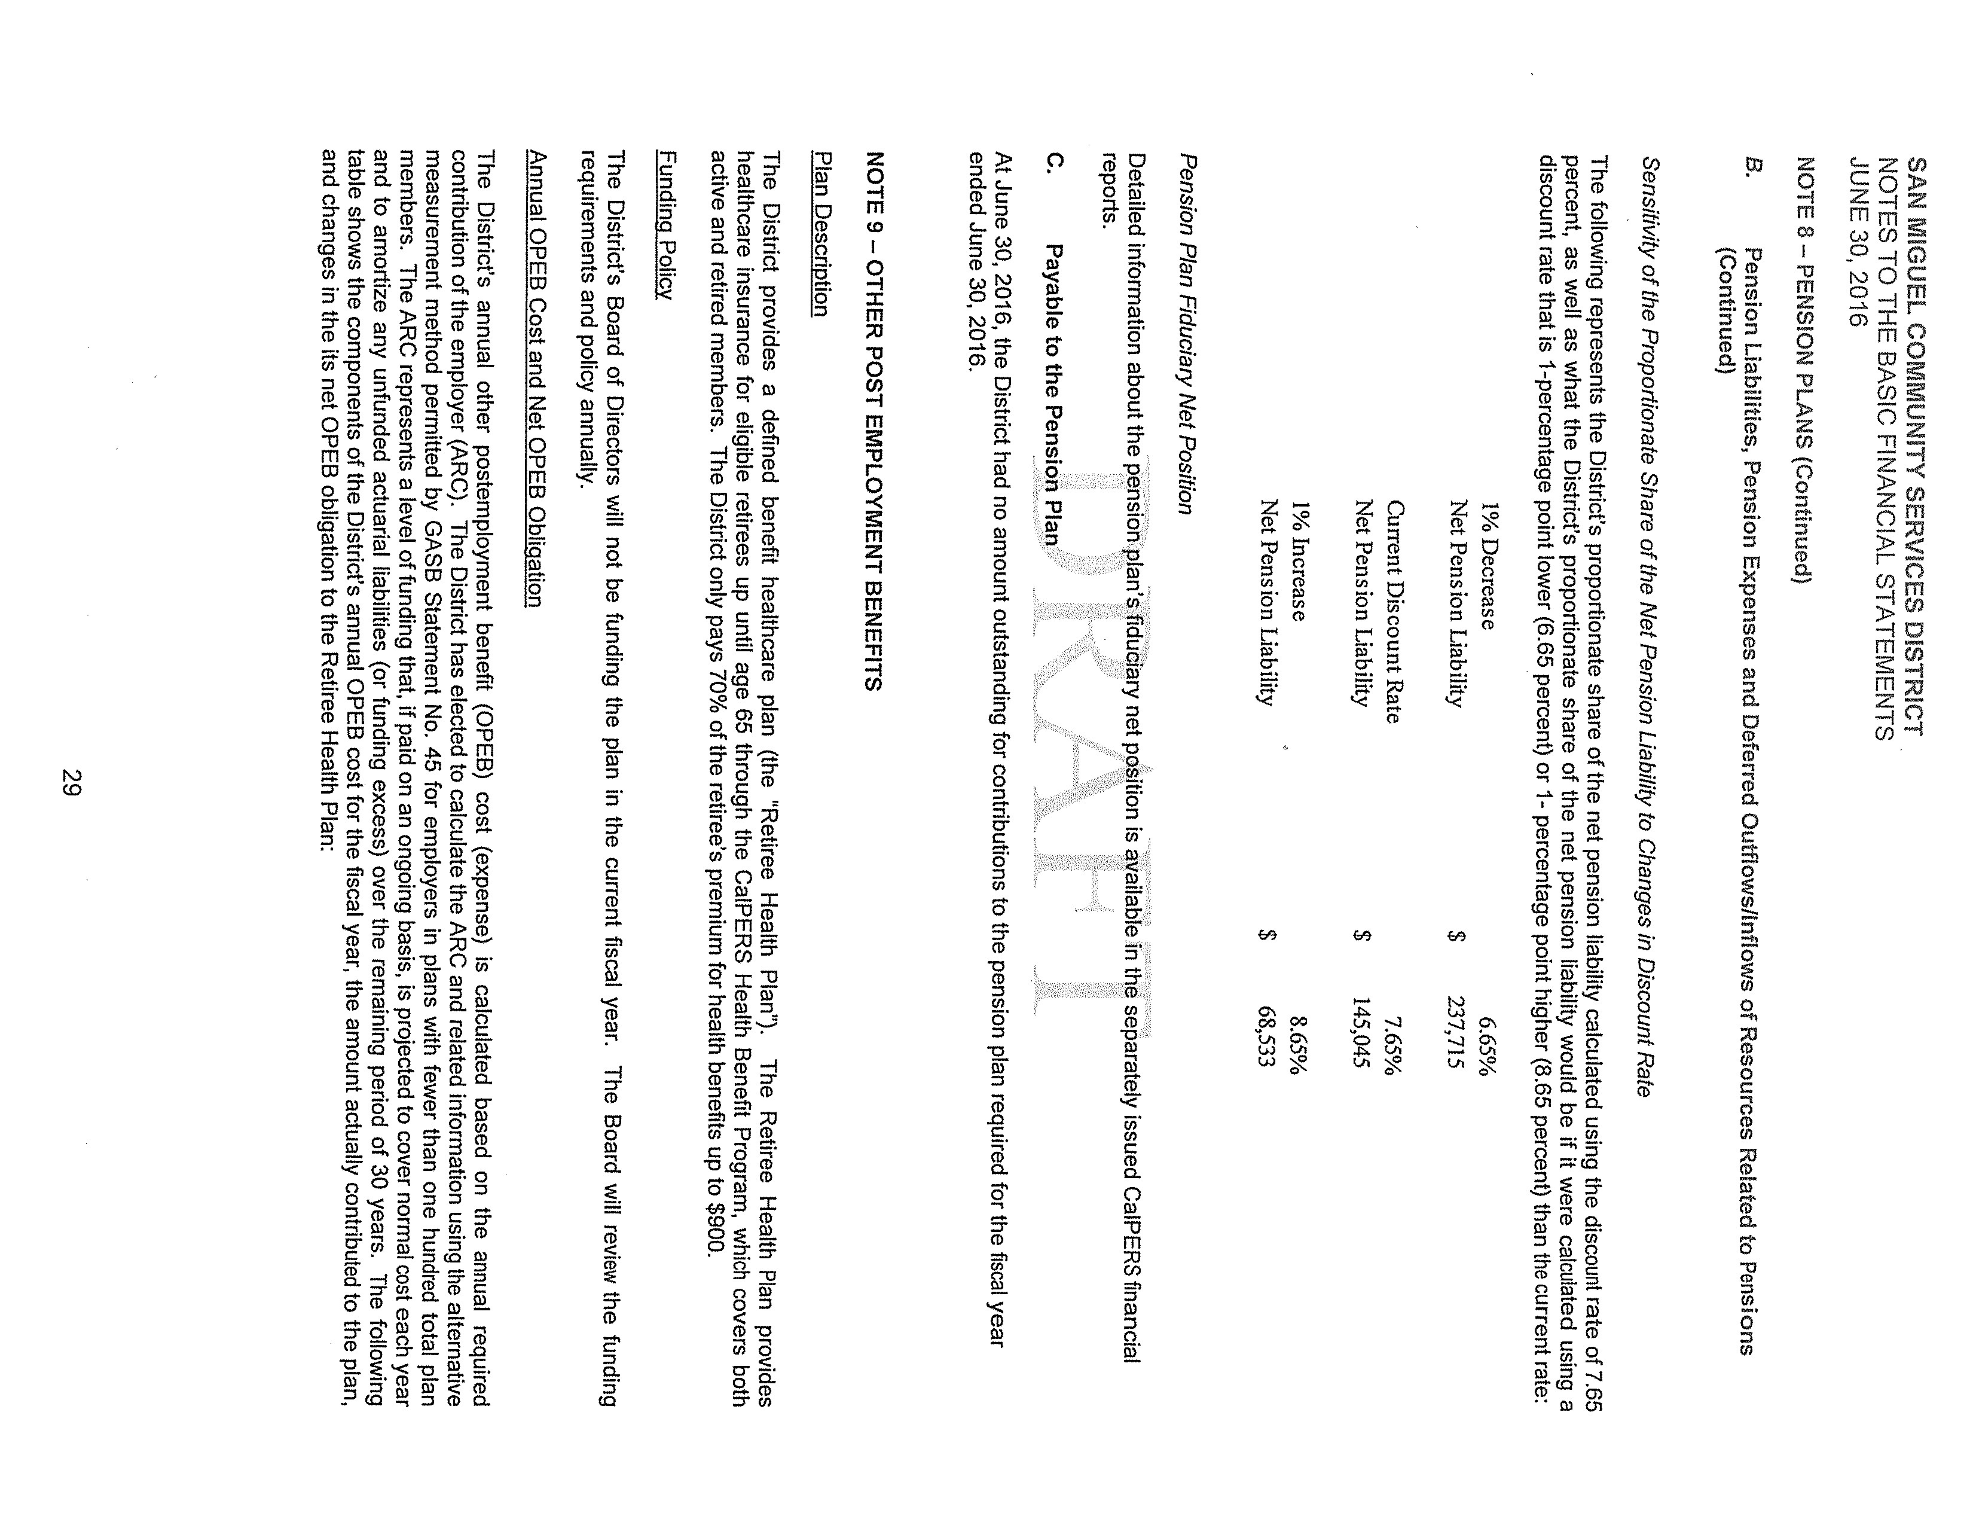
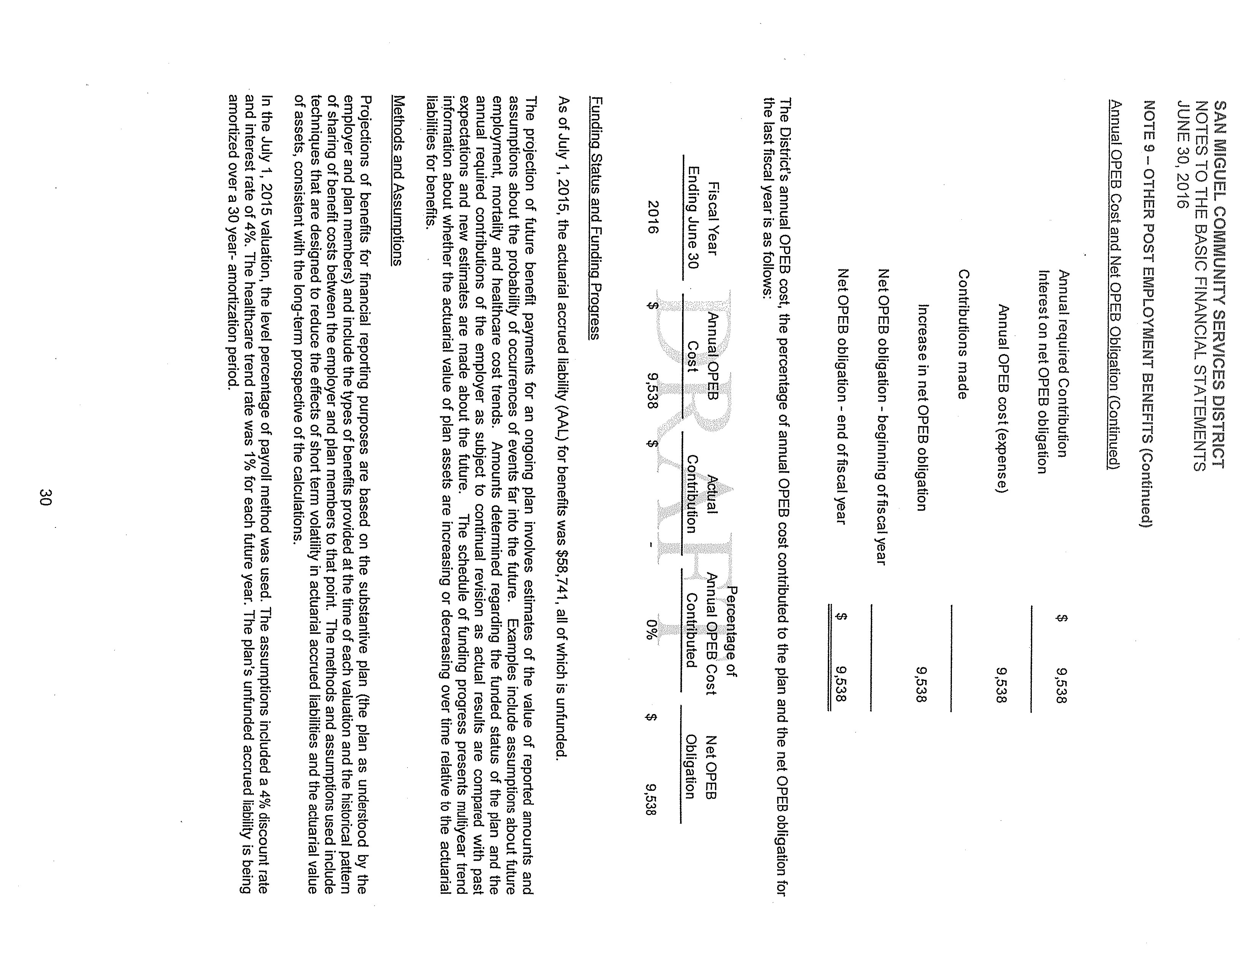
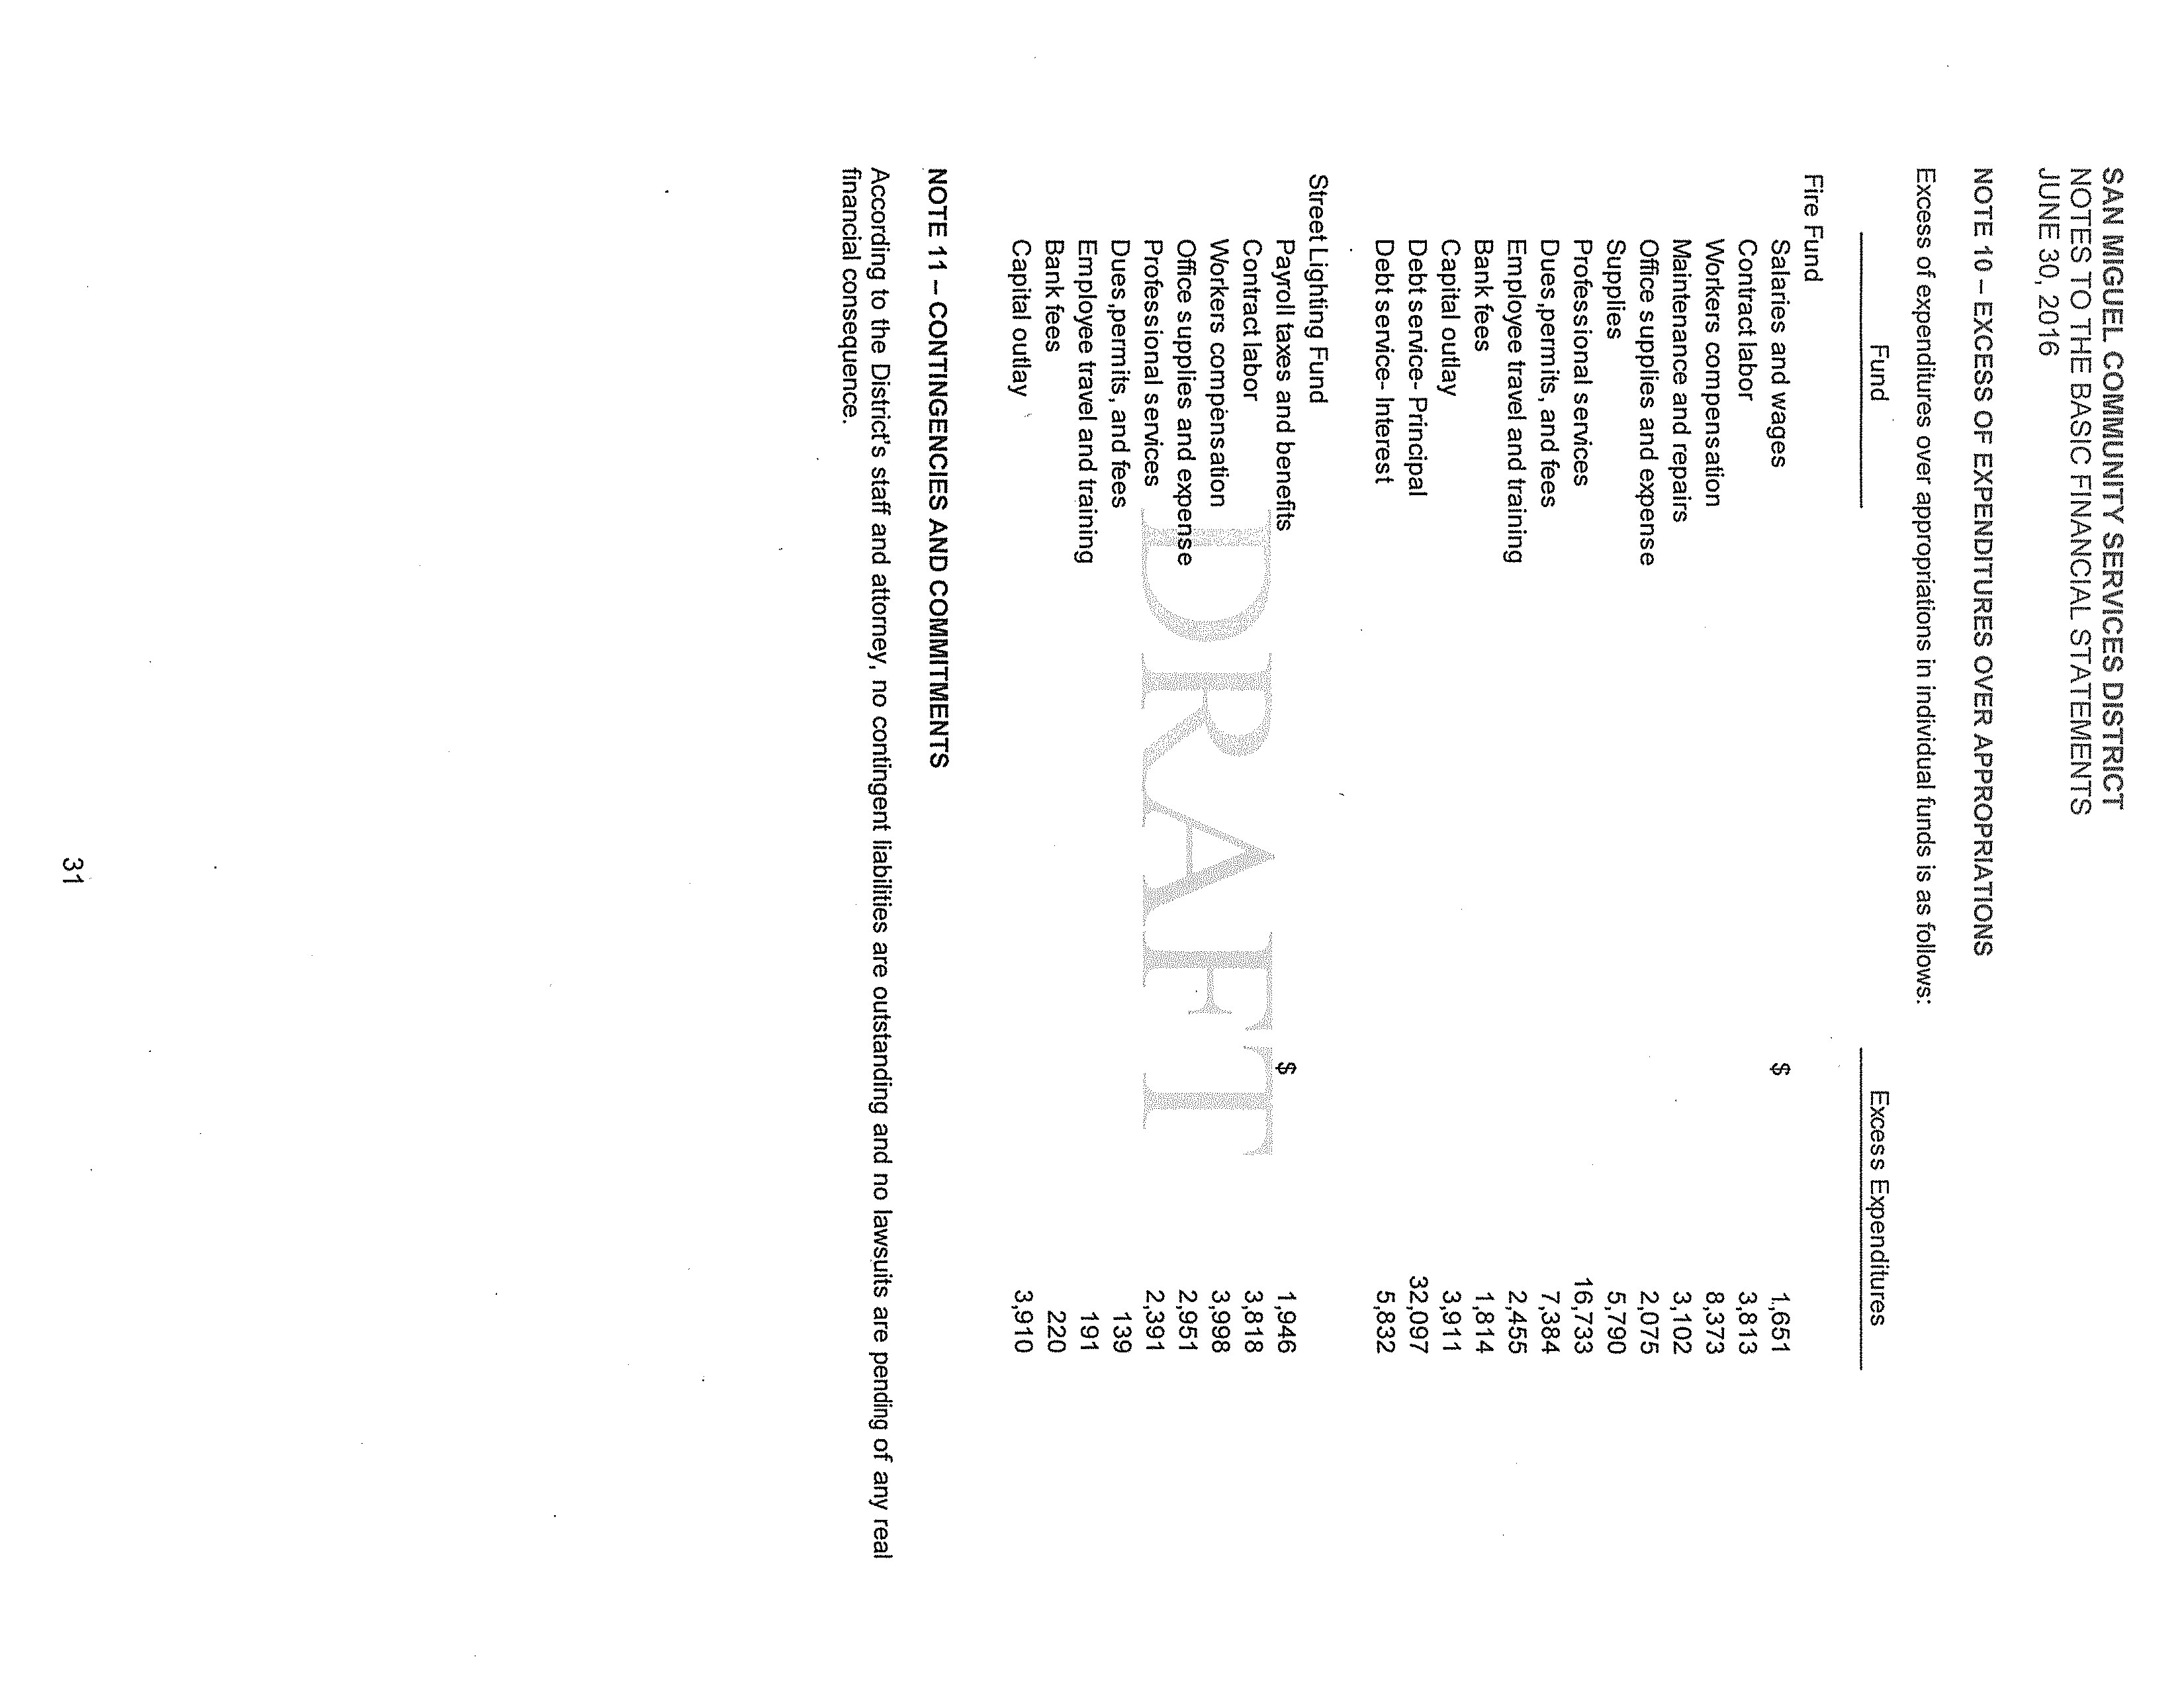
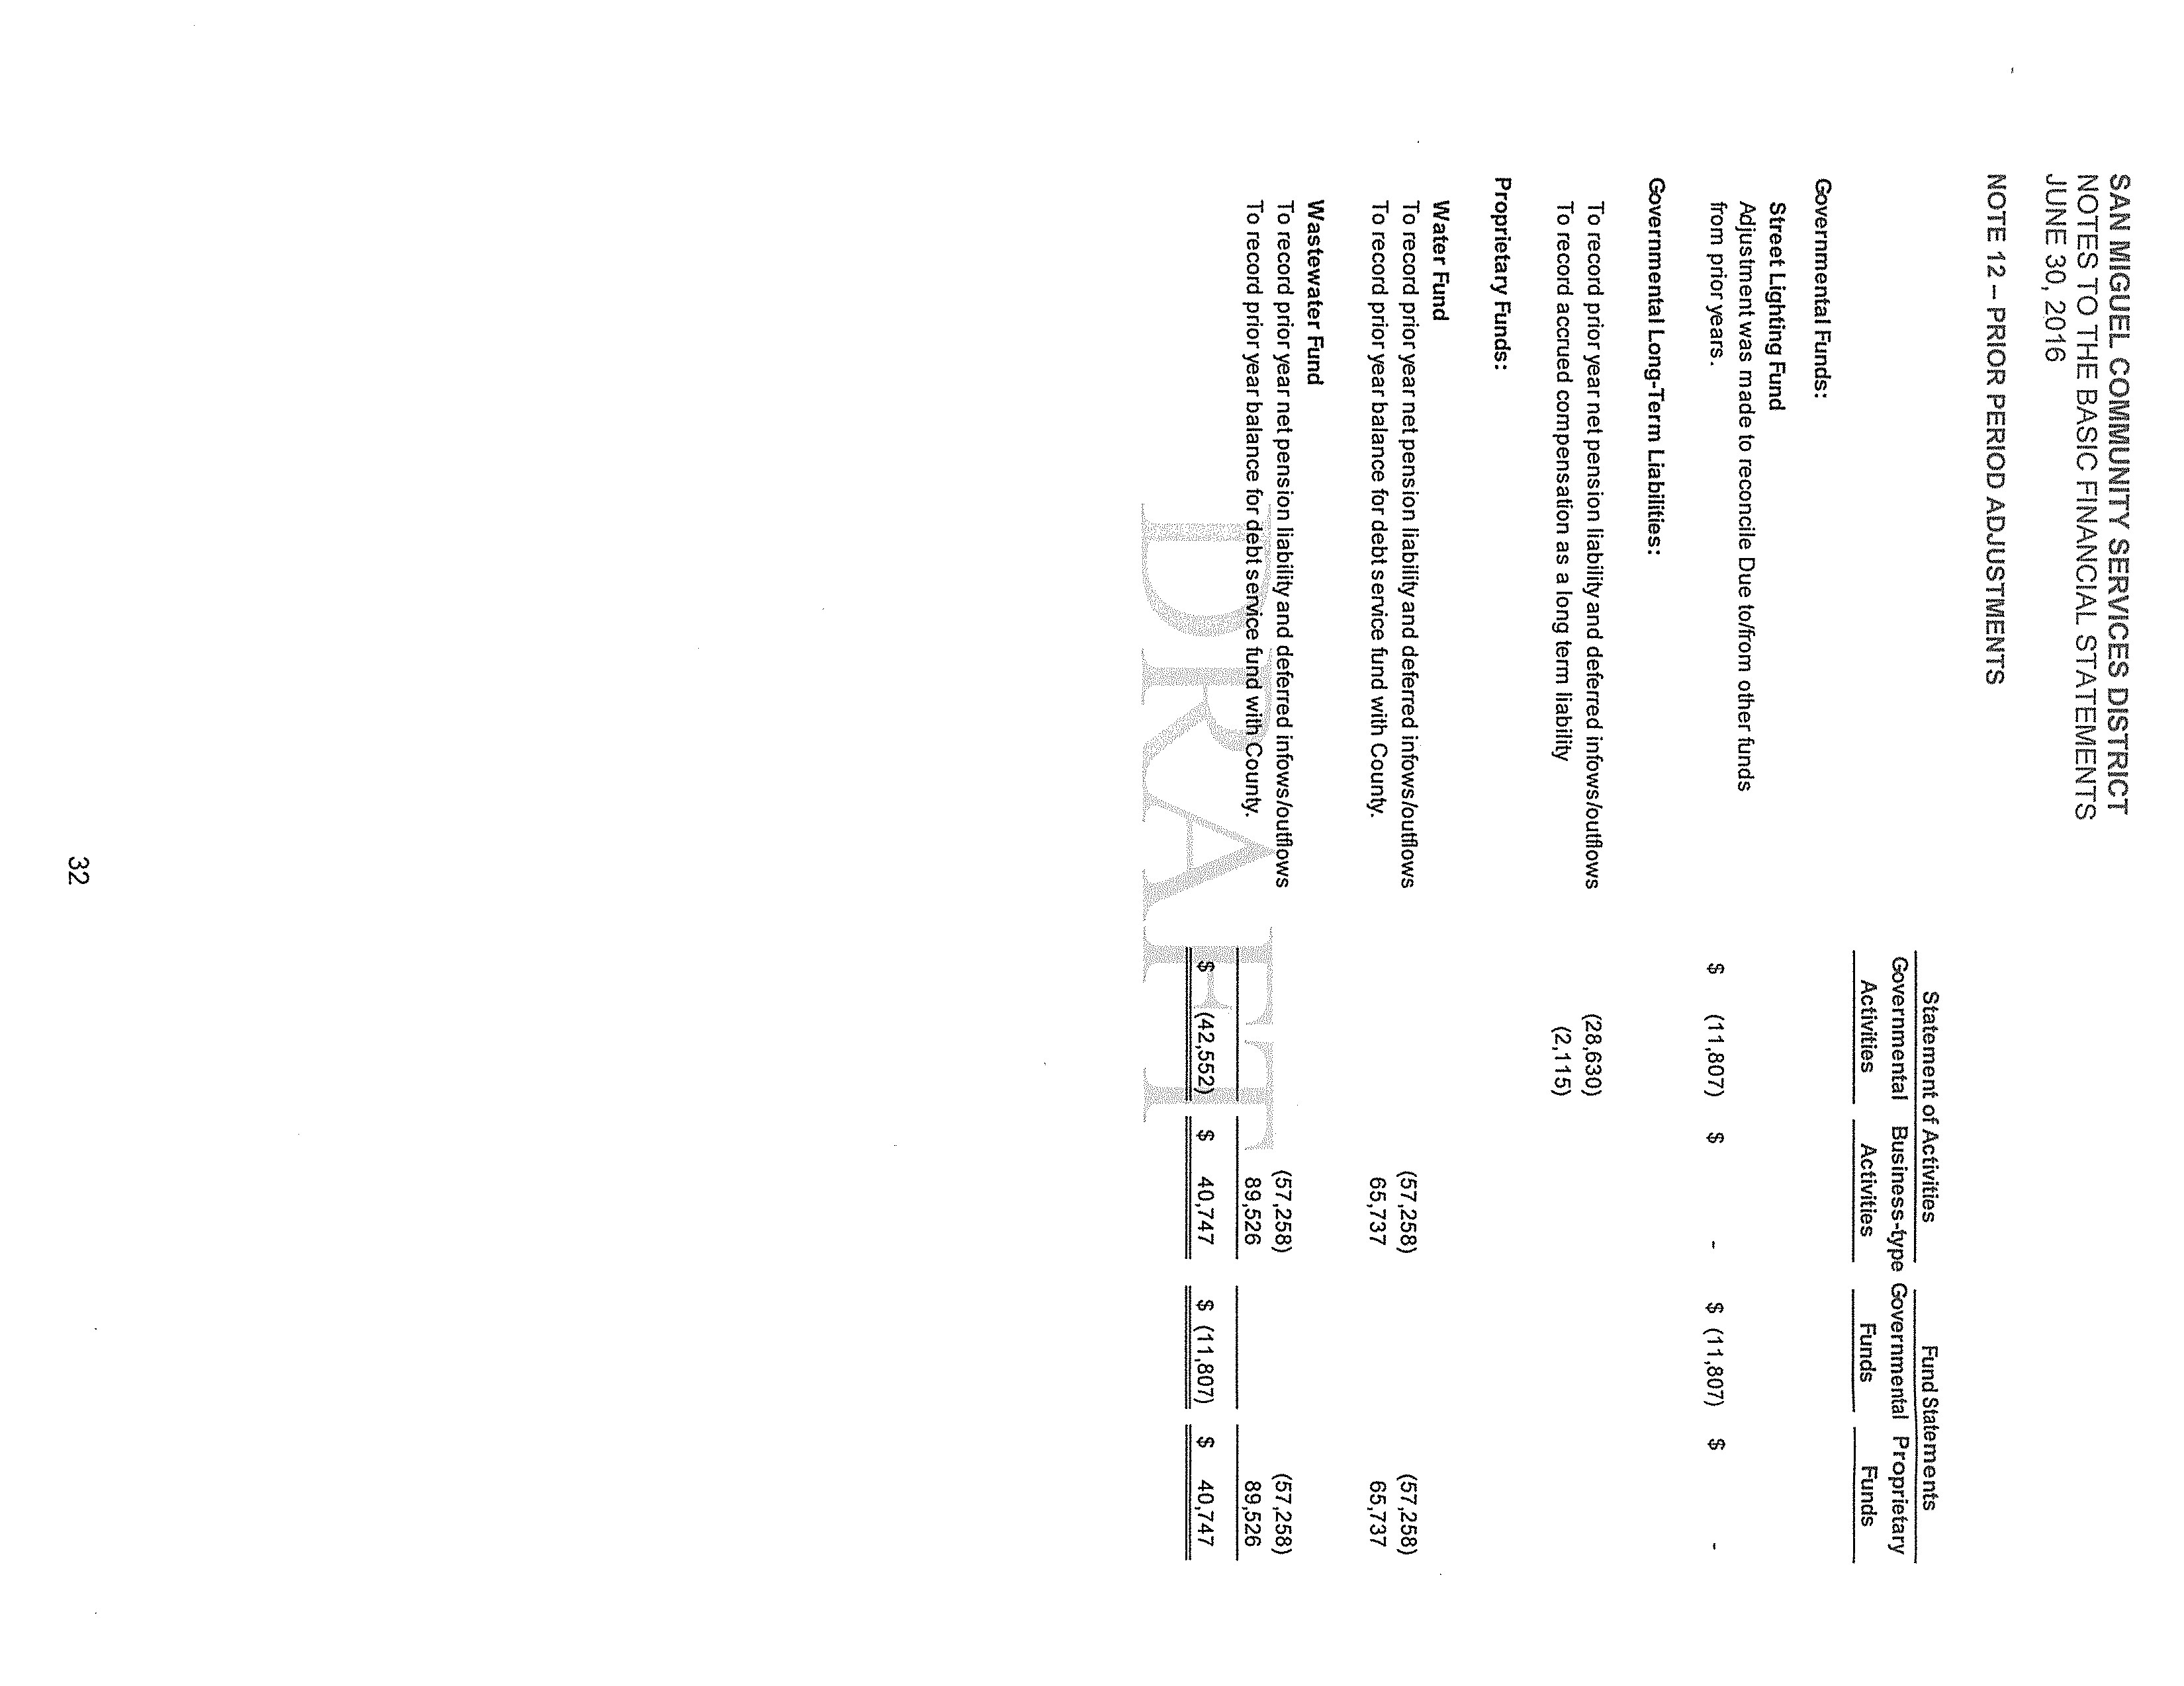
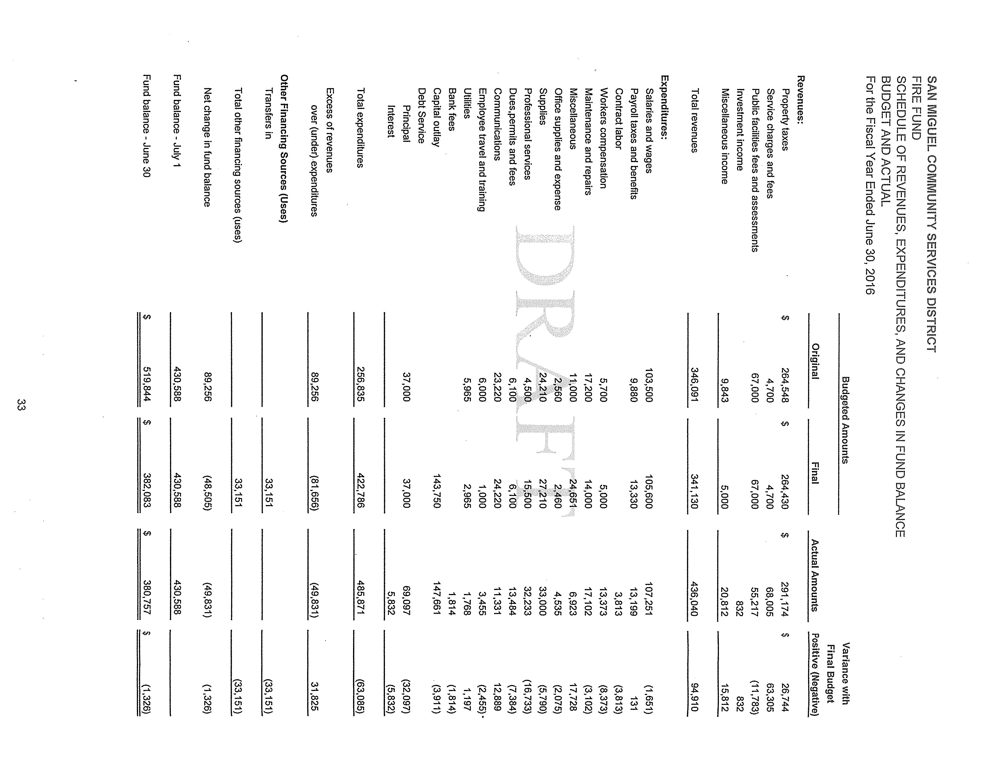
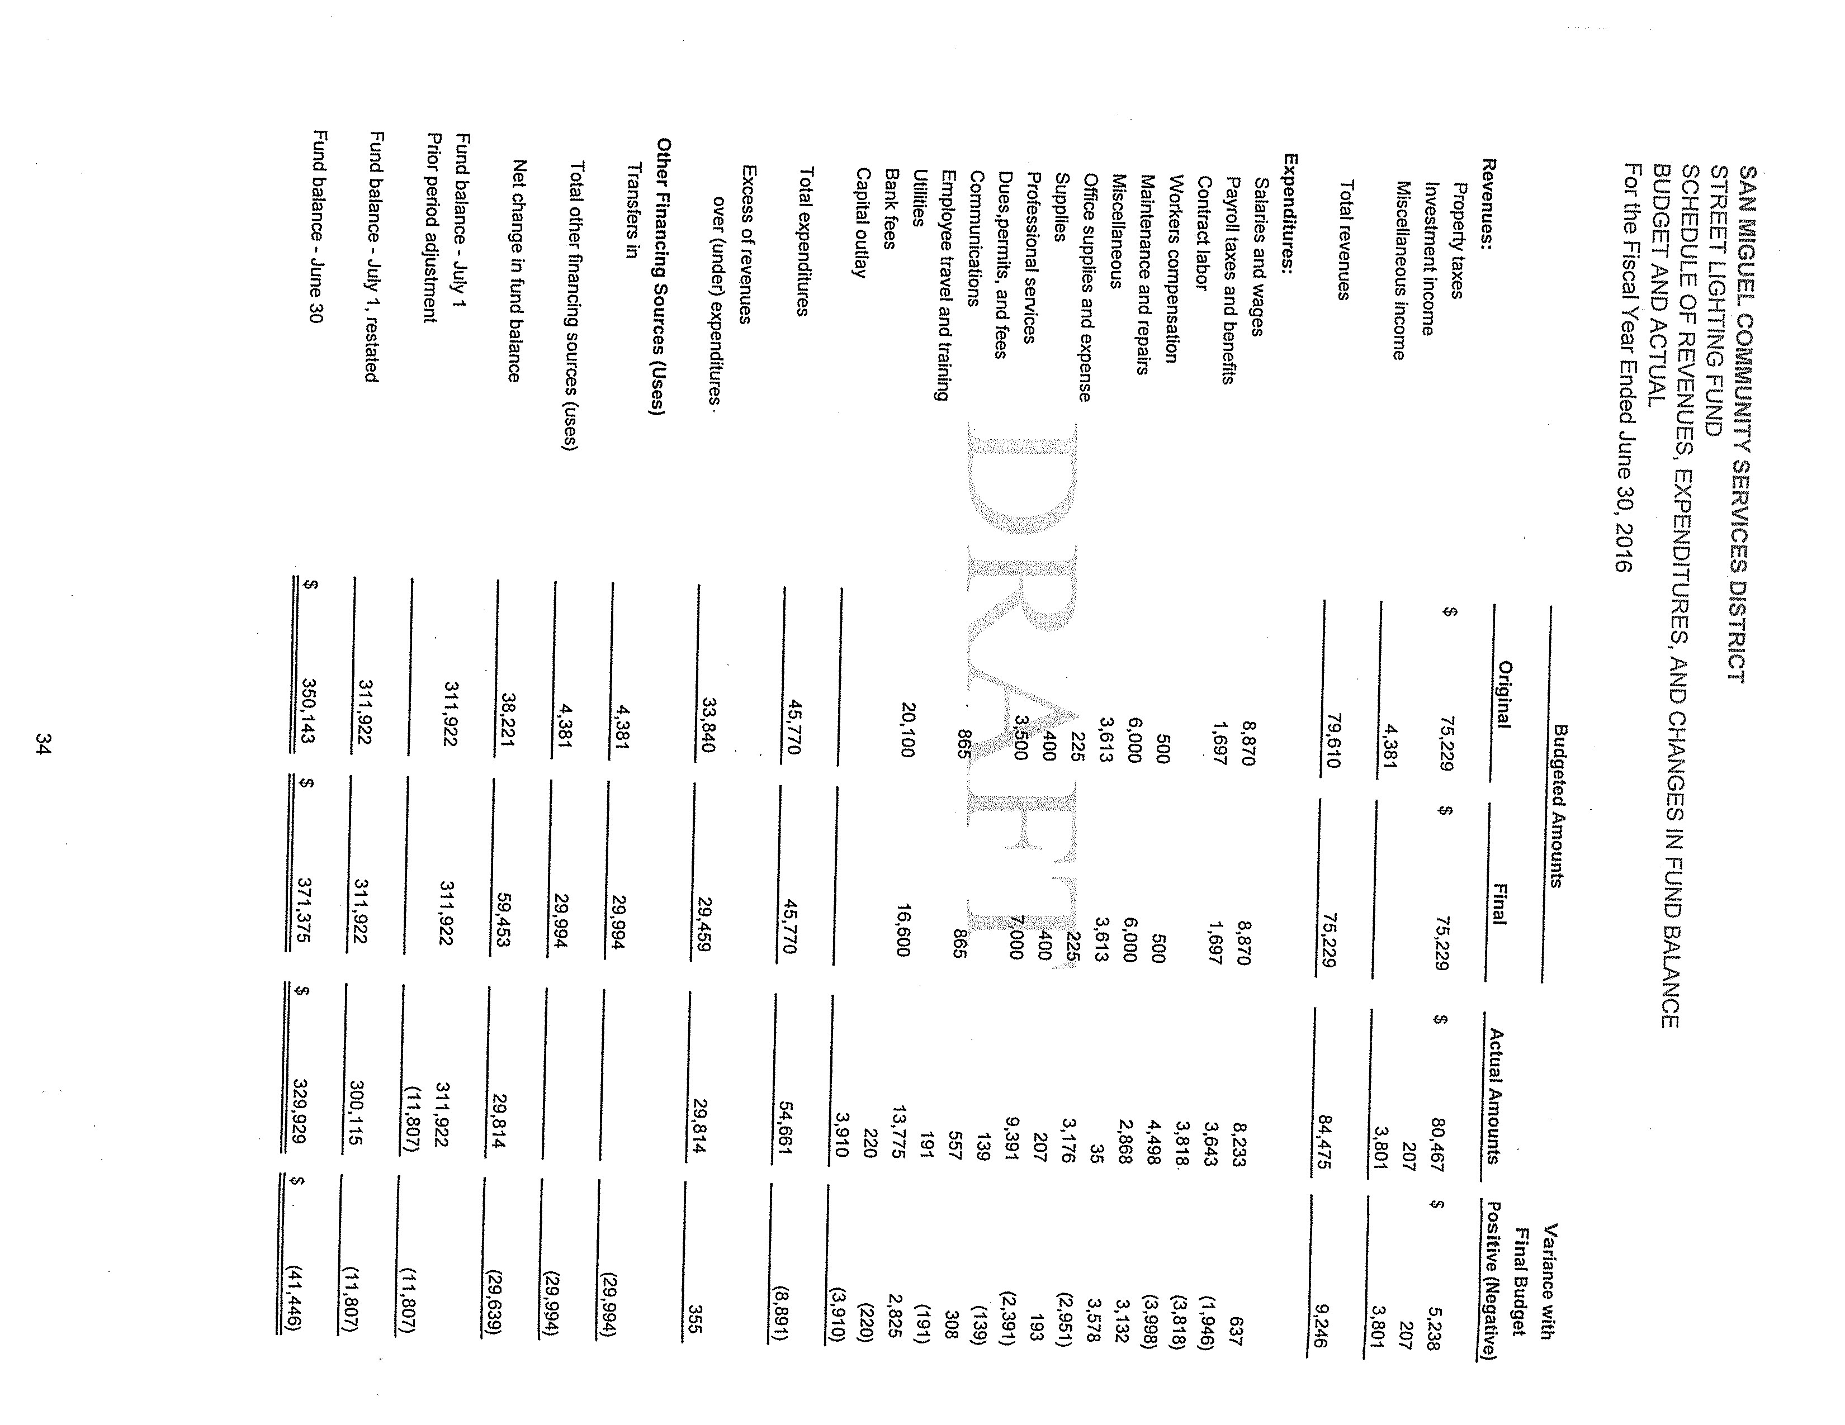
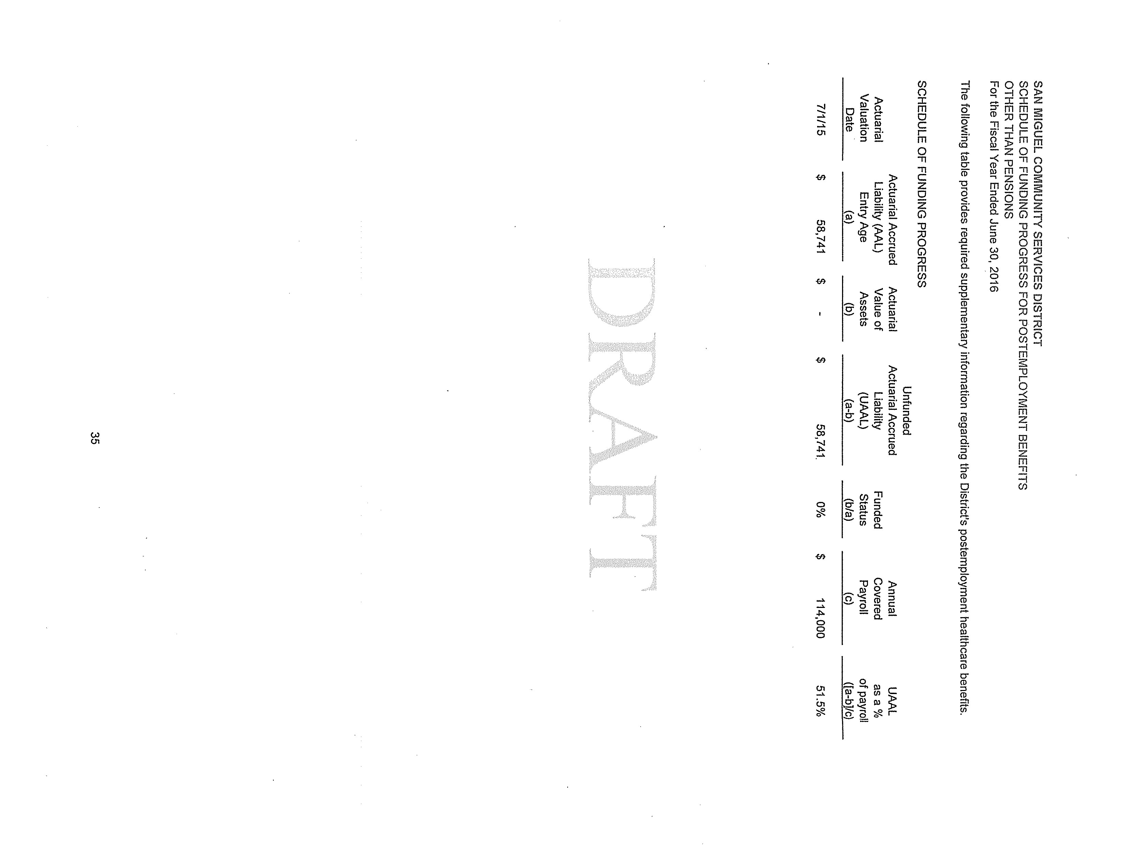
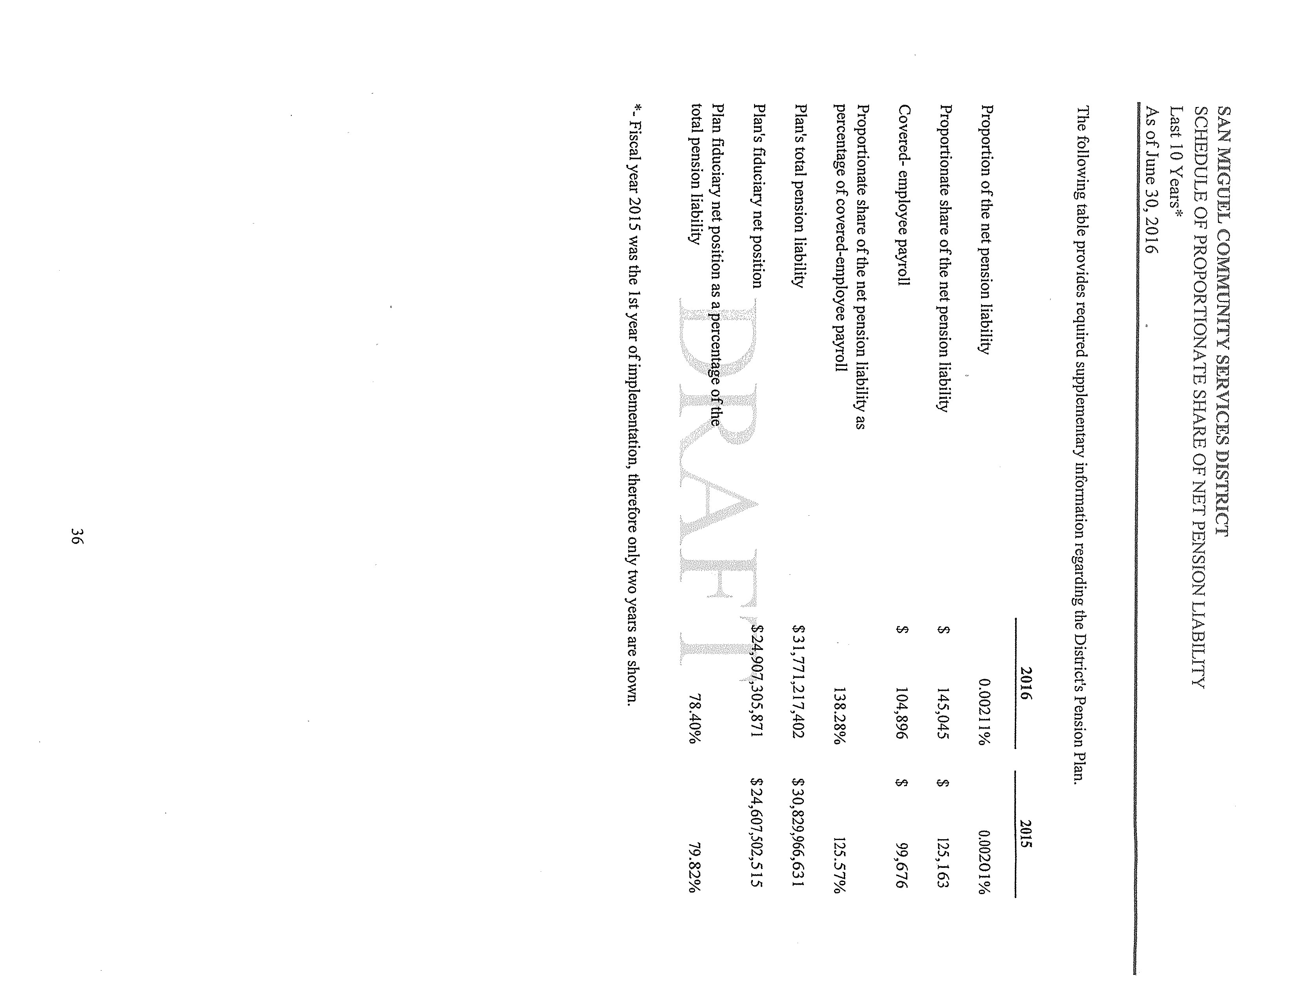
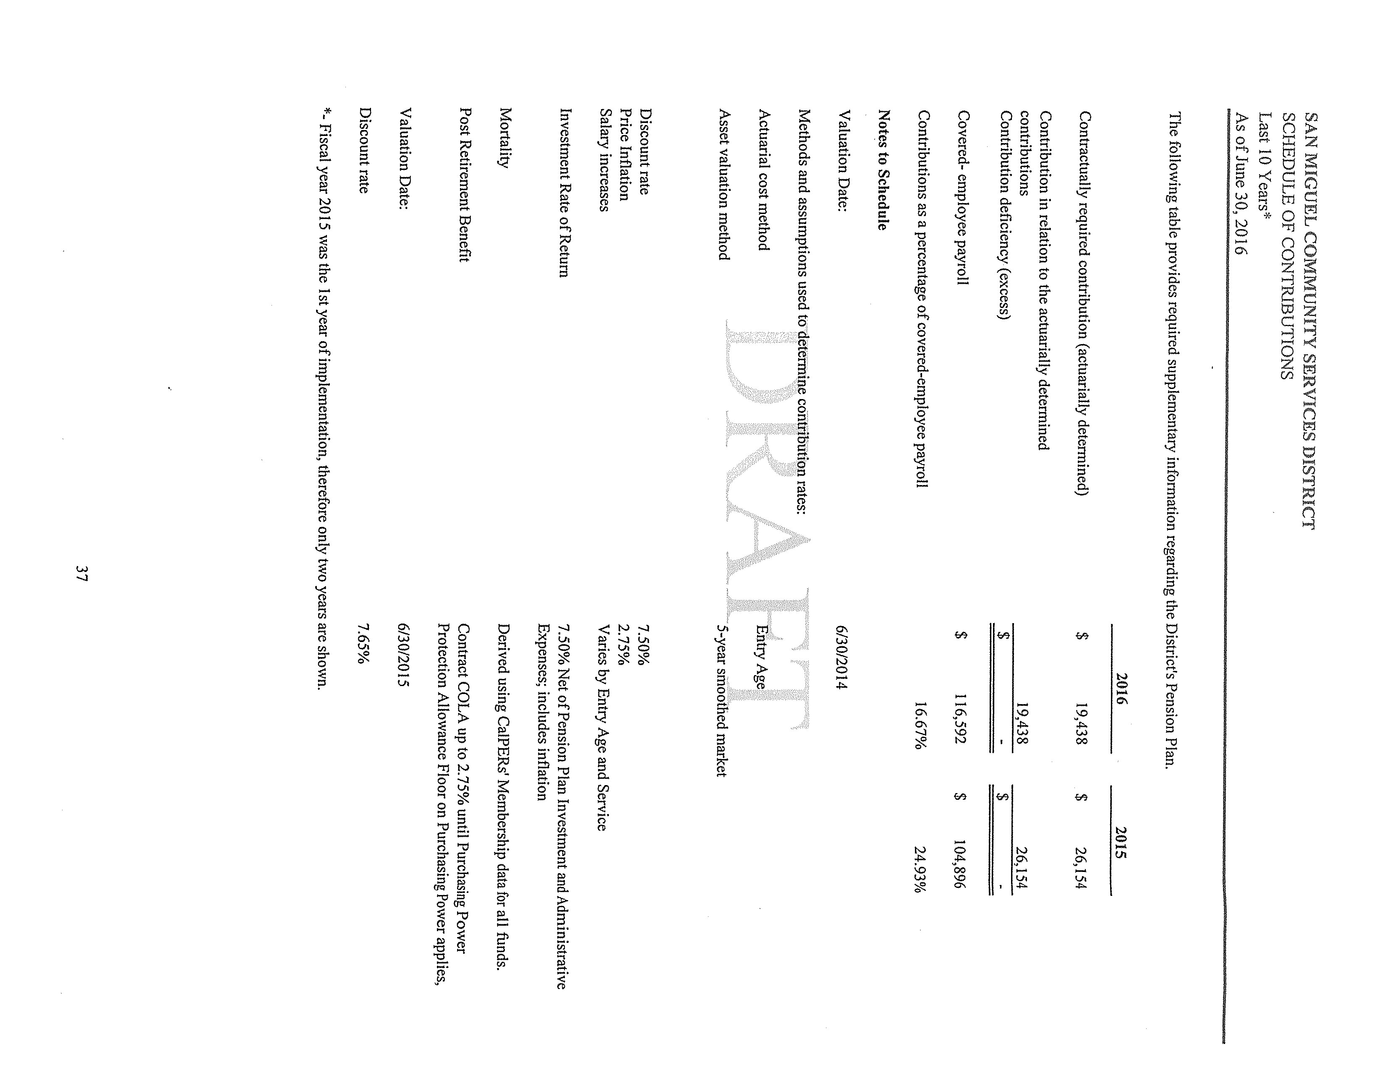

RESOLUTION NO. 2017- 55

A RESOLUTION OF THE BOARD OF DIRECTORS OF THE
SAN MIGUEL COMMUNITY SERVICES DISTRICT ACCEPTING AND APPROVING THE
INDEPENDENT AUDITOR REPORT ON DISTRICT’S FY 2015-16 FINANCIAL STATEMENTS

WHEREAS, the San Miguel Community Services District (“District”) is a community services district duly formed under California Government Code §61000 et. seq. to provide community services within the District’s service area, including water, lighting, solid waste, sewer and fire protection services; and

WHEREAS, Government Code §61110 et. seq. establishes procedures for the adoption of budgets for community services districts and financial accounting and cash accounts in accordance with generally accepted governmental accounting standards and practices; and

WHEREAS, the Board of Directors (“Directors”) of the District has reviewed and accepted the Independent Auditor’s Report on District Financial Statements.

NOW, THEREFORE, BE IT RESOLVED that the Directors hereby accepts and
approves the Independent Auditor’s Report for the FY 2015-16 Financial Statement of the District. The Directors hereby authorize the filing of the FY 2015-16 Auditor’s Report with appropriate County and State offices.

On the motion of Director , Seconded by Director and on the following roll call vote:

AYES:
NOES:
ABSENT:
ABSTAINING:

The foregoing Resolution is hereby passed and adopted this 14th day of December, 2017.

John Green, Board President
San Miguel Community Services District

ATTEST: APPROVED AS TO FORM:

______________________________ ______________________________ Robert Roberson Doug White, District General Counsel
Interim General Manager/Fire Chief
San Miguel Community Services District

Board of Directors Staff Report

December 14, 2017 AGENDA ITEM: XI. 3

SUBJECT: Authorization for Submission of an Application For Financial Assistance For The
Planning And Design Of Improvements To The Districts Wastewater Treatment Plant (WWTP)

STAFF RECOMMENDATION:

Authorize Interim General Manager to submit a Financial Assistance Application for a financing agreement from the State Water Resources Control Board for the planning and design of improvements to the Districts WWTP.

BACKGROUND:
The District currently treats an average of approximately 140,000 gallons per day. Over the past 2-3 years, there has been significant new residential development within the SMCSD boundaries. In 2016, the SMCSD commissioned an engineering study to evaluate the capacity of the WWTP to treat the wastewater discharges from the District under existing and future conditions. Based on the results of the study, the consultants determined the following:
Although the existing WWTP is achieving an overall organic constituent removal of 94%, it is recommended the SMCSD should begin to initiate future planning for plant expansion. The CA RWQCB typically requires dischargers to begin this planning process when the plant reaches 75% of capacity (150,000 gallons per day).
Based on discussions with the Department of Water Resources, it was determined that there may be grant funds available from the CA State Water Resources Control Board Clean Water State Revolving Fund Program to use for funding the planning and design of the required WWTP renovation / expansion. Because our District is classified as a Small Disadvantaged Community (DAC), the District is eligible for 100% grant funds and if we are awarded grant funding there will be no local matching funds required.
FUNDING:
No funding request is made in conjunction with this item.

Page 1 of 2 12-14-2017 BOD Meeting
FISCAL IMPACT
The renovation / expansion of the Districts WWTP was identified as a priority project in the recently updated Water / Wastewater .Masterplan. If grant funds can be secured to at least partially fund the planning and design phases of this project, it will result in a smaller financial burden to the District.
STAFF RECOMMENDATION
Board of Directors should discuss this issue and authorize the Interim General Manager to submit a Financial Assistance Application for a financing agreement from the State Water Resources Control Board for the planning and design of improvements to the Districts WWTP. .

PREPARED BY: APPROVED BY:

Blaine T. Reely
Blaine T. Reely, P.E., District Engineer Interim General Manager Attachments: Resolution 2017-57
Page 2 of 2
12-14-2017 BOD Meeting

RESOLUTION NO. 2017-57

A RESOLUTION OF THE BOARD OF DIRECTORS OF THE
SAN MIGUEL COMMUNITY SERVICES DISTRICT AUTHORIZING SUBMISSION OF APPLICATION FOR FINANCIAL ASSISTANCE FOR THE PLANNING AND DESIGN OF IMPROVEMENTS TO THE DISTRICTS WASTEWATER TREATMENT PLANT (WWTP).

WHEREAS, San Miguel Community Services District (“District”) has the responsibility
to maintain the communities wastewater treatment facility; and

WHEREAS, although the existing WWTP is achieving an overall organic constituent removal of 94%, it is recommended the District should begin to initiate future planning for plant expansion. The CA RWQCB typically requires dischargers to begin this planning process when the plant reaches 75% of capacity (150,000 gallons per day); and

WHEREAS, there may be grant funds available from the CA State Water Resources Control Board Clean Water State Revolving Fund Program to use for funding the planning and design of the required WWTP renovation / expansion; and

WHEREAS, the Board wishes to make application for grant funds in the amount of $250,000;

NOW THEREFORE, BE IT RESOLVED, the Board does, hereby direct the Interim
General Manager to sign and file, for and on behalf of the District, a Financial Assistance Application for a financing agreement from the State Water Resources Control Board for the planning, and design of improvements to the Districts Wastewater Treatment Plant (the “Project”).

This Interim General Manager is designated to provide the assurances, certifications, and commitments required for the financial assistance application, including executing a financial assistance agreement from the State Water Resources Control Board and any amendments or changes thereto.

The Interim General Manager is designated to represent the District in carrying out the District’s responsibilities under the financing agreement, including certifying disbursement requests on behalf of the District and compliance with applicable state and federal laws.

On the motion of Director _________, seconded by Director _________ and on the
following roll call vote, to wit:

AYES:
NOES:
ABSENT:
ABSTAINING:

The foregoing Resolution is hereby passed and adopted this 14th day of December, 2017.
Page 1 of 2

___________________________
John Green, Board President

ATTEST:
____________________________________
Douglas L. White, District General Counsel
Page 2 of 2

San Miguel Community Services District

Board of Directors
Staff Report

December 14th, 2017 AGENDA ITEM: XI 4

SUBJECT: Review and approve Resolution 2017-49 authorizing the Director of Utilities purchase a Trailer mounted Sewer Jetter from Jetter Northwest in an amount not to exceed $37,659.90 to be funded from the Wastewater Capital Reserve account.

RECOMMENDATION:

Review and approve Resolution 2017–49 authorizing the Director of Utilities purchase a Trailer mounted Sewer Jetter from Jetter Northwest in an amount not to exceed $37,659.90 to be funded from the Wastewater Capital Reserve account.

BACKGROUND:

UTILITIES DEPARTMENT
Currently the District does not have a sewer jetter and must contract out the cleaning and clearing of sewer lines to a private contractor. This jetter will allow District staff to perform the same services that we currently contract out ourselves and on a more frequent schedule.
Currently with contracted services we are at the mercy of the contractor’s schedule as to when they can clean our lines and or come and clear a blocked line. In the case of an emergency backup or spill situation we pay double the standard rates from the contractor, or have to request assistance from City of Paso Robles or Templeton CSD. Both of which are already backed up on their own work which often means a delayed response or inability to assist at all.
A prime example of this is recently we had a blockage on Prado leading to a backup in the sewer line. We were able to create a hole in the blockage to allow it to drain slowly but we were not able to get the contractor to come out for almost two weeks afterward to fully clean the line. Had this been a blockage in a different area, it may have resulted in a spill. Not to mention a large bill from the city or contractor and then the District personnel’s time on cleaning up the site.
Purchasing our own jetter will not only allow the District to clean our own lines on our schedule but will allow for immediate response, at any time, when a blockage is identified or a sewer spill is imminent.
In November, we had Fluid Resource Management clean 5 line segments. This took them 5 hours not including their drive time from Grover Beach, which we get charged for. Based on their fee schedule this cleaning to clear these 5 lines is estimated at $2,675. Before the end of the fiscal year we will still need to clean the remainder of the system. This will be another $12,000- $14,000.
Over the last three years we have paid a contractor $27,880 (average 9,293 per year) Last year cleaning cost reached $11,297, and due to the increased rates from the contractor and the additional sewer lines installed, the annual cost will likely escalate to over $14,000 per year over the next 23 years.
In the past two years the contractor has taken four to five days to complete the entire town. It would take our staff less time to complete the same work since we are not factoring for travel to and from the district. Although we would spread the cleaning out over an entire year it would likely take our personnel three to four full days to clean the entire system.
Quotes were solicited from 4 companies, only 3 responded
Jetters Northwest - $36,672.40 Written Quote
Sewer Equipment of America - $92,584 Written Quote
USA Jetting - $45,000 Verbal only
FISCAL IMPACT
Wastewater Capital Reserve $37,659.90 for the purchase of the jetter and necessary equipment.
Net annual savings of $8,897 from not contracting out cleaning services to a private company and factoring in our personnel costs. (based on last years contacted costs)
Potential payback of the proposed Jetter through savings is 4.23 years (based on last year’s cleaning cost)
If this Jetter Trailer purchase is approved now we can avoid contracting out cleaning services this year.
Current Wastewater Capital Reserve amount is $463,019
RECOMMENDATION
It is recommended that the Board approve Resolution 2017–49 authorizing the Director of Utilities purchase a Trailer mounted Sewer Jetter from Jetter Northwest in an amount not to exceed $37,659.90 to be funded from the Wastewater Capital Reserve account.

PREPARED BY:

Kelly Dodds
Kelly Dodds, Director of Utilities
Attachment: Resolution 2017-49, Quotes from Jetters Northwest, Sewer Equipment of America, Municipal Maintenance Equipment

RESOLUTION NO. 2017-49
A RESOLUTION OF THE BOARD OF DIRECTORS OF THE
SAN MIGUEL COMMUNITY SERVICES DISTRICT AUTHORIZING THE DIRECTOR OF UTILITIES TO PURCHASE ONE TRAILER MOUNTED SEWER JETTER.

WHEREAS, San Miguel Community Services District (“District”) Board of Directors
established a Capital Projects list which identified the purchase of a sewer jetter as a priority for the 2018-19 fiscal year: and.

WHEREAS, the Board of Directors recognizes the need to purchase a sewer jetter in order to
more efficiently maintain the sewer collection system under the Districts management; and

WHEREAS, the Board of Directors recognizes the need to have the appropriate equipment on hand to mitigate incidents within the collection system, to prevent spills and other health hazards; and

WHEREAS, the District Board of Directors authorizes the Director of Utilities to purchase a Trailer Mounted Sewer Jetter from Jetters Northwest in an amount not to exceed $37,659.90 from Wastewater Capital Reserve.

NOW THEREFORE, BE IT RESOLVED, the Board does, hereby, adopt this Resolution
for purposes specified herein.

On the motion of Director , seconded by Director and on the following
roll call vote, to wit:

AYES:
NOES:
ABSENT:
ABSTAINING:

the foregoing Resolution is hereby passed and adopted this 14th day of December, 2017.

_____________________ ___________________________
Rob Roberson, Interim General Manager John Green, Board President

ATTEST:
____________________________________
Douglas L. White, District General Counsel
Page 1 of 1
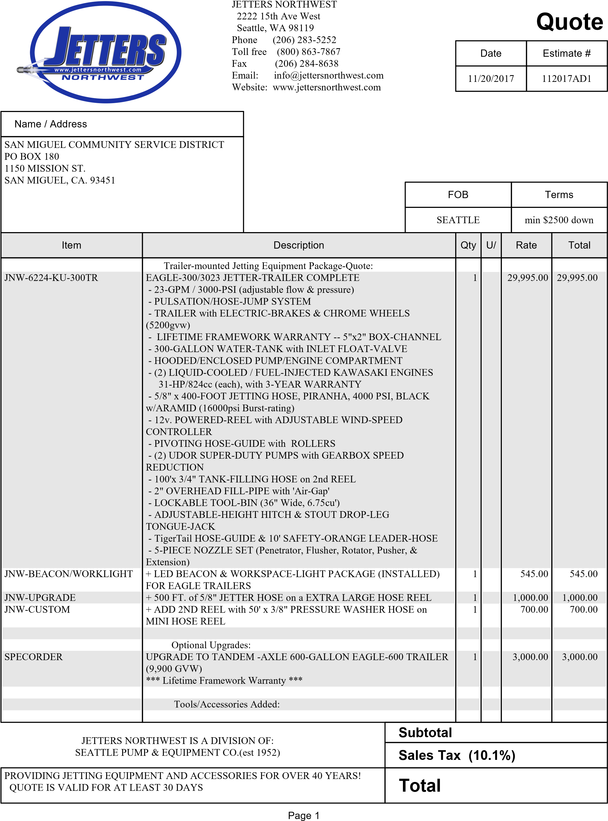
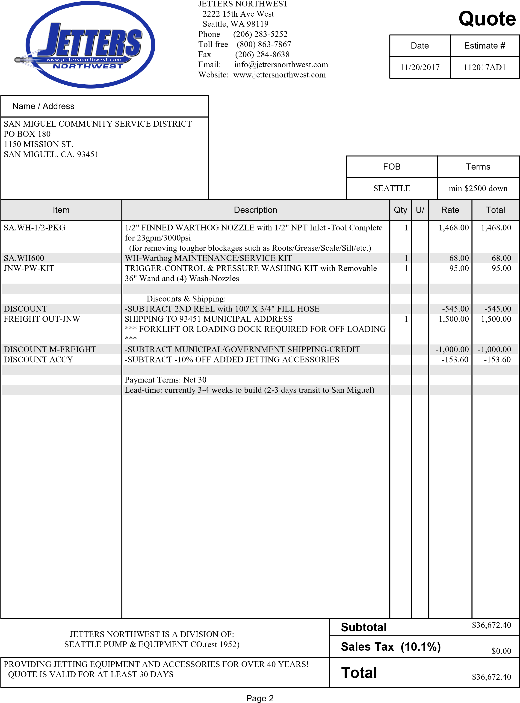

FAX (209) 830-8884

December 1, 2017

San Miguel Community Service District
1150 Mission Street
San Miguel, CA 93451

Attention: Kelly Dodds

Reference: Sewer Equipment 747-FR2000 ECO

Dear Mr. Dodds,

We are pleased to quote you One (1) New Sewer Equipment 747-FR2000 ECO Jetting Unit equipped as follows:

Engine & Pump

3.7L Ford Engine
Giant 40 GPM @ 2,000 PSI w/ 30 Min Run Dry Capability
Lighted NEMA 4 control panel
Auto Shutdown (For High Engine Temp/ Low Oil Pressure)
Air Purge Valve
Recirculation System
Tachometer/Hour meter
Painted Steel Shroud Enclosure w/ Locking Access Doors

Hose Reel & Hose

Rotating Safety Reel w/ 800’ Capacity of 3/4" Hose
Automatic Level Wind With Hydraulic Up/Down Action
Footage Meter (Mounted On Jet Hose Reel)
800’ Sewer Hose (3/4” I.D. x 3,000 PSI Operating Pressure)
Lateral Line Cleaning Kit (150’ x 1/2" Hose w/ Nozzle Mounted ON A Rolling Cart With Tongue Storage Pad, Includes Additions of 1,200 PSI Auxiliary Cleaning Circuit On Jet Unit)
Patriot II Root Cutter Kit (Ring & ADJ. Roller Skids, 4” to 15” Saws)

Trailer

Tandem Axles 14,000 GVWR
Electric Brakes w/ 2-5/16” Ball Hitch
(1) Steel Toolbox – Fender Mounted
D.O.T. Approved LED lighting

Tank & Fill

700 Gallon Black Super-Poly Water Tank
2.5” Fill System
Fill Hose Storage Rack

FAX (209) 830-8884

Accessories

10’ Leader Hose
BB Hose Guide
Tri-Star (Chisel Point) Nozzle
DD (High Flow) Nozzle
Finned Nozzle Extension
Nozzle rack
25’ Fill Hose
Wash down Gun w/25’ Ext. Hose
Upstream Pulley Guide
Paper Operator / Owner Manual

Options NOT included in price:

Engine/Pump Options:

UPGRADE TO CATERPILLAR 91HP DIESEL ENGINE $3,560.00
WASHDOWN SYSTEM W/50' RETRACTABLE HOSE REEL $1,236.00
HYDRAULIC TOOL CIRCUIT (RATED @ 9.5 GPM, SYSTEM ENGAGED $1,887.00
VIA MANUAL DIVERTER VALVE AND SUPPLIED W/ PARKER 60 SERIES CONNECTORS

Hose Reel/Hose Options:

DIGITAL 'SMART COUNTER' FOOTAGE METER $2,756.00
MINI MISSILE NOZZLE $412.00

Tank & Fill Options:

UPGRADE TO 700 GALLON DURAPROLENE™ (BLACK) WATER $4,839.00 TANK W/10 YEAR WARRANTY

Lighting Options:

LED ROTATING BEACON $505.00
ENGINE/WATER PUMP COMPARTMENT LIGHT $196.00
LED FLOOD LIGHT $419.00
LED ARROW STICK $992.00
LED ARROW BOARD $1,180.00
HAND-HELD WIRELESS 12v/110v RECHARGEABLE LED $312.00
SPOTLIGHT W/STORAGE BRACKET

FAX (209) 830-8884

Pendant Options:

BASIC PENDANT CONTROL WITH 35' CORD $2,267.00
(WITH HOSE REEL F-N-R CONTROL AND KILL SWITCH) INCLUDES MANIFOLD HYDRAULICS STANDARD PENDANT CONTROL WITH 35' CORD $3,055.00
(WITH HOSE REEL F-N-R CONTROL, THROTTLE UP/DOWN, WATER ON/OFF AND KILL SWITCH)
INCLUDES MANIFOLD HYDRAULICS
MASTER PENDANT CONTROL WITH 35' CORD $3,720.00
(WITH HOSE REEL F-N-R CONTROL, VARIABLE SPEED CONTROL, THROTTLE UP/DOWN, WATER ON/OFF, AND KILL SWITCH) INCLUDES MANIFOLD HYDRAULICS
WIRELESS REMOTE PENDANT CONTROL $6,724.00
(WITH HOSE REEL F-N-R CONTROL, THROTTLE UP/DOWN, WATER ON/OFF, AND KILL SWITCH) INCLUDES MANIFOLD HYDRAULICS

Trailer Options:

HOSE GUIDE/WASH-DOWN GUN/UPSTREAM PULLEY GUIDE $854.00 STORAGE TRAY
SPECIAL PAINT: SOLID COLORS $638.00
SIX (6) 18" D.O.T. SAFETY CONES AND HOLDER $349.00
ROOT CUTTER MAINTENANCE BOX $2,248.00
LONG HANDLED TOOL STORAGE TUBE $183.00
SPARE TIRE AND RIM $448.00
SPARE TIRE MOUNTING BRACKET $391.00
HYDRAULIC BRAKES $1,271.00
POWER JACK $745.00

Price: $86,325.45
Sales Tax 7.25%: $6,258.60
Price w/ Tax: $92,584.05

Special Notes:

- One year parts and labor warranty
- If any of the options listed above are desired, please add to price before tax is applied.
- Training included
- Prices quoted are firm for 30 days
- Freight to San Miguel, CA included in price

Thank you for the opportunity to quote on your equipment needs. If you have any questions, please feel free to contact me.

Sincerely,
NIXON-EGLI EQUIPMENT CO.

Greg Schmidt

Greg Schmidt
Area Manager

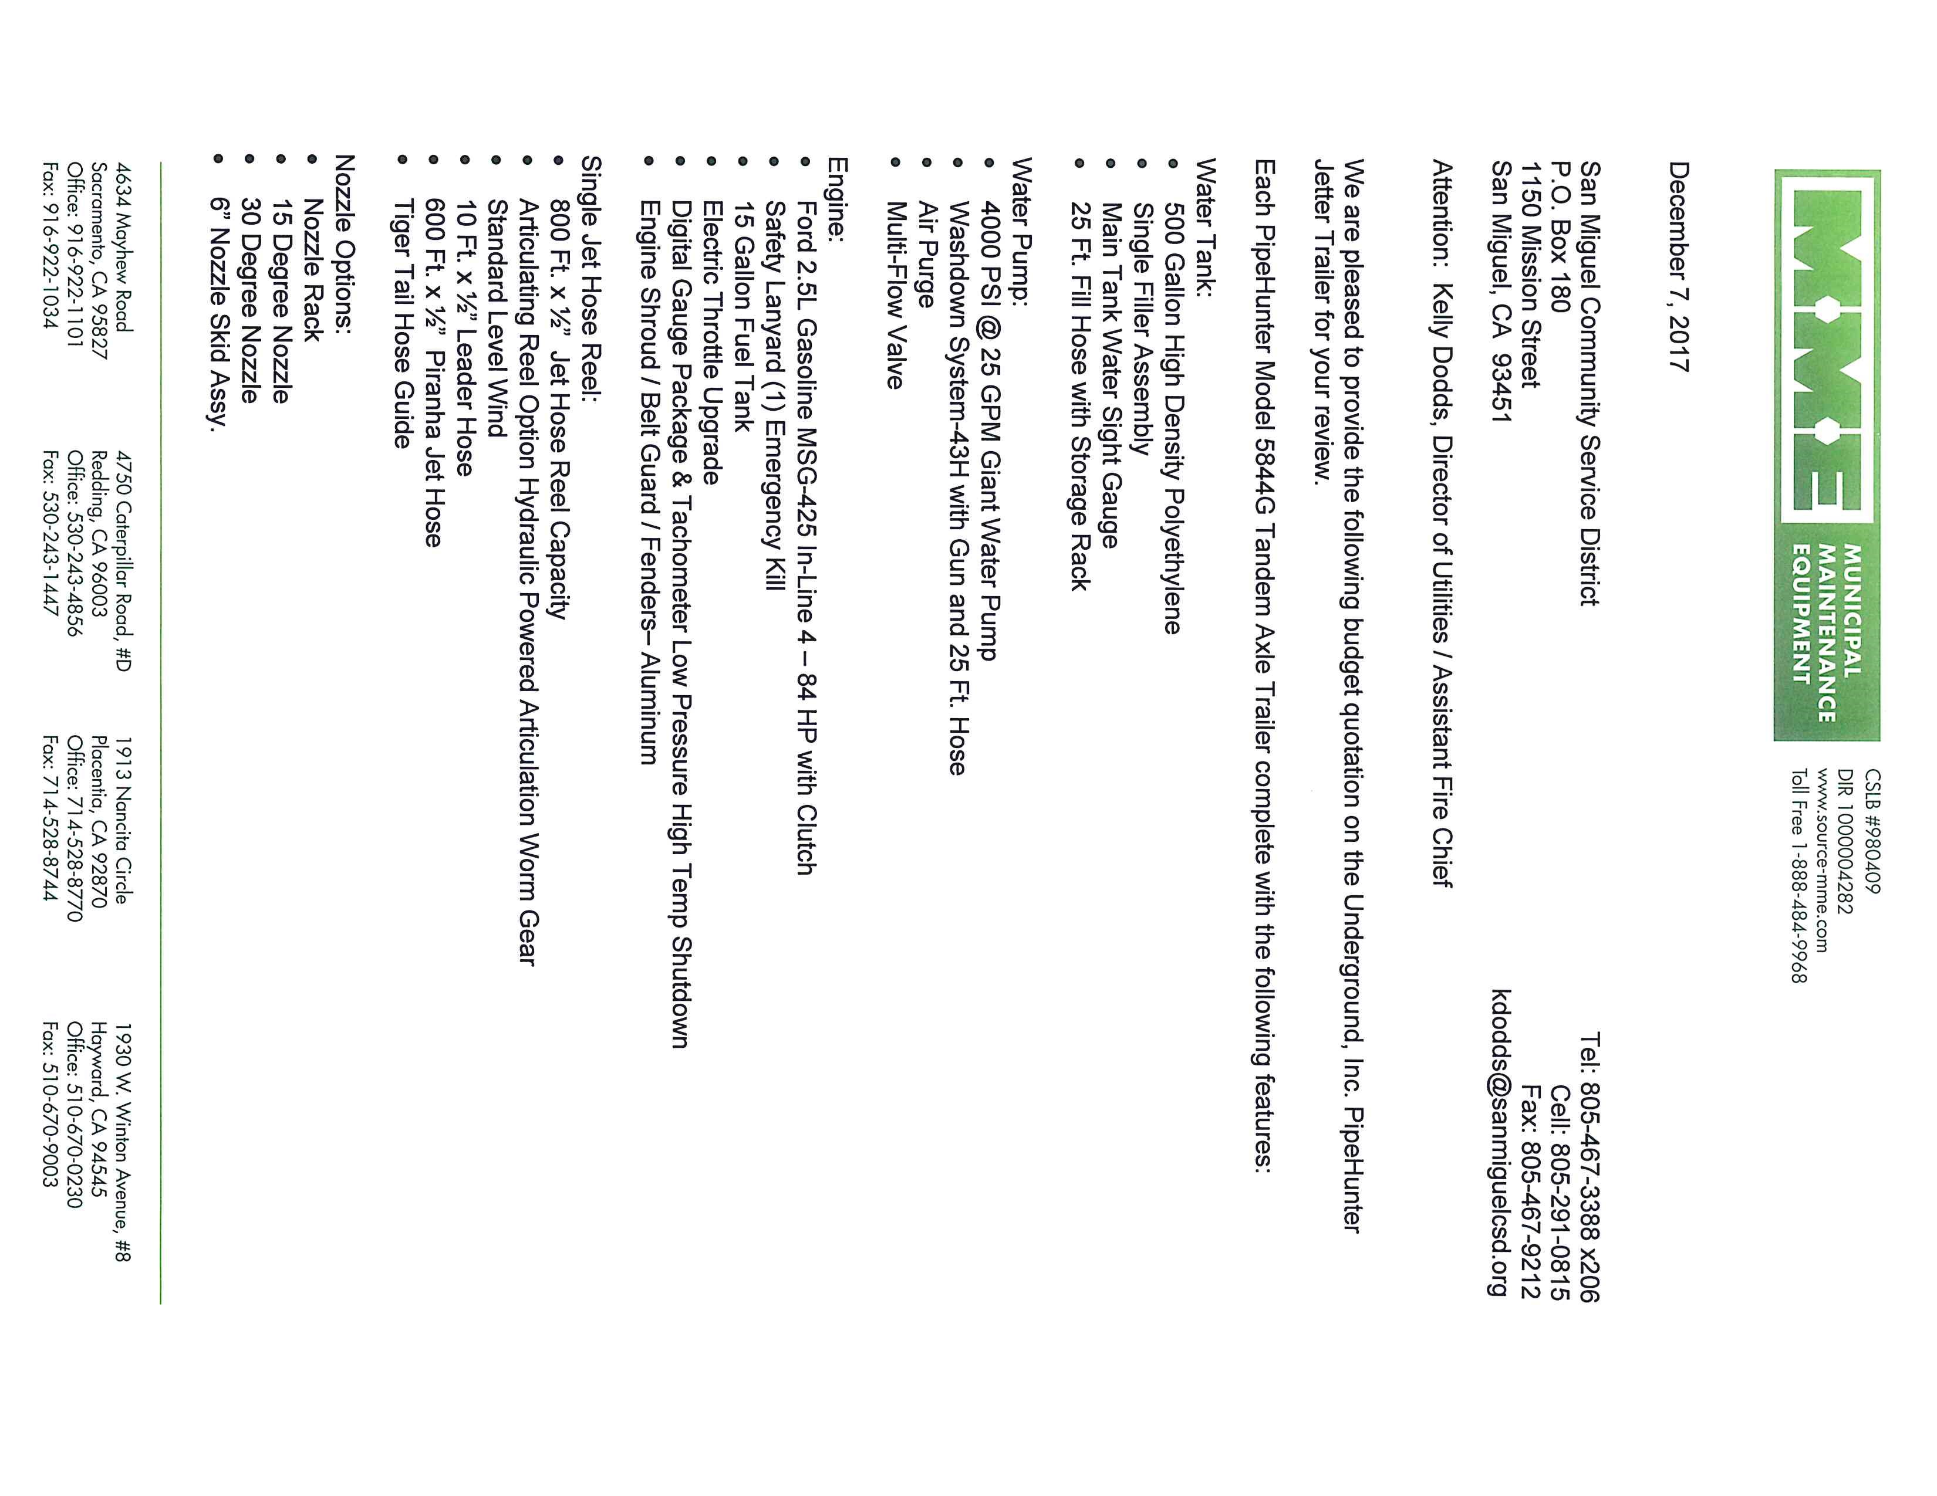
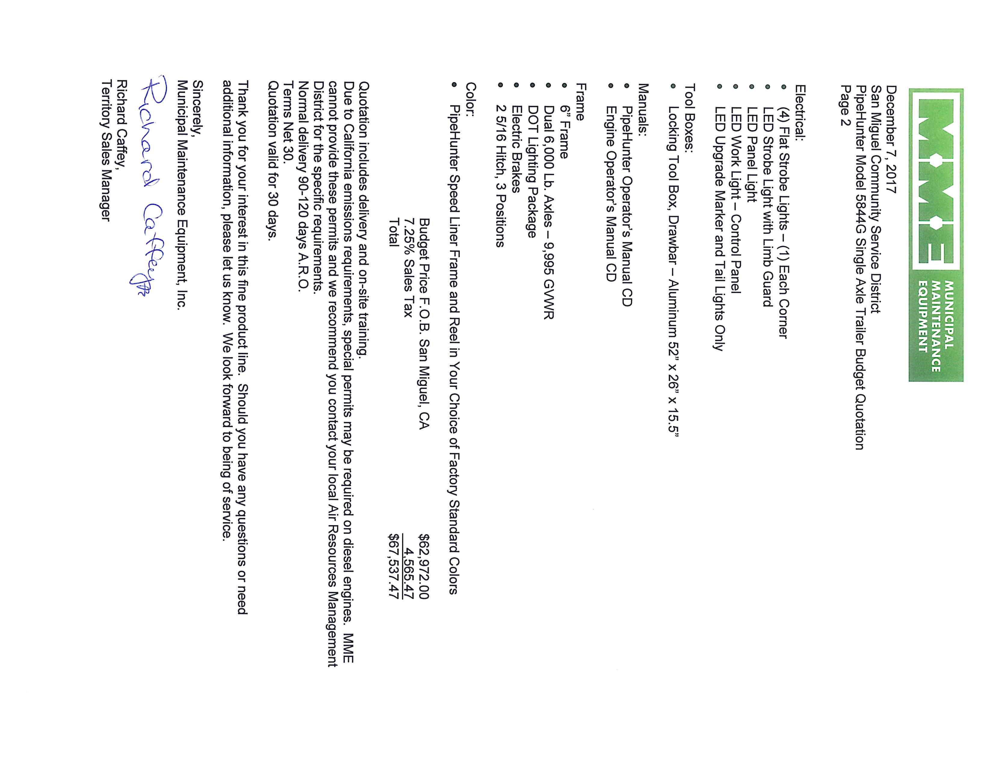
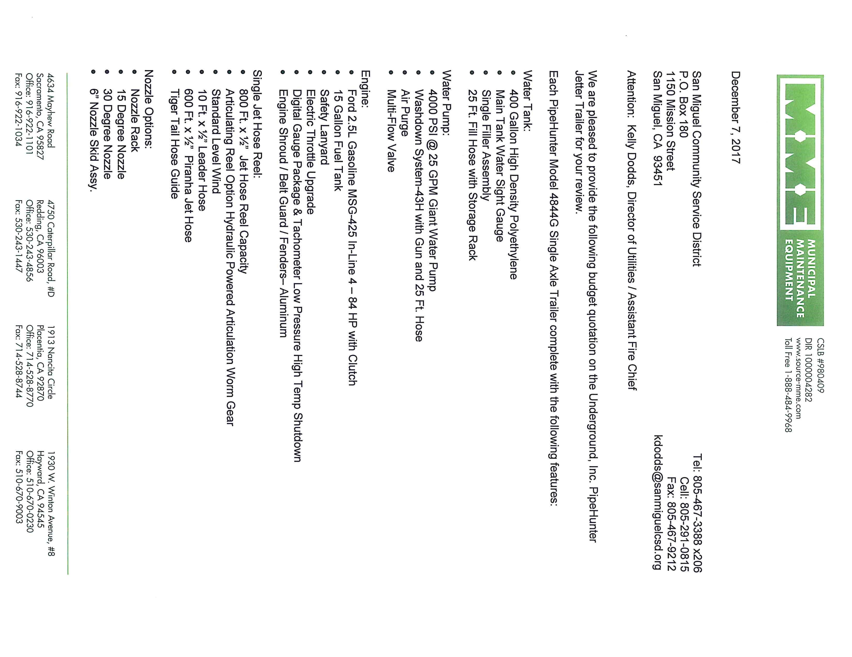
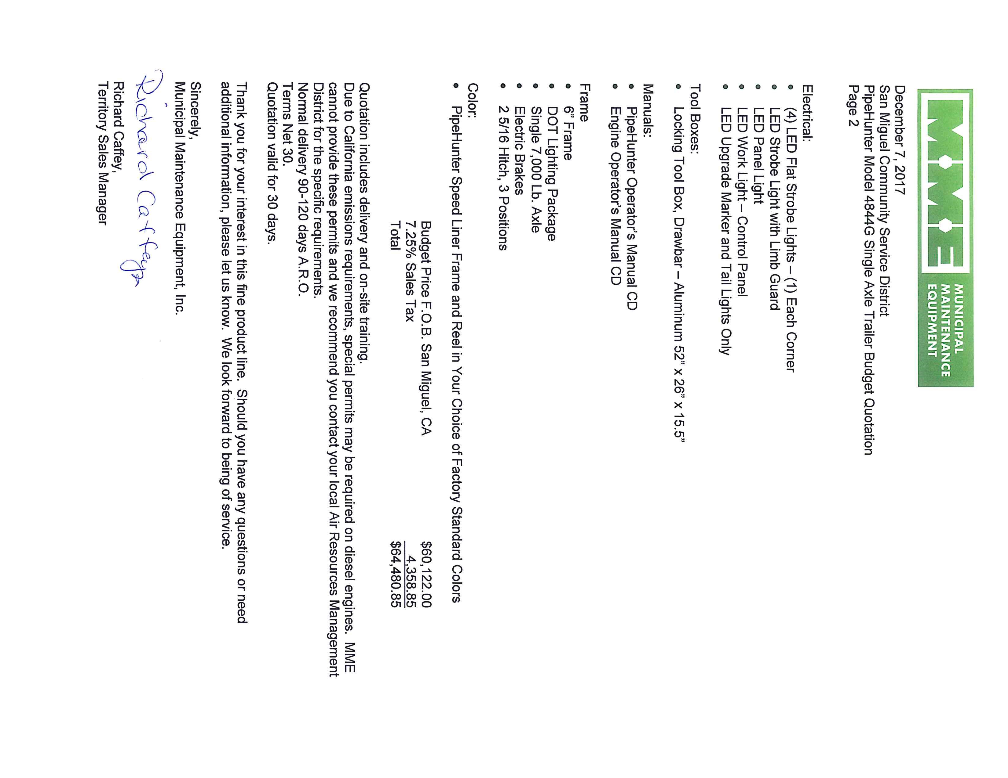

San Miguel Community Services District

Board of Directors
Staff Report

December 14th, 2017 AGENDA ITEM: XI -5

SUBJECT: Review and Approve Resolution No. 2017-56 authorizing the Director of Utilities to contract with Aqua Engineering to pull and evaluate the pump equipment at well 3 in an amount not to exceed $7,700. And Authorize up to $9,000 to make minor repairs to the well equipment if necessary.

RECOMMENDATION: Approve Resolution No. 2017-56 authorizing the Director of Utilities to contract with Aqua Engineering to pull and evaluate the pump equipment at well 3 in an amount not to exceed $7,700. And Authorize up to $9,000 to make minor repairs to the well equipment if necessary.

BACKGROUND:
Well 3 is one of three production wells operated by the District. It is one of two that are used on a daily basis to meet the daily water demand of the District.
This well was originally developed in the late 40’s or early 50’s and it has been in continuous service since its development.
This well has a line and shaft pump. This means that there is a column pipe that carries the water to the surface from the pump that is at the bottom of the well. Inside this column pipe there is a drive shaft that runs from the pump to a motor on the surface.
In 2009, the casing on this well was failing, and a new (smaller) casing was inserted into the existing casing to help slow the rate of sand infiltration and extend the life of the well. At the same time, a new pump assembly was installed on the existing column pipe. But, no work was done on the drive shaft or motor.
When the well was reassembled and put back in service it had a very small vibration, which is common, due to the variance on the bearings on the drive shaft.
Over time the vibration has gotten worse and is to a point where it needs to be addressed.
Because this well produces fine sand, over time the sand wears away at the pump, drive shaft bearings, and everything else that it contacts. This causes parts to wear out and creates vibrations in the drive shaft. If left unaddressed the vibration will get worse and further wear out the pump,
Page 1 of 2 12-14-2017 BOD Meeting
drive shaft, bearings, and motor. As the vibration worsens it also transmits through the above ground pipe and begins to shake the pipe apart.
WHAT WE NEED TO DO:
At this point we need pull the well pump out and thoroughly inspect all the components to make a determination on what needs to be replaced, repaired, etc.
Best Case scenario is that the pump is fine. And the only repairs needed are to the drive shaft bearings. We can replace the bearings and reassemble the well.
Worst case scenario is that the pump, bearings, and column all need to be replaced or repaired. In this case we would need to evaluate whether this type of pump will be the best in the long term or if switching to a submersible pump and motor would serve best.
In either case we will be evaluating the well pump equipment as well as options to reduce pumping sand as we move through the process to make sure that whichever way we go the result is a long lasting reliable well.
FISCAL IMPACT
The proposal from Aqua Engineering is for $7,700 to pull and evaluate the well equipment.
We are asking for an additional $9,000 to immediately make repairs and reinstall the pump equipment if is all that is needed.
In the event there is major repairs needed that exceed the authorized funds then this information will be brought back to the board for further discussion and allocation of funds.
Costs to repair and replace well equipment can be funded from Capital Reserve funds.
Current Water Capital Reserve amount is $653,516
RECOMMENDATION
It is recommended that the Board approve Resolution 2017–56 authorizing the Director of Utilities to contract with Aqua Engineering to pull and evaluate the pump equipment at well 3 in an amount not to exceed $7,700. And Authorize up to $9,000 to make repairs to the well equipment if necessary Total appropriation of $16,700 at this time from Capital Reserve
PREPARED BY:

Kelly Dodds
Kelly Dodds, Director of Utilities
Attachment: Resolution 2017-56, Proposal from Aqua Engineering
Page 2 of 2 12-14-2017 BOD Meeting

RESOLUTION NO. 2017-56
A RESOLUTION OF THE BOARD OF DIRECTORS OF THE
SAN MIGUEL COMMUNITY SERVICES DISTRICT AUTHORIZING THE
DIRECTOR OF UTILITIES TO CONTRACT WITH AQUA ENGINEERING FOR THE REMOVAL AND EVALUATION OF WELL EQUIPMENT AT WELL #3, AND APPROPRIATE $16,700 FROM WATER CAPITAL RESERVE.

WHEREAS, San Miguel Community Services District (“District”) owns and operates a Potable Water Distribution system including water wells within its boundaries;

WHEREAS, Well #3 is one of only three potable water wells operated by the District;

WHEREAS, the loss of this well would be detrimental to the sustainability of the water
supply to the citizens of the District;

WHEREAS, the Board of Directors recognizes that repairs such as this cannot always be
planned and budgeted;

WHEREAS, the Board of Directors recognizes that additional appropriations must be
authorized to perform these repairs:

WHEREAS, the Board of Directors authorizes an appropriation from Water Capital Reserve
in the amount of $16,700;

WHEREAS, the Board of Directors authorizes the Director of Utilities to contract with Aqua
engineering to perform the required work to assess and make repairs to equipment at Well 3;

NOW THEREFORE, BE IT RESOLVED, the Board does, hereby, adopt this Resolution
for purposes specified herein.

On the motion of Director , seconded by Director and on the following
roll call vote, to wit:

AYES:
NOES:
ABSENT:
ABSTAINING:

the foregoing Resolution is hereby passed and adopted this 14th day of December 2017.

_____________________ ___________________________
Rob Roberson, Interim General Manager John Green, Board President

ATTEST:
____________________________________
Douglas L. White, District General Counsel
Page 1 of 1

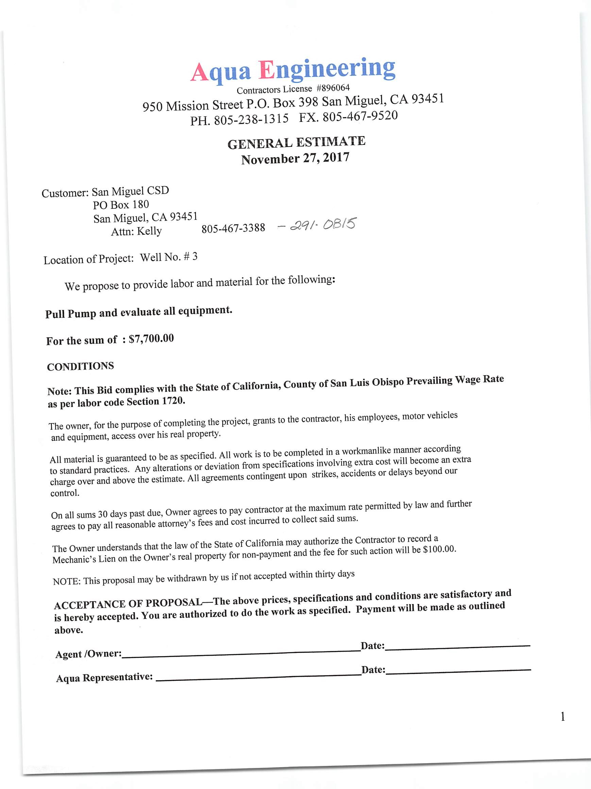

TITLE: | GENERAL MANAGER
REPORTS TO: | Board of Directors
PAY GRADE: | Employment Agreement
FLSA: | Exempt
CONFIDENTIAL: | Yes
____________________________________________________________________________________
SUPERVISORY RESPONSIBILITIES
DIRECT: Board Clerk, Director of Utilities, District Office Staff
INDIRECT: None
____________________________________________________________________________________
MINIMUM QUALIFICATION REQUIREMENTS
Unless required by law, experience and education may be substituted for each other upon approval by the Board of Directors. The following certifications are required at the time of hire date or an equivalent combination of education and experience sufficient to successfully perform the duties of the position:

EDUCATION: Undergraduate degree from an accredited four (4) year college or university with a major in Business Administration, Public Administration, Engineering, or a closely related field.

EXPERIENCE: Minimum of five (5) years of broad and extensive work experience in a management or administrative position in a private or public utility agency. Background should include responsibility for formulation and implementation of programs, budgets, and administrative operations.
____________________________________________________________________________________ CONTACT RESPONSIBILITY
INTERNAL: Interaction with: Board of Directors to receive policy direction and project directives, receive specific work assignments and review results; Board Clerk and Director of Utilities to discuss outstanding issues and coordinate assignments; and all other District personnel as required.

EXTERNAL: Interaction with: general public to answer questions pertaining to the San Miguel Community Services District (“District”); intergovernmental and regulatory agencies to foster cooperative working relationships; and community groups, businesses, media, and emergency service personnel as required.
____________________________________________________________________________________ PHYSICAL REQUIREMENTS
While performing the duties of this job, the employee is regularly required to sit, talk, and hear. The employee is occasionally required to stand, walk, stoop, kneel, or crouch.

Specific vision abilities required by this job include close vision, distance vision, peripheral vision, depth perception, and the ability to adjust focus.
____________________________________________________________________________________ ENVIRONMENTAL CONDITIONS
When working indoors, work is performed in an office environment with lighting and ventilation. The indoor working environment is subject to conversational noise from other personnel, as well as standard background noise found in an office environment and exposure to a computer screen.
____________________________________________________________________________________
DETAILED DUTIES AND RESPONSIBILITIES - ESSENTIAL FUNCTIONS

The General Manager is the executive officer of the District and for the Board of Directors (“Board”).

This at-will, exempt position plans, organizes, directs, and coordinates all District functions and activities, subject to approval by the District’s Board, in order to provide customers with safe and reliable water, wastewater, and fire services. This position provides day-to-day leadership for the District, and develops policies and objectives for the District in accordance with the Board’s directives. This position must perform each essential duty satisfactorily. The requirements listed below are representative of the knowledge, skill, or ability required.

Must be able to effectively lead, supervise, motivate, train, and evaluate personnel. Must be able to exercise sound and independent judgment to prioritize and manage projects. Must be familiar with public administration and budget development as they pertain to the District’s water, wastewater, and fire services. Must be able to maintain confidentiality, respond professionally to the public and emergencies, and prepare policy reports and letters. Must have knowledge of pertinent federal, state, and local laws, codes, and regulations. Must be able to communicate clearly and concisely, both orally and in writing.

Basic knowledge of personal computer use is preferred, as this position will be required to monitor timeclock use, set up video conferences for meetings, and assist in running payroll, among other duties.

The following tasks are typical for this classification. Incumbents may not regularly perform all the listed duties, but may be required to perform additional or different duties from those set forth below to address business or staffing needs and changing business practices, as defined by the Board.

Administrative
- Daily Administration o Provides day-to-day leadership for the District;
  - Plans, organizes, coordinates, and administers, either directly or through subordinate department heads, the work of the District in accordance with the adopted goals and objectives of the Board and applicable laws and regulations;
  - Directs and coordinates the development and implementation of goals, objectives, policies, procedures, and programs for the District, as defined by the Board;
  - Implements administrative policies, procedures, and work standards to assure that goals and objectives are met and that programs provide mandated services in an effective and efficient manner;
  - Coordinates the activities of the waste, wastewater, fire, and administrative departments to effect operational efficiency and economy;
  - Maintains cordial relationships with all persons entitled to the services of the District and attempts to resolve all public complaints;
  - Directs the maintenance of District records and documents; o Supervises the District’s facilities, services, and finances; o Maintains custody and manages the condition of all District property; and
  - Uses independent judgment and follows proper protocol to address emergencies and provide direction to department heads.
- Long-Term Operations o Plans, develops, and implements immediate and long-term District policies and goals, as defined by the Board;
  - Confers with administrative personnel and reviews activity, operating, and expense reports to determine if any changes in programs or operations are required;
  - Directs preparation of directives to department heads, outlining policy, programs, or operational changes to be implemented; and
  - Supports the District mission statement.
- Executive Officer for the District o Facilitates constructive and harmonious Board relations;
  - Attends all meetings of the District’s Board and such other meetings as the Board may specify from time to time;
  - Represents the Board and District in contacts with governmental agencies, community groups and various businesses, professional and legislative organizations, District customers, and the media;
  - Consults with legal counsel concerning matters of litigation, contracts, and District operations; o Monitors legislation on the state, federal, and local level;
  - Directs and coordinates changes required by new legislation; o Coordinates press releases as necessary; and o Acts as staff for the Board and advises the Board on District issues and programs.
- Budgeting
  - Directs and coordinates the preparation and administration of the District annual budget; o Evaluates and reviews current programs and formulates long-range financial goals of the
District; o Reviews all District expenditures; o Provides financial management for the District;
  - Manages all departmental budget, budget requests, and controls expenditures to ensure adherence to the District budget;
  - Ensures accurate records are being developed and maintained in all District departments;
  - Prepares procedures for tracking and evaluating the budget through the year; and o Calculates anticipated revenue or expenditures.

Personnel Supervisor
- Appoints and employs such personnel as the Board or he or she deems necessary for the proper administration and operation of the District, in accordance with District regulations and other applicable laws;
- Recommends changes in organizational structure and position classification;
- Maintains the authority to hire, discipline, and discharge employees;
- Approves or disapproves merit salary increases;
- Plans and directs the selection, training, assignment, supervision, and evaluation of employees;
- Delegates authority to carry out certain duties at his or her discretion;
- Provides supervision to District employees;
- Directs all personnel in accordance with District regulations and other applicable laws;
- Functions as the District’s bargaining representative in negotiations with personnel bargaining units;
- Coordinates investigations and resolutions of personnel grievances within his or her delegated authority;
- Approves overtime, vacation, and other time off for department heads;
- Trains personnel as needed;
- Analyzes problems that arise in the areas of supervision and implements solutions;
- Follows the employee relations system established by the Board when appointing, supervising, disciplining, and dismissing District employees;
- Evaluates and recommends to the Board, the hiring, promotion, or salary increase of District personnel; and
- Performs performance evaluations for department heads and other District personnel as needed.
____________________________________________________________________________________
DETAILED DUTIES AND RESPONSIBILITIES - NON-ESSENTIAL FUNCTIONS

Related Duties
- Performs all other related duties as assigned by the Board of Directors.

RESOLUTION NO. 2017-58
A RESOLUTION OF THE BOARD OF DIRECTORS OF THE
SAN MIGUEL COMMUNITY SERVICES DISTRICT APPROVING THE GENERAL
MANAGER JOB DESCRIPTION

WHEREAS, the San Miguel Community Services District (“District”) General Manager job description has not been updated for some time; and

WHEREAS, the District is seeking to fill the General Manager position with a permanent, full-time employee, and it must have an accurate job description prior to the appointment of a General Manager; and

NOW THEREFORE, BE IT RESOLVED, the Board does, hereby, approve the amended General Manager job description, attached hereto as Exhibit A.

On the motion of Director , seconded by Director and on the following roll call vote, to wit:

AYES:
NOES:
ABSENT:
ABSTAINING:

the foregoing Resolution is hereby passed and adopted this 14th day of December, 2017.

___________________________
John Green, President
Board of Directors

ATTEST: APPROVED AS TO FORM:

_________________________________ ________________________________
Rob Roberson, Interim General Manager Douglas L. White, District General Counsel

{CW050497.1} Page 1 of 1

San Miguel Community Services District

Board of Directors Staff Report

December 14, 2017 AGENDA ITEM: XI.7

SUBJECT: Review and Approve Resolution No. 2017-59 Appointing Robert Roberson as General Manager of the San Miguel Community Services District.

STAFF RECOMMENDATION:

Approve Resolution No 2017-59 appointing Robert Roberson as General Manager of the San Miguel Community Services District.

BACKGROUND:

Pursuant to Government Code section 61050, the San Miguel Community Services District (“District”) Board of Directors (“Board”) is authorized to appoint a General Manager to serve as the administrative head of the District’s government under the direction and control of the Board. The District’s General Manager position has been vacant since May 17, 2017.

On June 9, 2017, the Board appointed District Fire Chief, Robert Roberson, as Interim General Manager. The Board and Mr. Roberson executed a temporary employment agreement, which became effective on June 10, 2017.

Due to Mr. Roberson’s extensive knowledge of the District, its internal procedures by virtue of his service as Fire Chief, and his work as the Interim General Manager, the District desires to appoint him as the permanent General Manager of the District.

Under state law, the General Manager is responsible for (a) implementing policies established by the Board for the operation of the District; (b) appointing, supervising, and disciplining District employees, consistent with the employee relations system established by the Board; (c) supervising District facilities and services; and (d) supervising District finances. As General Manager, Mr. Roberson will be required to carry out these directives under the direction of the Board and in accordance with the terms of the Employment Agreement, which will be negotiated and brought to the Board for ratification at a subsequent Board meeting.

{CW050499.1}
Page 1 of 2

FISCAL IMPACT:
There are no fiscal impacts at this time, but there may be fiscal impacts upon ratification of Mr.
Roberson’s employment agreement.
STAFF RECOMMENDATION:
Staff recommends that the Board approve Resolution No. 2017-59, appointing Robert Roberson as the General Manager San Miguel Community Services District, or in the alternative, direct District staff to begin recruitment procedures for a permanent General Manager.

PREPARED BY:

Douglas L. White, District General Counsel

Resolution 2017-59

{CW050499.1}
Page 2 of 2

RESOLUTION NO. 2017-59
A RESOLUTION OF THE BOARD OF DIRECTORS OF THE
SAN MIGUEL COMMUNITY SERVICES DISTRICT APPOINTING ROBERT
ROBERSON AS GENERAL MANAGER OF THE SAN MIGUEL COMMUNITY SERVICES DISTRICT

WHEREAS, the San Miguel Community Services District (“District”) has had a need for a permanent General Manager a result of the vacancy to this position, which has been vacant since May 2017; and

WHEREAS, the District temporarily appointed the District’s Fire Chief, Robert Roberson, as Interim General Manager to fill the role of General Manager until a permanent General Manager is hired; and

WHEREAS, the District desires to appoint Mr. Roberson as the District’s permanent General Manager; and

WHEREAS, the Board hereby appoints Mr. Roberson as permanent General Manager.

NOW THEREFORE, BE IT RESOLVED, the Board does, hereby, adopt this Resolution
for purposes specified herein.

On the motion of Director , seconded by Director and on
the following roll call vote, to wit:

AYES:
NOES:
ABSENT:
ABSTAINING:

the foregoing Resolution is hereby passed and adopted this 14^{h} day of December 2017.

___________________________
John Green, Board President

ATTEST: APPROVED AS TO FORM:

________________________________
___________________, Board Member Douglas L. White, District General
{CW050498.1} Page 1 of 1

