Website Copy for Utilities/Others

California’s Low Income Household Water Assistance Program (LIHWAP)

California’s Low Income Household Water Assistance Program (LIHWAP) provides critical financial assistance to households struggling to make ends meet. Through LIHWAP, eligible low-income households can receive one-time financial help to pay current or past due water or sewer bills and keep their water on.

If your household income is below 60% of the state median income for California families – or if you are a recipient of CalFresh, CalWORKs or the Low Income Home Energy Assistance Program (LIHEAP) – you are already income-qualified for LIHWAP.

APPLY TODAY: To find out if you qualify for help paying your current or past due water or sewer bill, go to csd.ca.gov/waterbill to learn more.

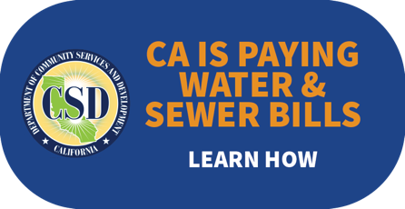
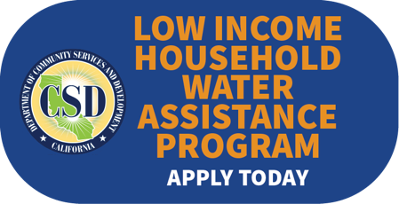

OR

