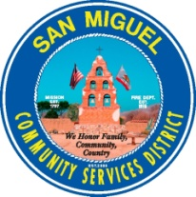Agenda
San Miguel Community Services District

NOTICE OF CANCELLATION
Organization & Personnel Committee
FRIDAY, January 13, 2017, 9:00 A.M.
SMCSD Boardroom 1150 Mission St. San Miguel, CA 93451

THIS SCHEDULED MEETING HAS BEEN CANCELLED

Meeting will be rescheduled and Notice will be re-posted for a future date and time as may be needed.

Attest:

STATE OF CALIFORNIA )
COUNTY OF SAN LUIS OBISPO ) ss.
COMMITTEE OF SAN MIGUEL )

I, Tamara Parent, Account Clerk of San Miguel Community Services District, herby certify that I caused the posting of this agenda at the SMCSD district office on January 12, 2017.

Date: January 12, 2017

Tamara Parent
Tamara Parent, Operation Coordinator/ Account Clerk II

